The role of the society and government in dealing with the issue of the poor.
Augambaev Alen 11 «C»
Nazarbayev Intellectual School

Word count: 3380
INTRODUCTION
This paper will examine the impact of poverty. As commerce, travel, and instant communication increasingly connect people, the world is still divided into huge differences between rich and poor countries. In addition, people in need become hostages to tunnel thinking, which adversely affects their life decisions.
I thought about poverty. Its influence on our city, country and the whole world. It motivates me that, in principle, poverty can be reduced to zero. I want to understand how and why this has not happened yet.
Governments often fail to eradicate poverty, leading to even greater degradation of the poor and the economy. For example, less than 10 percent of the world's population currently lives in extreme poverty and lives on $ 1.90 a day or less (Global Poverty: Facts, Frequently Asked Questions, and How to Help, paragraph 1). Funds that fight hunger, poverty around the world help people live, as well as the government, because they, therefore, do not have enough time to take care of this. Charities from this point of view give the government time, and soon they will begin to eradicate poverty.
Poverty does not concern me personally, but it is present in my country. Usually, when I walk around, I see people suffering from poverty. Furthermore, news programs describe the living conditions of the poor. I understand that poverty is difficult to cope with, and for this reason, I will investigate this problem and suggest possible solutions based on the research.
Since 1990, a quarter of the world has grown out of extreme poverty. Looking at the poverty trends of the whole world in our time, we can confidently say that more than 100 million people around the world will live in extreme poverty. Although authorities and numerous organizations are involved in solving the problem of poverty, it remains completely unresolved, despite the great successes of the world in overcoming global poverty.
Research can be used by economists, foundations, and volunteers struggling with poverty and hunger in the world, if necessary, psychologists. It will also show the importance of an early resolution of the problem involving the government and individuals, as this is in their interest.
CONTEXT
In 2015, the World Bank raised the international poverty line from $1.25 $1.90 per day the prices for accommodation in 2011 are based on the prices of accommodation in the USA. Besides, the United Nations Member States have adopted Sustainable development Goals that include targets for the eradication of poverty and hunger in all their forms(Global poverty: Facts, FAQs, and how to help, para. 19).
India's success in a country that is about to become the worlds largest quickly reduces extreme poverty, and the world may have underestimated India's achievements. Household consumption will include adjusting owner-occupied housing and measuring other items according to accepted international practice. The World Data Lab expects the consequences of these methodological adjustments to result in India’s current extreme poverty rate of 50 million, and its decline to 40 million by the end of 2019 (poverty below 3%).
According to the Joseph Rantry Foundation, 13.5 million people in the UK live in poverty, and this number is expected to grow. One of the documents said that “the numerous definitions of poverty and material deprivation cannot be completely separated from housing circumstances”. According to a housing charity shelter, poor housing conditions increase the risk of serious illness or disability by up to 25% in childhood and early childhood. The reduction in the social housing fund has been well documented - there are long lists awaiting a reduction in the number of real estate properties (the impact of poverty on welfare is difficult to ignore, for example, “poor quality and unsafe housing”). The Food Facility describes food insecurity from concern about food availability (moderate food shortages) to hunger. According to their estimates, in 2012, 28% of adults saved on food last year so that other members of their families could eat. They reported that in 2014, 8.4 million people in the UK faced food shortages (the impact of poverty on welfare is difficult to ignore, for example, “food insecurity”). In addition, the Hunger project provides tools and training to increase local agricultural production; gives partners the opportunity to create their own food banks and manage them; and encourages rural village groups to create sustainable, autonomous communities without hunger (Hunger project, 2019).
The UN General Assembly at its seventy-second session proclaimed the “Third United Nations Decade for the Eradication of Poverty (2018–2027)”. The goal of the Third Decade is to maintain the momentum created by the second United Nations Decade for the Eradication of Poverty (2008-2017) to eradicate poverty.
On January 8, 1964, U.S. President Lyndon B. Johnson introduced legislation that responded to a national poverty rate of about 19%. This legislation has the unofficial name of “The War on Poverty”. The legacy of the war on poverty continues to exist in such federal government programs like Head Start, Volunteers in Service to America (VISTA), TRiO, and Job Corps. according to the document of the National Bureau of Economic Research in 2019, according to Johnson's poverty standard, the poverty level decreased from 19.5% in 1963 to 2.3% in 2017.
Since in 2009, government social spending has accounted for approximately 21% of GDP in 34 member countries of the Organization for Economic Co-operation and Development. Government spending as a percentage of GDP grew or remained high after the global financial crisis in many European countries. This was not due to any significant increase in social spending, but because of a reduction in GDP in these countries. Generous government assistance programs can also be found in the world's richest and most prosperous countries. Germany is able to provide its generous social security programs thanks to its economic power.
According to the UNICEF, currently, 91 percent of the world's population has access to improved drinking water sources. Since 1990, 2.6 billion people have gained access to such sources, including 42 percent of the population of least developed countries. Improved drinking water sources are used by 96 percent of the urban population and 84 percent of the rural population. However, as of 2015, the number of people on the planet who were denied access to quality drinking water was 663 million. At the same time, 80 percent of them lived in rural areas.
One of the most important indicators of human well-being is income, as it determines the extent to which the population will purchase goods and services. UK income distribution statistics are mainly based on household income. In 2009, 10% of the families with the highest incomes accounted for 31% of all incomes, and 10% of the families with the lowest incomes accounted for 1%, so the income differences of the poorest are 31 to 1. Over the past decade, there has been some decrease in income 10% of the poorest people, while incomes of 10% of the richest people increased: in the 1990s, they amounted to 2.1% and 28.5%, respectively.
AIMS
The main goal of the study is to find out how society and government struggle with poverty. Therefore, this study will address the following research questions:
·What is the government doing to address poverty?
· What are the main factors affecting poverty and what changes have occurred?
·Why is the difference in the welfare of citizens great?
My hypothesis is that poverty in the world has decreased significantly since World War II, but it will still be one of the main problems in the world.
Perhaps this data can be used as another source of information to study and draw conclusions.
METHOD
These are studies on poverty and society, their relationships. My goal is to find out how our society treats poor people and whether they’re willing to do anything to deal with the issue. My research methods contain two surveys and interview. so, I’m going to find the right answers and draw a conclusion from all the information I’ve received.
Survey:
1) What is the attitude of people towards the poor?
2) To what extent are people ready to help the poor?
As the first method of the primary research survey was selected. One of my goals is to find out people's attitude to the poor and the level of their readiness to help the poor. For this I need a large audience to find out their attitude to poor people (to beggars and homeless people). The survey allows to cover many people and enables me to identify their opinion on the target issue and generalize the information received. Evidence sources will be the answer of citizens of my city (Ust-Kamenogorsk). The survey allows you to cover many people and get important information for my research.
Surveys are an effective type of content that allows you to connect with the audience and find out their opinion on the topic of the survey, which will help to draw conclusions / improvements.
Weaknesses of first method. People’s careless attitude towards completing the survey may prevent from gaining credible data or may lead to receiving inaccurate information. Questionnaire answers may also not be the same as possible answers from respondents. Also, I can create the wrong questions, this will lead to inaccurate data.
The reason for selecting this population is that the citizens of U-KA are the part of the society where the groups with low income below the threshold, homelessness and beggars exist.
Population was citizens of Ust-Kamenogorsk city, because I can conduct this survey in my city, in addition, my city also there are the social layers that are struggling with fulfilling their basic needs. the problems of poverty, no matter what types of poverty. There are not indifferent to the poor and are ready to help them in every possible way being abundant or perhaps in small poverty in terms of income. The survey was conducted among adolescents, and the views of adults would probably change to the outcome. About 50 people are enough for this survey. The conclusion may not be complete.
Interview:
1) What is the attitude of people towards the poor?
2) To what extent are people ready to help the poor?
3) How is the poverty being addressed in the society? (Poverty mean homeless and low-income groups)
Method 2 is an interview which conduct with the aim questions “To what extent are people ready to help the poor?”, “What is the attitude of people towards the poor?”, “How is the poverty being addressed in the society?”. Interviews are most effective for qualitative research. It helps me to explain, better understand, and explore research subjects' opinions, experiences. Interview questions are usually open-ended questions so that in-depth information will be collected.
Weaknesses of interview is can be very time-consuming, Candidates can rehearse answers, interviewer bias will affect the decision. Also, possible interview fatigue.
The sample can be head of a charity, charity worker. These people are knowledgeable about poverty and how to help them. I’ll send the questions of interview or, if its possible conduct eye-to-eye interviews.
Non-participant observation:
2) To what extent are people ready to help the poor?
3) How is the poverty being addressed in the society? (Poverty mean homeless and low-income groups)
Third method was non-participant observation. It makes it possible to see everything that happens with my own eyes, I can judge and observe. In addition, I will be more open-minded because I am looking for outsiders, and it is unlikely that there will be any additional feelings, and therefore I will receive bias data.
About weaknesses, people can start to behave differently when they notice that they are being monitored to the extent that aggression by the participant begins. It’s also not ethical if people don’t know what they are being watched. Possible difficulties with the impressions of the participants in the observation, understand them or determine what thoughts they.
Sample will be citizens and poor. These observations and follow up on people's reactions are best for this kind of research. Observation will be carried out according to the situation. If I meet a beggar on the street, I will get up nearby and will observe for about 15 minutes and monitor how events will develop, after making conclusions. Such observations are not limited to one.
RESULTS
The first research method that I used is survey. Questions were asked to the either of sample groups. First question (image 1), evaluate your level of awareness with the situation of poor people. According to a 10-point scale, 22.2% of respondents (selected 5.6.7) are knowledgeable on average, and only 5.6% of respondents are more knowledgeable (chose 9.10), 16.7% and 5.6% are less knowledgeable (3.4 selected)
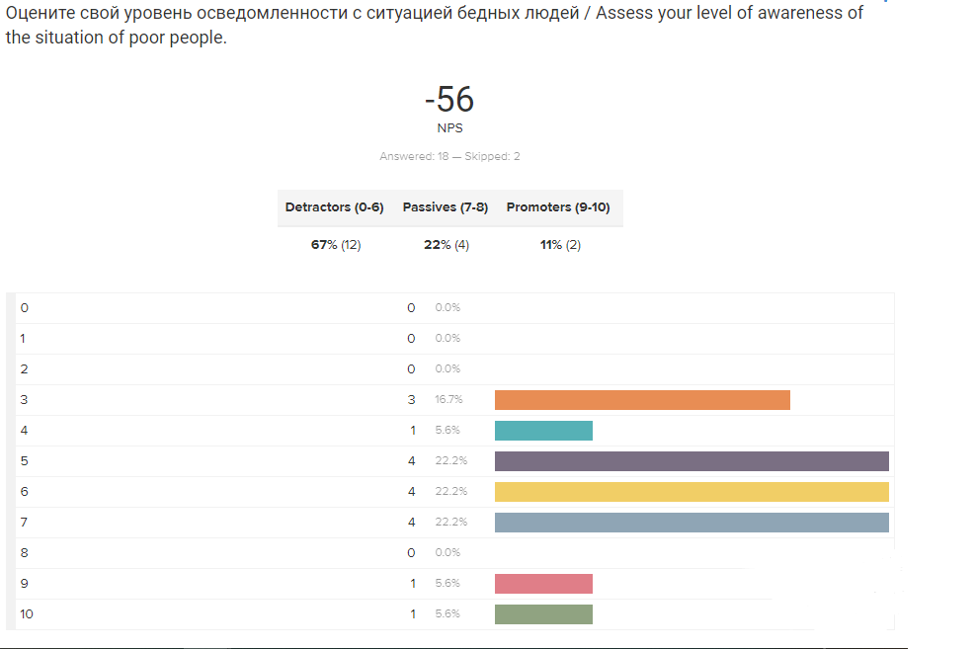
Image 1
The next question was asked to find out how people feel when they see a person in need. You can see (image 2) that 40% are sympathetic, and another 40% want to help when they see such people. 5% do not care what happens to those in need , the other 5% think about why they are in this situation
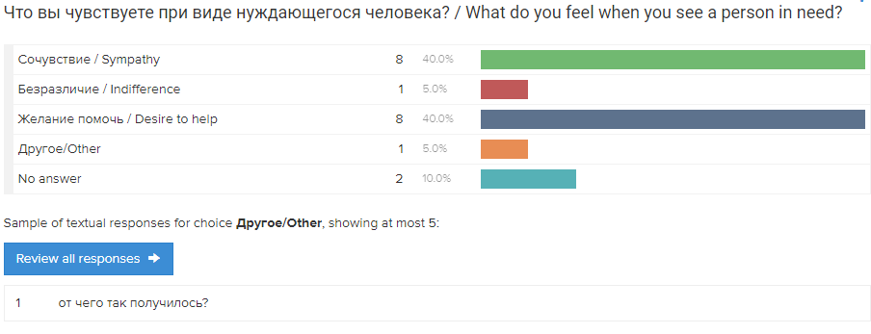
Image 2
In the third question (image 3), I am interested in how often people give money to the poor. As I thought, half (50%) rarely leave the poor. It is commendable that 15% always help (by money) the poor. 20% of respondents sometimes leave money. Only 5% never gave money to those in need

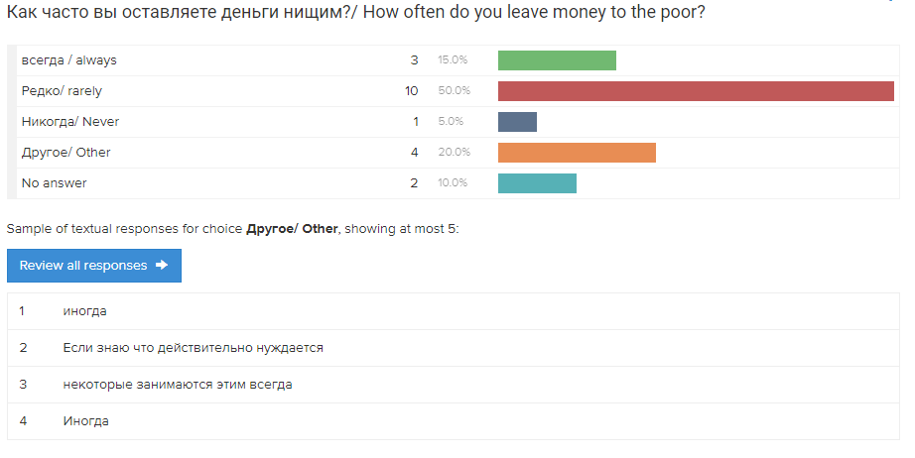
Image 3
The fourth question was for the sake of specificity, how much money people leave the poor. It happens in different ways, but mostly from 100 tenge and more.

On the question of how the poverty problem should be solved (image 4), many (more than 50%) believe that poverty should be solved exclusively with the help of the state.
Those who care (more than 20%) believe that society should make its contribution to solving this problem. Less than 15% think it depends on the situation of the poor.
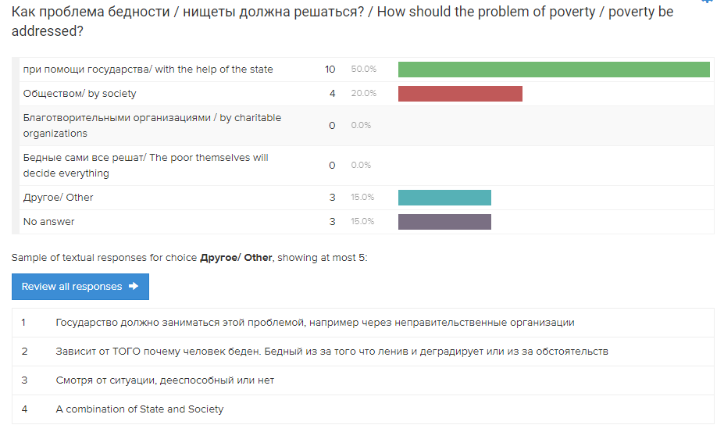
Image 4
In the following, respondents gave some ideas on how to solve the problem of poverty. The first one offers raise the level of minimum wages, education, motivate small businesses, give freedom to non-governmental organizations fighting poverty in particular. The second proposes to increase the number of jobs, and housing. The third thinks that it is necessary to increase the pension (including disability).

In the next question (image 5), respondents compare their material well-being with most of the rest (average). 50% live in abundance, and have much better financial well-being. There are also people who live on average, such 35%. However, 5% are worse than average.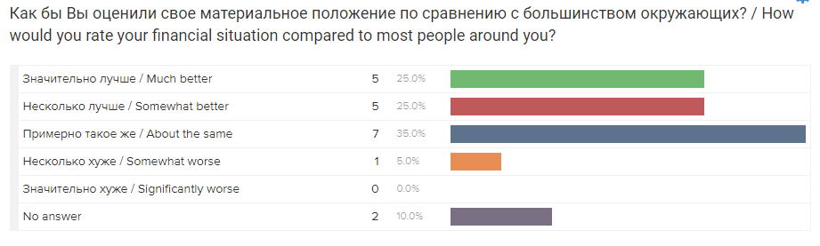
Image 5
The last question respondents chose the main causes of social inequality (image 6). 10% are sure that the unfair distribution of income is the main cause of material shortage. Ineffective government work in the social sphere, this is the reason for the social gap in the opinion of 20% of those surveyed. Corruption also affects poverty in the country, the same opinion of 25% of respondents. 35% think that fate and other external circumstances are to blame.

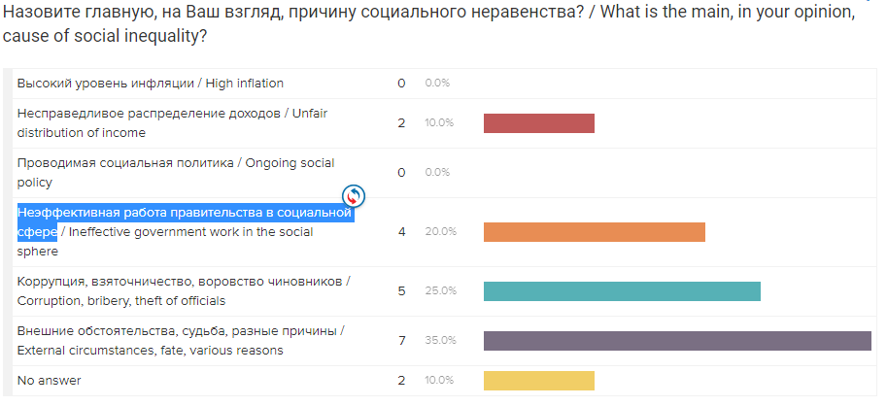
Image 6

The second method that is interview. The main purpose of the interview was to answer to the questions - “To what extent are people ready to help the poor?”, “What is the attitude of people towards the poor?”, “How is the poverty being addressed in the society?”.
I interviewed a charity worker. His name is Kuat Uly Amanbol. He said that he works in the Zakat foundation, which operates under the Spiritual Administration of Muslims of Kazakhstan. Kuat has been involved in charity work for two years now. According to him, this fund helps those in need with the help of generous, kind and rich people. They find people in need, talk with them and provide assistance depending on the situation.
The government does not provide any assistance to the Zakat Foundation.
When asked how many people you have already helped, Kuat replied that they have a lot of people asking for help and the exact number is not. He also added that due to quarantine from Ust-Kamenogorsk to Nur-Sultan, aid comes in the form of 600 boxes of food for 600 families, which are sent daily.
At the expense of future plans, this fund has a “Ghost Apartment” campaign, in which in 2019 2 houses were donated to families from Ust-Kamenogorsk and 180 apartments throughout Kazakhstan. In the future, they plan to continue this action and increase performance compared to last year.
Third method was non-participant observation.
The purpose of this observation was to answer such questions - To what extent are people ready to help the poor? How is the poverty being addressed in the society? (Poverty mean homeless and low-income groups).
Unfortunately, I could not make observations because of the outbreak of coronavirus, after which everyone is quarantined.
CONCLUSION
The main objective of this research work was to identify the influence of society and government in solving poverty problems. The following conclusions were made:
·What is the government doing to address poverty?
The government at least uses 4 different policies to reduce poverty. These are minimum wage laws, social security, negative income taxes and in-kind benefits. The Minimum Wage Act obliges all employers to pay the minimum wage to their employees, as determined by the government. Social security involves government benefits such as income support, tax benefits, unemployment benefits. Negative income taxes are a subsidy for low-income people. Natural benefits it is an alternative to regular benefits.
· What are the main factors affecting poverty and what changes have occurred?
1. Conflict.
Over the past ten years, the number of conflicts has sharply increased, they have become more complex and difficult to resolve. In conflict-affected areas, poverty is particularly high.
2. Hunger and delay in growth.
Hunger has been declining for ten years, but today its increase is due to an increase in the number of military conflicts and the effects of climate change. At the global level, the proportion of stunted children fell from 29.5% to 22.9%. In 2016, every fourth child was still stunted - 155 million children.
3. Small or no access to pure water, sanitation and hygiene.
Currently, 91 percent of the world's population has access to improved drinking water sources. Since 1990, 2.6 billion people have gained access to such sources, including 42 percent of the population of least developed countries.
4. Bad public works and infrastructure.
In recent years, huge positive changes in infrastructure have been observed in all parts of the world. We can say that today we are better connected than ever: the number of roads has increased, transportation systems have improved, and opportunities for high-speed Internet access have appeared.
· Why is the difference in the welfare of citizens great?
The difference in the welfare of citizens depends on how much money the government spends on health care and various social programs. generous social security spending will reduce poverty in the country.
As expected, the poverty level in the world is gradually decreasing, but due to certain problems, the poverty rate is fluctuating. In developed countries, the poverty rate is much lower than in developing countries.
EVALUATION
My research is good, but due to some limitations it was not possible to consider from all possible sides. In addition, in the initial study, there were few people who answered questions, which casts doubt on the exact conclusions. Nevertheless, the answers received may well be used. To improve the initial research, perhaps it was necessary to force people to take the survey, to be persistent, but not the fact that such treatment would be a good solution. In the second study, some aspects could be reduced and slightly generalized to find information in other areas. Nevertheless, these results are reliable and verified and can be used.
FURTHER RESEARCH
In the current study, I examined the obvious factors affecting poverty, such as conflict, hunger, and undeveloped infrastructure. To supplement my results, I would also look for authoritative people that will give reliable facts based on my studies or achievements. Additionally, you need to expand your horizons and find information on how gender inequality affects poverty, what is needed for the well-being of the poor and more. My next goal is to consider the problem of poverty from such perspectives, then I can supplement my conclusions, and perhaps this will open the way for new solutions, which will greatly reduce poverty in the world.
BIBLIOGRAPHY
https://www.thp.org/issues/hunger/
https://finance.yahoo.com/news/countries-most-generous-welfare-programs-110004319.html
https://en.wikipedia.org/wiki/War_on_poverty
https://www.unece.org/fileadmin/DAM/stats/publications/2018/ECECESSTAT20174_ru.pdf
https://www.un.org/ru/documents/decl_conv/conventions/agenda21_ch3.shtml
http://www.grandars.ru/student/mirovaya-ekonomika/problema-bednosti.html
https://www.concernusa.org/story/causes-of-poverty/
https://www.un.org/en/sections/issues-depth/poverty/
https://www.un.org/ru/sections/issues-depth/water/index.html
APPENDICIES
Appendix 1 – Online Survey
- Ваш возраст /Your age:
А. 15-20
Б. 21-25
С. 26-30
Д. 31-40
Е. More than 40
- Оцените свой уровень осведомленности с ситуацией бедных людей / Assess your level of awareness of the situation of poor people. (from 1 to 10)
- Что вы чувствуете при виде нуждающегося человека? / What do you feel when you see a person in need?
А. Сочувствие / Sympathy
Б. Безразличие / Indifference
С. Желание помочь / Desire to help
Д. Другое/ Other: __________
- Как часто вы оставляете деньги нищим?/ How often do you leave money to the poor?
А. всегда / always
Б. Редко/ rarely
С. Никогда/ Never
Д. Другое/ Other: __________
- напишите сумму денег, которые вы оставляете нищим. / Write the amount of money you leave to the poor.
_____________________________
- Как проблема бедности / нищеты должна решаться? / How should the problem of poverty / poverty be addressed?
А. при помощи государства/ with the help of the state
Б. Обществом/ by society
С. Благотворительными организациями / by charitable organizations
Д. Бедные сами все решат/ The poor themselves will decide everything
Е. Другое/ Other: ____________
- Если хотите можете предложить идеи для решения проблемы нищих, бездомных.
__________________
- Как бы Вы оценили свое материальное положение по сравнению с большинством окружающих? / How would you rate your financial situation compared to most people around you?
А. Значительно лучше / Much better
Б. Несколько лучше / Somewhat better
С. Примерно такое же / About the same
Д. Несколько хуже / Somewhat worse
Е. Значительно хуже / Significantly worse
- Назовите главную, на Ваш взгляд, причину социального неравенства? / What is the main, in your opinion, cause of social inequality?
А. Высокий уровень инфляции / High inflation
Б. Несправедливое распределение доходов / Unfair distribution of income
С. Проводимая социальная политика / Ongoing social policy
Д. Неэффективная работа правительства в социальной сфере / Ineffective government work in the social sphere
Е. Коррупция, взяточничество, воровство чиновников / Corruption, bribery, theft of officials
Ф. Внешние обстоятельства, судьба, разные причины / External circumstances, fate, various reasons
Appendix 2 - Online Interview
- Представьтесь, пожалуйста. / Introduce yourself, please.
- Как долго вы занимаетесь благотворительностью? / How long have you been doing charity work?
- С помощью каких людей вы реализуете деятельность в плане благотворительности? / With the help of what people do you carry out charity work?
- На сколько активно люди участвуют в помощи бедным? / How active are people in helping the poor?
- Какие поддержки вы получаете со стороны правительства? / What kind of support do you receive from the government?
- Поделитесь о ваших достижениях. Скольким людям вы уже помогли? / Share your achievements. How many people have you already helped?
- Есть ли планы на будущее? / Are there any plans for the future?
Appendix 3 – Non-participant Observation
Во время наблюдения я буду смотреть как прохожие будут действовать при виде нищего на улице. Будут ли они подкидывать деньги, игнорировать, смотреть на него и не подходят, выражая сочувствие или безразличие и другое. Ведя наблюдение, я буду записывать все их реакции и распределять по определенным блокам, это поможет мне сделать хорошие выводы.
Этим методом я получу информацию, которая ответит на основные вопросы всего исследования. Каково отношение людей к бедным? Насколько люди готовы помогать бедным? / During the observation, I will watch how passers-by will act when they see a beggar on the street. Whether they will throw up money, ignore it, look at it and do not fit, expressing sympathy or indifference and more. Conducting observation, I will record all their reactions and distribute them in certain blocks, this will help me draw good conclusions.
With this method I will receive information that will answer the basic questions of the entire study. What is the attitude of people towards the poor? To what extent are people ready to help the poor?

