How listening to music in a foreign language influences academic performance of students?
Kamzina Albina 11C
Nazarbayev Intellectual school
in Oskemen

Word count: 3731
Introduction
Music is one of the essential things in human life. As the Confucius said: «Music produces a kind of pleasure which human nature cannot do without». People are used to music listening during the study, working times, playing game and other moments. The presence of songs in foreign languages is one of the most salient aspects of globalization. The music is very powerful in its way of affecting a listener.
I love music so much since my childhood and the songs in English attracted me the most. Now my playlist mainly consists of songs in English. The lyrics are important to me, so when I look through it, I learn new words. I came to think that what we like might be useful.
Music is intentionally used as a tool for teaching language, society and culture. Songs encode cultural significance, inspiration, and views of the world. Music may play a very important role at a school in foreign language learning. It is a great tool to help students learn vocabulary as well as activate the minds of pupils, boost their awareness and offer lots of joy.
Since we are studying foreign language, I would like to know about the importance of listening to music in a foreign language in studying and academic performance.
My bias is that almost all teenagers in Kazakhstan listen to music in a foreign language. A bias appeared from my personal observations. Biased opinion is going to be overcome by searching for proved information on this topic.
Outcomes of the research would help to learn about the impact of music in a foreign language on academic performance and see its effectiveness in language mastering.

Context
There are different ways in which a foreign language can be learned. Listening to music in a foreign language also can be used as a tool for learning it. Many students enjoy listening to music, therefore learning language through music may enhance their desire to study.
From the ethical point of view, the research considers tastes of people in music, how it can help them with language studying, academic achievements and motivation. According to Marzieh Mashayekha and Masoud Hashemi (2011), music's function in learning can be described in terms of fostering social harmony, intensity of motivation and resource for learning.
- Enhancement of social harmony: Social harmony among learners is one of the most important factors for achieving effectiveness in teaching and learning.
- Power of motivation: Music is used to soothe spirit, to calm mind and body. Music helps learners to release themselves from stress and pressure.
- Training tool: Music is actively used for teaching language, society and culture. Songs represent spiritual significance, motivation and views of the world.

Referring to a cultural lens, music can be used as a tool of promoting culture and learning about other ones via foreign music. Youth culture in Kazakhstan is heavily influenced by Western culture, predominantly American due to globalization. For example, the influence of the western world can be seen from prevalence of music in English and change in the dressing style of youth. Now majority of young people prefer to dress in a street style. Street style comes from different types of youthful influencers such as celebrities, TV personalities and particularly Western musicians in the music industry.
Hilda Israel states that learning a language through songs in the target language will encourage students to recognize who they are in their own culture, and the music they enjoy. Students are also introduced to international language and culture by music as a teaching technique and therefore the learning environment becomes far more integrated than expected (Language Learning Enhanced by Music and Song, 2013).
Considering a science and technology lens, digital music is spread due to the development of technology, songs in foreign languages are released on different worldwide platforms, allowing people to enjoy the music of their favorite musicians easily. It shows that all content going digital is the one of the reasons why English songs are famous.
On a global scale, songs sung in English are listened to around the world, because it's commonly spoken language and USA music market is the biggest in the world. For example, «Shape of you» and «One dance» are the most-listened songs of all time on Spotify, proving that songs in English are the most popular among listeners. Music is actively used as a tool in teaching. For instance, Lozano (1979) introduced Suggestopedia - a second language teaching method that is based on calm mental states to improve content retention. Music plays a vital part in this method of teaching, because it makes students to feel relaxed.
Observing from national and local perspectives, many teenagers in our country listen to music in a foreign language. Studying the statistics, the experts of Yandex Music found that in the top of 10 performers who are listened to on repeat most often in Kazakhstan there is "a clear advantage in the direction of Russian-speaking performers". Considering Kazakhstan Apple Music Top 20 Songs, 50% of the songs were in English.
Listening skill is central to second language learning and has a positive effect on language skills. Proper awareness is the first step towards listening. Word is acquired by hearing, first vocabulary and word comprehension abilities are gained through listening, says Fiveash (Music as an educative enrichment medium for the remediation of children with reading problems, 1995). Music consists of vibrations and music needs listening skills.
Catharina Aletta Horn (Master of education in South Africa) says that music enlarges one's language, develops speech and articulation. She says music plays a key role in teaching English as a second language, emphasizing that the learner should have well-developed listening abilities to be 'capable of understanding, studying and enjoying the language.' Good listening skills allow the learners to master the language skills they need: listening, reading, writing and speaking.
According to Grobler (1990), because of their sensual knowledge, learners evolve totally in music through exploration, discovery and perception of tone. Krouse describes that through vigorous singing, the learner accidentally and naturally learns language mechanisms and vocabulary that contribute to circumstances of speech (Beginning English.Mastering Second Language First Three Years, 1998).

Aims
Project aim is to investigate how listening to music in a foreign language influences academic performance of students.
Research questions:
- What is the attitude of students towards music?
- What are the motives behind listening to music in a foreign language?
- How music in English helps with learning and success in academic performance?
- What are the advantages and disadvantages of listening to music in a foreign language?

During the research the effects of listening to foreign music on a listener’s skills will be learned and its effectiveness in learning a new language will be investigated. The hypothesis is that listening to music in English language is very helpful in learning the language.

Methods

In order to obtain data for answering the research questions, three primary research methods were used: survey, interview and focus group discussion.
A survey was used as the first method. It is used by producing a numerical data that was converted into statistics. This method helped to find out how much time students spend on listening to music, music in what language they prefer and see if lyrics matter to them.
Research question:
- What is the attitude of students towards music?

Almost all teenagers in our country listen to music in a foreign language, therefore the population of the survey was young people. The survey was conducted to be acquainted with their preferences in listening to music. It showed to what extend young people are attracted by music. The well-known website surveymonkey.com was used in order to create a survey that consisted of 8 questions and collected the data from the sample of 100 students of different schools in Oskemen of different ages that helped to answer the question above. It was quite enough to gather objective data and generalize information.
A survey gave a structured, quantitative data in the form of statistical analysis. A survey method has had the following weakness: It is suspected that some respondents could lie while answering a question about academic performance in English subject.
To get full, complete information about the effect of a foreign music on language proficiency and academic performance, several interviews were conducted as the second method.
The interview was used to understand the beliefs and motives behind listening to music, dive deeper into the topic. In addition, conducting the interview with several people provided with an observation from different perspectives. An interview was conducted using social media (VK and WhatsApp) where the questions were asked.
Research questions:
- What are the motives behind listening to music in a foreign language?
- How music in English helps with learning and success in academic performance?

The population of the method was students of NIS in Oskemen. The sample involved Beisenbayev Telgara and Yersultanov Daniyar (who received 7.5 points on IELTS exam). They are 11th grade students. While conducting individual interviews, their motives behind listening to music and the things they learned from music were revealed. Moreover, the interview were conducted with the teachers of the English language of NIS in Oskemen – Mariya Savina, Roza Auyespayeva and Zhanar Umbetayeva to ask if listening to songs in English has a positive impact on learning the language.
An interview gave a qualitative data with subjective opinions.
Results of this method were verified by the third method. It was focus group discussion. It provided evidence for arguments about effects of listening to music in a foreign language on academic performance.
There was some weakness: Since a face to face interview could not be conducted, Daniyar was not open enough in his answers, they weren't complete.
The third used method was a focus group discussion. Focus group discussion gave a chance to gather points of view about impact of music in a foreign language on academic performance from several people in a short time. The focus group discussion was conducted on WhatsApp, using the audio recorder. Participants used voice messages for the discussion.
Research question:
- What are the advantages and disadvantages of listening to music in a foreign language?

Target was 4 school students of 11th grade of NIS in Oskemen. They refer to the people who are the main focus of the project, so considering a common problem from different points of view was effective in drawing conclusions about impact of music in foreign language on academic performance of students and its benefits and drawbacks. In addition, being the same age encouraged members of the group to express openly their opinions.
Focus group provided with a qualitative data that included a summary of subjective conclusions.
Weak side of group discussion method was that since only students of 11th grade were chosen as a sample for discussion, the group might not be a good representative of the larger population in generalizing the gathered information.

Results
Oskemen students and the English teachers helped me to find the answers to the research questions. All three methods were used in order to reach the main aim.
Based on the survey 38% respondents spend 1-2 hours and 24% spend 5 or more hours on listening to music per day. This shows that music is really an important part of everyday routine of students.
94% of the respondents said that they listen to music in a foreign language, the remaining 6% said they do it sometimes. This confirms that foreign music is popular among young people.
In answering question about music in what language they prefer the most, the English language was the most frequent. Besides, significant number of respondents answered that they prefer music in Russian and Korean languages.
The 51% of respondents sometimes pay, 45% always pay and 4% never pay attention to songs’ lyrics. These answers suggest that the lyrics are an important aspect for listening to music.
More than half of the respondents are always motivated by songs in a foreign language to study that language, whereas 43% said that it was a little motivating. This shows that listening to music is actually motivating to study.
66 percent have a mark “5” in English, 32 percent “4” and 2 percent “3”. This indicates that the overall respondents’ foreign language proficiency is at a relatively high level.
According to a vast majority of people, listening to a foreign music probably helps with academic success in a foreign language. The information can be seen in the Figure1.
Figure 1. Opinions about influence of listening to music in a foreign language on academic success
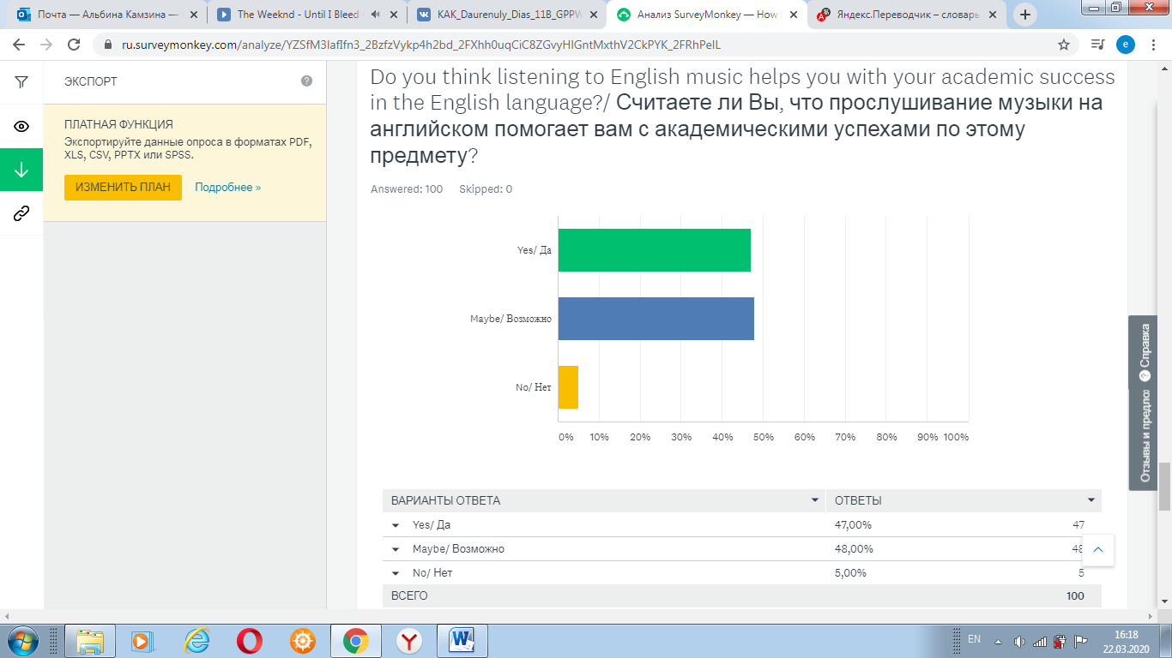

From the Figure 2 it can be shown that according to the opinion of the respondents listening to music helps to develop listening skills the most. Also, it is helpful in improving vocabulary and pronunciation aspects of the language.
Figure 2. Aspects of the language in developing of which listening to music is the most useful

The survey results were analyzed and the answers for 2 different questions were correlated between each other as shown below:
Table 1.Relationship between listening to music and mark
What is your mark in English? | Do you listen to music in a foreign language? |  | Number of respondents
 | Yes | Sometimes
5 | 66 | 0 | 66
4 | 28 | 4 | 32
3 | 0 | 2 | 2
Total | 94 | 6 | 100
Mode: «5» (mark)
This table shows that those people who listen to music in a foreign language sometimes are more likely to get lower mark than the respondents who listen to it regularly. Listening to music may be useful in showing good academic performance due to the improvement of different language aspects.

All 2 interviews with students indicated that listening to music in a particular foreign language was beneficial to the process of learning the language. Benefits that were mentioned:
- It helps to get used to what the language sounds like
- Improves listening skills
- Expands vocabulary range (discovering many new words and phrases)

Conducting interviews with the English teachers provided me with an overview from different sides. All of their answers confirmed that it enlarges listener’s vocabulary and it might also be useful to memorize particular grammar structures. Besides, according to all 3 teachers, songs might be actively used to teach particular grammar structures and introduce topical vocabulary. Moreover, one of the teachers mentioned other usefulness of music: being a great source of motivation to study.

4 students of 11th grade of NIS in Oskemen took part in online focus group discussion. All of the group members agreed that there is a variety of advantages of this activity (improving listening skills, vocabulary and pronunciation). In participant one’s point of view, listening to music is more helpful in coping with stress and it provides students with motivation. However, all of the participants agreed that listening to music in a foreign language is not the most effective way of mastering that language. Some participants put forward the idea that popular songs contain informal language and wrong grammar structures. It shows that some songs may negatively affect the listener's literacy, performance in speaking and writing tasks.

Clear links can be seen in data from all three research tools:

- From the survey it was concluded that listening to music helps to improve listening skills and vocabulary the most. In interviews and focus group discussion participants also mentioned listening skills and vocabulary as the aspects of the language listening to music is most likely to develop.
- People in all of the methods said that listening to music is quite motivating for a listener.
- During the interviews and focus group discussion it was said that listening to music may be not the most effective way of learning the language due to the presence of informal language and wrong grammar structures.

Conclusion
The research project was done in order to identify the impact of listening to music in a foreign language on students’ academic performance. The hypothesis made in the beginning stated that listening to music in the English language can be very helpful in learning the language. The hypothesis was partially confirmed, since the results of the study revealed only some cases when listening to music in a foreign language can help to improve the English level. The methods used to gather the data helped to draw the following conclusions:
Attitude towards music
- ​ What is the attitude of students towards music?

Referring to the answers of the survey respondents, it can be concluded that music is an important part of students’ lives, since they spend a lot of time listening to music every day. Most of the students prefer music in English and the lyrics are an important aspect for them. As for studying, for the majority of students music can serve as a source of motivation and help with academic performance.
Why music in a foreign language?
- What are the motives behind listening to music in a foreign language?
According to the interview results, listening to music is a great way to get used to the language. Along with it, music in the English and Korean languages is the most listened nowadays, because they have a better sound, rhythm and peculiar presentation.
The usefulness of music
- How music in English helps with learning and success in academic performance?
Taking into consideration both primary and secondary researches, the most significant importance of listening to music in a foreign language is development of listening skills, because listener will have to identify particular words and understand general meaning or message of a song. Catharina Aletta Horn (Master of education in South Africa) stated that music enriches one's language and improves speech and articulation, since the learner naturally learns language mechanisms through repetitive singing. All of these language proficiency developments will definitely help students to show better academic performance at school.
Pros and cons
- What are the advantages and disadvantages of listening to music in a foreign language?

Conducting interviews and focus group discussion showed that listening to music in a foreign language can be actively used not only as a teaching tool to develop different aspects of the English language, but also as a source of motivation caring about the moral condition of a student. However, it may be not the most effective way of mastering the language due to the presence of informal language and wrong grammar structures in popular songs.
The unexpected result was that music listening is not very useful method in language learning as it was thought. However, complete and well-founded information was received, which enlarged understanding of the topic and showed that listening to music may be useful in some certain cases.

Sample was the students and teachers of NIS in Oskemen, so due to the narrow location range of the sample, the obtained information is generalized based on this school. Despite this, the research may show valid results, because all the made conclusions are justified by statistics and qualitative data to summarize the information.

Evaluation
The project aim was achieved, but there may be some doubts about the validity of outcomes of the research due to several reasons:
- The sample for survey was Oskemen’s school students. They were from different schools and of the different age. However, the data was obtained only from 100 people and taking into consideration number of young people in the city, it is not enough for results to be objective. To apply the survey findings to the target population and increase external validity, the survey should have included more respondents and respondents from other regions of Kazakhstan too.
- The research methodology design helped well to draw the conclusions, especially the interview, because this section showed the real effectiveness of listening to music in a foreign language in certain cases. The conducted interview results were the most valuable, since it explored the research topic mostly from educational perspective. Respondents’ answers have been analyzed and significant parts were reflected in the results section. Nevertheless, the interview was conducted only with 2 students. Since people’s opinions differ from each other, more students should have been interviewed to increase the reliability of the results.
- Focus group discussion was helpful in measuring the effectiveness of listening to music in mastering the language. It has shown that this activity may be effective in some cases only. This allowed drawing a clear and reliable conclusion. Since students of only 11th grade were a sample for focus group discussion, the participants might not be a good representative of the larger population in generalizing the gathered information. Implementation of this method can be improved by enlarging the sample (including students of different age into the discussion).
Despite some weaknesses mentioned above, the outcomes can be considered to be reliable and representative, because most of the answers of all three methods’ participants were correlated between each other. Besides, biased opinion was overcome, since it was substantiated by primary and secondary research and showed that the majority of teenagers in Kazakhstan actually listen to music in a foreign language.

Further research
The issue was observed from global, national and local scales. In the world, generally, music is one of the important study tools. However, the research changed the perspective from national and local scales. It was thought that music is frequently used as a teaching tool in the country, and that this activity can be significantly useful in improving the language skills, but the research has shown that it is not the most effective way of mastering the language and music is not actively used as a teaching tool in Kazakhstan.
The purpose of further research is to find out and suggest the ways how music can be effectively used in language learning. There might be organized an experiment which will consider different methods of using music as a tool for learning the language and help to choose the best option. Also, to do the further research, the sample group of the research methods needs to be extended. For example, the study can be made not only in one city of the Kazakhstan as it was taken, but in the other regions which results can be slightly different. It will help to get the results which are close to the reality and will consider more parts of Kazakhstan. It would be easier to generalize the results at the national scale. As the result, national perspectives can be changed.
Besides, more face to face interviews need to be conducted, so a person could answer more openly and completely by showing his emotions. Moreover, focus group discussion may be conducted with the professionals in the field of education to get more helpful information and make the project more productive and efficient with conclusions than could have been made.

Bibliography
Fiveash, D. (1995). Music as an educative enrichment medium for the remediation of children with reading problems.
Grobler, (1990).The FAK and Afrikaans Music.
Hilda, I. (2013). Language Learning Enhanced by Music and Song.
Horn, C. A. (2017). English Second Language Learners: Using Music to Enhance The Listening Abilities of Grade Ones.
Krouse, M.A. (1988). Beginning English. Mastering Second Language First Three Years.
Mashayekha, M. Hashemi, M. (2011). The Impact/s of Music on Language Learners’ Performance.

Appendices
Appendix 1 - Survey
- How long do you listen to music per day?
- I don’t listen
- Less than an hour
- 1-2 hours
- 3-4 hours
- 5 and more hours
- Do you listen to music in a foreign language?
- Yes
- No
- Sometimes
- If yes, music in what language do you prefer the most? (open-ended question)
- Do you pay attention to songs’ lyrics?
- Yes, always
- Rarely
- Never pay attention
- Has listening to songs in a foreign language motivated you to study that language?
- Yes, it motivates me a lot
- It was a little motivating
- Never motivated
- What is your mark in English?
- 5
- 4
- 3
- Do you think listening to a foreign music helps you with your academic success in a foreign language?
- Yes
- Maybe
- No
- Which aspects of the foreign language did listening to music help you to develop? (multiple choice question)
- Listening skills
- Vocabulary
- Pronunciation
- Grammar
- Fluency

Appendix 2 - Interview
With the students:
Why do you listen to music in a foreign language?
In what way listening to songs in another language has helped you with your studies?
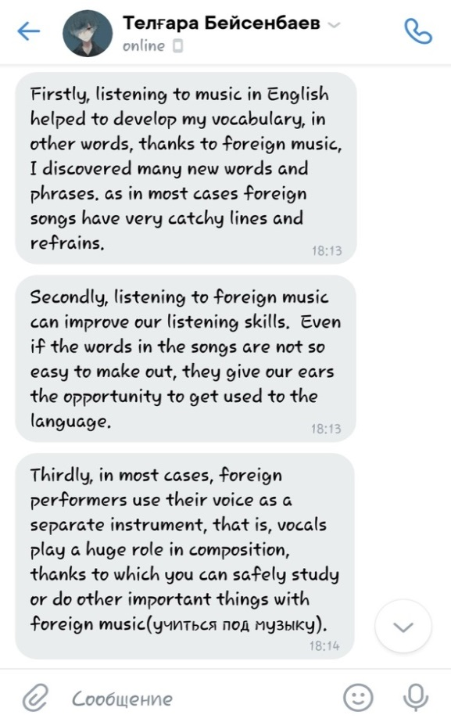

Interviews with the teachers:
How effective are songs in English in learning the language?
Do you use music as a tool for teaching the English language? How?
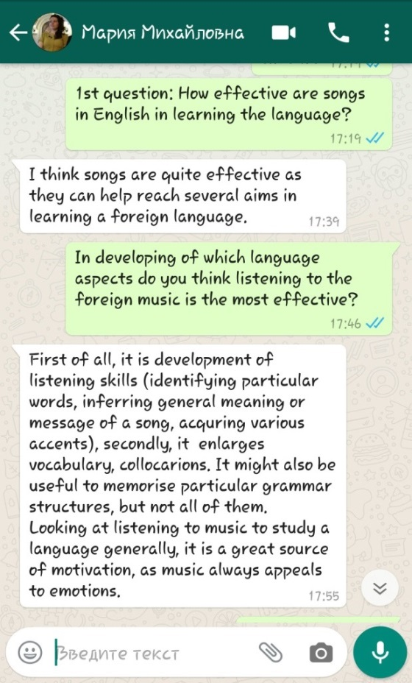
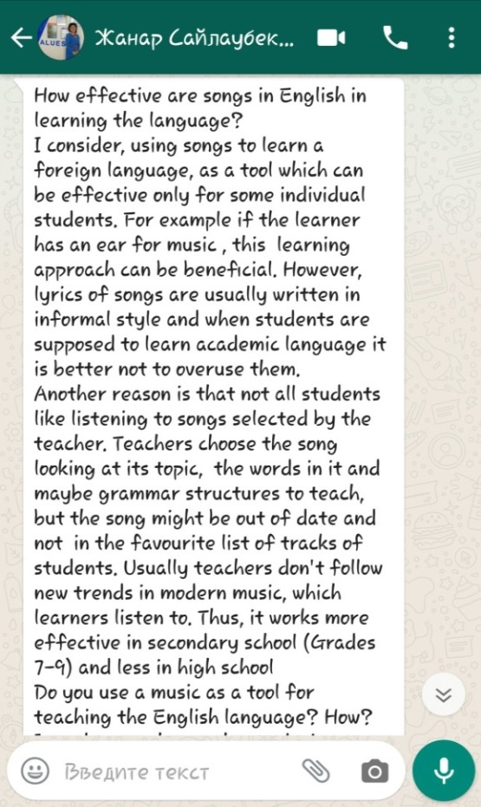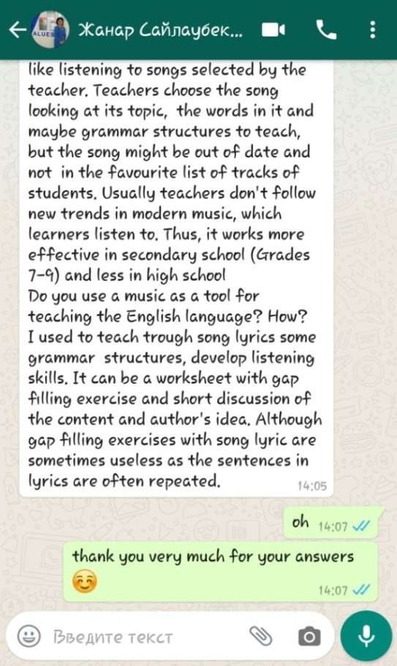

Appendix 2 – Focus group discussion
The transcript of the focus group discussion:
- Hello, focus group discussion participants. Today we are going to discuss how listening to music in a foreign language influences academic performance of students. The discussion questions are the following:
What are advantages and disadvantages of listening to music in a foreign language in terms of academic performance?
Is listening to music in a foreign language effective in mastering that language?
Participant 1: There are a lot of advantages of listening to music in a foreign language for our academic performance. First of all, it helps to enrich our vocabulary as there are new words and expressions that we do not know. I think that majority of students often search for their translation, therefore listening to music allows us to learn new words. Moreover, it helps to improve our listening skills and pronunciation. Majority of popular singers use informal language in their songs and sometimes they use wrong grammar structures, miss some words and verbs, therefore they can confuse students learning a new language. Personally, I think that listening to music is not the most effective way of learning a new language, especially for high school students. However, I think that it is more helpful to listen to music when studying, in general, for our academic performance, since music helps to cope with stress and anxiety. Also, it helps to focus on a particular task and it provides students with motivation.
Participant 2: I think that listening to music in a foreign language has a lot advantages and disadvantages. So if we talk about the positive aspects of this activity, it would be a big mistake not to mention its benefits in terms of pronunciation. From my personal experience, I can confidently state that pronunciation one of the most difficult aspects to improve one. It will not be difficult to repeat the song every time, on the contrary, you will enjoy it while practicing. So, repeating after the native speaker or good English user, will improve your articulation, pronunciation and getting rid of the accent. However, this activity also has its drawbacks. As the Participant 1 has mentioned before, the lyrics often contain wrong grammar structures which can negatively affect the students’ performance in speaking, writing tasks and reduce their overall marks.
- Participant 1 and Participant 2, thank you so much for sharing your thoughts on this topic. I totally agree with you that listening to music has a lot of advantages and some disadvantages. It cannot be as effective as reading a book, for example. Participant 3 and Participant 4, do you have something to add?
Participant 3: I think that music is extremely useful for learning last language for many reasons. One of the main problems language learners face is the time limit. There are so many hours per day in a classroom settings and not enough time for the repetition and practice. Music can fill some of the gaps, especially if you enjoy listening. While listening to the songs, you can learn lots of things about culture, vocabulary and pronunciation. Things that are difficult to learn from textbooks: intonation, specific grammatical features and so on, can be easier to master through songs. Also, you can easily understand the special accents of the singers.
Participant 4: There is a positive impact of foreign music on the performance of students in the particular development of the language, but, in my opinion, listening to the music helps you more to concentrate on a task. For example, many students listen to music while doing homework, because it helps to do the task better. I think that listening to music is not the most effective way to learn a new language, since many people do not pay attention to the lyrics of the song. The best way to learn is to study with a teacher or use books.
-Dear participants of this discussion, thank you so much for sharing your opinions on this topic. It was a pleasure for me to conduct the focus group discussion with you. All of your answers were very valuable for the research.

