DOMESTIC VIOLENCE IN KAZAKHSTAN

Ways of solution of the Domestic Violence:
Zhumagulova Zhuldyz Nurlankyzy
Nazarbayev Intellectual School

Word count: 3879

Introduction
“Countries with higher levels of gender equality have higher economic growth. Companies with more women on their boards have higher returns. Peace agreements that include women are more successful. Parliaments with more women take up a wider range of issues - including health, education, anti-discrimination, and child support.” - Ban Ki-moon, South Korean politician and diplomat who served as the eighth United Nations Secretary-General from January 2007 to December 2016.
Females in developed regions are now more literate than males, but they are still paid less and are poorly represented in political system and are less likely to enter or become a businesswoman in the top levels of business sector.
Now, just IMAGINE the situation in developing countries. Third world countries certainly do not have a dominance on gender inequality. In most countries, males earn more than females. In countries with low GDP per capita, however, inequalities for health, employment and bargaining power within marriage appear to be greater. ONLY SIX countries provide women equal legal work rights as men.
The motivation for choosing this topic is clear; I do want to make a contribution into solving this problem, at least in some parts of the world, as I do not want to be discriminated in future just because I was not born a man. I am partly biased, because the topic rises strong emotions as it is related to my personal life and situations that the great majority of females, including me face in everyday life.
My point of view on this issue is extremely clear and obvious. I wish with all my heart to put an end to this gender discrimination that persists throughout mankind existence. I sincerely hope that even if I am not able to stop the situation, my project and its outcomes will influence women's minds so that they realize that it is NOT acceptable to allow injustice and abuse of the opposite sex and we have to fight for our rights, as the modern world has a large number of organizations supporting and defending women's representatives.
Being a student, I will not be able to make drastic changes to the solution of such a large-scale, even global problem. However, at the end of my project, I plan to create brochures that can be put in the offices of psychologists, to whom in most women who suffer from gender inequality in its various manifestations come. In the brochures, I intend to indicate the rating of countries with the most and least widespread discrimination, the rights of women that are being abused and what rights women have, in general. A text that will motivate and encourage women to fight for their rights, develop and dissolve their opinions will not be out of place.
Context
Gender inequality recognizes that there is no equality between men and women and that gender affects the living experience of an individual.These differences emerge from variations in the principles of genetics, psychology and culture.Some of these distinctions are empirically grounded while others appear to be socially constructed. Gender equality in law is defined in the Conventions of 1952 and 1967 by the United Nations International Organization.In 1997, the European Union introduced gender e quality standards: equal treatment of men and women in the workplace; protected stay in the workplace of pregnant women, recently given birth and nursing; equal pay; penalties against managers carrying out discriminatory actions.
According to the world health organization (2017), as a result of domestic violence, about 400 women die each year in Kazakhstan; every third woman in the world is subjected to sexual or physical violence throughout her lifetime (en.cso-central.asia). This statistics prove that the problem of gender inequality and discrimination is exist and widespread not only in Kazakhstan, but throughout the world, furthermore this issue is both local and global scale.
Even if equity in the professions has achieved considerable success, in the absence of family and household issues, including violence against women within the walls of the house, which frequently victims of violence do not want to speak or announce, so as "not to make a mess out of the home."I believe this is every state's biggest "scourge," where law enforcement agencies have no chance to help victims without specific statements.
In our culture, intolerance of domestic violence against older women who suffer from their incompetent and violent daughters, mothers with many children who are financially dependent on their oppressive husbands, single mothers who deal with an inadequate state system every day, and girls who endure abuse from father and stepfather aggressors is essential.
"Women are paid less even when they do the same job as men. The 1991 U.S. Department of labor statistics speak for themselves: female computer programmers receive 83 % of the salary of male programmers, female financial managers receive 67 % of what male financial managers receive, and female elementary school teachers receive 89 % of the salary of male teachers, and so on. women's Starting salaries are usually less than men's starting salaries, and this has long-term consequences because pay increases are usually expressed as a percentage of the entry level.'- (S. Bern “Gender psychology”, 1974)
All the rights and freedoms set forth in this Declaration are available to all, without distinction of any kind, such as color, gender, language, faith, political or other opinion, national or social origin, land, birth or other status (Universal Declaration of Human Rights, page 2, article 2)

As the international feminist movement began to gain traction in the 1970s, the United Nations General Assembly proclaimed the International Year of Women in 1975 and hosted the first World Women's Conference in Mexico City. The period 1976-1985 was declared the UN Decade of Women on the Conference's urgent recommendation, and a voluntary fund for the Decade was set up.
The General Assembly adopted the Convention on the Elimination of All Forms of Discrimination against Women (CEDAW) in 1979, often referred to as the International Women's Rights Bill. The Convention's 30 articles clearly defined discrimination against women and introduced a national action plan to eliminate such discrimination. The Convention focuses on culture and tradition as dominant forces that shape gender roles and family relationships, and is the first human rights treaty to recognize women's reproductive rights in human beings
"Achieving gender equality and empowering women and girls is our time's unfinished task and the world's greatest challenge to human rights today," UN Secretary General Antonio Guterres said (March 1, 2018; UNOG, Switzerland)
Sustainable human development is one of the main factors in achieving gender equality. Gender equality and women's empowerment were on the agenda of all the major UN conferences, including the 2000 Millennium Summit in New York.This case was the highest level's most active conference, held to address peace and development issues. The Millennium Declaration is the most important development policy document ever written, ratified by leaders of 191 nations, including 147 heads of state.
This research refers to Cultural and Social lenses, as it investigates reasons for inequality of rights among people in cause of their sex and positions of representatives of opposite gender in society.
The main reason why a woman suffers domestic violence, which is also discrimination against the weaker sex, is low self-esteem. Often women are kept from breaking up with her husband-rowdy low self-esteem. The woman says, "Who needs me but him?". Another reason is completely defenseless. The woman, who has addressed for the help in police, appears completely defenseless before the husband and his relatives and the immediate environment. In most cases, she is threatened, demanding to withdraw the application. And sometimes her husband just beats her after that with special cruelty or even kills her. Here, the threats can extend to children. That is, by blackmail, a woman is sought to force her to stop resisting.
Regarding situation in Kazakhstan, fines for domestic battery and intentional infliction of minor harm to health are no longer provided for in Kazakhstan. This rule was removed from the code of administrative offenses on January 5, 2020. The law was signed by President Kassym-Jomart Tokayev. According to the updated code, if the perpetrator and the victim are in a family-household relationship, the offender faces a warning or administrative arrest for up to 10-15 days. Such decision can be also considered as discrimination of females’ rights and it’s support from the authorities.
Information used in the context will definitely help to reach aims of the research, as the written data is about general definition of the gender inequality, attitude of the UN at this problem, touching the topic in books, reasons for enduring discrimination and facts, proving that this problem not only widespread in Kazakhstan or in the CIS (Commonwealth of Independent States), but all around the world, in other words it is global scale issue.
Aims
The purpose of this project is that I would like the results of the project (brochure) to influence the consciousness of women and motivate them to fight for their rights and place in society. Thus, by answering the following questions during the project, I will be able to contribute to the solution of this large-scale problem - gender inequality.
- What are the reasons for enduring abusing from the opposite gender?
- Do community services support gender inequality?
- What are the ways of solving this problem?
Hypothesis: The main reason why most women endure discrimination from men - the fear of being maimed, but this problem does not move from the dead point, as community services, consisting in the majority of males turn a blind eye and do not consider infringement of rights of females as a crime. I believe that the main solutions are to promote equality in all countries and to create committees, supporting and protecting disadvantaged women. Potential outcome of my research is a brochure with brief information about gender inequality in the world, organizations that support females, women’s rights and some motivational quotes, these brochures I plan to put in psychologists’ offices, as women, facing discrimination in their life usually consult with them.
Method
Survey (FOR FEMALES)
Thank you for taking part in this survey! The outcomes of this survey will be used to investigate how gender inequality and in particularly domestic violence are manifested in Kazakhstan, therefore, your response is important in order to gain data about your observations and opinion towards gender discrimination in Kazakhstan. It should take only 3-4 minutes to complete. The survey is completely anonymous.
- What age group do you belong to?
- 15-25 y.o.
- 25-45 y.o.
- 45+ y.o.
- What social status do you belong to?
- Student
- Employed
- Housewife
- Retired
- Choose type of society that surrounds you
- Patriarchal
- Matriarchal
- Equal
4) Rate the discrimination of females from 1 to 5 in your area
5) Do the government and social services support the violation of women’s rights (domestic violence) in your living location?
- Yes
- No
6) Imagine the situation, you neighbor (female) suffers violence from her husband, What would you do?
- Give her an advice to leave him
- Talk to her husband
- Address to the police
- Nothing
7) Have you personally faced domestic violence (made by men)?
- Yes
- No

Interview
Hello, my name is Zhumagulova Zhuldyz, I am a student of grade 11 and I carry out a study about domestic violence and opinion of psychologists would be valuable and important for me. The outcomes of this interview will be used to investigate how gender inequality and in particularly domestic violence are manifested in Kazakhstan, therefore, your response is significant in order to gain data about your observations and opinion towards gender discrimination in Kazakhstan. Thank you for taking part in this interview!
- How often do women who experience gender discrimination consult with you?
- Why do women endure domestic violence, which is a manifestation of female discrimination?
- Why do men still think gender inequality is acceptable?
- What are the possible ways to solve this problem?
Survey (FOR MALES)
Thank you for taking part in this survey! The outcomes of this survey will be used to investigate how gender inequality and in particularly domestic violence are manifested in Kazakhstan, therefore, your response is important in order to gain data about your observations and opinion towards gender discrimination in Kazakhstan. It should take only 3-4 minutes to complete. The survey is completely anonymous.
- What age group do you belong to?
- 15-25 y.o.
- 25-45 y.o.
- 45+ y.o.
- What social status do you belong to?
- Student
- Employed
- Currently unemployed
- Retired
3) Rate the discrimination of females from 1 to 5 in your area
4) Kazakhstan passed a law abolishing fines for domestic tyrants. What is your attitude towards this issue?
5) Imagine the situation, you are walking down the street and see a man who is beating a woman, you want to help, but then you are told that they are married and that you should not interfere with somebody’s relationships. What would you do?
- Pass by
- Call the police
- Interfere
6) Have you been violent with a woman?
- Yes
- No
Results

According to 3 interviewed psychologists, the main reasons why women suffer domestic violence are: Religion and parents’ opinion: “The family must be preserved at all costs.” “All problems can be solved; you just have to try harder.” The lifeguard complex: “If I stay, I can help him get better.” Responsibility for happiness in the family. “A good wife can make a good man out of her husband.”; Parental responsibility: “It is better for a child to have such a father than to have no father at all.” “I had so much to do around the house to keep everything in order that I didn't think about my needs”. Psychologists suggest several ways to solve this problem, that is, to reduce the level of domestic violence, they are: Preventive activities of law enforcement agencies, centers of social services for youth, centers of medical and social rehabilitation, guardianship and guardianship agencies; Changing public attitudes and attitudes to domestic violence; Increasing the legal education of the population on the protection of rights.

Based on data from a survey for women, 67% of respondents were aged 15-25, 23% 26-45, and 10% 46+. 65% of them are students, 17% are working, 12% are housewives and 6% are retired. Just over the half of females consider society that surrounds them equal, four tenths patriarchal and only a few of them matriarchal. The rate of discrimination in area of respondents is equal to 2.42, which is low than average (1-does not exist; 5-strong discrimination). Exactly half of women believe that the government and social services support the violation of women’s rights and in particular domestic violence, and another half has an opposite view. There was a situation, when neighbor (female) was suffering violence from her husband, almost half of respondents would give her an advice to leave him, 6% would talk to her husband, 35% would address to the police and just over a tenth would do nothing. Almost 20% of females faced domestic violence personally, and others did not. Total number of respondents was 52.

The second survey was made for males, 64% belongs to 15-25 age group, 19% to 26-45 and 17% to 46+ groups. A quarter of men are employed, 64% are students and 11% are retired. Basing on the answers, the discrimination rate of females is equal to 2.1 (1-does not exist; 5-strong discrimination). There was also a question about the new law which abolish fines for domestic tyrants, the great majority of men thinks that this decision was not right, as it discriminates human rights and gives to husbands an opportunity of beating their wives and not being punished for that, however, there is a minority which considers that such fines harm the budget and the whole family. There is also a situation, regarding violence towards females, exactly half of males would interfere, 36% would call the police and 13% would pass by. Almost 90% respondents have not been violent with a woman, and others have. Total number of respondents was 36.

As all the questions were answered and some of them were alike, I can compare the results of two surveys. Basing on the males opinion, the discrimination rate of females in their area (mostly the East and the North Kazakhstan) was equal to 2.1, as regards the survey for women, the indicator was 2.42 that is in both cases respondents evaluated their region to respect women’s rights. In addition, almost 20% of females faced domestic violence, and 10% of men were violent with women; therefore, it is obvious that the results of the methods confirm each other. As regards comparison with the interview, the questions for this method and the survey are different, therefore, it is impossible to compare the answers and state whether they contradict or confirm each other. Nevertheless, the methods complement each other and provide complete answers for my research about the reasons of the domestic violence and ways of solving it.
Females | Males
Mostly 15-25 age group | Mostly 15-25 age group
Discrimination rate – 2.42 | Discrimination rate – 2.1
Faced violence – 20% | Were violent – 10%
Total number – 52 | Total number – 36

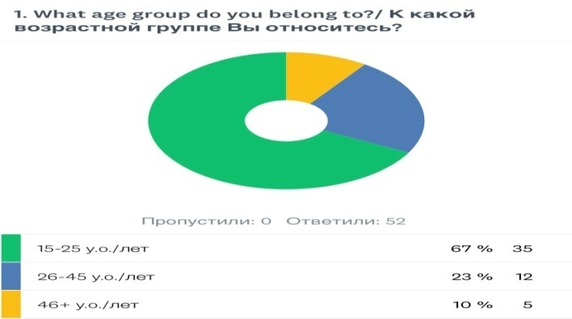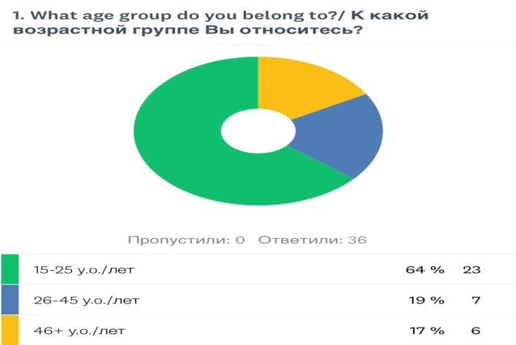

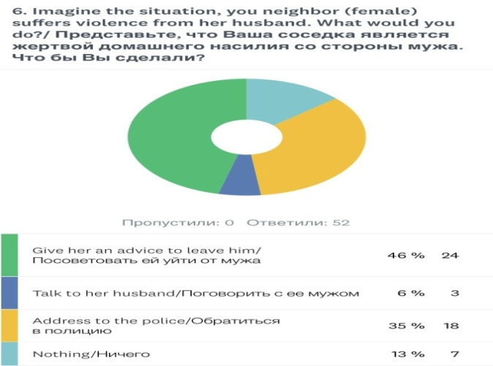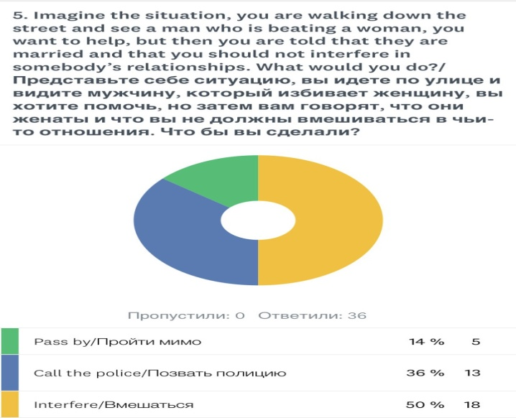

Conclusion
In response to each of the research questions it is possible to make the following conclusions:
- What are the reasons for enduring abusing from the opposite gender?
- According to the psychologists, the key factors for women enduring domestic abuse are: Religion and the opinion of parents: "The family must be protected at all costs." The Lifeguard Complex: "If I stay I will help him become better." Family happiness obligation: "A good wife will turn her husband into a good man."; Parental responsibility: "Having such a father is better for a child than having no father at all." In comparison to the results of the primary research, the main reasons for women were low self-esteem, completely defenseless and blackmailing, which slightly differ from the results that were received during the secondary research.
- What are the ways of solving this problem?
- Psychologists recommend many ways to address this issue, that is, to minimize the level of domestic abuse, such as: law enforcement agencies' prevention programs, community social care centers, medical and psychological recovery facilities, guardianship and guardianship agencies; Changing public views and views towards domestic violence; Rising population legal awareness on rights security
- Do community services support gender inequality?
- Unfortunately, the respondents’ opinion on this issue divided exactly in half. However, basing on the primary research, during which It found that fines for domestic violence in Kazakhstan were cancelled and it even is not considered to be a crime and violation of human rights, then definitely the community services and the government support gender inequality. As the authorities, in many cases, hides men’s guilt and shifts it to women because of the mentality and finding women on the social ladder, in their opinion, below the stronger sex
As a result of this research it is possible to conclude that there are much more reasons women put up with domestic violence than I has been found, thus, they were surprising. It is important to note that most of the reasons lie deep in the psychology of the victims as well as the influence of society on them. In order to struggle with this problem, the specialists recommend supporting the victims from different aspects and changing the attitude of the society towards this problem and propagandize gender equality.
Answers that have been received are valid, as psychologists are with experience and a good reputation that live in Kazakhstan, which means they know the situation with domestic violence in our country from the inside. As for the survey, the age category of respondents, social statuses and genders are different, therefore, the results are trustworthy. As regards the sample size, the total number of respondents is just less than a hundred which make the results more valuable. These results are definitely useful for the whole research, as they answer all the questions that were raised and complement the primary research with expected, but not found on the Internet and other sources. Received answers and results will be used during the creation of the brochure, which is the final product of the research.
Evaluation
Strengths: Multilingual sources were investigated (articles and works of professionals from Kazakhstan, Russia, the United States, the United Kingdom etc.). During the secondary research not only psychologists who were versed in the intricacies (which makes the results trustworthy) of this problem were interviewed (method – an interview), but also ordinary people, whose opinion was quite important (method - surveys). The outcomes of both researches are definitely valuable and will be used in the creature of the brochure, as including accurate figures and the fact that different categories of people (males and females; teenagers, adults and elderly people; students, employed, unemployed and retired) took part in the research and other people are likely to believe and trust the results and opinion of other individuals.
Weaknesses: Relatively low number of people have taken part in the survey (just less than 100); The results of the secondary research could not provide an answer for one of the questions of the whole research “Do the government and social services support the domestic violence?”, as the opinion divided exactly in half.
Improvements: Add more questions regarding the main aim of the research (about the government and supporting of the domestic violence); Ask more people by spreading the survey via different social networks.
Further Research
Further Research would include another survey with slightly changed questions and their types, based on the improvements in Evaluation section. It is also necessary to spread the survey, as humankind tends to trust researches with the highest number of participants.
Descriptions of the suggestions: The probability of the dividing opinion exactly in half decreases with the increase of the number of questions; the larger the number of respondents, the more trustworthy the outcomes. New questions did not arise, regarding survey it is the same ‘Do the government and social services support domestic violence? ’, as regards an interview, the results were quite expected, but not found in the articles and in the Internet during the secondary research, therefore, were not mentioned in the context section. Generally, all questions were answered, besides one about the government, as surveys’ results could not totally confirm the information from the primary research.
Unexpected results: I was more than sure that the majority of respondents will confirm my hypothesis about the supporting and loyal attitude of the government to the domestic tyrants, but it was not, as there was only one question, regarding this particular topic, and it was multiple choice question, eventually, the results divided exactly in half and it was impossible to draw an accurate conclusion. Due to such situation, in the further research it would be better to make questions open-ended and increase their number to conclude then.
Further Research would provide exact answers to the questions of the research, as regards personal perspective in local, national and global scales; it did not change, as I still strive to make a contribution into the reduction of the domestic violence, in particular, towards the females from their husbands, and I believe that inequality that exists in the modern society can be overcome by influencing people and motivating females.

Bibliography
http://www.mintrud.gov.by/profilaktika_dom_nasiliya/
https://m.ru.sputniknews.kz/society/20200105/12462132/kazakhstan-otmena-shtrafy-domashnie-tirani.html
https://naistetugi.ee/ru/о-насилии/кто-виноват-и-почему-женщины-не-уходят/
https://novayagazeta.ru/articles/2020/01/31/83712-domashnee-nasilie-eto-narushenie-prav-cheloveka
https://www.un.org/en/sections/issues-depth/gender-equality/
https://www.zakon.kz/4907400-gendernoe-ravenstvo.html

Appendices
