Garbage pollution issue and waste disposal in developing and developed countries
Argynov Al’zhan
Nazarbaev Intellectual school of Chemistry and Biology in Ust-Kamenogorsk

Word count: 4459

Introduction
“An understanding of nature, a humane, respectful attitude towards it is one of the elements of morality, a particle of worldview”
© K. Paustovsky
Do you check every time which garbage are you throwing out? Used batteries, glass, telephones are all waste that, if decomposed, can harm the environment. Hence, it is necessary to control the waste disposal from the beginning of the process to the end, this includes burning and recycling garbage.
In my opinion, it is regrettable to see that tons of waste get thrown into rivers and seas, most people begin to act or make some decisions about the problems only when it affects their area and our city has an acute problem of waste disposal. After all, the state instead of using it as an energy source just drained into the local river.
What motivated me to choose waste disposal as my study? The first is the frequent consideration of this topic in the classroom and in the news. I want to consider all of my knowledge about this problem and to search for it more in-depth. Once in eighth grade at the lesson during the class we were given a group work, where the assignment was to make a poster. Even though years have passed since then, I still remember the processes we decided to include in the poster that makes me want to study it more in-depth.
I think that my level of bias is high, because, my knowledge about this topic is superficial (I only know that this problem exists in most countries including Kazakhstan and I know that this waste has a negative effect on the environment). However, in the process of investigation, I will try to be impartial.
I think, my research will be beneficial to my city. In our school there is an eco-club and my research would contribute to promoting their project at the regional level, and in the long term, my project could help to create a completely new system for waste disposal, which could be implemented in some countries. I am also considering making some volunteering, to collect all garbage around selected vacation spots and to send it to the local recycling center. In my opinion, it will be useful for the recycling center and for vacation spots too.

Context
Step by step our planet is becoming more polluted. It is connected with using of plastic production, like plastic bags, bottles, shampoos, and other containers. Furthermore, people do not control their used things and throw it anywhere they want. Therefore, we need to control all the garbage that we throw out and recycle it.
Recycling is the process of collecting and changing old paper, glass, plastic, etc. so that it can be used again (https://dictionary.cambridge.org/). Recycling is good for the environment, in the sense, we are using old and waste products which are of no use and then converting them back to the same new products. Since we are saving resources and are sending less trash to the landfills, it helps in reducing air and water pollution. Energy saving is important if we are to reduce the future effects of global warming. For example, recycling of one aluminum beverage can save enough energy to run a 14 watt CFL bulb (60-watt incandescent equivalent) for 20 hours, a computer for 3 hours, or a TV for 2 hours(archive.epa.gov, 2019). This will depend on the energy consumption of your TV, but it gives you a great idea as to just how much energy can be saved during the process of recycling products.
Some countries like Japan made a lot of projects that are connected with waste disposal and all of these projects have a similar aim – to get zero all garbage. For instance, some activists from the town called Kamikatsu inspired all residents to take care of environmental problems, like pollution. It is hard to collect all garbage for landfills, because of mountains and they need to send it for local recycling centers. Kamikatsu is already close to achieving its goal, recycling about 80 percent of the 286 tonnes of waste is produced in 2017, far more than the national average of 20 percent(phys.org, 2019). It is really important to watch over one problem by all town, I think they are role models for other cities and towns and can inspire other counties to consider the issue of waste disposal.
If we discuss it narrower, like from a local perspective, Oskemen city is highly polluted. For instance, there is a river in Oskemen called Irtysh. Local garbage merges in it, and so our river became more lit by the time and it is necessary to recycle or to try not to drain all waste into the river. As evidence, the lowered self-cleaning ability and the continuation of wastewater discharges into the river by the existing sources of pollution in the cities Oskemen, Leninogorsk, Zyrjanowsk, and Semipalatinsk will increase the degree of pollution of the Irtysh. This will worsen the already existing problems of freshwater supply of towns like Oskemen, Semipalatinsk, Pavlodar, Karaganda, Omsk, and other settlements in Kazakhstan and Russia that are dependent on the Irtysh water (Sergej Schafarenko, "Cultural and Ecological Association Belovodie",1999). So, we have to take into account this problem more carefully.
If we can consider lenses, which waste affects they can be environmental, social, and economic. As an example, Impacts on biodiversity, ecosystems, quality of water, and groundwater from an end to an application(Environmental). When waste ends up at the landfill, chemicals in the trash can leech out into the soil, contaminating it. This will hurt plants, along with animals and even humans who come into contact with the soil(gorillabins.ca, 2015). Impacts from the increase in the use of landfill and incineration for sludge(Environmental). There will be costs from changing legislation and consultation (not monetized), Costs from monitoring to check that legislation is being met, as sludge is no longer available, they will have to be replaced by fertilizer (this could be organic and/or mineral) (Economics). For example: At $392 per ton, urea currently checks in with a per-unit nitrogen price of 43 cents. Of the three major nitrogen fertilizers, UAN remains the most expensive with a unit of nitrogen currently priced at about 50 cents(Mike Rankin,” Checking in on fertilizer prices and use”,2019). This means that fertilizers will continue to be costly for countries that are facing a similar problem, In addition, social impacts are owing to national practices and standards, benefits uncertain due to lack of evidence, Values include human health externalities from emissions (including energy recovery) (Ms. Rocio Salado. Additional expertise was provided by Daniel Vencovsky, Elizabeth Daly, Tony Zamparutti and Rod Palfrey, prepared by RPA, Milieu Ltd and WRC for the European Commission, 2008).
Perhaps the more important reason for recycling is that it will reduce pollution risks in our society. Perhaps the most obvious way to achieve this is to remove waste from landfills, which can introduce pollutants and other toxins into underground systems. Recycling also prevents materials from entering incinerators, which can lead to air pollution and the formation of heavy ash residues. Also, processing reduces the environmental damage caused by logging, mining, and other methods that contribute to the reproduction of raw materials. Most importantly, recycling prevents the release of many greenhouse gases and water pollutants.
Perhaps the most attractive reason for recycling is its ability to create many jobs, which could improve Oskemen’s economy. Recycling creates eight times more jobs than incinerators and incinerators produce. Recycling and waste reduction provide immediate opportunities for community development.
An empty water bottle is easy to throw in the trash. It's so easy to put your Snickers wrapper carry it belongs in the same bin. And, it's effortless to put that empty grain box in that special container. But then why do we so rarely do it? Ask yourself why you don't recycle more often? Well, now that you know the benefits that come from recycling there are no excuses when it comes to keeping environment clean.

Aims
The main purpose of my research is to evaluate effects of garbage pollution on the environment of developing and developed countries and to inform people about them. Also, to consider alternative ways of solving this issue, such as waste disposal. Therefore, this questions are going to be answered by investigation:
· To what consequences can careless attitude of people to garbage lead?
· To what extent is waste disposal solving of pollution issue?
· How urgent is this problem in the local area?
Hypothesis:
I think that during investigation and methods I will know about garbage pollution issue and its effects on the local area(Oskemen). Moreover, I expect that in survey respondents will answer that responsibility for garbage pollution belongs to the state.
Future use:
In my opinion, this research can be used to show people degree of contamination of some areas of developing countries and to present in some special scientific festivals or/and competitions.

Methods
First Method: Survey
I chose the survey method because I want to know the number of people who are aware of problem of garbage pollution and who are taking actions. Moreover, survey is convenient to ask a lot of people about intriguing questions.

1. How old are you?
0-13
14-17
18-24
24+

2.Do you know about the problem of pollution with garbage
Yes, I know
No, I don't know
Difficult to answer

3. How relevant is this problem in your city?
Choose from 0-100 |  | 100

4.What solution methods do you know?
Recycling
Burning
Instillation
Other

5. Is waste disposal a solution to garbage pollution issue?
Yes
No
What is it?
Difficult to answer
Other

6. Do you take care about environment?
Yes
No
Sometimes
Difficult to answer

7. If yes, how?
Picking up trash
Sending garbage to the recycling center
If possible I try not to throw garbage anywhere I want
Other

8. Do you think the issue of pollution of your city with garbage is a problem of the state?
Yes
No, not a problem of the state
The problem of population
This is a problem for everyone
Other

9. Who should solve the problem of polluting regions with garbage?
Government
Population
Me
Other

10. How effectively do local authorities solve problems in this area?
Extremely effective
Relatively efficient
Absolutely ineffective
Other

Second Method: Interview
I used the interview to get a personal opinion about this problem from specialists in this field(geography teacher and ecologist) and will also conduct interview with one residents of Oskemen.
Introduction:
Hello! My name is Al’zhan and I am doing research project on the topic garbage waste in Oskemen. I am very thankful for your participation in my interview and for your contribution to my project!
Questions:
- What is your occupation?
- What do you think about current level of garbage pollution in our area?
- How to reduce the amount of garbage in Oskemen (describe)?
- Is waste disposal a solution to garbage pollution issue?
Third method: Data analysis
I have photos and videos of polluted areas of Oskemen, like garbage containers, social places with full garbage bins. So, during this method contamination degree of local area by garbage pollution is going to be obtained. Moreover, it is hard to conclude all research project using only two methods which are based on questions/answers.

Results
Survey
The survey was conducted among 100 people from residents of Oskemen; the interviews were taken from the expert and resident: ecologist and citizen of Oskemen.
There are some key points from the survey and the interviews:
- As the survey showed, 84% of respondents think that garbage pollution is a serious issue in Oskemen city (Image 1).
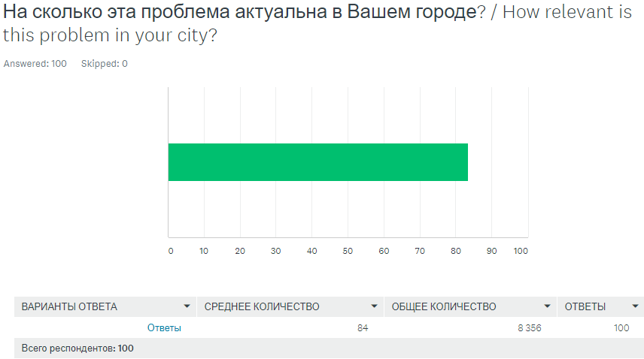
Image 1. Urgency of the problem in Oskemen

- The most well-known method to solve the problem among the survey respondents was recycling (approximately 93%), others are “Burning” and “Instillation” (Image 2). Moreover, enthusiast commented this question as following: “using alternative materials”, “using decaying materials”, “set filters on pipes of factories”, “put a restriction on the use of long-decomposing materials”. This information shows that the prevailing number of people are aware of garbage recycling rather than other methods.
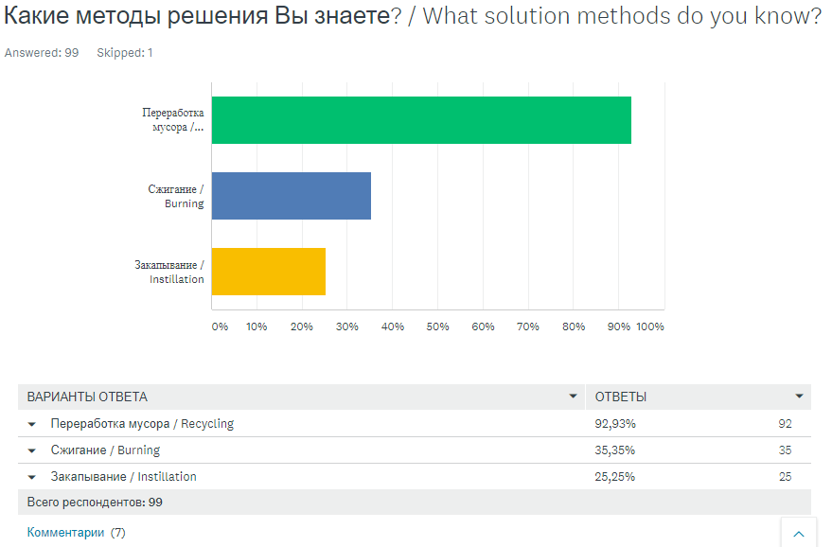
Image 2. Solution methods suggested by survey respondents
- Just over a half of respondents try not to throw garbage anywhere they want (61%), roughly one quarter of respondents take care of environment by picking up trash (26%) and small proportion is sending garbage to the recycling center (10%) (Image 3).
In addition, one respondent commented that he/she is using reusable bags, bottles and others. This data depicts that many people try not to throw garbage, thereby helping environment become cleaner. The data shows that people are ready to take actions to protect the environment, they are ready to clean up garbage, pick it up and some volunteers are already doing this, which will later lead to cleaning up of our nature and will make it cleaner.
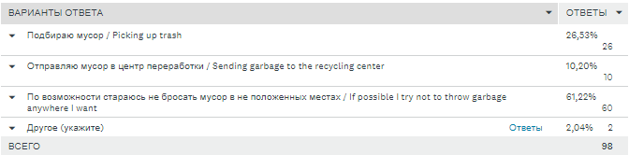
Image 3. The way people struggle with garbage pollution
- In question about responsibility of garbage pollution issue in Oskemen, nearly a half of survey respondents answered that it is a problem of the state, while other 40% states that it is problem for everyone, 11% think that it is problem of population and last tiny fraction state that it is not a problem of state (Image 4). Also, there are additional comments from some respondents like: “I do not care”, “Everyone should take care of themselves and their own Affairs, then the world will become cleaner”
The information received tells that not only government should take care of garbage pollution issue, but also everyone and this shows us that the population of Oskemen believes that the responsibility for nature and the environment is borne by both the people and the government itself because united work always leads to positive results, in this case it is a clean environment.
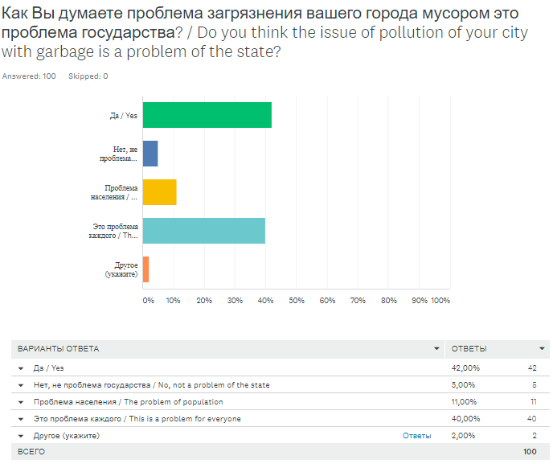
Image 4. Responsibility for garbage pollution issue
- In addition, there exists fact as age, because majority of respondents are in age 13-17 (83%) (Image 5). This information shows that people under the age of majority answer questions that are connected with the city and they may be prejudiced. They may be biased, because mostly problems like ecology are solved by adults and children may not be sufficiently familiar with this problem.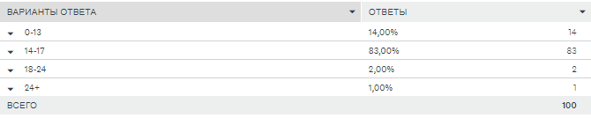
Image 5. Ages of respondents
Interview
As the interview showed all respondents think that current level of pollution of Oskemen with garbage is high and they can assume that the solution is garbage recycling, but the resident believes that garbage recycling does not solve the problem of garbage pollution(“Of course not, this is just a postponement of the problem for a longer time, in the end, a large amount of garbage will still accumulate, which will have nowhere to go if we do not start working on this problem”) and resident thinks that recycle will combat garbage pollution issue(“only recycle, as it was done in Switzerland, there is no longer garbage, on the contrary, they accept garbage from other countries.”) , but the second respondent who is a teacher of geography believes that this process will solve problem of garbage pollution ( “Yes. We can reduce the amount of pollution from garbage by treating the garbage and reusing it”).
Third respondent agrees with that fact that Oskemen has high level of contamination with garbage (“Garbage is not taken out, there are no litter bins in many public places and sidewalks, landfills are located not far from the villages. The locals suffer from the stench”) and second citizen advanced several ways to solve the problem (“First of all we need more trash cans on streets. Every shops should have litter bins, including separate for glass, plastic and paper “).
In conclusion Oskemen has a high level of garbage pollution since three of the respondents said that Oskemen has a bad environment and that citizens need to fight with this problem and put forward some solutions such as recycling garbage and installing trash cans.

Data analysis
In the majority of places in the photos and videos it is clearly visible that all the garbage is not only in the trash cans, but also behind it. What influenced this case?
Mainly influenced by factors such as the lack of trucks that would regularly clean these bins but also the number of bins that are installed in one place. Therefore, many places that are next to the trash cans are being contaminated with garbage. 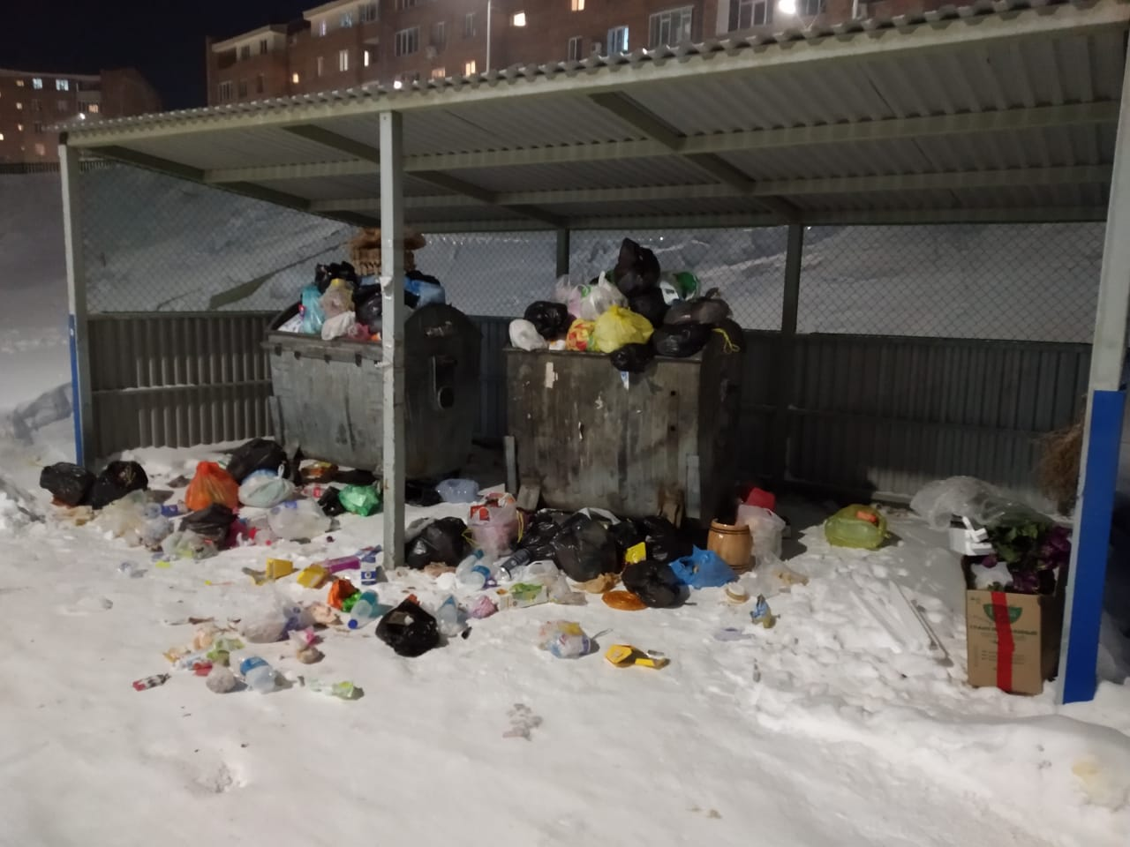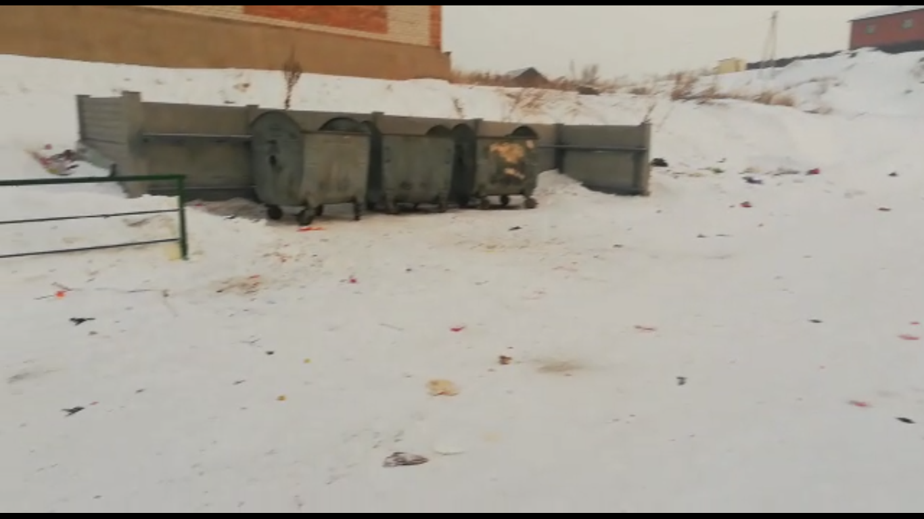
Image 6-7.Local trash cans
Also, in other photos volunteers who are taking actions to make Oskemen cleaner are presented. Mostly, in Oskemen, volunteers conduct subbotniks ( “subbotnik” - Saturday when people go out and clean up the garbage) near schools near their place of residence, and work together to remove all garbage from the area. These subbotniks are held in certain seasons of the year as spring, but in other seasons stops. For example, in winter there is more garbage and people generally do not pick up and clean these regions that are polluted with garbage, and in spring and summer volunteer activities are actively carried out. Hence, it is evident that in Oskemen there are people who care about nature.

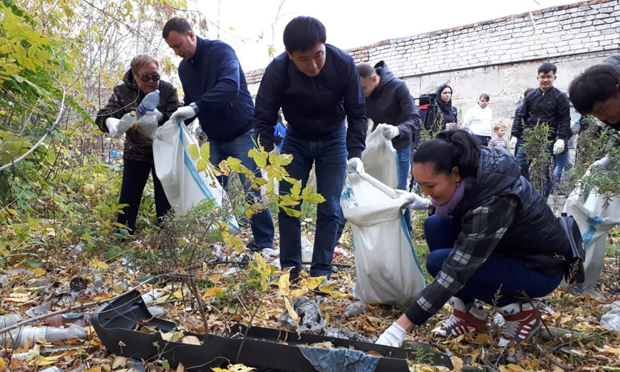
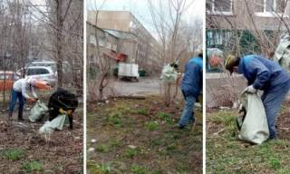
Image 8-9. Local volunteers are picking up trash
Photos provide information like contamination of the city and its counteracting actions to stop pollution. Hence, it is evident that in Oskemen there are people who care about nature.

Conclusion
Aim was partly reached because it was to evaluate effects of garbage pollution on the environment of Oskemen and to inform people about them and to consider alternative ways of solving this issue, such as waste disposal. One of the hypothesis is “Residents think that only government should take care of garbage pollution issue” and it is also partly confirmed during methods section (Survey).
In response to each of the research questions it is possible to make the following conclusions:
How much people care of garbage pollution issue?
The majority of people in the research are aware of the main causes and consequences of garbage pollution. In general, there is a high level of concern about this problem and 93% of survey respondents are aware of the problem of garbage pollution and about 80% of respondents acknowledging the problem. However, average age of survey respondents was 17 and therefore this may not be true for older people. It is not possible to generalize to the whole survey respondents.
What consequences can careless attitude of people to garbage lead to?
Interview and data analysis were used to find out following consequences:
- Contamination of local area with garbage
- Unpleasant smell in the air
- Landfills occupy large territories and lead to the decline of the fertility of lands·
To what extent is waste disposal solving of garbage pollution issue?
Mostly 60% of the participants in the survey and 2 people in the interview say that waste disposal is an effective solution (one of them is a geography teacher and the second is a student). Also waste disposal already became solution in particular places like Kamikatsu, Japan. Kamikatsu recycled about 80 percent of waste is produced in 2017. So, it is clear that waste disposal can be a partial solution to garbage pollution. Because, it is impossible to solve whole problem by using only one method. Also, before recycling sources of garbage need to be restricted or diminished (by using decomposable, biodegradable materials).
How urgent is this problem in the local area?
This problem of garbage pollution is acutely related to local regions because the survey was based on questions related to Oskemen and mostly people answered that Oskemen has a bad environment and a high degree of garbage pollution which in turn proves urgency of problem to the local area. Also, referring to data analysis it is shown that garbage thrown in majority of places, near trash cans and only minor number of people take care of it.
As a result of this research, it is possible to conclude that more needs to be done to raise concern about the issue of garbage pollution, particularly about how to respond at an individual level. This should be continued and could be enhanced through courses like Global Perspectives. Also, older people care less about this problem, so government needs to familiarize older people by sharing information about garbage pollution issue by using magazines and newspapers in the future.
The research (data analysis) also shows that some residents of Oskemen are willing to take actions to improve the environment in general and solve the problem of garbage pollution. Also, developed countries (Europe) try to minimize amount of garbage and to recycle existing litter, otherwise population of developing countries don’t worry so much about garbage waste. (Bali, Ubud,).

Evaluation
The strong side of my project is my interest in this research because the garbage pollution issue is really relevant in my city. For example, the majority of my classmates or students who study in 11th grade could not found interesting topics for them. What about me? In a few moments I thought about my topic then I started to investigate and create plans about my project work. In my point of view, the main weapon to do good and demanded a project, they should come from the soul. I have not any problems with this. Also, the strong point of my research project is a context. Because I have a lot of arguments and examples of garbage pollution issues. For example, discussing solving this issue in different lenses, as the global and local, attitudes of developed and developing counties towards garbage pollution issue and effects of this problem for different areas.
However, the weakness of my project was data analysis. Because in quarantine time it was really hard to take photos and videos of contaminated areas. So, I supposed to work with the data that I collected before the quarantine. Also, the weak point can be a survey, because most of the respondents are students in the age of 13-18, so they might be superficial in their answers. Because it is a really serious problem for investigation and needs answers of adults.
In addition, during the interview, participants could give incomplete answers because the interview was very short and written, that is, I sent questions to students and teachers, and these respondents sent me their answers and maybe they were short and this can also be a minus
Overall, I had to spend more time on my work. I think to do such research hard to NIS students because we have a lot of work to do except Global Perspectives and Project work. It was my first research work hence; it had some drawbacks that I must correct. This work was a great experience for me and next time I would do my best.

Further research
This research project has some areas for further investigation. Firstly, observation can be useful for this project. With this method, I can take relevant and exact results which I except during my research because of quarantine and I was working with data analysis. For example, in the survey respondents can make some mistakes due to the technical sides, which can affect my results. Sometimes due to a lack of time, respondents can pass survey not seriously.
As for an interview, it would be beneficial to take an interview face to face with respondents. Also, in quarantine time I did not found an expert like ecologist for an interview, so my results might be more clear by using the answers of an expert. Nevertheless, I have interviewed a geography teacher, who also has sufficient knowledge of the garbage pollution issue.
Secondly, my research project has a real influence on people, because first of all it is connected with the local area and global area. Our country is a developing country, therefore the temp of solving this problem is low. So, if continue this project and add extra data, like the effects of this problem on peoples' life it can be a very nice project to present.

Bibliography

https://altaynews.kz/ru/glavnoe-menyu/rubriki/novosti/kreativnyy-subbotnik-proshel-segodnya-v-ust-kamenogorske.html
https://archive.epa.gov/
https://dictionary.cambridge.org

https://phys.org/

Mike Rankin,” Checking in on fertilizer prices and use” (2019)
Ms. Rocio Salado. Additional expertise was provided by Daniel Vencovsky, Elizabeth Daly, Tony Zamparutti and Rod Palfrey, prepared by RPA, Milieu Ltd and WRC for the European Commission (2008)
Sergej Schafarenko, "Cultural and Ecological Association Belovodie"(1999)

Appendices

Appendix 1 - Survey (shown in methods section)

Appendix 2- Data analysis (shown in results section)

Appendix 3 – Interview

Hello! My name is Al’zhan and I am doing research project on the topic garbage waste in Oskemen. I am very thankful for your participation in my interview and for your contribution to my project!
Questions:
- What is your occupation?
- What do you think about current level of garbage pollution in our area?
- How to reduce the amount of garbage in Oskemen (describe)?
- Is waste disposal a solution to garbage pollution issue?

1. geography teacher
2. the level of contamination is very high. You can see it at the landfill. It occupies a very large territory. All types of garbage are filled in one place. When the wind blows, some types of debris are scattered around. Unpleasant smell in the air. Sometimes there is a fire in the landfill.
3. by processing. Separate garbage, plastic, Tetrapak and other wastes. This requires environmental education, which affects the consciousness of the population.
4. Yes. We can reduce the amount of pollution from garbage by treating the garbage and reusing it.
1. student 1
2. I believe that we have a lot of garbage in the area of our city and in the region as a whole. There are 3 garbage cans that are divided into different materials, but in the end everything still goes to one solid dump.
3. only recycle, as it was done in Switzerland, there is no longer garbage, on the contrary, they accept garbage from other countries.
4. Of course not, this is just a postponement of the problem for a longer time, in the end, a large amount of garbage will still accumulate, which will have nowhere to go if we do not start working on this problem
1. student 2
2. Garbage is not taken out, there are no urns in many public places and sidewalks, landfills are located not far from the villages, the locals suffer from the stench.
3. First of all we need more urns on streets. Every shops should have urn, including separate for glass plastic and paper.

4.Partially. It is good method to reduce garbage. But firstly we need to collect this rubbish, citizens should be active.

