People awareness about saving natural resources like water and electricity
Tursynbekova Dilnaz 11 “B”
NIS Oskemen

Introduction
More recently, humanity believed that the resources of the earth are inexhaustible, and the impact of man on nature is negligible. Today it is not a secret for anyone that many environmental problems are caused, first of all, because of people's indifference to nature and lack of awareness about conservation.
For choosing this topic motivates me articles, where is written that simple actions like saving water and electricity, which any of us can adhere to, can positively affect the conservation of natural resources and the state of nature. So, I decided to conduct a study and find out whether the environment really deteriorates due to lack of awareness of people and find out how simple actions help to solve big problem.
In regard to biases, this topic concerns me, since I live in that city where there is enough water and electricity, but citizens are indifferent to use of natural resources and suffer from it themselves.
To sum up, if the research will show that people are really not sufficiently aware of the conservation of resources, then using this research it will be proved that simple actions are an important aspect of the conservation natural resources.

Context
In regard to environment, it should be noted that simple actions can not only preserve natural resources but also keep the environment clean. Since there is a direct, close relationship between our energy consumption and the state of the environment. When you save water and often try to leave electricity off thereby consuming less energy, the amount of toxic fumes emitted by power plants is reduced, and the resources used to generate energy are reduced. Each of us can invest effort in simple actions, as a result of which the Earth’s natural resources are preserved and the ecosystem is protected from destruction.
In detail, the most visible way to reduce energy consumption for the environment is to reduce emissions from power plants. Most plants burn fossil fuels to generate electricity. Although this method of energy production is relatively inexpensive, our planet pays for it - carbon dioxide, sulfur dioxide and nitrogen oxides are just some of the by-products resulting from energy production. (SaveOnEnergy,2019) When resources for energy capture are ignited, in order to provide the inhabitants of the earth with energy, a large amount of carbon dioxide is released into the air. As you understand in the environment, everything is very closely interconnected and it all depends on the actions of human, as this can have harmful consequences for our land and our lives.
On other hand, saving electricity and water, a person will not only bring great benefits to the environment but also to himself, since most of the money that is spent on a communal apartment every month can remain in your pockets. Based on this, it is possible to understand that saving natural resources and saving your money for this will bring double benefits to yourself both directly and others, because the country's economy also depends on environmental conditions and natural resources. So at least our actions will not affect grandly to the development of the country's economy, but it will help to keep the economy in a stable state, since it costs a lot of money to take clean water and filter it for suitability for drinking, which is a very painful expense for a country, especially for countries like Kazakhstan where there is it in less quantity.
In Kazakhstan, it should be noted that in spite of all the negative impact that residents could go through, they still do not really understand the whole aggravation of this situation. The reason is that the state is doing everything possible to save resources, but above all, people must understand this themselves, which is a problem for us. For example, a decrease in water levels in the Aral Sea led to dramatic changes in the climate of Kazakhstan, dust storms carried salt, and wind erosion intensified. As a result of the uncontrolled process, a huge part of agricultural land was lost. And all this is because people still do not understand the complexity of these situations, which have a pernicious effect not only for the economy but also for themselves. This is a real danger for the country, for instance 65% of all sown areas in India are not provided with artificial irrigation like in Kazakhstan and it is impossible to fill the water shortage of this scale. (Imemo,2019) That is why humanity is suffering and the country's economy is getting worse.
Indifference to water and excessive pollution of water bodies will lead to the destruction of the economy and social life of the inhabitants of this country, since the state of the water economy significantly affects the economy of the country. Just as it happened in India, about 200 thousand Indians die every year due to lack of access to clean water and led to the loss of 6% of India's gross domestic product (GDP Guide, 2018) It’s worth considering.

Aim
The main aim of this research is to provide arguments and examples that small actions can affect something big with regard to natural resources. Namely the conservation of electricity and water resources at home and the respect for them, will affect both the state of human life and the country's economy respectively.
How do people know that indifference to resources adversely affects the economy?
How can small conservation actions lead to solution to big problem?
What are the main criteria of solving environmental problems?
I hypothesize that the result will be very useful and necessary as the problem of resources is very widespread in our country. The result can be used as accurate.

Methods
The aim of the survey was to collect quantitative data and respond to closed-ended questions about the attitude of people towards thriftiness of natural resources in our city and get an exact information of what action they do to keep water and electricity in save. With help of survey, I can get exact answer for any my question and do conclusion by trying to find the way of solving this problem. Unlike interviews and focus groups, the number of stakeholders is not limited and you can collect as many answers as possible, and this is very important to get a general view of the problem. Several questions will be asked, which will help me answer the main research question, also pattern level of awareness about the use of the water, electricity.
The purpose of the interview is to get formulated and accurate answers in accordance with their opinion, since they will help me how to solve problems associated with "How much people use resources?" It will help to get answers to those questions that I cannot get with the help of the survey and can prevent biased or random answers as it was in survey, because in the polls there are only exact answers. In my study, qualitative data is important, as I need detailed and in-depth information about the opinion of the people regarding their opinion about how we should do to achieve right results. The feedback collected as a result of the interview will be useful in comparing the outcomes of the data I have obtained earlier during the survey.
I will be interviewing a housing and communal services specialist in our city, since she has been working in this field for more than ten years and can answer all my questions using her accurate data, facts, and calculations adding her own opinion about this problem. In addition, this specialty provides for how residents of our cities use water and electricity and for what I
can also ask her how, the use of natural resources for everyday life has increased over several years and her reasons in detail. The feedback collected as a result of the interview will be useful in comparing and evaluating the results of the data that I received earlier during the survey. In the interview, I also took into account the shortcomings of the survey, which allowed me to observe the answers of the respondents and study their answers deeply.

Results:
The survey was conducted among 100 people from school students and residents from city Oskemen and nearby regions. Semi-structured interviews were taken from the expert of Housing and communal services of our city and from five 16-17 aged NIS high school students. ​
There are some key points from the survey and the interviews:
According to the results of the survey, 85 % of respondents agree with idea that irrational use of natural resources will lead to the degradation of natural systems, while 15 % people think that this is not main reason for degradation (Image 1). However, according to the answers of the head of sector of housing and communal services, the degradation of resources is even more affected by their pollution rather than their overuse. She provided the example of situation of the residents of Oskemen that they suffer more from pollution of water sources due to wastes consisting of heavy metals that are released from large manufactories.
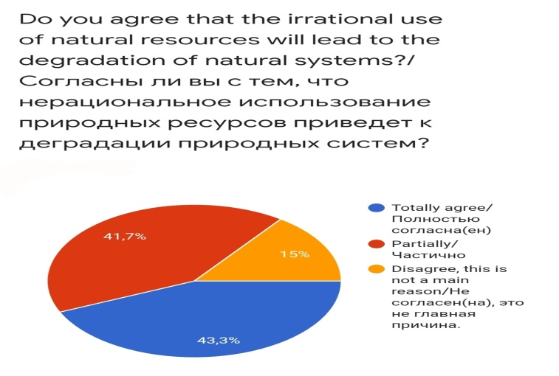
Figure 1-affect of irrational use of natural resources
When it came to which is the best method of saving natural resources, the opinions of respondents and participants of the focus group agreed, because 48.3% of survey respondents chose a reduction in consumption with a daily limit of using water and two students from the focus group supported this opinion. Also according to the majority in the focus group discussion three students, as well as the expert supported the idea of ​​installing special water counters, since only 75% (figure 2) of the houses in city Oskemen have counters installed, therefore 25% of residents do not pay attention to the amount of electricity and water used, because despite this they will pay the same amount of money. To sum up, majority of two method participants supported the idea of installing water counters.
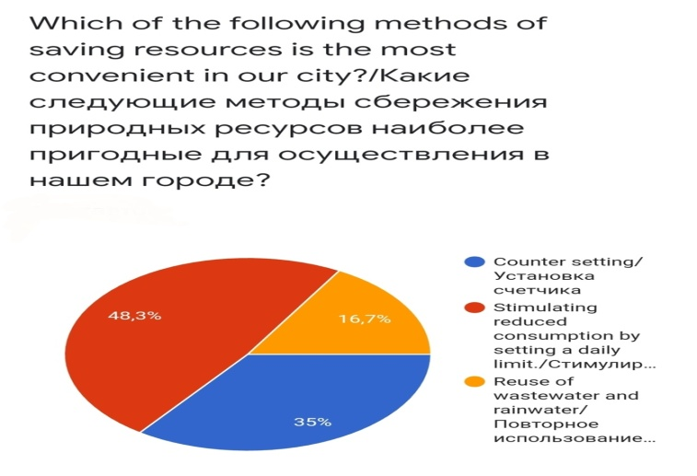
Figure 2- Methods of saving resources
In the survey and during focus group discussion, there were asked questions to find out how much they care about saving water and electricity in their homes (prepared the general data in a table tabulating different questions) The 40% of respondents take a shower 3-4 times a week for one hour and 60% of respondents don't turn on the light in the hallway before going to bed. Also, both focus group students and more than half of respondents of the survey (65%) try to turn off taps and lights depending on situations. The argument of focus group discussion participants was that in NIS Oskemen school they had lessons that are meant for learn about the environment, about the state of nature and methods of conservation of water and electricity compared to other schools, so the school holds special events and there are lessons where there is an opportunity to discuss this topic in order to delve into and have an idea of global issues. One of the focus group participants, Participant 1 mentioned in her answer that "We focus on global topics and understand our own responsibilities in relation to mother-nature". As a result of focus group discussion and results of survey it turned out that all five focus group discussion students and by calculating an arithmetic mean 55% of the survey respondents make enough effort to save the amount of water and light they use.
How often do you take a shower?  And how long? | every day/ Каждый день | 3-4 times a week / 3-4 раза в неделю | Twice a week/Дважды в неделю | Once a week/Раз в неделю
More than 2 hours/Больше двух часов | 3 |  |  | 16
1-2 hours/часа. |  | 36 | 2
30-40 minutes/минуты | 4 | 11 | 21
less than 30 minutes/Меньше 30 минут | 10

According to the survey a total of 44 respondents (73.4%) chose marks "4" and "5", which confirms their agreement on special school programs. So, it can be concluded that 90% of participants support the initiation of training programs on the conservation of natural resources. But in this case, a resident of Oskemen from whom I interviewed answers to question "What decisions can affect students so that they begin to understand the seriousness of the problem of preserving natural resources from childhood?" answered that school lessons about conservation of natural resources will only increase the number of useless and unnecessary items. To sum up, opinion of the interview respondent and the results of the survey contradict each other.
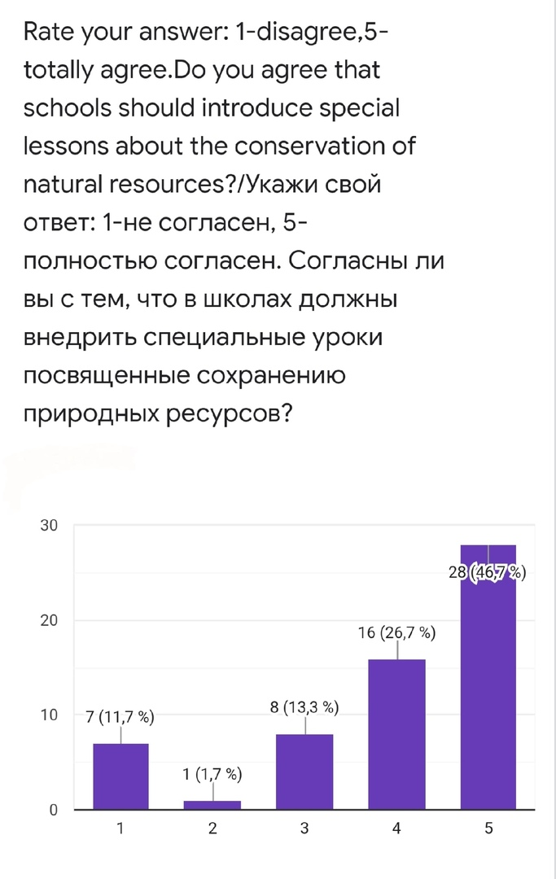
Image 3- consent to the introduction of lessons

Conclusion
As expected from the research as a whole it is possible to conclude that research participants have a concern about saving natural resources like water and electricity. In response to each of the research questions it is possible to make the following conclusions:
- How much do people worry that indifference to resources adversely affects the economy?
The majority of people in the research have a concern about impact on the economy that is caused by indifference to saving natural resources such as water and electricity. There is a strong concern of the problem in general with 65% of survey and focus group discussion participants confirm the problem. Nevertheless, other 25% don’t think about that the subsequent consequences of insouciance can affect the economic condition of the city, forasmuch according to the specialist answer, citizens who are against setting a counter think that excessive use of resources will affect only their financial condition. Because fixed monthly payment for use of water is only 2000 tenge, if every citizen will set a counter, most of them will have to pay much more than 2000 tenge. That is, they worry about their finances and pay less than they should, thereby without installing counters and using the resources as they like. Furthermore, according to the expert’s answer, majority of people try to follow restrictions and fines established by the government for littering recreational parks, which shows resident’s indifference to the environment.
- How can small conservation actions lead to solution to big problem?
From the research as a whole it is possible to conclude simple actions that every person individually does will certainly lead to partial solutions to such global problems. The research has shown valid results, because in the responses it was mentioned that what hard work the government would not have, if every resident does not contribute to the solution to this big problem, then all efforts are empty. For instance, according to the secondary research government take a decision to install a counter in each apartment with the goal that residents will use water to the extend because of corresponding payment.

- What are the main criteria of saving natural resources?
The main criteria of saving water and electricity according to the survey and interview include:
- Teaching students the right attitude to the environment through the introduction of special school subjects and events.
- Stimulating reduced consumption by setting a daily limit.
- Installation of a counter in each apartment.

As a result of this study, it can be concluded that more needs to be done to raise awareness about the problem of saving vital resources. In addition, there is evidence that such schools as NIS already have special lessons and events that increase awareness among young people and make it possible to disclose it to others in the form of a project through courses such as Global Perspectives.

There were unexpected answers where in the survey there are four respondents who are NIS students to the question "Have you had any special events and lessons in school dedicated to the conservation of natural resources?" they answered “no, it was not”. I suppose they did not understand the essence of the issue, since topics related to natural resources and the environment are often discussed in NIS.
Over the course of the research, the hypothesis that approximately 60% of survey respondents will disagree with the introduction of special lessons about saving resources were rejected, since as a result of the study 75% of survey participants supported the idea of introducing a lesson. So results of three methods has reached research aim.

Evaluation
Even if all research aims were achieved, there were some challenges during the research. Sample group strictly kept for each method in order to get reliable information and an accurate result.
Despite the enough number of respondents, the majority of population of the survey included only 12-30 years old people and the number of participants from other regions out of Oskemen was about 20 out of 110. The survey involved both school students and ordinary residents from several regions, therefore with the help of special regulatory functions that includes “Google form” survey platform, it was possible to come to a general conclusion and to compare results with outcomes of interviews.
The representative sample of the interview was focused on five 16-17 aged high school students, but three of them were very active by giving additional information beyond asked questions. Also, some participants answered biased after other member’s answers, but discussion at last was conducted by initially prepared focus group discussion questions.
The third method that going to evaluated is interview. Since interview were taken from Housing and communal services specialists of city Oskemen, this method was the most valuable and helped to answer two aim questions. Interviewees provide their personal opinion based on accurate evidence and examples from the city water utility enterprise database.
Coherent conclusions made from all three method results and secondary research allowed to state that the outcomes are reliable and representative, because research was conducted diversely including three suitable methods.

Further research
The first action to improve the project should be add some changes in sample group of interview, since all three interviewees were from the same profession. The sample group should include also residents who can share with their personal perspective and experiences of saving natural resources or ecologist of Oskemen who can tell in detail about the current methods of conservation of natural resources and the work that is already being carried out.
Also, one way to improve the confidence of conclusion will be using semi-structured interview questions in focus group discussion, since it can help clarify complex questions which occur during discussion related to conservation of water and electricity. Precisely, each participant of focus group discussion can share with his personal perspective in depth and find out the exact opinion regarding to problem of saving water and electricity.
Moreover, another research tool can be used, for instance, social experiment, to wit after the introduction of special lessons of teaching the conservation natural resources, observe how students will have a different attitude to their use. Because if every student will keep simple rules regarding to conservation natural resources, the state of human life and the country's economy get better respectively. This can be cited as evidence that small actions can lead to great results.
The research changed my perspective, since I thought that majority of the respondents who participated in research would not understand the importance of natural resource conservation, but it surprised me, when the results of the method refuted my perspective. In general half of the research participants have already followed simple but extremely important steps to save water and electricity at home.

Bibliography
- BRIEFING from https://www.europarl.europa.eu/RegData/etudes/BRIE/2018/625181/EPRS_BRI(2018)625181_EN.pdf
- (GDP Guide, 2018) from https://www.un.org/development/desa/dpad/wp-content/uploads/sites/45/WESP2019_BOOK-web.pdf
- OECD Better Life Index (2017) from http://www.oecdbetterlifeindex.org/countries/norway/
- Mahfuz Judef (17th June, 2014) from https://www.researchgate.net/post/How_can_we_increase_awareness_of_environmental_protection
- Сritical literature (2015) from https://www.kritika24.ru/page.php?id=52266
- Water quality in Oskemen (1 March, 2019) from https://ustinka.kz/kazakhstan/ust-kamenogorsk/44167.html

Appendices
Appendix 1 - Survey
- Which age group do you belong to?/К какой возрастной группе вы относитесь?
- 14-15
- 16-18
- 19-25
- 26<
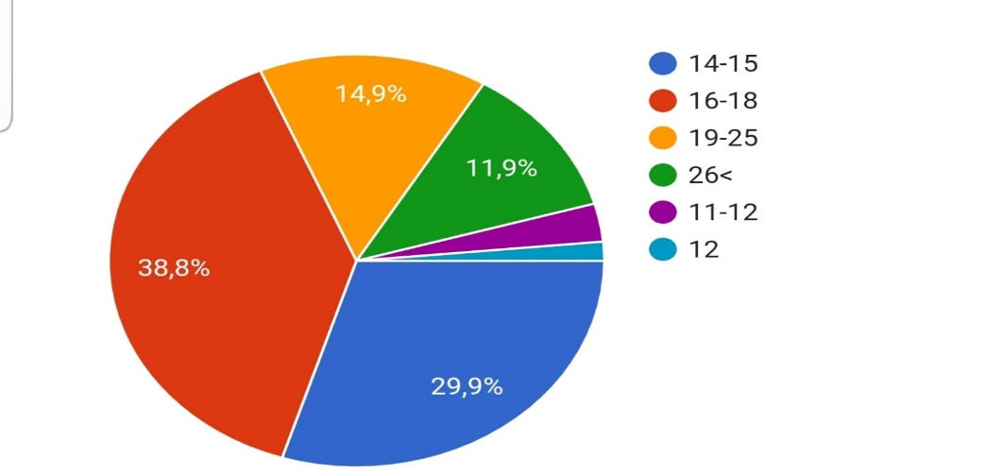

- How often do you leave the tap open while brushing your teeth?/Как часто вы оставляете кран открытым в процессе чистки зубов?
- Always leave open/ Всегда оставляю открытым.
- I try not to leave the tap open/Стараюсь не оставлять кран открытым.
- Never leave the tap open/Никогда не оставляю кран открытым.
- I do not pay much attention to this / Не обращаю на это особого внимания.
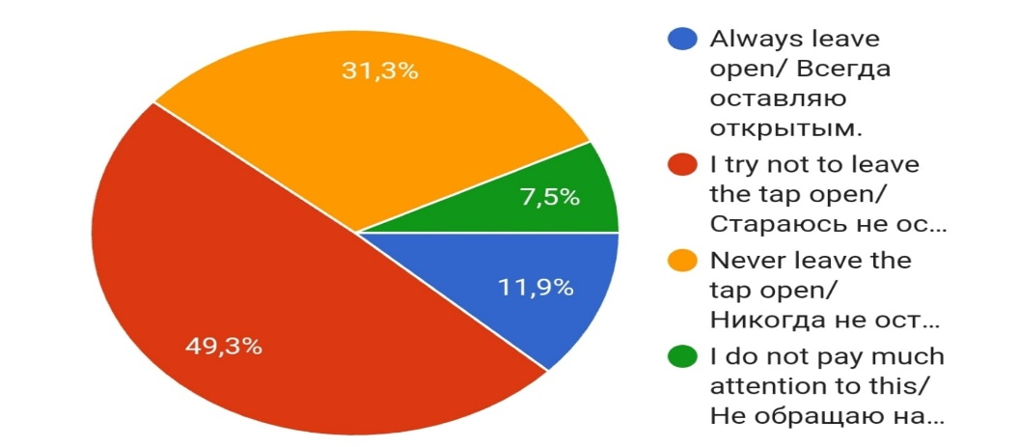
- How often do you take a shower? / Насколько часто вы принимаете душ?
- every day / Каждый день
- раза в неделю.
- Twice a week/Дважды в неделю
- Once a week/Раз в неделю
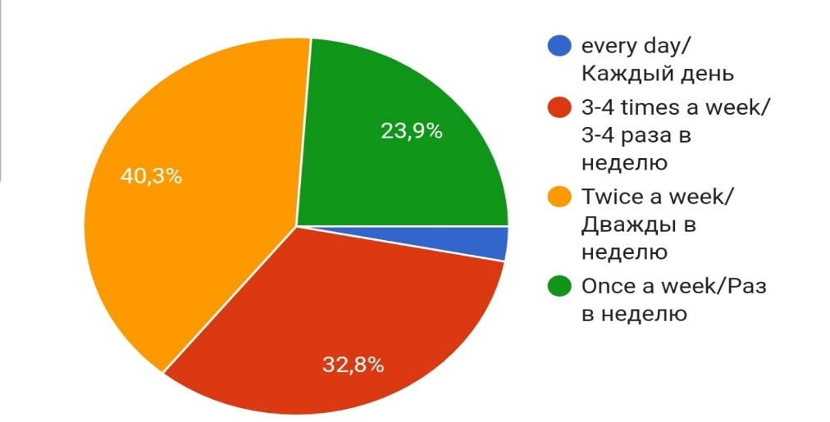

- And how long? / И как долго?
- More than 2 hours/Больше двух часов.
- 1-2 hours/часа.
- 30-40 minutes/минуты
- less than 30 minutes/Меньше 30 минут
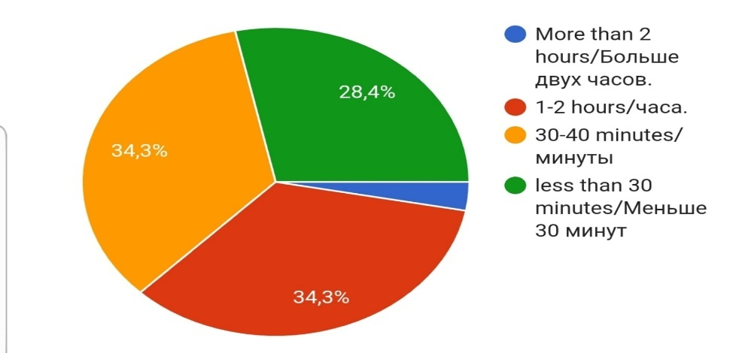

- Do you prefer to turn on the light in the next room(hallway) before going to bed, if there is nobody there? / Предпочитаете ли вы перед сном включать свет в соседней комнате(прихожая), если там никого нет?
- Yes/Да
- No/Нет
- Hard to answer/Затрудняюсь ответить.
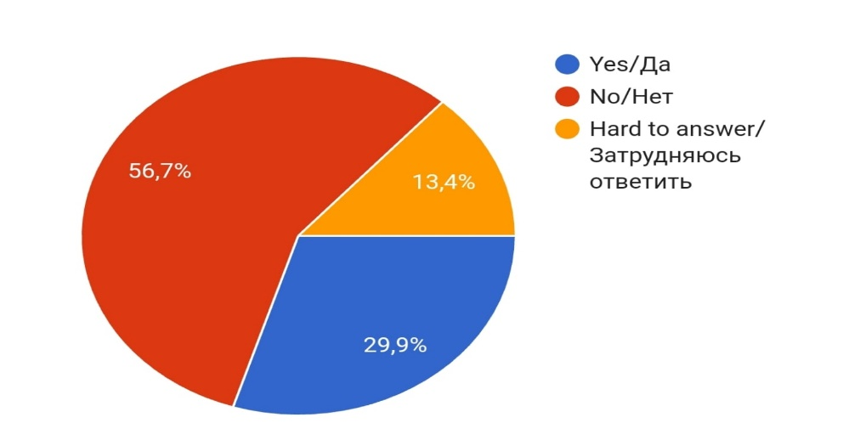

- Do you turn on the light in the clear daytime? / Включаете ли вы свет днем, в ясный день?
- It happens/Бывает
- Depending on what situations/Смотря в каких ситуациях.
- Try to keep lights off/Стараюсь не включать.
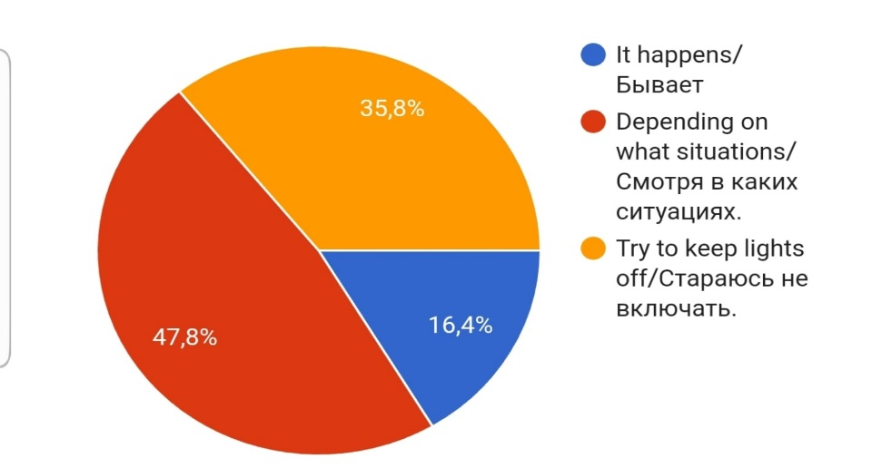
- Did your school have any special lessons about this issue? / Проводились ли в вашей школе специальные уроки, посвященные проблеме экономии ресурсов (вода, электричество)?
- Yes/Да
- No/Нет
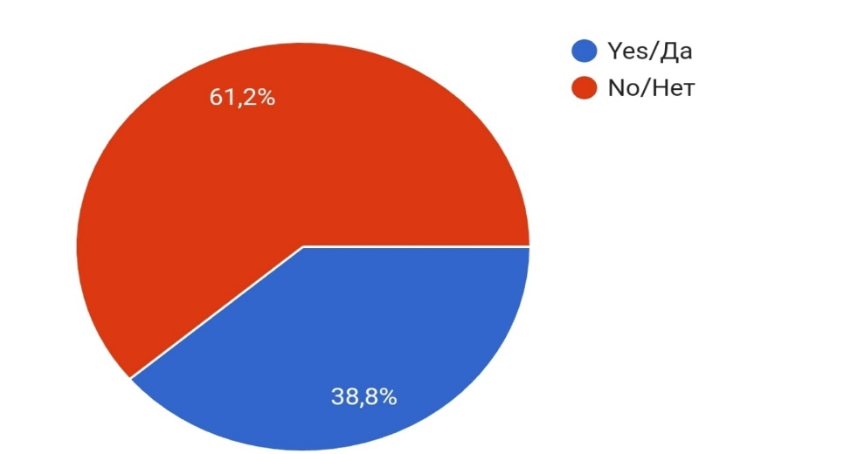
- Rate your answer: 1-disagree,5-totally agree. Do you agree that schools should introduce special lessons about the conservation of natural resources? / Согласны ли вы с тем, что в школах должны внедрить специальные уроки посвященные сохранению природных ресурсов?
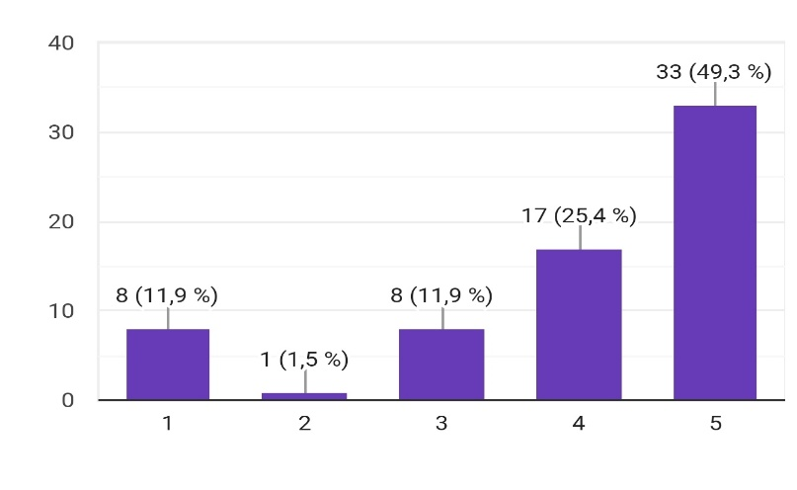
- Which of the following methods of saving resources is the most convenient in our city? / Какие следующие методы сбережения природных ресурсов наиболее пригодные для осуществления в нашем городе?
- Counter setting/Установка счетчика
- Stimulating reduced consumption by setting a daily limit. / Стимулирование сокращения потребления с установлением лимита на день.
- Reuse of wastewater and rainwater/Повторное использование стоков и дождевой воды.
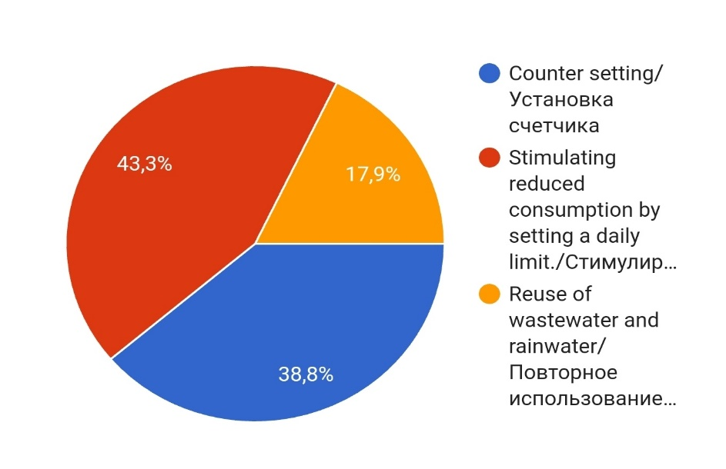
- Do you agree that the irrational use of natural resources will lead to the degradation of natural systems? / Согласны ли вы с тем, что нерациональное использование природных ресурсов приведет к деградации природных систем?
- Totally agree/ Полностью согласна(ен)
- Partially/Частично
- Disagree, this is not a main reason/Не согласен(на), это не главная причина.
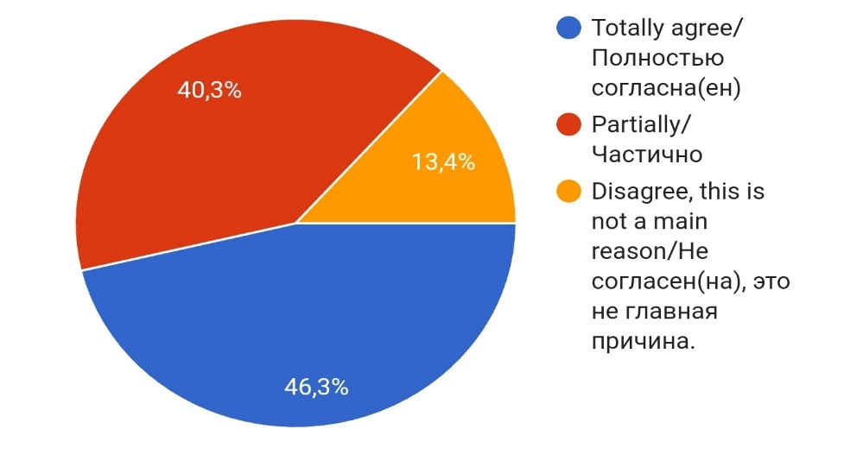
Appendix 2 – Semi - Structured Interview Questions:
1. Do you think that in our city residents use resources to the extent?
can you bring the facts?
2. How much has the need of residents for water and electricity increase over the past
five years and what is the reason? ​
3. What decisions and methods did you make for saving natural resources and for preventing the use of resources in larger amounts? ​
4. What saving methods can you offer to our residents? ​
5. What do you think will lead to excessive use of resources? ​

Appendix 3 - Focus Group Discussion Questions:
1. How much do you care about saving water and electricity in your home? ​
2. Which method is more practical to economize according to your experience? ​
3. What should we do individually to save nature electricity? ​
4. Should government do any actions and how effective will it be? ​

