A

How does Anime affect to academic performance?

Kuzembaev Adilzhan

Nazarbayev Intellectual School of Chemistry and Biology in Oskemen

Word count:3752

INTRODUCTION
The students of nowadays are encompassed by innovation and technology, where get to huge collection of data is only a fingertip away. With this growing popularity of videos. One of them is anime which of viewers percentages mostly teenagers which are normal students of school which from kindergarten know how to talk with gadgets. However, adults say that Anime has bad influence on the academic performance of the students. But in some developed countries like Japan this type of animation uses like attractor of students attention. How shows this experiment after using this methodic a desire to study of some students rose significantly. Thus animation has positive effect of academic advantages; the introduction of this anime can raise the level of education.
During this research work I can be biased on topic, but I can confidently say that I will to be neutral on this topic and In order to reduce bias to a minimum throughout my research. By using in my report all findings that I have collected during the primary research and secondary research to draw clear view of this problem.

The relevance of this study is to determine the impact of popular animation on the educational process. The results of this study can be used by Tokyo Metropolitan Asuka High School’s experiment or can be used by Kazakhstan or other countries.

How does Anime affect to academic performance?
With the development of technologies, entertainment becomes more popular and easy to access with this in Japan developed industry of anime. Before multiplication always need payment and big amount of the finance, but anime is first entertainment which able to become popular without big budget and advertise. This ability becomes one of the reason to open the gate to mind of teenagers and adults.
The creator of Final fantasy and one of the principals in Square Enix Masamune Sakaki said that to create one anime with 13 episodes they cost near of 200 million yen(or 2 million dollars). When one of the most popular animation of WaltDisney «Tunglet» cost over the 260 million dollars. This budget is 100 times more than anime costs. This money is main reason too big price in cinema and at TV program.
On the other hand multiplications are always oriented to show bad and good sides of characters and describe correct road to find own road in society. When Anime do attempts to show the real worlds bad and good sides and dangers which are waiting. For example teacher in Narayana School Howrah Debashis Mandi says that anime affect to knowledge of students in science. For example his students who watched «Parasite» they have knowledge about natural selection and parasites(they do not learned in the class), or students who watched the «Terraformars» learned about parts of human which affect to evolution and unique skills of each insect. This help them to be successful in this topics and lessons. (Vira Nurziani, 2017)
Along with-it Anime can show the unexpected things. For example popular anime Jormungand show you the realistic life of arm dealers. And how they travel the world, problems which they meet on the road and relationship between boss and bodyguards. Or as Anime is Japan multiplication they love to present their culture and national dishes. For example by watching «Shoqugeki no Soma» you can know the types and types of dishes which loved by gourmets of Japan. For example in one episode you can learn all stages of «Okinawa Beef Teppanyaki». This dish only can be cooked perfectly by restaurant which has three stars of prestige. This show it’s rarity and hard of cooking.(Theo J Ellis, 2015)
Sometimes Anime can be connected with topics of politic and its problems. Actually these types of anime have big amount of censorship because of ability to discredit the government of Japan. But Anime which see the light represent the problems of corruption in society and having of too much power when you have wrong intentions. All of these problems show in the country of middle ages where children who are starving because of corrupted government and how citizens can react to this Injustice. By this young population can easily and early understand what should they do and start searching the solutions of unfavourable life.
If we watch the statistics we can say that each country have its own influence of anime on the society. Under this words easily can be mentioned countries like USA, France and Philippines. Which is on the top of Demand to the Anime (The Parrot Analytics, 2018)? The demand of this country to the Capita (the amount for per head) is 0.9 in USA, when in the Philippines and France is near of 0.5. This statistic show that big amount of viewers in Europe, Asia and America love to watch the Anime and interest on Japan animation.
That can mean possibility of Anime to affect on aspects of society which mentioned from the top. This show that Anime have power similar to film industry, but it not limited by big censorship like films in our time which do attempts only to show good sites of humanity or totally criticize the different countries mentality. By this films become the gun on hands of government when anime is entertainment to show all mistakes of our civilization.
Despite the all advantages Anime have possible issues. From the words of the “Reddit” redactor NyaaFlame because most of people have wrong impressions about Anime it’s hard to talk about it in public places as you can look like pervert in eyes of society. For example user of popular social media “Reddit” u/Anonymoose-N(Carl Campbel) have fiery to talk in school about Anime because most of his classmates have worst expect about place of anime and it’s features.
Along with it most of Anime series are aggressive and is mostly based on fighting and killing enemies. If mentally not-established child watch it he will exposed to the such cruel scenes. Plus to that if child will addict with anime his personality might be constructed from different characteristics of heroes in anime.(MYNEWSFIT, 2019)
Taking everything above into the account, the anime provides freedom of speech and affect on the knowledge of young generation on different science. However Anime can easily affect on the academic performance.
AIMS:
The main purpose of this research is to find out how the Anime affects on academic performance. However, the usage of anime can be provided to two types: when teenagers watch them without some purpose or interest and when they watch them to gain new opportunity and knowledge. Therefore, in order to achieve my main goal, the effect of both usage should be researched. Thus, following questions will help to achieve this goal:
- 1) What are the advantages of watching Anime?
- 2) What are the disadvantages of watching anime?
- 3) How anime affect a student's academic performance at school?
By using these questions it will be possible to answer my main question, as information related to anime in teenager’s life will be easily found. My hypothesis about this topic is that anime might be useful to develop children’s creativity and develop their knowledge in science, but all of this might happen only by proper use.
RESEARCH METHODS:
Interview
This interview is conducted to determine the influence of Anime to the academic performance of NIS students. The respondent of interview is psychologist: Good afternoon! Thank you for agreeing to be interviewed! You were chosen as a sample group for this interview, because your given answers are important in investigating how anime affects to the academic performance of NIS students. Your answers will be used in examining the influence of watching anime on academic performance and mental condition. Please be free to express your thoughts and point of view, your opinion is highly valued and considerable
1) Can you tell me a about yourself?
2) What is your bias about Anime?
3) Do you think that anime can damage the mental condition of young viewers? Why?
4) How animation affect on motivation at lessons?
5) Tell me about the 3 most animation experiences which you had?
6) How do you view the future of Japan animation?
7) What is the one decision you suggest to make Anime useful at studying?
Focus group
The Sample group of usual viewers of Anime: Good afternoon! Thank you for agreeing to be interviewed! You were chosen as a sample group for this interview, because your given answers are important in investigating how anime affects to the academic performance of NIS students. Your answers will be used in examining the influence of watching anime, educational institution on academic performance. Please be free to express your thoughts and point of view, your opinion is highly valued and considerable
1) Do you feel satisfied after watching anime?
2) How you combine Anime and education? How it affect on your academic performance?
3) It is claimed it is hard to combine entertainment and school. What do you think about it?
4) How your school and Anime impact your life satisfaction?
Survey
This survey need to evaluate affect of anime on academic performance of NIS students
1) How old are you?
2) Do you watch Anime?
3) If you watch anime, which genre do you prefer?
4) If you watch it? How much time did you spend to watch Anime per day?
5) How often do you put off your homework to watch anime?
6) Do you think the knowledge gained by watching anime is useful? Why?
7) Do you notice any negative effects of anime? if yes, which ones?
8) What influence anime has on the perception of information?

Results:
The survey was conducted among 113 people from NIS students all of them are students of middle and high school; the interviews were taken from two experts; the focus group interview was conducted among two sample groups.
There are key findings from the survey and interviews:
- 14.29%(16) watch Anime for 1-3 hours per day, 14.29%(16) watch anime for 3-6 hours, when other 71.42%(81) of respondents watch anime less than 1 hour or they are not viewers of Anime. Since indicator values of “less than 1 hour” and “not viewers” were the same, the mean was calculated. Mean=28.25 showing that the central tendency for this sample size could be a neutral attitude. When experts say that in our century the number of persons who watch animation a rare thing. While focus group interview respondents say that most of teenagers can limit themselves.
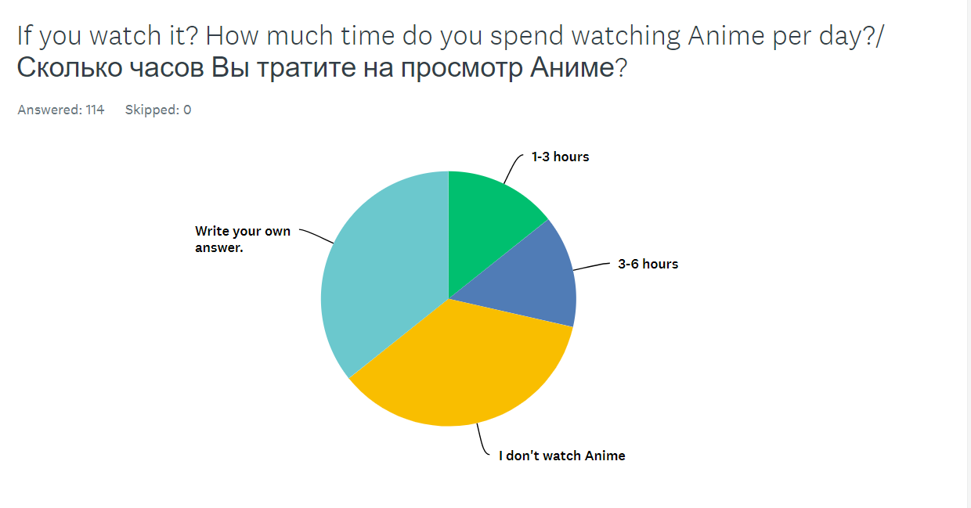
- According to survey results, the amount of students which put away homework because of new episode less than 20% when students put higher study than anime is over than 60%. To the surprise the experts and anime viewers have similar idea in terms of this question. 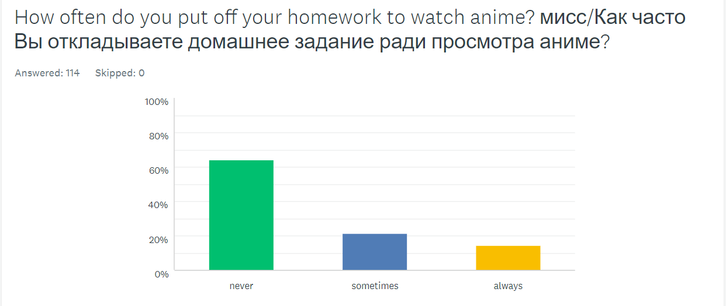
- 35,71% of respondents do not notice negative aspects of anime when more than 60% of respondent says that anime provides smoking and violence. While experts managed other negative aspects of Anime like addiction and lose of concentration.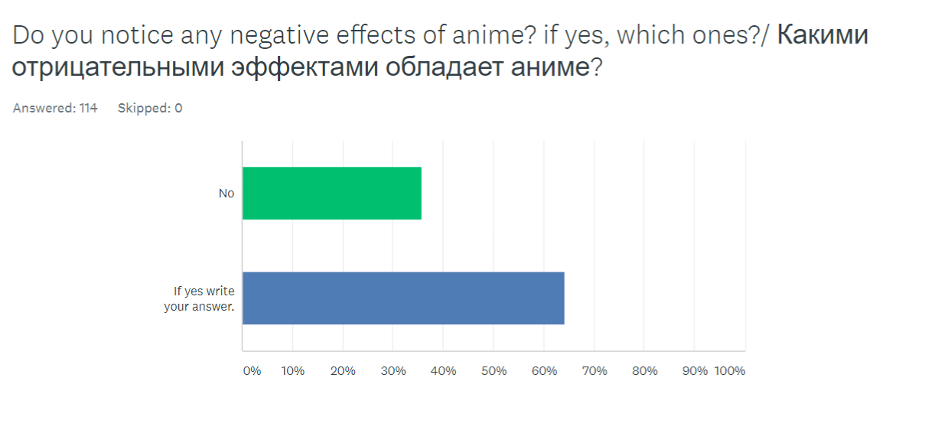
- On this question 14% of respondents answered I do not know. When other 86% mentioned several advantages. For example, respondent №14 answered <<Yes, it made feel motivated and confident, there are a lot of life lessons to learn>> or respondent №86 answered that <<Yes, sometimes you can use gained knowledge in order to solve some specific problems.>>. While experts had problems to answer on this question. But group of Anime viewer mentioned similar answers with respondents of survey.
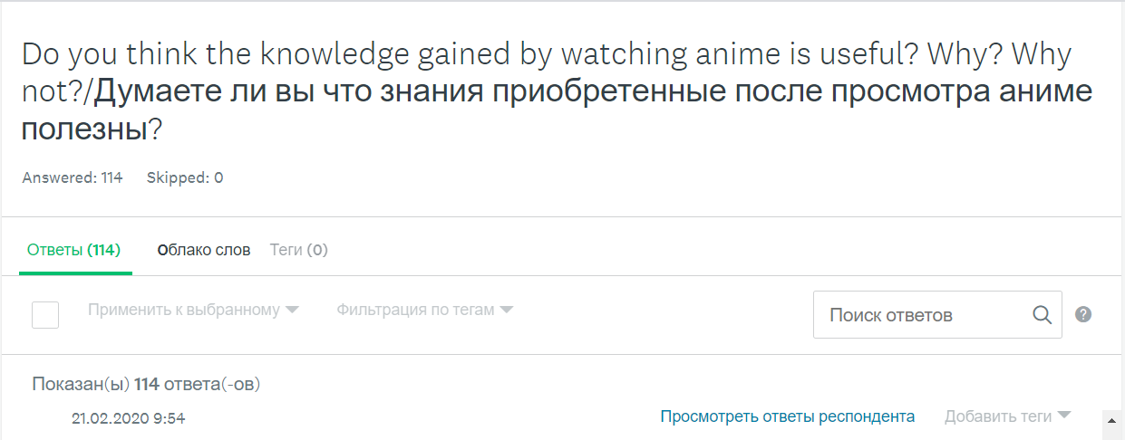
Interview and FGD correlated:
All FGD and interview respondents state that including anime to education system have several advantages, because some animes provides useful data which help to improve their knowledge. To achieve this Japan animation company should work together with Ministry of Education. By this both sides can create interesting animation which can develop level of academic performance at their country. Example of successful experiment in this industry can be Anime named Doctor Stone which give explanation of most scientific terms and gadgets.

Conclusion:
- The main purpose of this research is to find out how the Anime effects on teenagers. The hypothesis I made at the beginning indicated that I expect more positive responses from participants about the effect of Anime on academic performance. The results of my research gave me the following conclusions:
- 1) What are the advantages of watching Anime?
Responses of students show that anime has several pros in terms of developing academic performance. For example, one of the respondents said that in anime eye-catching graphics attract a viewer to listen which makes gaining of knowledge easier. But the response of psychologists was a categorical no. This was expected because most of the adults have a bias in this topic. Part of them may say that it is for kids when someone says that anime is an unscrupulous type of cartoon. In other words, it was not correct to ask adults because of their bias in terms of the cartoon industry.
2) What are the disadvantages of watching anime?
This questions answers had been unexpected because of all participant of each method have own opinion but all of them says that Anime has different types of disadvantages. For example, focus group participants said that anime can cause addiction when experts (interview) mentioned that anime has vulgar scenes. But these answers had been expected because most of them had been mentioned in secondary research.
3) How anime affect a student's academic performance at school?
At this question, we have a big amount of different and unforeseen answers. In the responses to the interview, both experts said that they do not have a clear idea on this topic. But participants of focus group discussion gave the most useful answers to this question. Participants mentioned the useful effects of animations like "Teraformars" and "Parasite". In their opinion, these animations the best way to learn how acts parasites or to understand the theory of evolution. The same answer I had when conducted secondary research. To the surprise students who answered the survey had a different idea to this research question, they say that Anime distract from homework. This idea has good support like how much, students cost time to watch this japan animation.

To conclude, Anime have pros and cons to the academic performance. I concluded that if students can control them self the cons of anime can be solved when pros of watching will happen in same way.

Evaluation:
Although all research goals have been achieved, there are still problems that were noticed during the study.
First of all, there are several weaknesses in the survey. First, the highlighted group was not created correctly, because only a NIS student participated in the survey. Even if they have an idea about this problem, only students of the same school cannot create the right kind of the whole problem.
The second method that I am going to evaluate is focus group. This method most valuable because at this method two party conduct the debates which give more information than expected. By this method I gained several information that I cannot take from other method. For example Focus group shows that experts is not best respondents because they do not have clear imagination about academic performance. When typical anime viewers have clear idea in my topic.
Despite this by using this method I gained useful information and after comparing results they give me conclusion of my research work.

FURTHER RESEARCH:
The first action to improve the project should be changing the population sample of the questionnaire. The sample group should include also students of other schools not only of NIS. Additionally, questions to identify their school should be added. And the survey should be conducted among more than 200 respondents in order to receive more opinions of people.
Moreover, another research tool can be used, for example, experiment. By conducting an experiment I could identify how anime industry affects to the academic performance. So then results will be compared with results of other methods. After this I will be confident about results of this project.
Also in the future I want to conduct new interview with another respondents. By this I can compare answers of the two different groups to same questions.

Bibliography:
https://www.reddit.com/
https://www.quora.com/How-many-anime-and-manga-fans-are-there-in-the-world
https://www.parrotanalytics.com/insights/the-global-content-marketplace-audience-demand-for-anime/

