Why are alternative sources of energy not so widely used?
Bolatbekov Adilet
08.05.2020
Nazarbayev intellectual school

Introduction
It is not a mystery that our world is being more and more polluted. Water, air pollution, soil contamination, acid rains are all caused by human manufacture. Polluting environment has a bad impact on our health and also jeopardizes the whole life on earth. There are many clean technologies that allow gaining energy without affecting our nature. However, many countries do not hurry to implement them. I am going to research the reasons for that and investigate if it is reasonable to use clean sources of energy.
I live in a pretty polluted region of our country. There are several industrial enterprises which cause air pollution by toxic wastes they emit. In addition to this, exhaust fumes from vehicles create a toxic area near roads. When I stand on a bus stop and smell the exhaust gases, I think about how is it possible that countries still do not use clean technologies. I believe that it is more beneficial to reject all fossil fuels and start employing alternative clean sources of energy. This can make me biased because I believe that using sun, wind, or water energy is much better and beneficial. You do not have to spend money on mining and transportation fossils, and you do not pollute the environment. However, if countries are not using new clean technologies, then there should be reasons for that. Therefore, I want to explore those different factors and discover why countries do not invest and do not implement alternative energy sources.
At the end of the research, if it turns out that clean technologies are more beneficial, I am going to try to implement them into our school’s energy supply system. This could help to improve and develop our school.

Context
Electricity is the most important resource in our life. It is used everywhere: to light our houses, charge our phones, or to run many industrial processes. We can not see our lives without electricity, because if it disappears, almost every factory and home stuff will stop working.
As we can see electricity plays essential role in our lives and its production is a very important issue. There are many ways of producing electricity. The most common technology is by using fossil fuels. The “U.S. Energy Information Administration” discovered that 63.3% of the electric energy in the U.S. is produced by fossil fuels (coal, natural gas, petroleum, and other gases). However, burning fossil fuels produce many greenhouse gases that pollute our environment. The other type of producing electricity is by using wind, solar, or water power.
How does the process of producing electricity work? Each electricity generator has a turbine which generates electricity. To rotate it different sources of energy are used. In the fossil fuelled plants oil, coal, or gas is burned and the heat boils water. Then the pressure causes the steam to flow and rotate the turbine. In wind power plants the turbine is rotated by wind and in water power plants falling water cause its rotation. However, solar panels work in other way. Solar panel is made of a special material called “silicon”. When the sunlight hits the panel, electrons start to move, creating direct current (DC). Then, that direct current is converted into alternating current (AC) in the inverter to power the appliances.
Every type of electricity generation has its strengths and weaknesses, and in the future electricity generation should suit many criterions as efficiency, low cost, and cleanliness for environment. A pound of oil produces 2.4x10^7 Joules (S.I. unit for energy) or 270 watts a day. A solar panel with an STC rating (STC means standard test conditions and indicates how much power a panel will produce under ideal conditions) produces 175 watts a day. However, in the real life it will produce much smaller amount of energy because such conditions as shadowing, temperature, and reflectivity.
By U.S. Energy Information Administration, Short-Term Energy Outlook, (January 2019) in 2010 in the U.S.A. about 400 billion (about 10%) kilowatt-hours of electricity was generated by renewables. In 2018 that number increased to 700 billion (17%) kilowatt-hours. In addition, according to United States Environmental Protection Agency (EPA) carbon monoxide emissions fell by 15%, lead emissions fell by 82%, nitrogen dioxide emissions fell by 22% in the period of 2010-2018. As we can see, using alternative sources of energy make a big difference in air pollution.
However, we should also consider the prices for both sources. According to United States Environmental Protection Agency (EPA) heating oil costs 3.01 dollar per gallon, so factories spend a lot of money to buy the fuel for their machines. However, alternative sources of energy do not require any fuel, all expense are spent on the upkeep only. It means that producing power by clean sources of energy is much cheaper and easier.
Nevertheless, looking on this globally we can notice the difference of costs for fuel and electricity in different countries. For example, gasoline price in Sudan is 0.52 dollars per gallon, so they do not really need another source of energy, because oil is cheap and affordable for them. On the other hand, in Norway gasoline costs 6.95 dollars per gallon, so it is essential to use oil less.
According to the statista.com in 2019 China invested 83.4 billion dollars, USA invested 55.5 billion dollars and Japan 16.5 billion dollars in clean energy. Also, by the US Energy Information Administration (EIA) China takes the first place in the amount of produced clean energy with 1.5 million GWh. However, the ratio between produced clean energy and total energy is only 24.5%. Countries that are close to 100% clean energy productions are developing Albania, Iceland, Norway and Uruguay.
Taking everything above into account, alternative sources of energy are important in fighting against pollution, because they reduce the amount of emissions produced by human activities and support solving global environmental problems. However, even if clean sources of energy support “clean world”, some countries do not see the economical profit from it, because fossil fuels absolutely satisfy their needs.

Aims
The main goal of my research is to identify why all countries do not widely use alternative sources of energy than fossil fuels. In order to achieve my aim advantages and disadvantages of both ways of producing electric energy need to be researched and compared. I need to investigate about the dependence of alternative sources of energy on geographical, ecological, economical and other aspects of different countries. Therefore, my questions are going to be the following:
- Are alternative sources of energy more profitable than fossil fuels?
- How geographical location, ecology, economy, and policy of a country affect the effectiveness of alternative sources of energy for a country?
- Are there any other aspects that may affect countries’ choices?
- To what extent are people ready and willing for changes in energy use?
By answering these questions I can gather enough information to reach my main goal and give a reasoned answer for the main question.

Methods
The main aim of my project is to identify why countries do not use widely alternative sources of energy. I need to investigate the dependence of alternative sources of energy on geographical, ecological, economical and other aspects of different countries.
In the research, a focus group discussion was used. Focus group discussion is important, because it can offer a bigger range of opinions from people with professional knowledge. By conducting a focus group discussion it is possible to gain more professional opinions, which is important in understanding the causes and sequences of the problem more clearly.
- How clean technologies are dependent on geographical location?
- Can the geographical location of countries affect their interest in alternative sources of energy?
- How likely is it possible to implement technologies to countries with an unsuitable geographical location?
The sample group was 2 geography teachers, 2 physics teachers, and a history teacher. It was effective, firstly, because teachers of NIS school are highly specialized in their subjects and can give reliable information. Secondly, in that kind of discussion teachers interact with each other, discuss which helped me to get an answer that is viewed from different sides.
Focus group discussion gave only qualitative data because it was possible to gather opinions and reliable information from a few specialists.
The focus group discussion can be verified by data analysis. I can supplement gathered information with some statistics and confirmed facts.
Lack of time could be a weakness of that research method because in that case, teachers will not be able to explain their opinion fully.

Survey helped me to gather quantitative information about people’s attitudes towards alternative sources of energy.
- What is people’s attitude towards alternative sources of energy?
- How much do people care about environmental issues?
My sample group was students from different schools, teachers and some workers. By using that sample I gathered opinions of different professional and age groups. I am asked about 150 people. It would be enough to cover all my target age and social groups.
That research method gave me quantitative data. The gathered information was about people’s opinions and feelings about alternative sources of energy.
This method can be verified by focus group discussion, where I can get more specific and reasoned answers.
Possible weaknesses can be only closed questions, which will limit people with certain answers.

My 3rd method was data analysis. It is effective in analyzing examples of other countries and other data.
- Which political, economical situations prevent countries from implementing alternative sources of energy?
I am used official websites of the UN and UN countries’ departments as sources.
By using this method either qualitative or quantitative data was gathered. I analyzed the speeches of some competent people and get qualitative data. By analyzing official statistics I got quantitative data.
This method could be verified by interviews with some specialist so that I can ask questions that I need.
The weakness of that method could be that documents might be limited. Also, another weakness might be that it is hard to analyze huge numbers of documents.

Results
Survey was about people’s readiness and willingness for changes in energy use. More than half of the respondents know about wind, solar, waves, hydroelectric power and nuclear energy. 36% of the respondents know about geothermal and biomass energy. This means that, overall, the citizens of Oskemen people are aware of recent alternative energy sources.
Moreover, 87.5% of respondents are ready to spend more money to support alternative sources of energy. ¾ of respondents believe that alternative sources of energy are more efficient.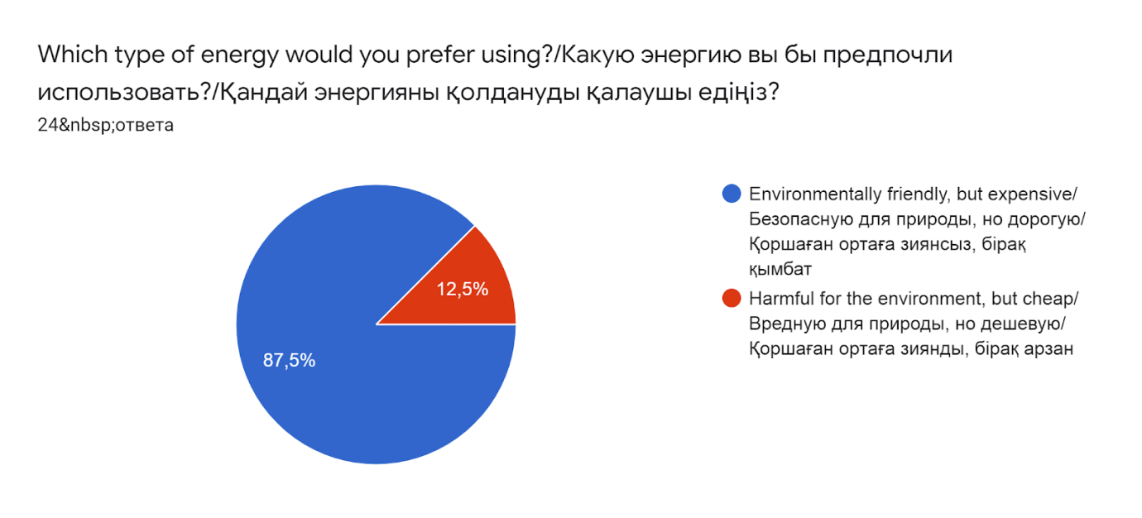
Label 1

In addition, 84% of respondents believe that it is possible to implement alternative sources of energy in Oskemen city and 92% of respondents are ready to support that idea.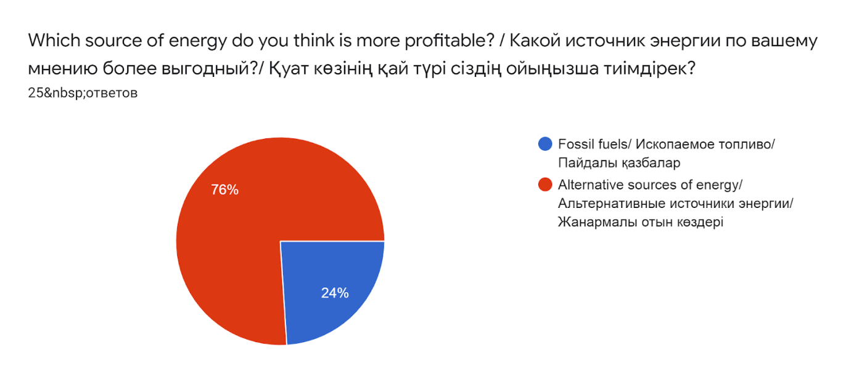
Label 2
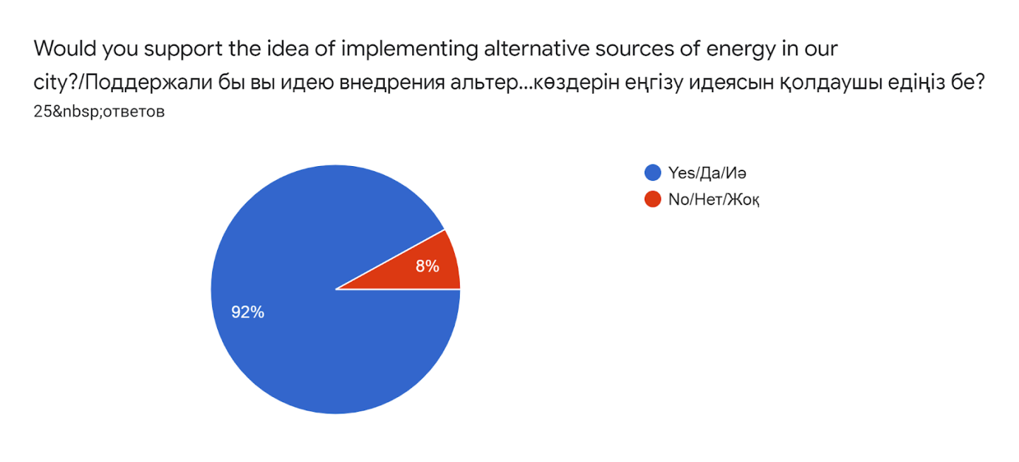
Label 3
So, overall, it is possible to say that people are ready and willing to have alternative energy as the main source of energy.

During interviews, I gathered more specific and professional opinions. All respondents mentioned that there are not only geographical issues but also political and economical. The case is that countries have built stable energy systems on fossil fuels, and many companies earn money on that. However, if there is a rapid change in energy system, it will cause instability and many people can lose their jobs. Also, one of the respondents said that alternative energy technologies are not developed enough, so they are not efficient enough to replace fossil fuels yet. However, the survey showed that most of the people believe that alternative sources of energy are more efficient. Their belief is based on the knowledge that fossil fuels are bad for the environment and any solution would be efficient. Another respondent mentioned that in many cases people do not consider the expenses and pollution by manufacturing alternative energy technologies. For example, to build one solar panel you need to mine oil, turn it into plastic and then construct it.
However, the majority of the respondents agreed that in long periods alternative energy technologies are profitable.

In the focus group discussion, I gathered a lot of valuable information about the effectiveness of alternative sources of energy. All the respondents agreed that countries with developed energy systems will struggle during the change. This is because they will have to remove companies that provide fossil fuels and support alternative energy. Also, respondents agree that it is possible that some countries will prevent the development of alternative sources of energy.
In the end, all respondents mentioned the importance of the development of alternative sources of energy.

Conclusion
From the research, it is possible to conclude that people in Oskemen city are ready for changes in the energy system and ready to pay more for clean energy. However, those technologies are not ready, in terms of price and complexity, to replace fossil fuels.
- Are alternative sources of energy more profitable than fossil fuels?
  - To mine, produce and transport fossil fuels requires money every year. However, alternative energy technologies require it only once. So, they should be more profitable. But interviews and the focus group discussion showed that alternative energy technologies do not have enough energy capacity.
- How geographical location, ecology, economy, and policy of a country affect the effectiveness of alternative sources of energy for a country?
  - Geographical location plays a big role because several conditions should meet for a proper work of alternative energy technologies. However, there are also political issues. The secondary research showed that developing countries are better in implementing alternative sources of energy that developed countries. This is because developing countries do not have established energy systems, so it is easier to implement new technologies from scratch. It was confirmed by the focus group discussion. Ecology also plays a big role, because countries with a high level of pollution are more interested in investing into the clean energy sources. For example, China is one of the most polluted countries and the amount of investments by China was 83.4 billion US dollars in 2019. Also, not all countries’ economy can allow investing enough.
- To what extent are people ready and willing for changes in energy use?
  - It is possible to say that people are willing to support the idea of alternative energy. The majority of surveyed people mentioned the bad impact of alternative energy technologies; however, they think that positive sides overcome negative sides.

Evaluation
The research had its strength and weaknesses. The availability of the experts in necessary spheres could be one of the strengths of the research. Thanks to that, it was possible to have interviews and focus group discussion with a high level of validity. However, the weakness is the possible biases of the interviewed people, because they could have their beliefs that fossil fuels is the worth method of producing energy. Interviews and the focus group discussion with qualified people can minimize the effect of that bias.
Questions for the survey were carefully created to avoid any bias. So, the answers are as true as possible. 125 people of different age groups were interviewed. However, it is too less to generalize, because it is only about 25 people from each age group. The way to improve it is to have a bigger sample. The population for the survey was the citizens of Oskemen and the sample group consisted of 125 people which included all age groups. 125 people is not a big sample for this research, so the results can differ from the real fact. It is better to use a sample group that consists of at least 500 people.
Interviews were conducted online, using social networks, because of the quarantine. Overall, they were conducted well, but there was a lack of visual contact, which would have played a big role in understanding. Nevertheless, valuable information was gathered during those interviews. The way to improve this method is to conduct it alive, record everything and listen again if necessary.
Focus group discussion was also conducted online due to the quarantine. There was a lack of visual contact that could have influenced it. However, experts in physics, geography, and computer science had a good discussion that gave a lot of valuable information about the accessibility, efficiency of alternative energy technologies.
Different information sources were used, so the validity is on a good level because the information is verified by different sources.

Further research
There are many ways of improving the research project. First of all, the research methods should be improved. The survey should have at least 500 respondents. Secondly, it is possible to have interviewees with more authority. For example, scientists in such sphere as engineering, physics, geography. That would improve the quality and validity of the research.
The aim of the research was to identify why countries prefer fossil fuels than alternative energy sources. During the secondary research, the statistics showed that developing countries have better results in implementing alternative energy technologies than more developed countries. At first sight, it is not obvious, so this was unexpected.
During the research, the possibility of implementing alternative energy technologies in Oskemen and readiness of its citizens was discovered. It turned out that the city has a base for totally clean energy. However, the hypothesis was that the city is far from being clean.
The research showed why some countries do not use alternative sources of energy as the main source of energy. Further, it will be important to investigate how it is possible to transit to alternative energy system without influencing the economy and policy of a country.

