The influence of Young Adult fiction drama series
on the behavior and psychological state of adolescents
Beysenbaev Telgara 11 «G»
Nazaraev Intellectual School

Word count: 3870
Introduction

According to the UNICEF and the WHO data for 2012 and 2013, Kazakhstan has been a leader in suicides among teenage girls and was in the 2nd place for suicides among teenage boys all over the world(Bukanova, 2014). There are several factors that explain such high suicide rates among young people, such as: school bullying; absence or loss of values; falling standards of social behavior and alienation(Raisa Sher, 2012). I believe that over the past 5 years, the residual effect from the series that streaming services offer has been added to the factors that cause teenage law violation.
I am interested in this topic, because of my personal experience. At the age of 15 I noticed that my empathy and desire to share the pain and suffering of the screen heroes went to a new level. I hope no one will blame me for this, but also at the age of 15 I first tried alcohol and cigarettes. And I'm 100% sure that this was due to my desire to imitate the heroes of my favorite series. After this incident, I seriously thought about the impact that series have on teenagers, as this was not only about me, but also about my peers. Hence, this finding prompted me to choose this topic.
Since childhood, my parents and relatives insisted that cartoons and series that I watch are harmful to me. Therefore this idea instilled in my subconscious mind might lead to a potential bias. As a result, I might overrate the negative influence of the drama series and underestimate its essential benefits.
The main stakeholders of this research are parents of affected teens. This research paper can help them better understand their children and choose a specific procedure for the proper upbringing of their child. Other equally important stakeholders are crime fighting organizations. The results can serve as an excellent beginning for the creation of specialized programs aimed at reducing juvenile delinquency in Kazakhstan.
Context
For many years, the influence of suicide in the media has been a subject of interest in the social and medical sciences. Available evidence suggests that suicidal stories and distressing content in media can provoke suicidal and deviant behavior among the population (Sisask&Värnik, 2012). Suicide contagion is a very real phenomenon. It is where a person by being exposed to suicide has an increased likelihood of attempting it. Young people are particularly vulnerable to suicide because teens strongly identify with their peers. Broadcasting reports of suicide not only creates a feeling of normalization, but if there is an additional “appeal” of martyrdom, young people can take a romantic view of suicide(Foster, 2019).
"13 Reasons Why "- a series of Netflix online service, tells the story of a schoolgirl explaining 13 reasons for her suicide. The series premiered on March 31, 2017. In the USA, monthly statistics on suicide rates among Americans aged 10 to 64 years were analyzed. It was shown that in April 2017, the suicide rate among 10-17 aged adolescents increased by 28.9 percent, which is significantly more than predicted only on the basis of seasonality and trend levels. The total number of suicides in this age category that month exceeded the corresponding figure for any other months from 2013 to 2017(Bridge, 2017).
A similar study was also conducted with the sample of 729 Americans, aged 18 to 29. The findings suggest that whether the streaming drama series instigate self-harm and suicide on its own or not, it does reach vulnerable young people and may play a role in encouraging similar behavior in those who are exposed to them (Romer, 2019).
Unfortunately, the attitudes that teenagers see on media are often accepted in real life. A recent research showed that the average North American child witnesses 12,000 incidences of violence on television per year. Media violence also results in children behaving aggressively themselves or seeing violence as an appropriate type of behavior ("How Media Impacts Youth and Children - The Disturbing Facts", 2018).
On global scale, suicide accounts for 50 percent of all violent deaths among men and 71 percent of such deaths among women. The act of killing yourself is the second leading cause of death among young people aged 15-29. Adolescents are considered the most vulnerable to exposure to the media, including suicide copycats. Although there is a high suicide rate in the world, from more than two hundred countries it is known that only twenty-eight countries have national suicide prevention strategies. Promoting responsible media coverage of suicides is part of many strategies to reduce suicides (World Health Organization, 2014).
However, observing this problem from the local perspective, contrary to developed countries, not much research has been done about Kazakhstan. The only thing we can refer to and make assumptions on is statistics. Over the past 5 years, Kazakhstan has registered 33,051 cases of teenage pregnancy, including 9,906 abortions among girls from 15 to 18 years old(Bakhtiyar Maken, 2016). Kazakhstan takes the third place in the world in the number of suicides and the leading among the countries of Central Asia. Unrequited love, exams or a quarrel with parents are the main reasons teenagers decide to commit suicide. However, the information space also poses a threat. In the beginning of 2019, nearly 2,000 materials promoting cruelty and violence have been blocked, more than a hundred of which have called for suicide. They even spelled out instructions on how to do this. In all cases, it was foreign content(Rakhmanberdiev, 2019). All this ultimately leads to the fact that viewing distressing content by adolescents is still in no way limited.
From a sociological point of view, study of the effect that television has on adolescents can play an important role in the study and application of new types of training aimed at combating crime among Kazakhstani teenagers. When it comes to culture, Kazakhstan's foundations on the parental approach to educating adolescents on topics such as moral values, sexual and reproductive health, alcohol and drugs, law violation, and etc., will be examined. Furthermore, from psychological perspective, the impact of series on adolescents will be investigated in a wide range of approaches from looking at childhood and society to the biology of the brain to seek to understand individual behaviour of adolescents.
Taking everything above into account, the problem of the appearance of real life copycats among adolescents has an effect on social, cultural and psychological aspects and it also raises concerns about the further effects it will have in individual’s life.
Aims
The main aim of this research is to investigate the effect of watching drama series on the behavior of adolescents. In order to achieve the goal, the following research questions are going to be referred:
- What effect does Young Adult fiction drama series have on Kazakhstan teenagers?
- How likely are teenagers to adopt either the bad or the good habits of the characters in the series?
- To what extent is an average parent of an adolescent concerned about the content of drama series?
It is assumed that this project will be useful to change people's opinion about the harmlessness of the drama series. Moreover, this research paper can help parents better understand their children and choose a specific procedure for the proper upbringing of their child. Furthermore, the results can serve as an excellent beginning for the creation of specialized programs and organizations aimed at reducing juvenile delinquency in Kazakhstan.

Method
To collect the relevant information, three types of methods were chosen: survey, interview, and focus group interview. The research design is correlational, that is why these methods were used to obtain both qualitative and quantitative data concerning the effect that such series have on teenagers’ minds and describing the possible reasons, which affect their behavior.
The first method I used was a survey. The main aim of using this method was to investigate the students’ viewpoints about the negative effect that those drama series have on the behavior of adolescents. This method was chosen for the possibility of obtaining quantitative data to acquire statistics that will be compared to qualitative data received from the other 2 methods. The survey was anonymous, to allow young people to share the truth about what they watch on the internet, without the risks of it being exposed. The survey was aimed at the population of 14-17 years old students and consisted of 8 questions, to find out the connection between watching young adult drama series and changes in the behavior of teenagers, for instance, violation of the law. The survey was conducted anonymously to obtain versatile and objective data. The main reason of choosing this sample is desire to obtain real, objective and relevant information.
A sample of 150 students provided answers to the following research question:
- What effects do YA fiction drama series have on Kazakhstan teenagers?
and their answers were really important to make the right claims about the adolescents' attitudes towards such content; and helped to obtain information on the behavior of adolescents from their own perspective.
However, these surveys had a weakness. The population sample included only NIS students (the survey was aimed at any average student, but unfortunately only students of NIS passed the survey) who may not spend a lot of time for series and they may do not know about any kind of impact those series have on them. Even though the questionnaire gave us very valuable statistics, they are unfortunately not able to provide completely generalisable information in response to research questions.
The second method that I used was a semi-structured interview. The opinions of experts who may help students in processing issues such as bullying, disabilities, low self-esteem, social anxiety, problems with authority and problems at home was thought to be priceless. Therefore, 4 school psychologist, were selected as a sample. Firstly, this method was used to be sure that the interviewee correctly understands the questions he/she is being asked, as the questions about teenagers’ behavior might be quite confusing. Secondly, as the interview is semi-structured, there is an opportunity for the investigator to bring up new issues that may be relevant to the study which arises during the discussion with the expert. The main aim of providing an interview with the psychologist was to get an answer to the questions:
- How likely are teenagers to adopt either the bad or the good habits of the characters in the series?
- To what extent are the average parents of young people aware and/or concerned about such possible issues?
and obtaining information about the impact these series may have on teens. Psychologists answered questions about the influence of the drama series on the character and behavior of a teenager. The main drawback of this sample is that psychologists were not allowed to share all frank details about students’ life and their problems, due to the confidentiality.
The third method I used was a focus group interview. The sample group consisted of 6 students who are netflix binge-watchers(they were found by extra question in a survey). I chose them because they could share important qualitative data about how this hobby affected their life(particularly their behavior, lifestyle and psyche). The interviewees decided to remain anonymous, so their answers were more frank, including sensitive details. Unfortunately, this method had minus; some details were specially missed by students due to the presence of other participants in a room.
Results
The main findings from the survey and the interviews have been summarized as:
- According to the survey, the majority of the respondents never obey the age restrictions imposed on the series. In psychologists’ opinion, this is because of the desire to stand out among peers and the lack of parental control (Appendix 2).
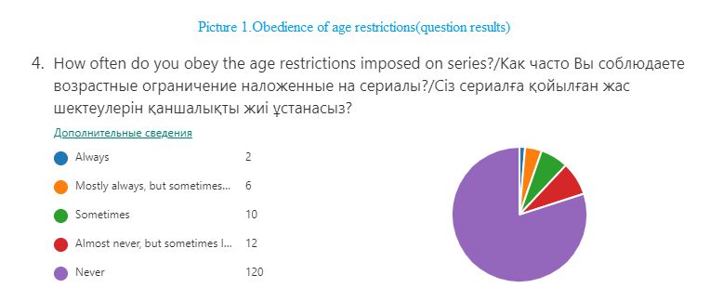
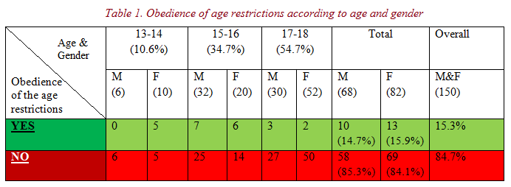
From the table above, it is clear that main respondents were 17-18 years old (54.7%). Therefore, the results show us that:
- 84.7%(127) of the respondents admitted that they do not comply the age limits (e.g.16+, 18+ and 21+) imposed on the series, while the other 15.3%(23) of the respondents do.
- However, there is a contradiction between survey results and experts’ opinions. The questionnaire shows that both genders almost equally (males-14.7%, females-15.9%) comply the age restrictions imposed on the series, while the psychologists assert there are some significant differences between male and female teens’ behavior, such as men are more likely to violate restrictions than women(Appendix 2).
- When it comes to the interviewed experts’ opinion about the negative effect that series have on teenagers, all of them unanimously claim that serials affect the development of children, the images are remembered for a long time, and cause a desire to repeat what they saw in the series(Appendix 2). Therefore, there is a correlation between answers from respondents and psychologists.
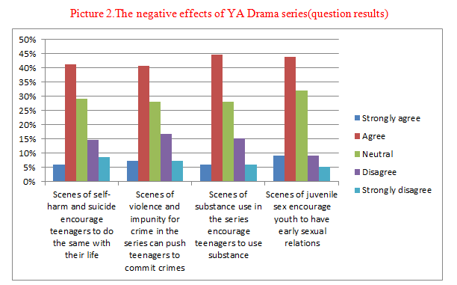
The chart gives following information:
- The majority agrees (6%-9.3% strongly agree), (40.7%-44.7% agree) with the statements or are neutral(28%-32%). Psychologists also believe that there is a constant tendency that most teenagers begin to abuse psychoactive substances and commit offences precisely due to imitation of screen heroes(Appendix 2).
- However, there are those who disagree with the proposed opinions (9.3%-16.7% disagree) and (5.3%-8.7% strongly disagree), but they are almost 3 times less than the previous category.
Below, there is cross-tabulation table of favorite characters from series and respondents’ gender.
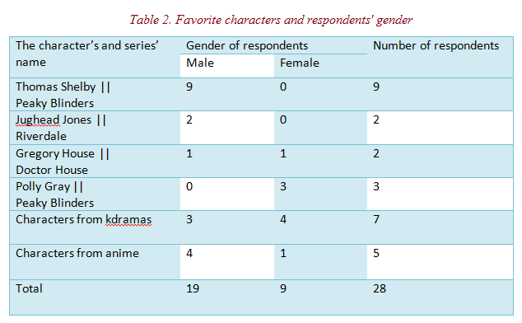
The results shown in the table above shows modern teens’ role models from serials. There are some key points from these questions’ responses and interviews that we need to disaggregate:
- According to psychologists, teenagers prefer to choose their favorite character of the same gender as themselves. They think that by identifying themselves with the characters of series with which a person has a certain measure of similarity, they are imbued with sympathy for them to such an extent that they allow themselves to include another in their own “I” (Appendix 2). Therefore, as it was shown in the table, there is an imitation of series characters.
- Mode: Thomas Shelby and Peaky Blinders. Despite the fact that this hero and this entire gang are protagonists and fight evil, they very often resort to violence, kill, show smoking and drinking alcohol, as something very aesthetic. It may mean that most of the males like such characters as Thomas and would not be against considering him as their role model.

The sample of the focus group discussion consisted of 6 Netflix binge-watchers aged 16-17. The results showed that:
- 4 out of 6(that is 67%) participants have tried alcohol and cigarettes more than a few times, and explained it by the fact that they were inspired by aesthetic scenes from the series(Sex Education, 13 Reasons Why, Riverdale) as well as the ideology of "living life to the extreme". There is a contradiction between interview with authority(Appendix 2), since unexpectedly, none of the participants had problems in the family or elsewhere. All were from prosperous families and were pleased with their surroundings.
- 5 out of 6(that is 83%) participants admitted that after watching the drama series they were depressed for a long period of time(from 1-2 weeks to 1-2 months).Because of empathy for the main character, as well as differences in the realities of the real world and the world on the other side of the screen.
- The same 5 participants admitted that they had some suicidal thoughts due to depression caused by watching series. However, they survived this period due to their environment and fairly stable psyche. They noted that without the support of their environment and a stable psyche, the result could be completely different. It correlates with the answers of psychologist(Appendix2) that believes that support from the surrounding people is the most effective tool in prevention of the deviant behavior.

Conclusion

This research was conducted in order to investigate the effect of watching Young Adult fiction drama series on character and the psyche of adolescents. The hypothesis was that watching such series negatively affect teenagers’ psyche and may lead to deviant behavior.
In response to each of the research questions it is possible to make the following conclusions:
- What effect does YA fiction drama series have on Kazakhstan teenagers?
Referring to the answers of the survey respondents, 54% agreed that watching drama series may lead to appearance of real life copycats and interviewed psychologists stated that the images from series are remembered for a long time, and may cause a desire among adolescents to repeat what they saw in the series. Such results were expected, as the study that was conducted by Jeffrey Bridge (2017) also revealed similar results that drama series (e.g. “13 Reasons Why”) can lead to Wherther’s effect that shows the link between the release of series and suicides rate among adolescents.
- How likely are teenagers to adopt either the bad or the good habits of the characters in the series?
Mitchell J(2018) in her study managed to show that repetition of violent scenes causes adolescents to fixate on aggression, which can contribute to the development of appropriate patterns of behavior. Interviewed psychologists also stated that there is a constant tendency to commit offences precisely due to imitation of screen heroes at teen age. Such an exact answer by psychologists was very unexpected, since I strived to find solid evidence of that while secondary research, so there had been a suspicion that they would struggle to answer. It can be concluded that the likelihood of adoption of characters' bad habits in the series by teenagers directly depends on their psychological state.
- To what extent is an average parent of an adolescent concerned about the content of YA fiction drama series?
83% of focus group interview participants admitted that their parents have no idea what their children are watching. It correlates with survey results, 84.7% of the respondents do not obey the age restrictions imposed on the series and nobody worries about it. These results were unexpected, since the secondary research suggested that parents think that television can lead adolescents to copy what they see on the screen(Hosmer, 2018). Even though the sample group is not that large and from a specific school, the reaction from the overwhelming majority of respondents does provide a good level of validity and generalisability.
As a result of this research it is possible to conclude that received results support the hypothesis, since secondary research suggested that drama series offered by streaming services may lead to real life copycats all over the world and this was reinforced by experts’ opinions and a survey. I am not particularly sure of my conclusions, since it was difficult to connect the high suicide statistics in the country with the negative effects of the series, and the main argument in all of this was the opinion of psychologists. However, I believe that this project will be useful to change people's opinion about the harmlessness of the drama series offered by streaming services.
Evaluation
Even though all the research aims were attained, I do not feel strongly confident about my conclusions due to several reasons:
- There are several weaknesses of the survey. As I have mentioned before in methods section, survey results are not completely generalisable, as the sample group consisted of only NIS students, who spend most of their time studying and they may not know about the impact those series have on them. Furthermore, some questions were not constructed correctly, resulting in low validity. For instance, it was really hard to make conclusions from the agree/disagree question, as there were much more people who voted for the “neutral” option, also the correlation of the choice between agree/disagree was almost equal.
- The interview also had its drawbacks. Although the interviews were semi-structured and provided an opportunity to ask clarifying questions, they were conducted remotely, that’s why there was a risk of misunderstanding of questions by interviewees. Also during the interview, it was noticeable that psychologists felt uncomfortable in answering questions regarding frank themes that could lead to the omission of some important details. However, this method was the most reliable and valuable, since the interviews with authorities covered all research questions and provided detailed answers to them. Also, as the interview was semi-structured, there was an opportunity for the investigator to bring up new issues that may be relevant to the study which arises during the discussion with psychologists.
- There were some drawbacks of the focus group interview. Due to the need to listen to each of the participants in the interview, I had to reduce the number of questions, so the information content of the answers decreased. Also, as in the case of interviews with psychologists, some of the participants were reluctant to share some of the innermost details of their lives. Moreover, the interviewees I selected might have some preconceptions related to the topic, which could reduce the credibility of the obtained results. It was, however, not as informative as was expected and did not provide the deeper information that was hoped for.

All methods were useful in obtaining answers to research questions and the research design can be considered as relatively effective. An additional survey with parents would, however, have provided a much better conclusion to research question 3. The results complemented each other by comparing the quantitative data received from the survey with qualitative information from two types of interviews. The answers from the interview explained the statistics obtained from the polls, and in some places, on the contrary, the statistics obtained from the survey helped for further discussion based on them that positively affects the triangulation of methods.

Further Research

In order to improve the existing work, I need firstly to change one research method: focus group discussion, since this method did not provide much new information that the survey did not reveal. To get more helpful information and make the project more productive and efficient I could have done social experiment instead. For instance, it could be an extensive experiment where people’s behaviour is monitored, over a long time, before and after watching a particular series, in order to identify changes in behaviour. Even though this method has some drawbacks, such as bias of participants and inability to reach a large sample group, my conclusions would be more valid and based on more concrete evidence results.

Although there wasn’t really any unexpected results, the following further research questions should be considered:
- How does coverage of crime-related topics in media affect the emergence of real copycats?
- How to help teens that have come under the negative influence of TV shows?
My own perspectives have not changed much, I just realized that such cases are rare and mainly appear when combined with other mix of problems.
I would like to expand my sample group to get more generalisable data. Also, I thought about investigating new website or special groups in social medias devoted to the subject I am studying. The purpose of such investigation is creating a good platform for communication and observation of the sample group I need. Also, such product can help to provide large and more public discussions and also provide more honest responses, as it is almost anonymous. This will help to better understand the problem and get more information about its relevance and scope throughout the whole Kazakhstan.

Bibliography:
- Bridge, J. 2017. NIMH » Release Of “13 Reasons Why” Associated With Increase In Youth Suicide Rates. [online] Nimh.nih.gov. Available at: <https://www.nimh.nih.gov/news/science-news/2019/release-of-13-reasons-why-associated-with-increase-in-youth-suicide-rates.shtml> [Accessed 8 May 2020].
- Bukanova, Z., 2014. Kazakhstan And Turkey Show Highest Suicide Rates Among 15-19 Y.O. Youth. [online] Главные новости Казахстана - Tengrinews.kz. Available at: <https://en.tengrinews.kz/health/kazakhstan-and-turkey-show-highest-suicide-rates-among-15-19-256369/> [Accessed 8 May 2020].
- Foster, J., 2019. Specialists Seek To Ban 13 Reasons Why. [online] Familyzone.com. Available at: <https://www.familyzone.com/anz/families/blog/13-reasons-why> [Accessed 8 May 2020].
- How Media Impacts Youth and Children - The Disturbing Facts. (2018). [online] Available at: <https://www.thecabinchiangmai.com/blog/how-media-impacts-youth-and-children/> [Accessed 8 May 2020]
- Maken, B., 2016. 33 Тысячи Случаев Беременности Среди Подростков Зарегистрировано В Казахстане За 5 Лет - Депутат. [online] Главные новости Казахстана - Tengrinews.kz. Available at: <https://tengrinews.kz/kazakhstan_news/33-tyisyachi-sluchaev-beremennosti-sredi-podrostkov-295592/> [Accessed 8 May 2020].
- Mitchell, J. and Prinstein, E., 2019. Treatment of Disorders in Childhood and Adolescence, Fourth Edition. Chapel Hill: The Guilford Press, p.372. [Accessed 8 May 2020].
- Niederkrotenthaler, T. and Stack, S., 2017. Media And Suicide. London: Transaction Publishers, p.270. [Accessed 8 May 2020].
- Rakhmanberdiev, E., 2020. Казахстан Занимает Третье Место В Мире По Количеству Самоубийств - Новости Казахстана И Мира На Сегодня. [online] Новости Казахстана и мира на сегодня. Available at: <https://24.kz/ru/news/social/item/346068-kazakhstan-zanimaet-trete-mesto-v-mire-po-kolichestvu-samoubijstv> [Accessed 8 May 2020].
- Romer, D., 2019. Did Netflix’S 13 Reasons Why Really Increase Suicide Rates?. [online] New Scientist. Available at: <https://www.newscientist.com/article/2201621-did-netflixs-13-reasons-why-really-increase-suicide-rates/> [Accessed 8 May 2020].
- Telebarisov, M., 2011. Refworld | Kazakstan: Concerns Over Adolescent Suicides. [online] Refworld. Available at: <https://www.refworld.org/cgi-bin/texis/vtx/rwmain?page=search&docid=4da7ebfa15&skip=0&query=raisa%20sher%20&coi=KAZ> [Accessed 8 May 2020].
- WHO, 2014. Preventing Suicide A Global Imperative. [online] Apps.who.int. Available at: <https://apps.who.int/iris/bitstream/handle/10665/131056/9789241564779_eng.pdf> [Accessed 8 May 2020].

Appendices:
Appendix 1: Survey:
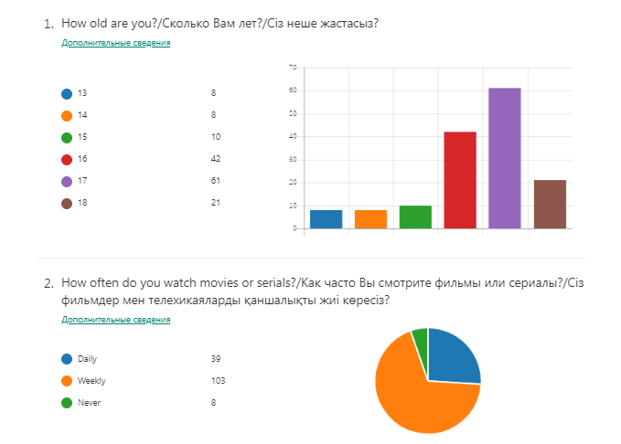
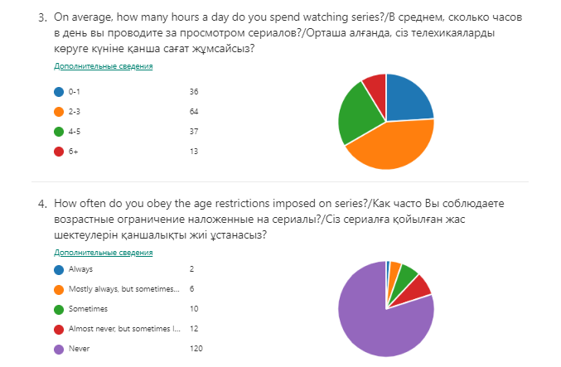
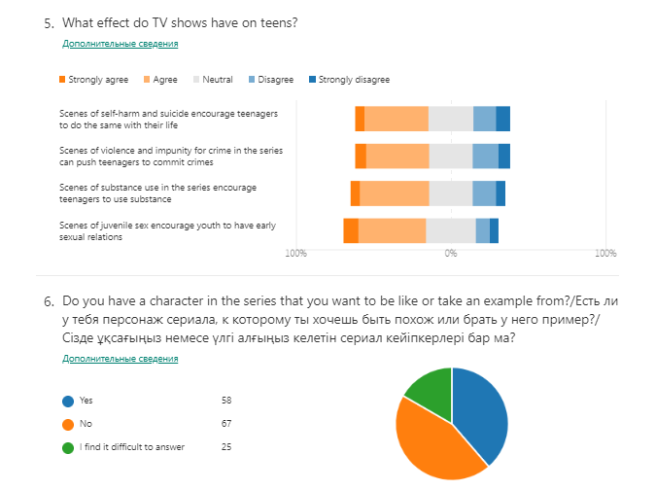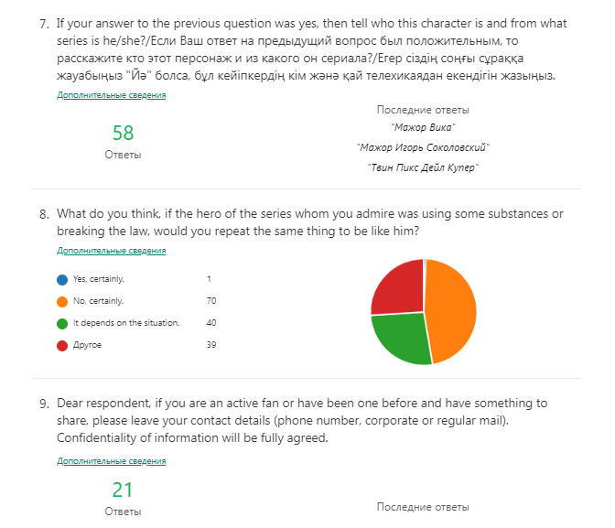

Appendix 2: Semi-Structured Interview Questions:
- What do you know about the factors that cause rebellious behavior of adolescents? What about the ones that lead to substance abuse, breaking the law and committing suicide?
- Why do teens not comply with age restrictions when watching series?
- What do you know about the negative effect that serials have on teenagers?
- Are the serials able to push or call for such offences(substance abuse, law violation)?
- Why are teenagers inclined to desire to be like their idols?
- Why do they repeat even the most terrible character traits?(like alcohol, drug, cigarettes use)
- How likely are teenagers to adopt either the bad or the good habits of the characters in the series?
- To what extent are the average parents of young people aware and/or concerned about such possible issues?
- Do they mature at all about the potential dangers of serials?
- What can they do to prevent such phenomena?
Appendix 3: Focus Group Interview Questions:
- How many years have you been watching serials?
- What are your preferences for the series? Do you comply with the age limits imposed on them?
- Compared to yourself in the past, after watching all these series, in which direction have you changed? Is there a role for the series?
- How do you thing, how likely are you to adopt either the bad or the good habits of the characters in the series?
- Was it that you did something bad or illegal after you saw it on the show?
- Have your parents noticed a change in your behavior, if so, what have they done?
- Summing up all your experience and this reasoning, do you agree that TV shows can be the cause of a teenage crime? For example, the use of substances and so on.

