Nazarbaev intellectual school, oskemen
How tourism affects the environment?
Zheniskhanova Yerkezhan 11b

Word count: 3799

How tourism affect the environment?
Introduction:
Tourism is the world’s largest industry which is gradually increasing nowadays. This topic is interesting for me, because environment of my country worries me and I like visiting different nature-rich recreation centers of Kazakhstan. The most attended countries are Maldives, Seychelles, European countries. Also Kazakhstan is one of the countries that faced to rapid growth of tourism. So, in this case the question arises: Is it true that tourism has any bad effects on environment and will ecology of our country become worse after rise of tourism?
I am biased about the fact that tourism affects the environment. I think that large tourism can lead to bad consequences and change local climate. Pollution occurs in water as well as on the land. Also tourism leads to degradation of underwater life. Flora and fauna of marine life is shortening every month. Tourism industry is overusing water to hotels, swimming pools and other entertaining activities. Often wastewater from that stuff goes straight to seas and oceans. According to increase of tourists, amount of transport also rise and it cause pollution of atmosphere. Harmful gases lead to Global warming and Acid rains. Moreover, to build touristic accommodations, camps, recreation centers they have to cut forests, disturb animals and their habitat.
I will compare different data to make conclusion and suggest way of solving that problems. In this research I will try to find answers to questions like: How tourists affect on appearance of environmental problems? Is it important to develop tourism if it has bad influence to the environment?
Context:
Tourism may be competitive industry that requires the capacity to adjust continually to customers’ changing needs and wants, as the customer’s fulfillment, security and delight are especially the center of tourism businesses. (2019 go2 Tourism HR Society)
If consider this problem from a Global perspective, tourism has bad influence on ecology and environment. Worldwide tourism is closely connected to climate alter. Tourism includes the development of individuals from their homes to other goals and accounts for around 50% of activity developments; quickly growing discuss activity contributes approximately 2.5% of the generation of CO2. Tourism is in this way a critical supporter to the expanding concentrations of nursery gasses within the environment. (Source: Mountain Forum) The number of widespread voyagers is expected to expand from 594 million in 1996 to 1.6 billion by 2020, counting massively to the issue unless steps are taken to decrease surges (Source: WWF) (Source: United Nations Environment Programme (UNEP), 2001)Kazakhstan may be a special locale within the world since of its history, geological position, and measure. Being the world’s 9th largest nation and found within the center of Eurasia, it is additionally the biggest landlocked nation within the world. These components have brought around inside the country's particular climate and nature, which show up to acclimatize the brightest cases of the scene of both landmasses. (2016 VisitKazakhstan.kz)
Nowadays, Kazakhstan is being listed as the country with developed tourism, but this also has downside, since the influx of tourists adversely affects the environment. 15 thousand foreign tourists visited Kazakhstan in 6 months( Tengrinews.kz, 2014). The volume of natural contamination in Kazakhstan developed by 4% in 2016, Kazpravda.kz reports citing an examination conducted by Ranking.kz. "After 3 a long time of decrease, the sum of poison outflows into the air within the Republic of Kazakhstan expanded again, and in 2016 the entire volume of outflows was 2.3 million tons, 4.2% more than in 2015. This development has for all intents and purposes neutralized the endeavors of the state and commerce to diminish the level of natural contamination accomplished within the past three a long time. From 2013 to 2015, the volume of hurtful outflows into the climate diminished by 8.6%," the study notes.
In 2011, the volume of inbound tourism, according to the Statistics Agency of Kazakhstan, was 5.7 million people. It should be noted that this number over the past few years has been stable, ranging between 4-5 million people.
Kazakhstan too incorporates a wealthy culture and history, from otherworldly pioneers to artisans and entertainers. Nearby present day concert lobbies and international-level entertainers are conventional artists, keeping lively eras of melodies and sonnets. Connected expressions are still well known for beautifying houses and yurts, whereas exhibition halls hold a few of the finest cases of workmanship by Kazakh artists. Kazakh wanderers have continuously lived in agreement with nature, so the numerous normal sights are imperative in Kazakhstan. From antiquated days, when individuals were taking off drawings on the rocks in Tamgaly, to the cutting edge day, where there are endless nature saves over the nation. Whether you need to head out on a brief climb, a fast excursion, or a longer journey through the mountains or steppes, there’s no deficiency of wonderful places. ((https://www.advantour.com/kazakhstan/tourism.htm), n.d.)
The social impact of tourism, however, extends far beyond it. Improving the living conditions of the local population, increasing employment and income, improving the status of women and disadvantaged social groups and overall poverty reduction are some of the areas that fall within the scope of the social impact of tourism.
Economicly, it has positive effect. The 2017 Financial Affect Report by the World Travel & Tourism Board shows that the industry creates one out of 10 employments around the world, developing at a pace that beats business within the worldwide economy for the 6th sequential year. The report moreover demonstrates that among modern employments, the segment accounts for one in five.
The social and cultural impacts of tourism can result in changes to plans of conduct, way of life and the quality of life of the inhabitants or neighborhood people. Tourism, like all commerce meanders, can have an impact on communities and may be positive or negative, and in a few cases both.
For 10 months of 2018, Katon-Karagay state national natural Park was visited by 3699 people, 213 of them are non-residents. In recent years, the area is actively developing cultural and educational tourism.According to the reserve "Berel mounds" more than 10,000 people visited the reserve-Museum "Berel" and the glass Sarcophagus. (http://www.br.katonkaragai.kz/ru/, n.d.)
Aim:
Research aim- to recognize ecological affect of tourism and try to identify how development of tourism in Kazakhstan can impact on environment. I think that crowd of people lead to climate change in a particular areas and I am afraid of future of my country. Environment can suffer from big amount of tourists and citizens are to live in bad ecological conditions. Identify which tourism is more popular and why?(ecotourism or site tourism)
Research questions:
Is ecotourism is more popular or site tourism?
How tourists affect on appearance of environmental problems?
What should touristic organizations do in order to save our ecology in good conditions?
Is it important to develop tourism if it has bad influence to the environment?
Which part of Kazakhstan can face with ecological issues?
Based on this my hypothesis is think that future ecological issues of Kazakhstan can be caused by tourism. I think that my research will be helpful for society and to clarify solutions. I think that ecotourism is less developed in our country, even if we have all chances to develop them.
To do primary research I will use anonymous survey. Answers which I get from this survey I will use to make some statistics which describe amount of people who visit nature and clean after themselves and people who do not. After this I will compare that information with statistics of other countries and count our chances to have clean environment. Also to get more full information in primary research time I can go to any touristic places in my city and get answers for my questions from workers and people who face with this every day.
Finally, I believe that this research proves that nowadays ecotourism is more needed and actual.

Method section:
Mixed method were used to collect information to this research. Investigate point- to recognize environmental influence of tourism and attempt to identify how improvement of tourism in Kazakhstan can effect on environment. I have used anonymous survey, interview from 3 people and made a focus group discussion with students and teachers of our school who travels a lot.

In primary research, I used anonymous survey. Answers, which I got from this survey, I used to make some statistics and make quantitative data, which described amount of people who visit nature and clean after themselves and people who do not. 120 people answered for my questions and they were my sample, while my population was tourists, touristic organizations and their workers, also ecologists and people who are knowledgeable in this sphere.

According to the results of survey, I could create questions for interview. I have taken an interview from three people (sample): worker of touristic organization in East Kazakhstan region, person who travels frequently and one of ecologists of our city. Population of interview was tourists, touristic organizations and their workers, also ecologists and people who are knowledgeable in this sphere likewise in survey. From worker of organization and tourist I got qualitative data, because they shared their own experience and answered for my questions due to real human actions on vacation. While ecologist answered me about significant changes in environment, that caused by tourism. Quantitative data, which gathered that from interview, helped me to make statistics that descried ecology before and after tourism started developing in East Kazakhstan.

The last type of method was a focus group discussion. I have chosen this type of method to answer last research questions. I organized a meeting of people, who visit different touristic places each season. My sample consisted of four people that visited a lot of recreation center. While discussing I have collected data that can explain “which season are less ecologically harmful?” and “which season is more popular to visit?”. This information helped me to identify seasons, when our country suffers from tourists and estimate chances of Kazakhstan to keep environment clean. All participants expressed their point of view about this problem. When I listened different ideas about tourism and different answers to question “Should we develop tourism in our country despite that it harms ecology?” made me think about pros and cons of tourism and draw conclusions only after thinking hard.

Tools for survey: Do you think it is important to develop tourism in Kazakhstan? Do you know that development of tourism have negative impact on ecology? How often you visit nature or some touristic places. Do you clean after visiting nature or camping? Can we prevent our country from damaging of environment? Which kind of wastes do you often face to?
Tools for interview: How often do you travel or visit nature? Have you ever visited touristic places in Kazakhstan? How do you rate ecological issue in Kazakhstan? What should tourism organizations do to keep our environment in good conditions? How do you think I is ecotourism is good alternative for tourism, which exists now? Is it important to develop tourism if it has a bad impact on the environment? What part of Kazakhstan may face environmental problems?
Tools of focus group discussion: How often do you travel? What do you know about bad influence of tourism to the environment? What parts of Kazakhstan are more faced to environmental problems caused by tourism? What do you think about Oskemen? Is our city suffering from tourism? What should tourism organizations do to keep our environment in good conditions? How do you think why ecotourism is not so popular in our country? What do you think how development of tourism in Kazakhstan will affect the ecology? Do we risk losing all the beauty of nature by developing tourism?

Results for survey
There are key findings from the survey: Fortunately, 90,63% of people clean up after themselves when they visit touristic places. After analyzing question “Do you think it is important to develop tourism in Kazakhstan?” it was clear that almost all people think that developing of tourism in Kazakhstan can have good effect on our economy. To question “Can we prevent our country from damaging of environment?” 81.25% of respondents answered that it is possible, while 18.75% think that our mentality don’t allow us to take care about ecology.
The majority (48%) of respondents rarely visit touristic places and nature. I believe that this is good for nature, because where there are few people there is less garbage.
“Do you think it is important to develop tourism in Kazakhstan? Explain your answer please.” To this question all people answered positively. All of them think that developing of tourism will have pleasant effect on our economy and amount of income will rise. Also they mentioned that we have great nature and a lot of sightseeing and our hospitable mentality can help us to develop this sphere.
Analyzing the answers of respondents aged from less than 18 to 54, it can be concluded that the vast majority know that tourism has negative influence on ecology. Also it can be seen that amount of people, who do not clean after themselves reduce by people become older and more mature. This tendency means that older generation, which understands importance of keeping Earth clean, should teach youths to be more neat. Additionally, the most spread type of wastes is trash near coastal areas, which made up 43 out of 123 (35%). It implies that people do not rest near beach correctly and they do not throw trash into waste bins.
Result for interview:
Respondents rate ecological issue in Kazakhstan approximately by 6-7 out of 10. I think that this means that Kazakhstan is quite a polluted country. Also they know and understand that tourism have negative impact on environment. They also mentioned that development of infrastructures lead to extra work of factories and to more pollution occurs.
Respondents know that tourism is one of the most profitable spheres of work. That is why they agree with the idea that development of tourism is important, but I realized that we also should try to reduce pollutions and move to ecotourism. Also respondents agreed that ecotourism could be a good alternative for tourism, which exists now.
As summer is the most popular season for tourism and beach tourism is widespread, it becomes clear that cities with hot climate are more at risk of environmental degradation. Also large and more popular cities attract more tourists and more pollution occurs there, respondents think that large amount of people will cause air pollution as amount of traffic increases.
Results for focus group discussion:
Even if my sample for focus group discussion travels rarely they were aware about this topic. They gave me interesting answers and some new ideas in the way of solving main problem of my research. They mentioned that largest cities of our country like Almaty, Nur-Sultan and Kokshetau are more likely to have environmental problems, because they are popular among tourists. While East Kazakhstan region seems to face with environmental problems caused by tourism less than other cities, because tourism is not very developed in our hometown.
Conclusion:
In response to each of the research questions it is possible to make the following conclusions:
Is ecotourism is more popular or site tourism?
Unfortunately, in Kazakhstan ecotourism is not so popular, it is due to people do not think about their actions. Nonetheless I think that our country has all chances to develop ecotourism, because we have greatest nature and the main thing to do is to change people’s behavior. I believe that, if we will teach our children to take care of nature and explain the importance of preserving the environment, then in the future they will be able to develop ecotourism in the country.

How tourists affect on appearance of environmental problems?
Firstly, to build all of touristic facilities a lot of forests cut down, that is large change of ecosystem, also to make all materials for construction a lot of factories are working and emitting gases into the atmosphere. Secondly, transports by which tourists travel also makes air pollution. In big cities local residents have to face with noise pollution, because of different entertainments for tourists (bars, crowded streets, night clubs, restaurants, main squares etc.). And the main problem, which occurs because of tourism, is the land pollution. Tourists often do not care about ecology; they simply do not clean after themselves after camping, throw thrash anywhere they want.

What should touristic organizations do in order to save our ecology in good conditions?
Touristic organizations and government should fix the law on nature security and increase the fine for causing hurt to environment, limit the number of visitors that will come, government ought to apportion money to protect touristic places and to reconstruct and clean them, and organizations must draw up the rules for the behavior of people in touristic places.

Is it important to develop tourism if it has bad influence to the environment?
Despite that tourism has a lot of bad consequences we should develop tourism. The reason for this is that tourism is one of the one profitable spheres and in order t reduce amount of pollutions we should develop ecotourism. I believe that ecotourism is the most suitable solve of this issue.

Which part of Kazakhstan can face with ecological issues?
It was concluded that the most vulnerable cities are Almaty and Nur-Sultan. These cities are the biggest ones of our country and that is why the mot attractive ones. They prone to have a lot of air, noise and land pollution, as many tourists want to see these cities (about 55 thousand people visit Almaty per year).

I made 3 methods to do this research and I noticed that all respondents have approximately similar responses. I detected that all of them think that development of tourism is important for economy of country, that ecotourism is the best way to reduce amount pollution. But as the quarantine was declared I could not take interview from specialists and create a focus group discussion with different people. As I planned in methods section interview from worker of touristic organization in East Kazakhstan region, person who travels frequently and one of ecologists of our city and focus group discussion with four people that visited a lot of recreation center. Even if my plans for methods section were failed I made 2 of my methods with people that I know and I think that ideas and answer they shared were valuable and useful for me. Also while conducting focus group discussion I faced with problem that as my respondents are at home and all of them have their household routine connection t the chat was not simultaneously, but I got all needed answers.
So, my hypothesis was correct, that in the future environment of Kazakhstan can suffer from tourism but we can solve it now if we will act correctly and move to ecotourism. After working on context section and gathering a lot of information my bias confirmed, tourism really can lead to bad consequences and ecology suffers from it.
Evaluation:
- The first survey method was conducted to answer the some research questions, like How tourists affect on appearance of environmental problems? What should touristic organizations do in order to save our ecology in good conditions? Is it important to develop tourism if it has bad influence to the environment? In the survey, both multiple-choice and open-ended questions were compiled, which contributed to obtaining complete answers to the questions asked. This method helped in an anonymous way to find out the precise opinions of independent respondents as they were not biased regarding their attitude to this topic. Strong sides of my survey are that I conducted it among different aged group of people and could recognize how person’s opinion changes by years. Weak side of first method was that amount of respondents was less than wanted, I think that if number of respondents were bigger the results would be more reliable and I would get more ideas for open ended questions in survey.
- Unfortunately, I can’t say that my second and third methods covered perfectly. As we had quarantine and I could not contact to ecologist and worker of touristic organization to conduct an interview and invite them to focus group discussion. Even if my plans for methods segment were failed I made 2 of my methods with people that I know and I think that thoughts and answer they shared were profitable and useful for me. Moreover, while conducting focus group discussion I confronted with issue that my respondents are at home and all of them have their household routine, because of that the chat connection was not at the same time, but I got all required answers. I tried to make triangulation, I used information that I get from survey to construct questions for interview and after interview I went back to my research aim and questions and thought up on questions that we should discuss.
- While writing the survey results, I had to generalize the answer and output the average responses, but when I did the cross-tabulation, I looked at the responses of each Respondent and entered the answer in the table. Thus, I can say that the conclusions I made are fairly generalized. But I think that my sample interview and focus group discussion was not different aged people and their answers have to be similar.

Further research:
My research was about negative impact of tourism to the environment and I think that this topic is relevant today, because nowadays all people like traveling and going out to the nature. My research is helpful to recognize real consequences of tourism and how we can prevent all those ecological problems.
In order to improve the existing work I think that I should to change focus group discussion to observation, in order to see how people actually behave. As results of interview and focus group discussion were roughly similar I guess that people can lie that they clean after themselves. Also in further research I should find contacts of experts and plan our meeting for interview much earlier, because expert opinion is very important for any research. There were no unexpected results and answers, my hypothesis proved and biased opinion did not change.
While writing conclusion I understood that in major case this problem related to person’s behavior. That is why I want to add to further research some investigations about how we should nurture our children in order to explain them importance of saving the Earth cleanl
References
https://traveltips.usatoday.com/positive-negative-effects-tourism-63336.html
https://www.advantour.com/kazakhstan/tourism.htm
http://www.br.katonkaragai.kz/ru/
https://www.linkedin.com/pulse/positive-negative-effects-tourism-social-cultural-prince-mdusman
https://www.go2hr.ca/getting-know-bcs-tourism-industry/what-is-tourism
https://www.gdrc.org/uem/eco-tour/envi/two.html
https://visitkazakhstan.kz/en/about
https://en.tengrinews.kz/environment/kazakhstan-to-develop-its-tourism-industry-254241/

Appendices:
Q1
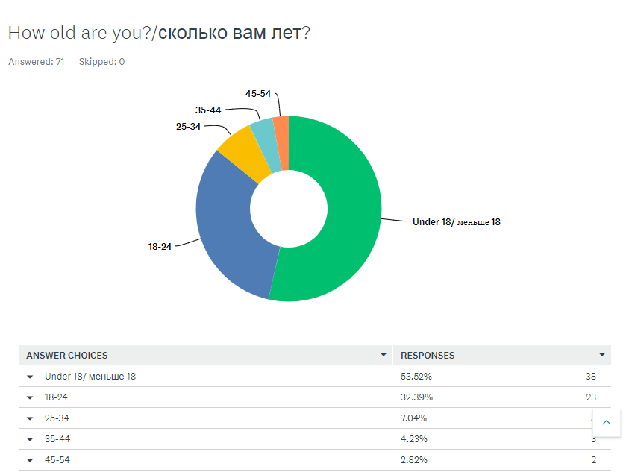
Q2

Q3
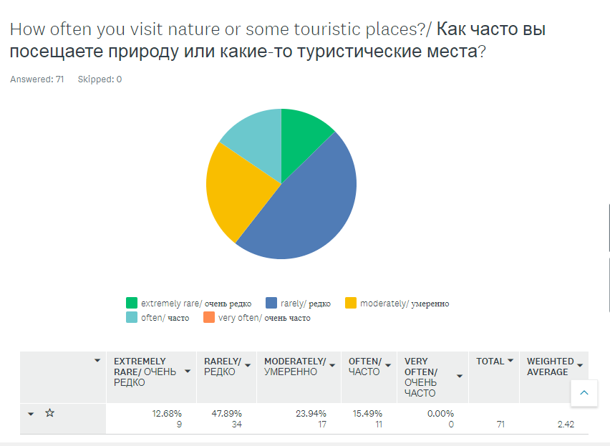
Q4
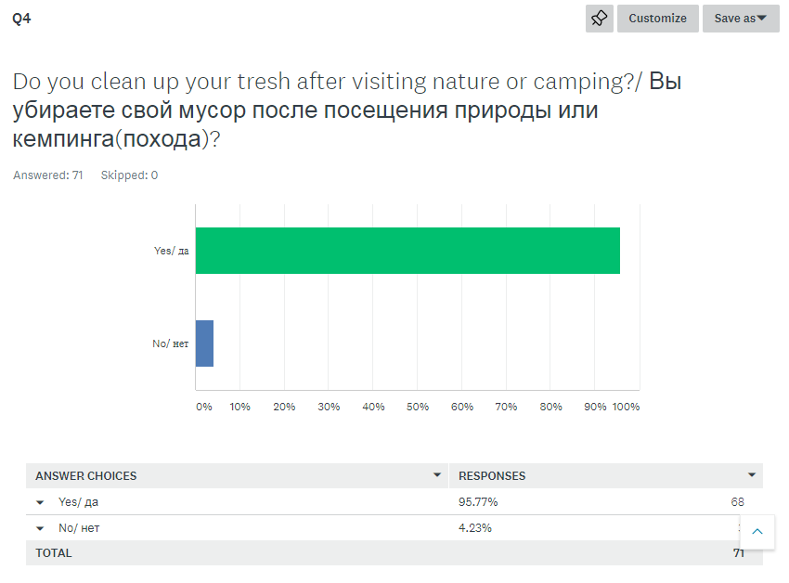

Q5

Q6
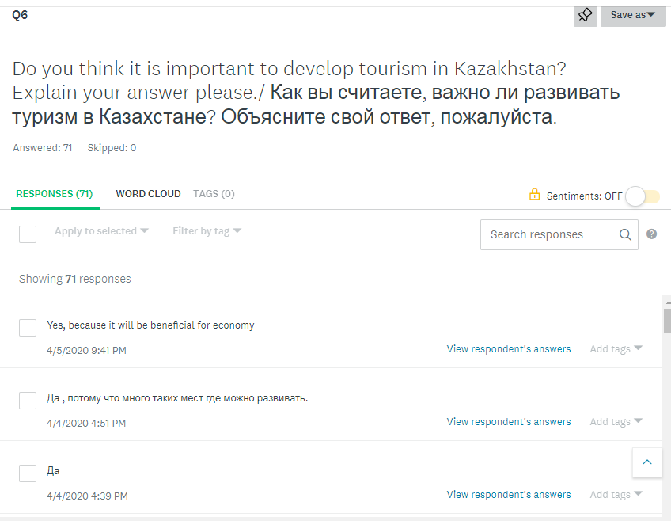

Q7
Q8

First respondent (interview):
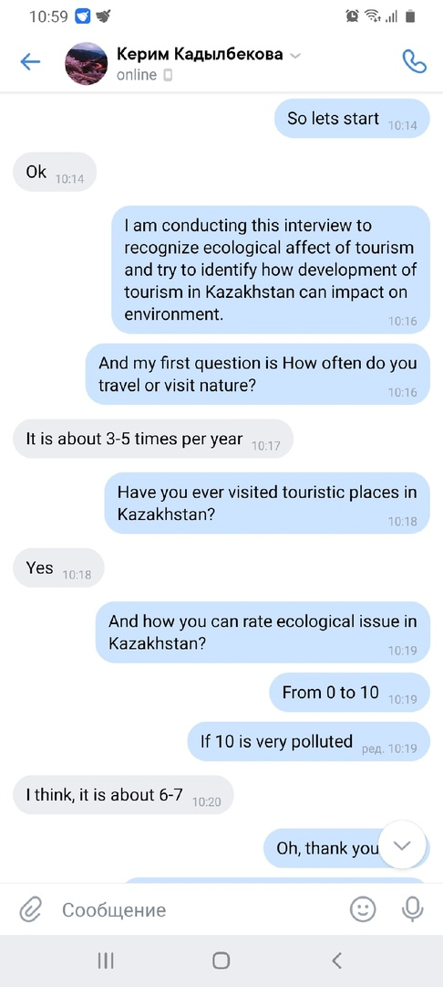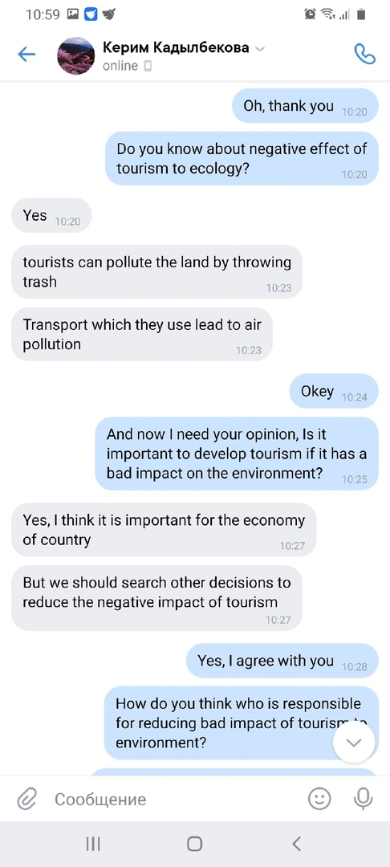
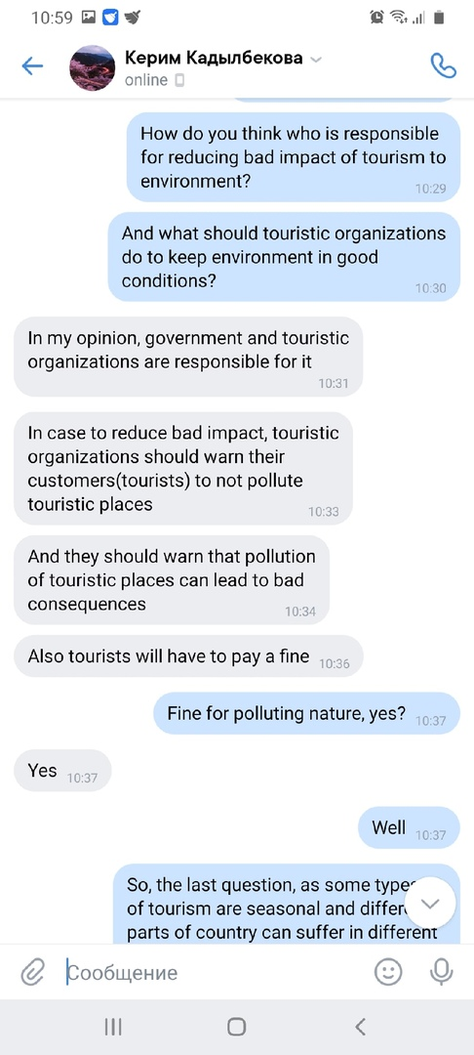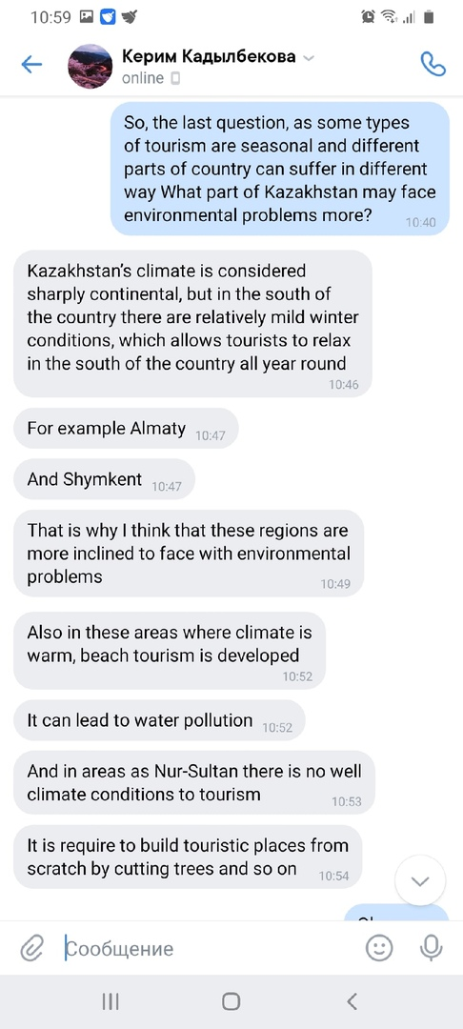
Second respondent (interview):
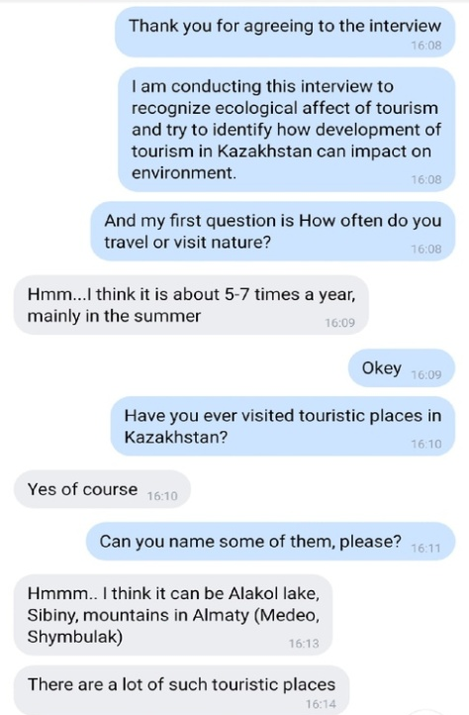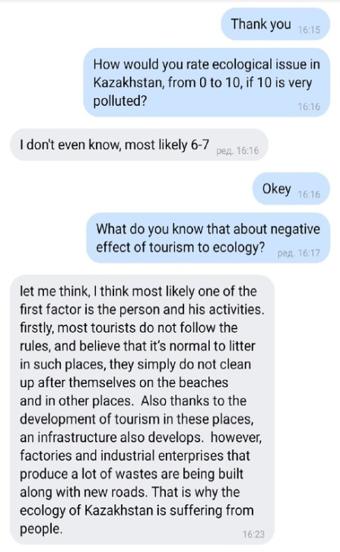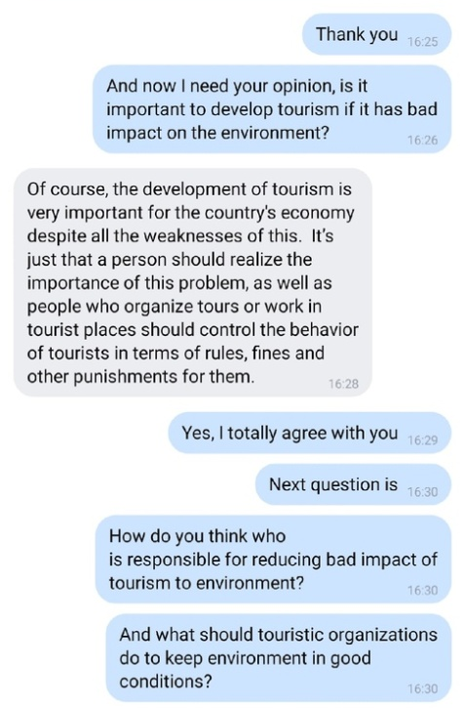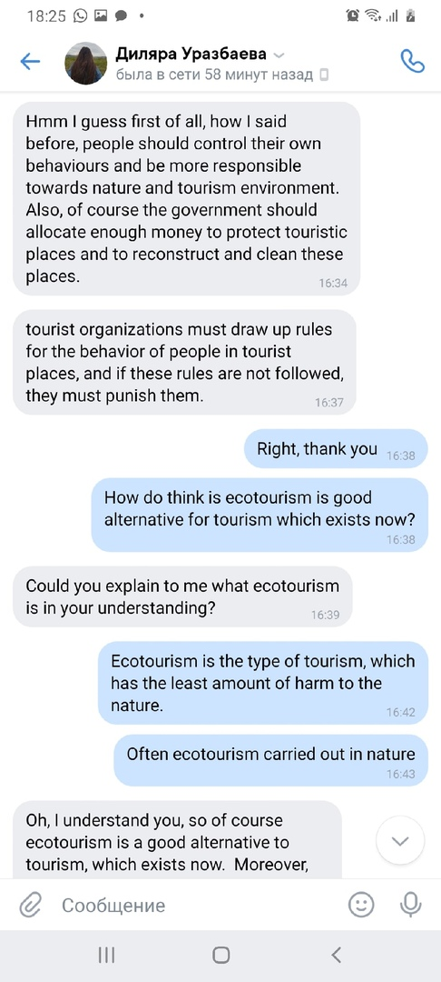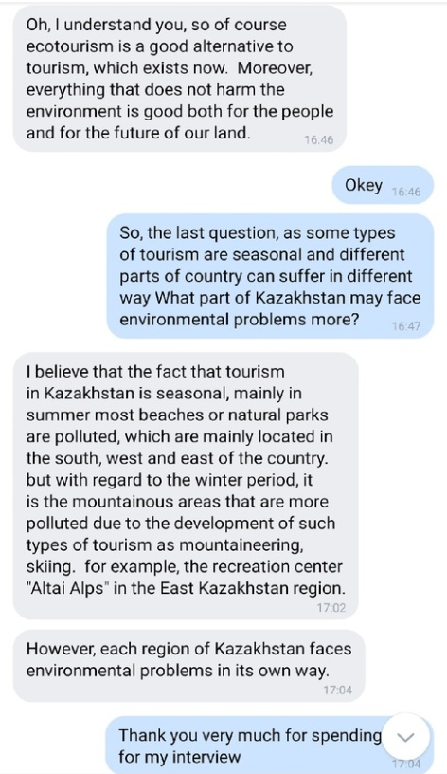

Focus Group discussion:
