"The impact of the "Zeigarnik effect" on education"
To what degree does "Zeigarnik effect" influence teenagers' productivity at school?
Altynkhan Yerkezhan, 11 "A"
Nazarbayev Intellectual School Oskemen

Word Count: 3462

"The impact of the "Zeigarnik effect" on education"
To what degree does "Zeigarnik effect" influence teenagers' productivity at school?
Introduction
Memory is a vital aspect of human life. Memory is a record of your personal experience. It is a record of trial and error, defeat and success. Past failures will warn you against repeating them (Wilfred Peterson, "Success"). In other words, remembrance is a natural ability to store, save, and afterwards recall data and past experiences in the human brain. There is even a whole field of psychology, which is called cognitive neuroscience.

It is interesting to mention, Russian psychologist Bluma Zeigarnik noticed that a waiter had better recollections of still unpaid orders. However, after everyone had paid, he was unable to remember any more details of the orders. Thus, the Zeigarnik effect suggests that students who suspend their study to perform unrelated activities (such as studying a different subject/ playing a game)-, have a tendency to remember material better than students who complete study sessions without a break.

Since teenage students are overloaded with various responsibilities and obligations, such as preparing and taking final exams, choosing a future career, it was obvious to detect major stress-related issues caused by the overwhelming education process. The most affected aspect of teenagers' psychology is a memory. I was motivated to investigate how scholar teaching and learning methods influence the correlation between significant short-term memory loss and young adults' cognitive skills because, as a student, I fear that memory-related problems will affect my academic performance as well as other students' too.

It may seem bias that the current education system negatively affects young adults' memorizing skills since I firmly believe that a scholar curriculum could be improved by perceiving Zeigarnik effect as an efficient learning strategy.

By conducting the research, a specific correlation between Zeigarnik effect and academic performance will be acknowledged, thus it will be favourable for both, teachers and students. Indeed, further investigation can encourage teenage learners to discover new perspectives about learning whilst educators can identify the strengths and weaknesses of students' learning strategies.

Context

The Zeigarnik effect was named after its founder, Russian psychiatrist and psychologist Bluma Wulfovna Zeigarnik. The effect is a psychological phenomenon describing a tendency to remember interrupted or incomplete tasks or events more easily than tasks that have been completed (Bluma Zeigarnik, 1927).

Nowadays common applications of the concept include:
- Generating effective news headlines or teasers;
- Creating attention-grabbing trailers in the film industry;
- Using cliffhangers in the production of serialized books or TV shows;
- Designing multiple and interrelated quests in the gaming industry;
- Creating click-inducing advertisements to promote online sales.

Therefore, the Zeigarnik effect is strongly connected to cognition, which has an important role in human life. Dr Pascal Michelon (2006) explains that "cognitive abilities are brain-based skills we need to carry out any task from the simplest to the most complex. They have more to do with the mechanisms of how we learn, remember, problem-solve, and pay attention, rather than with any actual knowledge".

The main brain functions involved in cognition are these:
- Perception (recognition and interpretation of sensory stimuli),
- Attention (ability to sustain concentration on a particular object, action, or thought),
- Motor skills (capacity to mobilize our muscles and bodies, and manipulate objects),
- Language (translation of sounds into words and the generation into verbal output),
- Visual and spatial processing (perception of the spatial relationship between objects, and visualisation of images and scenarios),
- Executive functions (capability to plan, and execute a goal), and memory (Ulla Gain, 2019," Framework to categorize the cognitive functions").
- Memory is the power or process of reproducing or recalling what has been learned and retained especially through associative mechanisms (Definition, Merriam-Webster Dictionary). Memory problems can lead to forgetfulness.

What is forgetfulness then? Forgetfulness is outlined as a memory lapse or inability to recapture stored data in the brain. According to the research of "Alzheimer's Disease International" (2016), 131.5 million people will be living with moderate memory-loss conditions, such as dementia, by 2050 worldwide: 29.9 million from North and South Americas, 15.8 million from Africa and 18.6 million from Europe. It is interesting to note that Asian countries are showing the highest research outcomes (67.2 million civilians). Gary W. Small (2004) found an increase in the tendency of memory complaints across all adult age groups, including young adults between the ages of 18-39. Twenty per cent of 18,332 US representatives are prone to have memory complaints; this included 14% of young adults (ages 18-22), 22% of middle-aged adults (ages 40-59) and 26% of older adults (ages 60-99).

There are several reversible causes of minor memory loss and dementia-like symptoms. First of all, emotional distress can change the brain structures involved in memory. Executive editor of "Harvard Health Blog" Daniel Pendick (2013) explains that a high level of stress hormones over time can damage the hippocampus (associated with processing memory), thus hippocampus reduces its ability to recognise and form memories.

"Since teenage students are overloaded with various responsibilities and obligations, such as preparing and taking final exams, choosing a future career..."( Introduction, pg. 1), nowadays they are more likely to suffer from short-term memory lapses, associated with stress and anxiety. According to a survey, conducted on social stress by "Medium Magazine" collected a wide variety of opinions about the stresses of relationships formed as a student, voiced by the students of Prosper High School. The students voted and claimed the three central causes of social stress to be academic struggles, perfectionism, and over-scheduling. For example, a significant majority of NIS students confirm that the learning process is mainly inhibited by stress at school. Thus, the data they have learned does not last for a long period in their heads, which reduce the efficiency of learning and processing data.

In this case, modification of learning strategies tends to have an advantage of progressing memory. Regarding the data shown, the influence of the Zeigarnik effect on young adults' memory has a noticeable benefit. By designing study sessions with appropriate breaks involving unrelated activities, teenage students are more likely to experience intrusive thoughts about the topics they cover and may be better able to reflect on and consolidate these thoughts. Then, learners may be, therefore, motivated to set reasonable limits on the amount of multitasking they do, thereby increasing work performance while reducing cognitive overload and frustration.

Aims

Regarding the hypothesis, I firmly believe that the vast majority of the sample population will show a high-level of memory-related concerns. The primary purpose of the investigation is to find out to what point the Zeigarnik effect impact students' memory. Therefore, to achieve the research objective, the phenomenon should be proven in practice.

Thus, the following questions are as follows:
- How do teenagers perceive and self-asses their memorizing skills?
- How can we manage the Zeigarnik effect to improve students' memory?
- What are the pros and cons of integrating the phenomenon into the education system?

Methods

First, a survey named "Academic struggles and forgetfulness" was distributed via a programme "Survey Monkey". The questionnaire was anonymous. The research tool was applied to obtain specific information from the large proportion of the sample population. The survey contained eight questions. Seven of eight related to the theme: one of them gathers information about the age of responded. Moreover, the subjects of the study were students: they are more prone to suffer from social stress and anxiety at school. The total number of respondents was over 40 individuals of Grade 7-12 to maintain the reliability of the investigation. Yet, surveys perceive a minor disadvantage: questions that bear controversies may not be precisely answered by the interviewee. For this reason, the alternative data gathering method such as face-to-face interview is required.

To gather more detailed information about the Zeigarnik effect, the semi-structured interviews were conducted with individuals chosen precisely to maintain the outline of the significant points of 'academic amnesia' and efficiency of the Zeigarnik effect in a process. The interview consisted of 7 questions and was taken face-to-face from a psychologist from NIS with 10-year experience of working with mental health issues. Consequently, an individual with substantial expertise increases the credibility of the results. The second interview was needed to increase the credibility of the method results. The following discussion was recorded online by a social network "Discord" with a Psychology course student, who previously researched an issue of stress-related health concerns. Thus, it was useful to choose this person as a population-representative.

The interviewee answered to six related open-ended questions, besides for one regarding the working experience at NIS. The pro of online interviews was an opportunity for long-distance communication since the representative is living in Almaty: however, poor internet connection affected the quality of the research tool which can be acknowledged as a minor con. The semi-structured interview typically produces rich qualitative data. However, tet-a-tet interviews are the slowest method of data collection and analysis: thus, processing and generalising data could be demanding and stressful.

Due to the lack of information about the application of the phenomenon in real life, the overt-participant observation was prepared. The overall number of participants was sixteen 8-10 Grade students, who volunteered to participate in the investigation, divided into two groups of eight people. The first group of representatives has read a summary of the novel "The Lord of the Flies" with ten-minute pauses between each chapter, whilst the second team had no breaks at all. At the end of the investigation, all students took a 5-question test to evaluate the ability of data recall. Moreover, the advantage of overt-participant observation is the flexibility of the research technique: researcher can follow up with different directions and ideas if something unusual occurs. Then, this is the most ethical form of observation, as it requires no deception and participants can give their informed consent. However, due to the unstructured format, the research method is very time-consuming.

The information taken from the questionnaire, interviews, and participant observation has been analyzed, and it has given the following results.

Results

The information taken from the questionnaire, interviews, and participant observation has been analyzed, and it has given the following results.

There are three bar charts given here, representing the survey question summaries. The conclusions drawn are as follows:

Regarding the graph (Graph 1), the total number of respondents was 40 individuals of Grade 7-12 between age 12 and 19. The percentage of students, between age 15 and 16, was just above half of the research population (55%), showing the highest peak among respondents. Moreover, students of age 12-14 are the minor group of the population with 17.5% responded.

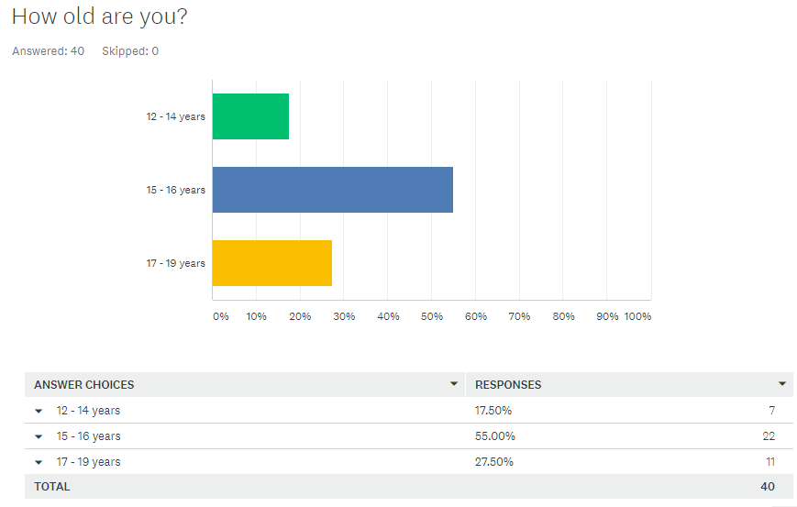
Graph 1 ('Students' age' graph)

The second graph (Graph 2) underlines the answer to the research question "How do teenagers perceive and self-asses their memorizing skills?". Turning to the details, 52.5% of learners, participated in the study, tend to be content with their memory: 35% - "Satisfied", 12.5% - "Quite good", 5% - "Excellent".

However, a significant part of the research subjects showed concern with their cognitive skills. To be more precise, the percentage of students, who rated their memory as below-average level, was overall 47.5% (2.5% - "poor", 20% - "It could be better", 25% - "Not Bad").

Yet, the average rating is shown to be "Satisfied", demonstrating the approximate equilibrium of the results collected (52.5% "satisfied" and 47.5% "dissatisfied").
The table (Table 1) illustrates the parallel between age and academic stress. The data analysis is as follows:

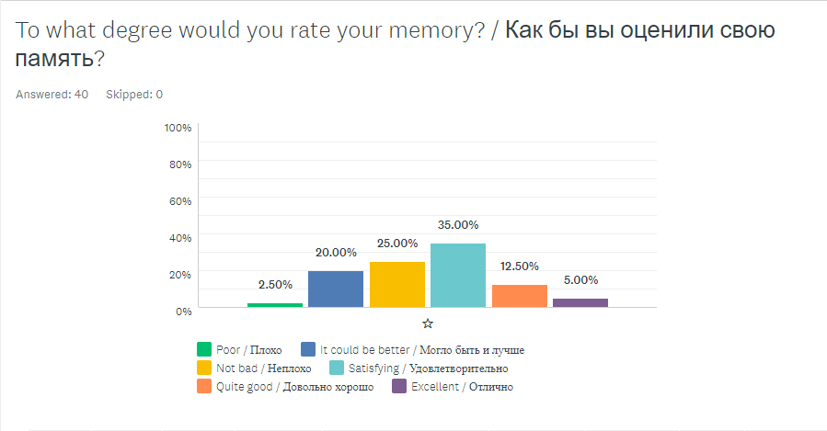
Image 2 ('Students' memory scale' graph)

It is clear from the data that older students tend to suffer from academic stress more relative to younger learners. To be more -precise, there was 22.5% of respondents who tend to have stress-related forgetfulness due to "Test anxiety": those respondents were young adults of age 17-19. And, 20% of the study subjects having troubles with "Study-overload" were a part of the older study group (15-19 YEARS). In the other hand, the percentage of 12-14-year-olds participated in the investigation was 17.5%: 75% of them faced "Test anxiety", 2.5% - "Study overload".

In the final survey analysis, the results of the investigation indicate the moderate level of stress-related forgetfulness among young adults regarding advanced study programmes and exam preparations.

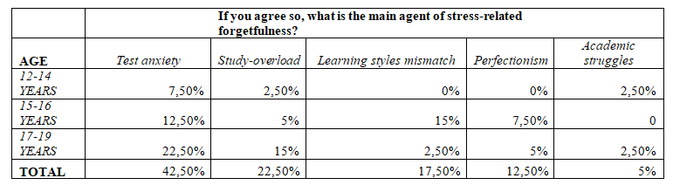
Table 1 ('The parallel between age and academic stress' table)

The interview and overt-participant observation outcomes underline the answers to 2 research questions: "How can we manage the Zeigarnik effect to improve students' memory?" and "What are the pros and cons of integrating the phenomenon into the education system?"
The conclusions are drawn, elaborating qualitative data analysis from the interviews, as follows:

- "Since teenage students are overloaded with various responsibilities and obligations, such as preparing and taking final exams, choosing a future career..."( Introduction, pg. 1), nowadays they are more likely to suffer from short-term memory lapses, associated with stress and anxiety (Context, pg 2). At this point, the vast majority of respondents confirmed the fact that stress inhibits memory. Yet, the responded college student claimed that teenage learners are less prone to stress and anxiety relative to adults: they tend to be more flexible and energetic, both psychologically and physically.

- Regarding stress-related forgetfulness, the school psychologist considered the fact that the Zeigarnik effect might be suitable to improve students' memory. Yet, the phenomenon should be improved as well: several studies, attempting to replicate Zeigarnik's experiment, failed to find any significant differences in recall between "finished" and "unfinished" tasks (e.g. Van Bergen, 1968).

Moreover, the overt-participant observation results confirmed the effectiveness of the phenomenon. The outcomes are elaborated below:

It is clear from the graph that the vast majority of the research subjects who had no breaks between learning showed lower data recall efficiency. On the other hand, students who had ten-minute pauses in between reading tend to have higher scores rather than "no break" representatives.

Conclusion

In response to each of the research questions, it is possible to make the following conclusions

- How do teenagers perceive and self-asses their memorizing skills?

Regarding my hypothesis, the vast majority of the research population will prove frequent memory complaints. Therefore, students are prone to stress and anxiety, making them exposed to stress-induced issues (Context pg 2). The percentage of students, who rated their memory as below-average level, was overall 47.5% yet; the majority was content with their cognitive skills: 35% - "Satisfied", 12.5% - "Quite good", 5% - "Excellent". Finally, the average rating is shown to be "Satisfied".

- How can we manage the Zeigarnik effect to improve students' memory?

Nowadays common applications of the concept include:
- Generating effective news headlines or teasers;
- Creating attention-grabbing trailers in the film industry;
- Creating click-inducing advertisements to promote online sales.

Regarding the Results, the phenomenon could be sufficient for improving students' memory.
Learners should study with 10 to 15-minute breaks between study sessions to advance academic performance while teachers should provide more flexible schedules to maintain students' productivity level.

- What are the pros and cons of integrating the phenomenon into the education system?

The advantage of the Zeigarnik effect is that it is useful yet simple. The respondents confirmed the sufficiency of the phenomenon they tried at home. However, the practical use of it at school environment might be arduous. Surprisingly, several studies failed to replicate Zeigarnik's experiment: teachers don't have extra time for breaks, which is the major disadvantage.

In the final analysis, students don't have serious concerns with memory. Some of them confirmed they need improvement of their cognitive skills: the phenomenon could be sufficient.
In the final analysis, students don't have serious concerns with memory. Yet, some of them confirmed, they need improvement of their cognitive skills. In this case, the phenomenon could be sufficient: teachers and students should maintain short breaks between study sessions to improve productivity.

Evaluation
Therefore, the researcher questions are answered. Though, there are several points concerning the conclusions made:

The procedure of gathering and generalising information was both complicated and problematic. At first, it was arduous to find credible and relevant data on the Internet. The Context section contained data accumulated from various sources like online newspapers and healthcare magazines. Thus, it took an extra amount of time to determine the authenticity of the papers and to re-check the reliability of authors. For further investigation, I should use the RAVEN technique beforehand.

The method and conclusion sections have strengths and weaknesses. First, the strong side of the survey was in its vast population: larger sample sizes provide more accurate mean values and smaller margin of error. The conclusions presented based on the survey results were acceptable. Yet, there was a notable weakness which diminished the reliability of the research outcomes. The older survey representatives, students of age 17-19, were biased against the education system relative to the younger part of the group. Therefore, it would be better to expand the research population.

Moreover, the authority of the research representatives, specifically the interviewees, was questioned due to several reasons. The college student who participated in the investigation showed the lack of in-depth knowledge of psychology and sociology, which were their majors. The misconceptions arrived after the interview inhibited the process of generalising the data: it was arduous to find and then re-check information given by the representative.

On the other hand, the local professional psychologist showed no tendency to disinform, yet they were biased towards their workplace or NIS. In other words, they did not reveal any specific information about stress-related issues of students and confirmed that learners are not stressed at all. This opinion conceived a controversy between the survey and interview results. However, the vast majority of the conclusions were based on the interviews depending on their strong sides.

The strength of the research design was the experience of the psychologist. Thus the research methods were significantly improved: inaccurate and vague questions were deleted from the interview afterwards.
In the final analysis, the strengths and weaknesses were identified to improve the research in the future.
Further Research
Through the investigation, I have changed my perspective on education. I tended to be biased against the education system. Now I believe that students do not suffer from severe stress-related issues since my hypothesis was declined throughout the practical implication of the Zeigarnik effect. It was interesting to observe that young adults are less prone to memory complaints due to natural memory flexibility and mental energy. Finally, the implication of the project has improved to accommodate learners in academic purposes: people can use it to maintain high-level productivity at school.

The suggestions arrived out of the research project emerged then.
The research methods should be improved. First, the survey population contained 40 people from NIS curriculum, which was not enough to maintain the credibility of the investigation. Therefore, it is necessary to expand the research population up to 100 representatives from different schools and colleges but Nazarbayev Intellectual Schools.

Second, the research questions were inaccurate and contained controversies:
- 4 out of 8 eight questions presented irrelevant data;
- The meaning of the questions was misunderstood due to the lack of learners' background knowledge.
For this reason, the context should be added to the survey subject.

Then, the major weakness of the interview was its subjects. The first interviewee was not an authority, the second was profoundly biased. The reliability of the research was significantly demoted. Consequently, the representative group should be expanded for 5 to 6 people, mainly professionals in psychology or sociology, nor changed.

It is important to note that, the overt-participant observation approved the hypothesis, yet the research aim was not achieved effectively. The problem focused on the sample group. The population contained 2 Groups of 8-10 Grade students, which was the minor group of the survey. By the way, the contrasts of two method populations conceived a dispute between conclusions. The investigation samples should be corresponding to maintain the equivalent of the data gathered.

Bibliography

Franco, F. (2018, December 26). How Stress Affects Your Memory. Retrieved from https://psychcentral.com/blog/how-stress-affects-your-memory/
Gain, U. (2018, March 13). The cognitive function and the framework of the functional hierarchy. Retrieved from https://www.sciencedirect.com/science/article/pii/S2210832717303101#s0020

Hines, T. (n.d.). Brain Anatomy, Anatomy of the Human Brain. Retrieved from https://mayfieldclinic.com/pe-anatbrain.htm

McIntosh, J. (2014, June 5). Memory complaints in young adults linked to poor health and lifestyle factors. MedicalNewsToday. Retrieved from https://www.medicalnewstoday.com/articles/277777

Memory. (n.d.). Retrieved from https://www.merriam-webster.com/dictionary/memory

Michelon, P. (2006, October 19). What are Cognitive Abilities and Skills, and How to Boost Them? Retrieved from https://sharpbrains.com/blog/2006/12/18/what-are-cognitive-abilities/

Types of Memory: Different Brain Memories Facts, Jobs. (2019, September 27). Retrieved from https://human-memory.net/types-of-memory/

When you should seek help for memory loss. (2019, April 19). Retrieved from https://www.mayoclinic.org/diseases-conditions/alzheimers-disease/in-depth/memory-loss/art-20046326

Zeigarnik Effect. (2016, February 1). Retrieved from https://www.goodtherapy.org/blog/psychpedia/zeigarnik-effect

Appendices

- Appendix 1 – Unstructured Survey Checklist

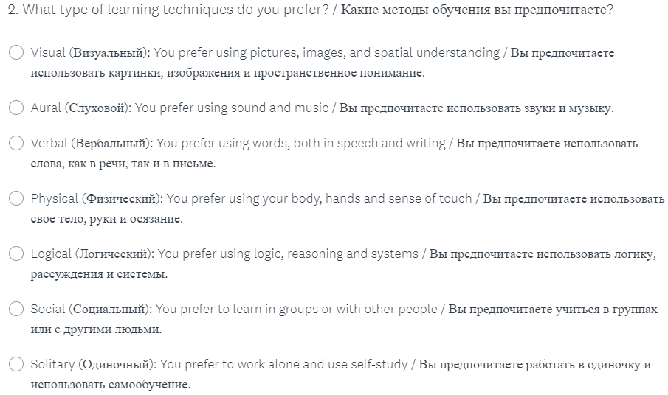
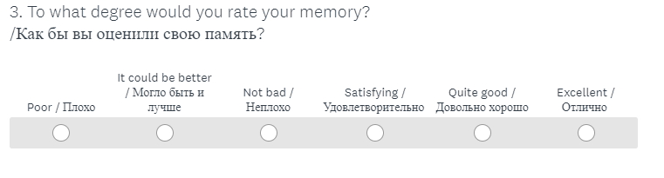

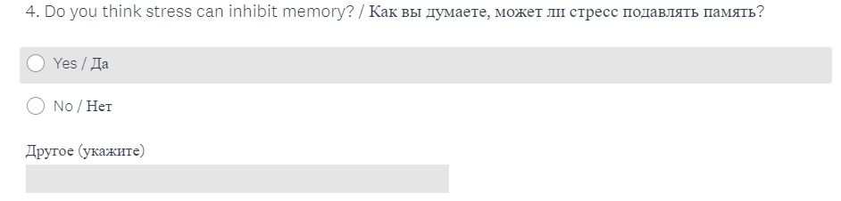

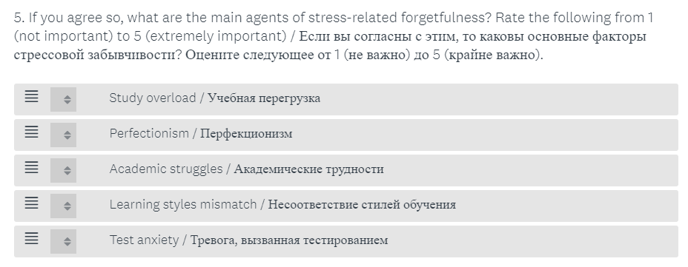

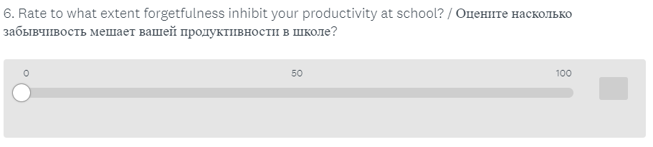

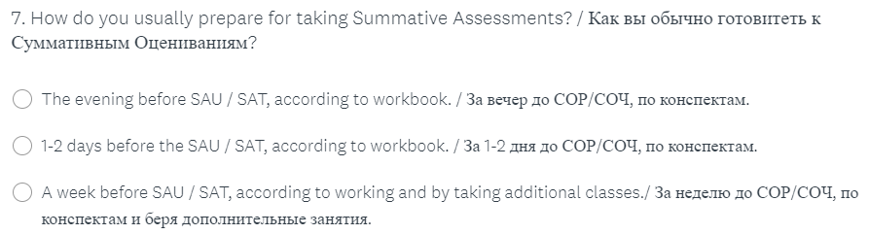
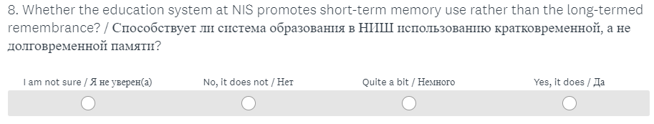

- Appendix 2 – Unstructured Interview Checklist

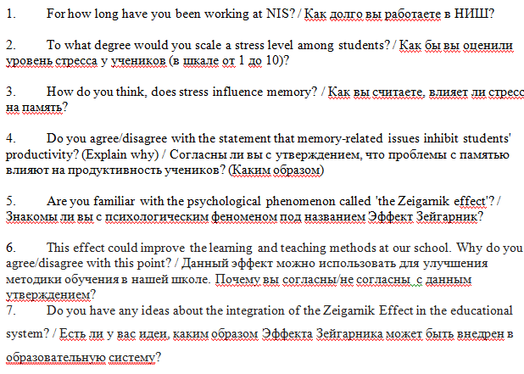
- Appendix 3 – Unstructured Overt-Participant Observation Checklist

