People’s awareness towards Genetically Modified products and their actions against them
Sabina Sabiyeva
Nazarbayev Intellectual school of Chemistry and Biology in Ust-Kamenogorsk

Word count: 5020

Introduction
Humanity is still experiencing the issue that is related to genetically modified products, although understands their hazardous effects. As for aftermaths of consumption of these kind of products there is an example stating that since GMOs were introduced into the food supply the rate of chronic health conditions among children in the United States increased from 12.8% in 1994 to 26.6% in 2006, particularly for asthma, obesity, behavior problems. This value in the entire U.S. population has been dramatically increasing with an estimated 25% of the U.S. population suffering from multiple diseases (Swanson, 2013, para.4, http://farmandranchfreedom.org/gmo-multiple-chronic-disease/ ). This research is focused on identifying the reasons for continuing to use GM food by individuals, their awareness and intentions whether they refuse using such kind of artificial food or not. The chosen topic reminds the words of author, who’s books are mostly linked to the natural health (for example “The Golden Treasury of Natural Health Knowledge”), John H. Tobe, “Any food that requires enhancing by the use of chemical substances should in no way be considered as food”, because it is the main point of exploration.
This topic becomes interesting for me in regular way with every visit to the grocery store. I saw the cover of a particular product with the text “Without GMO”. I had questions in my mind like “Can we really trust this text?”, “How do I know whether this food is fully natural or artificial?”. In order to find answers for them, I decided to start exploring this topic.
In Kazakhstan national legislation and administrative legal system in the field of biosafety are not fully developed, which makes the country to be vulnerable in terms of control of genetic engineering activities and monitoring of them. Therefore, there is a need to strengthen the existing capacity towards using GMO (The Sixth National Report on Biological Diversity in The Republic of Kazakhstan, 2018, page 124, para.7).
The potential bias of this research might be the point of people’s careless attitude towards their own health. They state that healthy eating is the key aspect of being well, however not all of them check the validity of products that they eat in daily life. If humanity is against to use genetically modified food, why do they don’t act in order to reject this kind of artificial meals?
This research contains information about people from developing countries that use GMO and their views towards this issue. Results of the exploration will be published in platforms like ScienceOpen.com, where articles can be read by experts, in order to refer to food scientists. Perhaps the project will become a following step to search alternatives of genetically modified food by them. For example, mutagenesis or selective breeding. According to source, these types of seed improvement techniques approved for non-GMO and organic farming (Folta, Jacquet, 2018, https://gmoanswers.com/ask/are-there-any-alternatives-gmo).
Context
Nowadays the problem of excessive using of GMO products is urgent and someone will not clearly be familiar with it. Individuals need to notice the harmful effects of such kind of products because there are lots of aftermaths mostly connected with human body like diseases as asthma and obesity. This exploration is focused on identifying the position of people from developing countries towards genetically modified food, their intentions on a way of dealing with this problem and following steps to tackle it.
Key definitions: GMO (genetically modified organism) - organism whose genome has been engineered in the laboratory in order to favour the expression of desired physiological traits or the generation of desired biological products (Fridovich-Keil, J. & Diaz, 2020, J. Genetically modified organism, https://www.britannica.com/science/genetically-modified-organism ). Selective breeding – combining traits from similar and dissimilar plants by crossing into one genetic background with improved traits, Interspecies Crosses – breeding and tissue culture techniques that permit genetic exchange between plants not crossing naturally, Mutagenesis – using chemicals or radiation on seeds to change DNA and occasionally induce a favourable trait (Folta, K. & Jacquet, M. 2018, https://gmoanswers.com/ask/are-there-any-alternatives-gmo ).
The main secondary sources are following:
Controversy abounds over the use of genetically modified seeds that produce crops like soy, corn, canola and others, that are resistant to a widely used herbicide, glyphosate, the health effects of which are still unclear and people use them in daily basis. Recently it was identified that , resistance to a second weed killer, 2,4-D has been linked to the glyphosate resistance and also to growing of non-Hodgkin’s lymphoma and some of neurological disorders, researchers claimed in the International Journal of Environmental Research and Public Health (Brody J. 2018, Are GMO foods safe?, https://www.nytimes.com/2018/04/23/well/eat/are-gmo-foods-safe.html ). Hence, these seeds can be hazardous for health.
Scientists can refer to other methods of growing food products when eliminating the artificial ones. There is a number of methods used in food production including selective breeding, interspecies crossing, hybridization and mutagenesis. They approved for non-GMO and organic farming (Folta, K. & Jacquet, M. 2018, https://gmoanswers.com/ask/are-there-any-alternatives-gmo ). Therefore, cutting of GMO consumption can be real and the first steps are clear.
As for GMO labelling, people need them due to be aware of what consist products that they buy day by day and to ensure this condition, organizations must meet the requirements and use labels (S.Lamb, 2020, https://www.statnews.com/2020/02/19/why-we-need-mandatory-labeling-of-gmo-products/ )
This topic covers economic and scientific lenses. Economic lens includes the fact that GM food is less costly to produce than growing them in original way. While thinking about the countries that still use GM food, in mind there would be some points like “they use it for not spending the budget of nation”, “for executives it is profitable to collect money of citizens and make less investments” and so on. Indeed, they are looking for the growing of economy. For example, large corporations such as Bayer, BASF, Dow Agro Sciences, DuPont, Monsanto, and Syngenta sell agricultural products to farmers, including GMO varieties of seed for crops including cotton, maize, and rice. Due to improving of yield and reducing the production costs, smallholder farmers and export markets will take an advantage. (Cornish, 2018, What are the political drivers for GMOs in developing countries?, https://www.devex.com/news/what-are-the-political-drivers-for-gmos-in-developing-countries-92091 para.6-7). Nevertheless, blaming them is not fully correct, because humanity’s well-being depends on the level of the economy of country.
Scientific lens is related to nutritional science. In order to cut the amount of GMO there must be something that can replace it and less dangerous for humanity. Therefore, it demands new inventions in nutrition sphere. They can address to breeding method supported by GMO. Experts have created the technology called CRISPR, which use bacterial systems to simplify genetic editing, allowing for easier development of GE organisms and could be used to expedite growth of useful GE crops, facilitate disease elimination, or even alter entire ecosystems (Rangel, G. 2015, http://sitn.hms.harvard.edu/flash/2015/from-corgis-to-corn-a-brief-look-at-the-long-history-of-gmo-technology/ ).
As for perspectives, 1) food organizations or companies are in demand of having alternatives of GMO products, because they need nutriments that are profitable, cheaper, have low rate of crop loss and don’t need special conditions like water, weather, etc. as genetically modified ones; 2) Perspective of nutritionists linked to expanding the horizons of science and create GMO replacement while meeting expectations.
Materials mentioned above can navigate on the way of getting the results of this research. With help of facts that show the detrimental sides of unnatural GMO food, there are some needs to share this information with people and know their awareness. Also after doing exploration there should be a solution to the issue and methods of combating with these products, that followed to creating the aim of identifying them.
The GMO consumption becomes urgent time after time due to finding out the negative effects of it like allergies, diseases among human beings and it affected all inhabitants of the Earth. The Institute for Responsible Technology (IRT), reported that rats fed a diet of potato with GMO after ten days of feeding were negatively affected to organs by this diet. It was supposed that the toxicity was because of genetic modification techniques. They claimed the process of making the GMO caused it to be toxic and thus all GMOs were high risk for toxicity (Norris, M. Will GMOs Hurt My Body? The Public’s Concerns and How Scientists Have Addressed Them, 2015, http://sitn.hms.harvard.edu/flash/2015/will-gmos-hurt-my-body/ ). Hence, the issue distributed all around the world.
This research is related to the social aspect of this trouble, whether people from developing countries like Kazakhstan are familiar with it or not and what they can do in order to cut it. In Kazakhstan national legislation and administrative legal system in the field of biosafety are not fully developed, which makes the country to be vulnerable in terms of control of genetic engineering activities and monitoring of them. Therefore, there is a need to strengthen the existing capacity towards using GMO (The Sixth National Report on Biological Diversity in The Republic of Kazakhstan, 2018, page 124, para.7). Also it is referred to the scientists/nutritionists and call them to change artificial products to the natural ones or just use safe methods of growing food with help of special GMOs.
Aims
This research is aimed to identify whether people from developing countries are familiar with the problem of GMO consumption and if so, what they will really do in order to combat with it. Also it has a purpose of exploring the reasons for continuous using of artificial products by humanity. By knowing numerous points of view of individuals throughout the topic of genetically modified product binging, this exploration can reach these goals. There is a list of questions that are going to be addressed:
How aware are individuals from developing countries of consequences of excessive genetically modified food intake?
How important is it for people to have a label for a GMO product in stores? Do they really need them?
What are the following actions for human beings to deal with these hazardous nutriments?
I predict that after conducting this research, it will be clear whether people from developing countries introduced with the problem of genetically modified food or not, and if they are familiar with it, their intentions will be identified. If no, there will be hints towards the following steps of individuals on the way of stopping the usage of these products.
Methods
For primary research methods that had been chosen are: questionnaire, that was used for collecting data from individuals from several countries and checking whether they are familiar with GMO consumption or not, observation, which allowed to look for people’s reaction and behavior in particular situation like checking for GMO in products from grocery stores and case study, that helped to find the solutions to the issue, connected to the topic of this research, that was the problem of not combating GMO in Kazakhstan. Questionnaire and observation were closely linked to people and their union gathered the whole image of people’s opinion, action and intention towards genetically modified products, while case study combined them by analysis of current situation in one particular country.
The first method was questionnaire and it was both quantitative, because there were open-ended questions and qualitative due to closed questions. It had 10 questions and had been conducted on Microsoft Forms platform within 1 week. This method was chosen in order to gather the information like the number of individuals from 100 who are ready to deal with the problem of genetically modified products usage, in terms of their age difference and living area, and their intentions, opinions about what actions can be done by them. With the help of this tool the question “What are the following actions for human beings to deal with these hazardous nutriments?” was answered. One hundred of representatives of developing countries like Kazakhstan, Russia, Moldova, Ukraine were chosen as population and sample group due to active using of GMO in production by these countries because of profitability, low cost of these artificial products. The questionnaire was conducted with the help of the platform Microsoft Form. While conducting this tool, data were collected within one week which could be counted as success. What about obstacles, it was hard to look for equal number of people from one country, in ideal there should be at least 25 representatives per country (see Appendix A for raw data). Questionnaire can be verified by observation method due to collecting information that are linked to individuals like their intentions, reactions, answers towards the topic of research.
The second method was observation and it was qualitative due to getting the data related to people’s reaction, mind. The observation was held in supermarket “City Center” between 8th and 11th of March, 2021. The aim of choosing this method was checking the awareness towards genetically modified food of individuals from Kazakhstan, in particularly at the local grocery store of Ust-Kamenogorsk, by their looking at the labels of products and whether they contain GMO or not. What about questions, “How aware are individuals from developing countries about the issue of GMO consumption” and “How important is it for people to have a label for a GMO product in stores? Do they really need them?” were answered throughout this method. Citizens of Ust-Kamenogorsk were chosen as population and costumers of local grocery store was a sample group, because these kind of stores had been visited by citizens more than others in daily basis. Observation was conducted by visiting the grocery store and looking at costumer’s behavior like did they check the product for GMO or not. It was easy to observe people and there were no misunderstandings (Appendix B). However, getting accurate data was difficult due to uncertainty about what kind of information from label they were looking for. This method can be verified by questionnaire, because questionnaire had the question about records in the package of products about GMO. Throughout the observation it would be clear do people need these records or not, because they do not search for this information in grocery stores.
The last method was case study that was also qualitative, because it searched ideas from sources in depth. The purpose of its usage was detailed studying the topic throughout analyzing the solutions to the issue that was narrow to the topic of the research. With the help of case study, the question “Why Kazakhstan cannot combat with GMO consumption?” was answered. For the population Kazakh nation had been chosen, because Kazakhstan was one of the developing countries and sample group was the government due to connection of this problem with politics. The case study was conducted by analyzing the Sixth National Report on Biological Diversity in the Republic of Kazakhstan (2018) and the article from newspaper "Kazakhstan Pravda" (2010), (Appendix C) that show the reasons for the powerlessness of Kazakhstan in getting rid of GM products and choosing clarifications that can be done by the government. Solutions were presented by the researcher, then the most effective solution was pinned. It was successful to find the sources and select the essential information from them, nevertheless there was an obstacle for researcher about examining the solutions for the question and choosing the most profitable one among them, because it should be suitable for aspects of society like economy and people's thoughts and possible to fulfill by the government and people at all. This method can be verified by both of previous methods (questionnaire, observation), because after knowing the intentions and awareness of individuals towards artificial products that consist GMO, researcher could easily choose the most important solution. For example, if people were aware of the problem of GMO consumption, then there was no need to publish advertisements about aftermath of nutriments with these harmful components in products, that was one of presented solutions.
Results
Following tools were used for achieving the aims of the research:
The first method was questionnaire, where overall 100 representatives of Kazakhstan (36), Russia (23), Moldova (19) and Ukraine (22) were asked for several questions in Microsoft Forms platform anonymously, that were related to the topic of the research. Results kept within providing this tool answered all three research questions: “How aware are individuals from developing countries of consequences of excessive genetically modified food intake?”, “What are the following actions for human beings to deal with these hazardous nutriments?”. Pie chart 1 shows, that the majority of respondents (61 out of 100) wanted to deal with consumption of artificial products. This result proved that intentions of individuals towards GM products were combating with this problem.
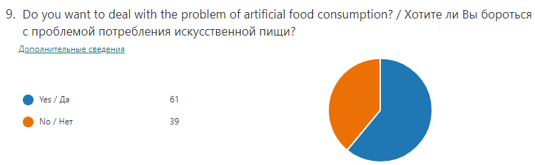
Pie chart 1. Intentions of people towards dealing with active GMO consumption
According to the answers of the survey, there are labels in the package of GMO food in countries of most of the respondents (64 out of 100), (pie chart 2). 10 respondents out of 30 (who have chosen to the previous question (“Are there any records in the package of GMO products in your country?”) the answer “No” ), replied that they were not able to differ artificial products from natural ones at all, while other 11 mentioned the appearance and smell of products as the key difference of GMO consisting nutriments (table 1).
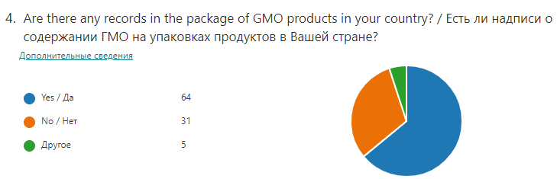
Pie chart 2. The availability of the labels in countries
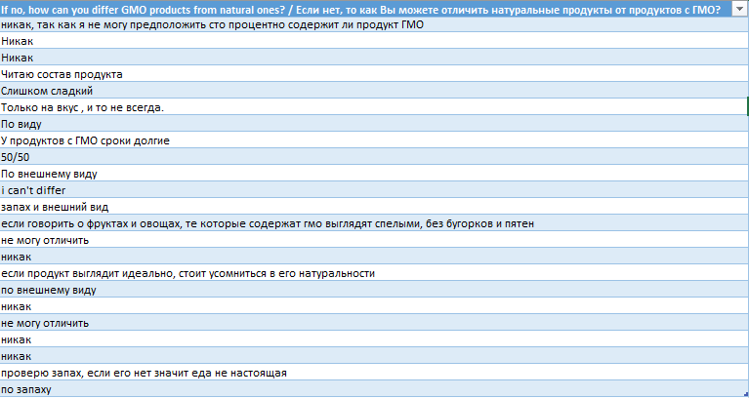
Table 1. People’s experience in differing GMO products from natural ones
According to Table 2, there was a trend among all 4 countries’ (Kazakhstan, Russia, Moldova, Ukraine) dwellers that farmers are those, who should be responsible for consequences of consumption of GM products (37), on the second place there was the government of these countries, when 11 respondents from Kazakhstan were the majority of all these people who answered for this question so. Then, the third place gained costumers (20 out of 100) and the fourth was grocery store administration (14), where the majority of respondents from Kazakhstan (8). Also there was 1 person from every country except to Ukraine answered as “all of them” which stated that all people above (the government, farmers, costumers and grocery store administration) were responsible and vice versa 3 respondents from Russia noted none of them to be so. Overall, farmers were selected by the majority of respondents (37) and therefore situation from their side must be searched.
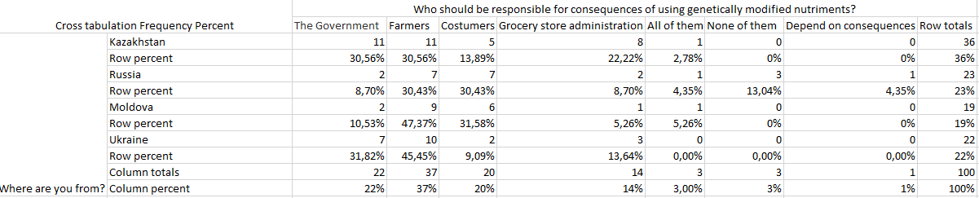
Table 2. Cross tabulation for place of residence of respondents and their opinions about who’s responsibility consequences of GMO were
From those who wrote their own unique opinion to the question about suggestions for following actions of getting rid of GMO products, 9 individuals out of 29 pinned that GMO food should not be supplied by organizations, at the same time such kind of products should not be bought by costumers in order to reduce demand. As for others, 9 out of 29 claimed that this issue should be recognizable everywhere and people must share all information about GMO consumption with others, 4 respondents were relying on others and answered that if there will be an idea, they will help what they can, 2 others wrote that GMO are a symbol of human development and there was no need to combat with them, 5 others had no idea about it (table 3). To conclude, according to these answers, the most popular methods to combat with GMO are restricting from producing these kind of products by organizations due to stopping to use them by individuals and consecrate this issue to a wide range of society. May be with help of these solutions, the usage of artificial products will drop.
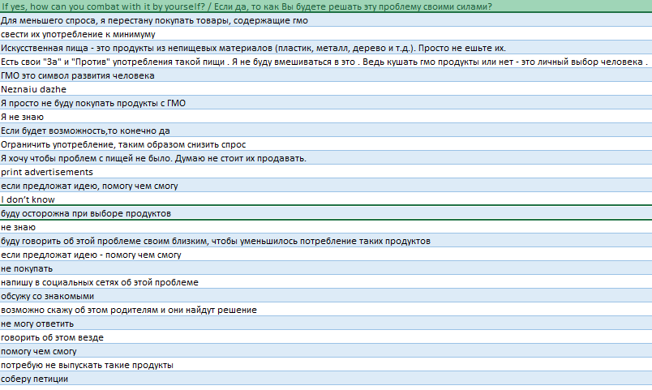
Table 3. Suggestions for following actions against GMO
The second method was observation, that had been provided in local supermarket for three days in order to check the awareness of costumers from Ust-Kamenogorsk city towards the problem of consumption of products with GMO. The question “How aware are individuals from developing countries of consequences of excessive genetically modified food intake?” was answered after conducting the results of this tool. By people’s actions and reactions, it was clear that most of them (14 out of 30) did not look at the package of food that they were buying, while others had different behavior as shown in table 4. For gender differences of observed people, 8 men and 6 women out of all 30 individuals haven’t looked at the labels of products, while 5 women and 7 men checked products for something. For other 4 females it was difficult to identify particular behaviors. Overall, there was a trend towards 16-20-year-old people to be interested in product cover that have found surprising by researcher, because individuals that are more than 21-year-old expected to be so.
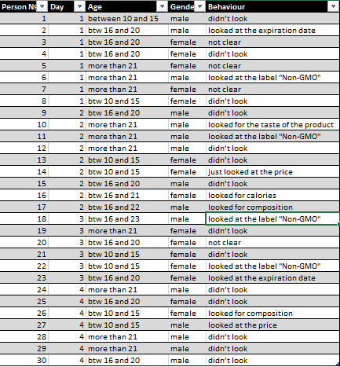
Table 4. Behavior of costumers

The third tool was case study, that was used for analyzing the question “Why Kazakhstan cannot combat with GMO consumption?” rising from conducted questionnaire and observation. In order to answer this question, the Sixth National Report on Biological Diversity in the Republic of Kazakhstan (2018) and the article from newspaper "Kazakhstan Pravda" (2010), (Appendix C) were chosen and there were bullet points that gave the reasons for powerlessness of Kazakhstan in getting rid of excessive GMO consumption. After identifying all of these information, possible solutions to the issue has been provided by researcher. Among them the best approach has been chosen that was importing special equipment, that could help to identify genetically modified products, from other countries. To conclude, the government should provide these manipulations in order to minimize harmful effects of GM consisting food.
Overall, with help of this research, it was clear that the problem of GMO consumption has become more urgent and the humanity should held it on his own hands. Lots of new information have been discovered throughout the project like the reasons of still using genetically modified products especially in developing countries, people’s view of this issue and their intentions towards it. The aims of the research achieved after getting the results, it was identified that individuals are familiar with hazardous effects of using GMOs.

Conclusion
By conducting the primary and secondary researches, the aim of identifying the awareness of people from developing countries about GMO consumption and what will they do in order to combat with it has been reached. The hypothesis was confirmed due to getting clear information that people are introduced with this urgent issue and also they are ready to act against GMO production.
With the help of the survey, research question "How aware are individuals from developing countries of consequences of excessive genetically modified food intake?" was answered. By the survey results it was found that 100 representatives of Kazakhstan, Russia, Moldova and Ukraine knew the existence of the problem of excessive using of genetically modified products, however there were some answers that stated the point that GM food are not dangerous. Overall, negative opinions about these artificial products outweigh these views. The reasons for that are also supporting facts from different sources of the secondary research. For example, according to the researches of the International Journal of Environmental Research and Public Health, using genetically modified seeds could lead to glyphosate resistance, exacerbation of non-Hodgkin’s lymphoma and several neurological disorders (Brody J. 2018, Are GMO foods safe?, https://www.nytimes.com/2018/04/23/well/eat/are-gmo-foods-safe.html ). To sum up, individuals are aware of the hazardous effects of using GM products and their negative attitude towards them are proved by other researches.
The second question that was answered with the help of the survey method is “What are the following actions for human beings to deal with these hazardous nutriments?”. According to gathered ideas from respondents, the most popular ones are stopping the production of these artificial food by organizations with the way of rejecting them by customers and sharing the information about these issue with the society. The secondary research identified another method of actions against GMO that was using breeding, interspecies crossing, hybridization and mutagenesis by scientists in growing food due to their recognition as organic and non-GMO (Folta, K. & Jacquet, M. 2018, https://gmoanswers.com/ask/are-there-any-alternatives-gmo). Overall, not only scientists can combat with excessive GMO consumption, but also customers and ordinary people.
By the observation tool, the third question “How important is it for people to have a label for a GMO product in stores? Do they really need them?” was answered. In agreement with the results, during four days of conducting of observation, 14 costumers out of 30 didn’t look at the package of products, however other 12 people, except for 4 remaining ones for whom it was difficult to detect behavior, checked covers for some information. That’s why it can be stated that individuals still need labels for non-GMO approval, because numbers above are fairly equal and also due to narrow numbers of the sample. Also it has proved that mandatory labeling can help people to be introduced with the consistence of products that they buy because they deserve honest and clear information (S.Lamb, 2020, https://www.statnews.com/2020/02/19/why-we-need-mandatory-labeling-of-gmo products/#:~:text=You%20might%20expect%20a%20company,they%20consider%20buying%20GMO%20products ).
The last tool was case study and it started from the question that was found throughout the whole research by conducting questionnaire and observation. Narrow question to the topic was identified “Why Kazakhstan cannot combat with GMO consumption?” and answered. It was based on the Sixth National Report on Biological Diversity in the Republic of Kazakhstan (2018) and the article from newspaper "Kazakhstan Pravda" (2010) that claimed that in Kazakhstan the national legislation system on the relation to genetic engineering is weak and therefore it cannot take an action against GMO consumption. There were some solutions to this topic from the researcher and among all of them the most effective one has been chosen. Alternative method to the identification of products that consist genetically modified organisms can be importing special equipment from other countries. Finally, Kazakhstan will be on the starting path to eliminating the usage of artificial food.
It was found that people from developing countries are aware of negative effects of GMO consumption and in order to deal with these issue they can suggest some actions as in the results of the survey. Individuals still need the labels on products that prove using GMO during production, because they deserve it. Kazakhstan can get rid of GM food consumption despite the fact of having weak legislation system, but still should start to reach strong one. There can be an equipment from other countries that can easily identify whether the product contains such components as GMO or not.
Conclusions that were found are in high degree of confidence due to getting answers for all research questions. Also all data can be generalized, however it would be better, if there was a larger number of people in the sample group. Thanks to the answers of people in conducted survey, case study method and more options for solution to this given issue, the understanding of the problem of excessive GMO consumption has advanced.
Evaluation
By completing the research all research questions were answered. Overall quality of the whole work is fairly high.
As for the strong points of the survey that was conducted first, it had sample group from 4 countries: Kazakhstan, Russia, Moldova and Ukraine, and this fact has affected to get variety of views from different perspectives. Moreover, due to asking dissimilar types of questions like multiple choice, open-ended and closed, yes or no ones, there was an opportunity to gather information of different aspects and also for respondents the survey was interesting and engaging. Although there were some obstacles during managing this survey. First was having not precise number of respondents relying on their place of living, for example there were only 19 people from Ukraine and 36 others from Kazakhstan. If they were equal, it would be much accurate. Second was related to not answering some questions by respondents, for instance after choosing "yes" option to the question "Do you want to deal with the problem of excessive GMO consumption?" someone didn't write his suggestions towards actions against GM food. In order to handle this problem, this question can be changed as necessary question in Microsoft Forms platform.
The second method was observation, and for strengths despite the fact of having lack of the detected data for the first time, second one was luckily done. There was different information about every observed person like age, gender and behavior. For the weaknesses, due to a problem with identifying some person's reaction, the results of this method is not so distinct. To improve this, the observed group should be expanded in order to minimize the number of people with not understandable reactions.
The last method was the case study, where solutions for the narrow topic that was related to Kazakhstan's weakness towards cutting the amount of usage of GM food, were found by the researcher. For the strong points, the most effective solution had been chosen and there were no obstacles during the completion of the case study table, also choosing sources to analyze was quite easy. Therefore, there are no significant weak points.
The possible bias didn’t have an impact on the results and conclusions, however the researcher didn’t find any reasons for why people still do not act, while knowing how urgent this problem is.
Further research
There were some moments that should be fixed in order to get clear and reliable research.
First thing that should be mentioned is expanding the number of sample group, because 100 representatives are not enough to fully analyze the awareness of people from 4 developing countries (Kazakhstan, Russia, Moldova and Ukraine) and their points of view. Therefore, the number of respondents should be changed to 200.
Secondly, there will be some more subtopics that are related to the topic of the research like "The government's views towards the problem of excessive GMO using", "Life without GMO, consequences of rejecting them".
Thirdly, observation that was held in local supermarket can be improved too. There were some obstacles that are related to identifying people's reaction. Therefore, more individuals should be observed by researcher, 30 of them are not enough. Then maybe another unexpected and unique reactions will exist.
Finally, new research question can be added that is "Can people from developing countries fully cut the usage of GMO, if they already have ideas how to do it?".
Overall, at the end of the research, there are some information that have been learnt about the issue like people can suggest the solution of the given problem, Kazakhstan is able to deal with it by importing special equipment from other countries that can easily identify whether the product contains GM elements. As for personal perspectives, they haven't changed a lot, because this issue still occurs at the present time and despite the fact of being aware of the problem of excessive usage of GMO products, individuals should allocate their attention to how to deal with it.
Bibliography

Swanson, N. (2013). GMOs and Multiple Chronic Diseases, http://farmandranchfreedom.org/gmo-multiple-chronic-disease/

Cornish, L. (2018). What are the political drivers for GMOs in developing countries?, https://www.devex.com/news/what-are-the-political-drivers-for-gmos-in-developing-countries-92091

The Sixth National Report on Biological Diversity in The Republic of Kazakhstan, (2018). https://www.cbd.int/doc/nr/nr-06/kz-nr-06-en.pdf
- Jacquet,M. (2018). Answer for question “Are there any alternative options to GMO?”, infographics made by Dr. K.M.Folta, https://gmoanswers.com/ask/are-there-any-alternatives-gmo
- S.Lamb, (2020. https://www.statnews.com/2020/02/19/why-we-need-mandatory-labeling-of-gmo-products/
- Fridovich-Keil, J. L. and Diaz, Julia M. (2020, April 10). Genetically modified organism. Encyclopedia Britannica. https://www.britannica.com/science/genetically-modified-organism
- Brody, J. (2018) Are GMO foods safe?, https://www.nytimes.com/2018/04/23/well/eat/are-gmo-foods-safe.html
- Rangel, G. (2015), http://sitn.hms.harvard.edu/flash/2015/from-corgis-to-corn-a-brief-look-at-the-long-history-of-gmo-technology/
- Norris, M. (2015) Will GMOs Hurt My Body? The Public’s Concerns and How Scientists Have Addressed Them, http://sitn.hms.harvard.edu/flash/2015/will-gmos-hurt-my-body/

Appendices
Appendix A – survey question 3, place of residence of the respondents
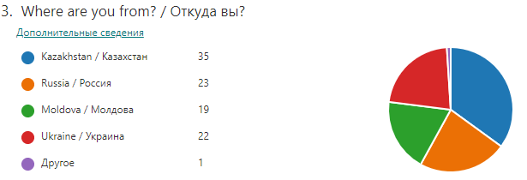
Appendix B – observation comment
The observation was conducted in person in a private setting and results were recorded in Excel table.
Appendix C – sources that had been used
- The Sixth National Report on Biological Diversity in the Republic of Kazakhstan (2018), https://www.cbd.int/doc/nr/nr-06/kz-nr-06-en.pdf
- Kazakhstan Pravda 28 September 2010 № 255 (26316), https://unece.org/fileadmin/DAM/env/pp/gmo/Pres_Astanina-Japan.pdf
Appendix D – survey questions
