Effect of technologies on human`s brain
Kamelkhanova Aruzhan 11 "C"
Nazarbayev Intellectual school of Chemistry and Biology
Oskemen

Word count: 6233

Introduction
Is it true that technology can alter our brain? People spend a lot of hours a day on technology. But if everyone knew what effect technology has on the human brain, perhaps he would change the way he uses technologies.

From year to year, wide usage of new technologies creates more and more differences between people of the present and the past. For instance, one of the most noticeable sign is that the attention span of people is down from 12 to 8 seconds for the last 20 years. (Simon Maybin, Mar. 10, 2017, Busting the attention span myth, Retrieved from https://www.bbc.com/news/health-38896790 ) Since it has a direct impact on people`s mind and daily life, it is quite interesting for me to investigate this topic in order to identify what other impact on brain work do new technologies have and whether people can control it to prevent negative effects. In addition, I was motivated by an interesting Ted talk of a neuroscientist Susan Greenfield about the impact of technology on human mind. (TEDx Talks, Jul. 4, 2014, Technology & the human mind | Susan Greenfield | TEDxOxford [Video], Retrieved from: YouTube https://youtu.be/oc7ZYj4CCdM ) After watching this video, I realized that before I didn’t know anything of the listed in the video, and I developed an interest in this topic.

Problems about the harmful impact of technologies are common for the whole world. Because new technologies are now needed in almost every area of human activity. This became more important during the period of pandemic when almost everyone switched to the online mode. Kazakhstan, like any other country, is no exception. People of Kazakhstan are also had to work and study from home, spending almost whole day at computer. In this regard, the amount of demand for sites and applications has also increased. Because people sit at home and work and a large number of them prefer entertaining themselves with the help of the internet. For example, traffic to popular sites such as the New York Times and The Washington Post increased by more than 50 percent for the first month of the quarantine. (Ella Koeze and Nathaniel Popper, Apr. 7, 2020, The Virus Changed the Way We Internet, Retrieved from https://www.nytimes.com/interactive/2020/04/07/technology/coronavirus-internet-use.html ) That is why researching the impact of digital devices on the human brain is more relevant than ever.

This research is not biased. Because this topic is related to the scientific lens and in order to conduct the research there is necessity to cite proved facts and refer only to reliable information. However sometimes people have a hypothesis about the impact of technologies on human brain. Myself, as a majority of people, tend to discuss only about the negative effects of modern technologies, and this opinion may be biased.

This research can be quite valuable for NIS students. We spend huge amount of time online now and sometimes we even spend a whole day at computer and smart phone. It is necessary for us to know the impact of technologies on our brain and to find ways of solving this problem. Because it can affect our study process and we can improve it. Also, we study biology in depth and can understand the biological and psychological reasons for the emergence of problems due to devices. Students can use the outcomes of this study to be able to control the effect of new technologies and be more productive in their studies. My contribution will be an appeal to the students of our school in TedX to draw attention to this problem and try to minimize the harmful effect of technologies by themselves.

Context
During the past thirty years, new technologies have changed daily life of people. Almost all the individuals of different ages are now active users of modern devices. Every day they visit a lot of web sites and pages, contact with others online and acquire a huge amount of information. Thus, human brain does painstaking work every day. Brain has to analyze the information, highlight the necessary and remember the important. Decades ago, life was different and the brain did not have to work so hard. However, the human brain was able to adapt to modern needs. The question is how new technologies affect brain system.

One of the most major impact of technologies on brain is reduced attention. People, spending time behind the screen, overextend the brain and constantly change the focusing object. It can be caused by repetitive changes in attention, which impair executive functioning. In most cases, this can lead to disorder called ADHD (Attention deficit hyperactivity disorder). The US Centers for Disease Control and Prevention found out that the prevalence of ADHD is 5% worldwide. According to the Dr. Dimitri Christakis, a pediatrician and director of the Center for Childhood Health, Behavior, and Development at the Seattle Children's Research Institute, people, often using digital technologies, create a brain habit in which they are constantly looking for something interesting and this leads to distractibility, which is the main problem of people with ADHD. ( Jacqueline Howard, Jul. 17, 2018, ADHD study links teens' symptoms with digital media use. Retrieved from https://edition.cnn.com/2018/07/17/health/adhd-symptoms-digital-media-study/index.html ) Spending significant periods of time with digital media, people neglect live communication. Consequently, they become socially isolated, which may cause poor health outcomes and depression. Statistics shows that 90% of young adults in US are users of various social media cites, such us Facebook, Twitter, Snapchat and Instagram, and most of them visit these sites at least daily. It demonstrates one more drawback-technological addiction. People cannot control themselves and become addicted to devices. It starts to be hard to individuals to control their emotions. In some cases it can be followed by hyperactivity and impulsivity, while some people easily get depressed. It has significant impact on cognitive and brain development, as well. Reading, language skills and behavior can be influenced. (Small, G. W., Lee, J., Kaufman, A., Jalil, J., Siddarth, P., Gaddipati, H., Moody, T. D., & Bookheimer, S. Y. (2020). Brain health consequences of digital technology use. Dialogues in clinical neuroscience, 22(2), 179–187. https://doi.org/10.31887/DCNS.2020.22.2/gsmall )

Along with it, technologies can affect the brain positively. In fact, the impact of technology depends on how they used. If people filter their online experience, they will stay away from negative impact. For example, social media can provide communication without any obstacles. People gain the ability to connect with others despite time and distance barriers and strengthen their personal networks and interactions. (Roeder, A. (2020, May 28). Social media use can be positive for mental health and well-being. News. https://www.hsph.harvard.edu/news/features/social-media-positive-mental-health/ ) According to the results of research of several scientists and neurobiologists of University of California, Video games improve sensory, perceptual, and spatial cognitive function. Moreover, they increase performance when running an independent memory task. (Clemenson, G. D., Stark, S. M., Rutledge, S. M., & Stark, C. (2020). Enriching hippocampal memory function in older adults through video games. Behavioral brain research, 390, 112667. https://doi.org/10.1016/j.bbr.2020.112667 ) Also, with the help of new technologies, it is available to create an interactive learning environment. This is one of the futuristic discoveries of our time. The interactive system is aimed at improving memory, attention and associative skills. The correct use of sound, animation, and presentations helps to train working memory and cognitive abilities in relation to memory and attention.( Pradeepika, N. S., Jan. 16, 2020, Using technology to improve memory and brain functions. Retrieved from https://www.researchgate.net/publication/338631334_Using_technology_to_improve_memory_and_brain_functions )

Nevertheless, technology can be highly addictive. The problem is not only in the technologies, but in people's own minds, in how people become addicted. “Mr. Harris, a former Google ethicist, popularized the idea that technology is uniquely addictive and hijacking the brain. His catchphrases like "Well spent time" have become industry mantras.” ( Bowles, N. (2019, October 6). Addicted to Screens? That’s Really a You Problem. The New York Times. https://www.nytimes.com/2019/10/06/technology/phone-screen-addiction-tech-nir-eyal.html?smid=url-share ) Interesting websites and social media attract attention and occupy people's mind with digital world. According to the statistics, on average, a smartphone users check their device 63 times per day and spend about 3 hours behind the screen. In addition 71% of users sleep with their mobile phones beside them, which shows how human brain is dependent on devices. (Zuckerman, A. (2020, May 29). 109 Technology Addiction Statistics: 2020/2021 Data, Facts & Insights. CompareCamp.Com. https://comparecamp.com/technology-addiction-statistics/#:%7E:text=A%20study%20by%20Common%20Sense,%2C%20text%20messages%2C%20and%20notifications. )

If to look at it from local level, according to the Ministry of Digital Development, as a result of modern telecommunications infrastructure creation in Kazakhstan, the percentage of internet users in the country amounted to 81.3 percent in 2018 and majority of them use internet daily. (Number of internet users in Kazakhstan exceeds 81%. (2019, August 29). Trend.Az. https://en.trend.az/business/it/3111263.html ) Since the number of Internet users in Kazakhstan is growing every year, one of the most relevant issues is technological addiction. Therefore, student of Nazarbayev University School Of Medicine Akbota Tolegenova conducted research with 400 students of Nur-Sultan city. Results have shown that the potential prevalence of Internet addiction was found to be 19.75%. (Akbota Tolegenova, May. 2018, PREVALENCE OF INTERNET ADDICTION AND ITS ASSOCIATION WITH MOOD AND SLEEP DISORDERS AMONG YOUNG ADULTS IN ASTANA, KAZAKHSTAN, Retrieved from https://nur.nu.edu.kz/handle/123456789/3303 ) Thus, it can be concluded that in Kazakhstan there are more and more people addicted to technologies, and this makes this problem relevant at the local level.

Taking everything above into account, through an active social life on the Internet, people increase social interaction and the development of social capital on the Internet, which positively affects psychological well-being. As well as, using some interactions people can improve cognitive functions and visual memory. However, there is a huge number of negative consequences of technology in a case of incorrect usage. They impair alertness and brain activity in the long term. Moreover, the internet is quite addictive.

Aims
The main purpose of this research is to find out how new technologies affect human brain system. Will be investigated positive as well as negative effects. Thus, the following questions are going to be referred to:

- How technologies affect brain and its development, according to public opinion?
- How technologies affect brain and its development, according to specialists’ opinion?
- How can technologies affect human’s behavior and habits, according to public opinion?
- How can technologies affect human’s behavior and habits, according to specialists’ opinion?
- What are the positive effects of technologies on brain?
- What are the harmful effects of technologies on brain?

By answering all these questions, it will be possible to achieve the main goal, as the necessary information about how new technologies affect human brain system will be received.

Based on personal hypothesis, it is supposed that results will show that there are more negative effects than people guess, and it has a huge impact on brain development. However, if to use technologies correctly it may even contribute to thinking skills development.

Methods

In this research have been used three methods, namely survey, interview and focus group discussion. Questionnaire helps to ask simple questions about technological impact on daily life of a large number of people, which can provide with a statistic data. Interview is for investigating the topic in depth through asking open-ended questions about technological impact on brain to specialists. In FGD was conducted as a debate and there considered arguments about both positive and negative effect of technologies. Each method cooperated with another one. For instance, interviews help to understand the trend of data, that have been gathered in the survey and in the FGD, there it can be discussed from different perspectives.

The first one was the questionnaire, as it is the foundation of the following steps. As it aimed to collect brief opinions of a huge number of people, it is quantitative. However, there are 3 open questions, which help to gain qualitative information. The survey was chosen to learn about public awareness about technological issues and what positive or negative effects people can name. Through this method it was possible to identify the answer to the research question «How can technologies affect human’s behavior and habits?». The survey covered population of Ust-Kamenogorsk(74 people) and Nur-Sultan(26 people), which creates national picture of the issue. And the sample was people of all ages as this research is aimed to investigate the impact of technologies on all people from youngest users to those who are over 40. The method was conducted through the platform, named Google Forms, where the user can create a survey with various question with multiple options and full answer requiring questions as well. In this case, there were 10 questions, 7 with different options and 3, where it was necessary to write full answer. The program automatically analyzed data and displayed pie chart for each multiple choice question, which is quite convenient. Everything went okey, the program was working without problems and letting know about each new respondent. As for obstacles, it was little head to find an equal number of people of a particular age group. Data, collected with the help of the survey was verified by both interview and FGD, as information given by psychologist and arguments of debate participants confirmed and substantiated the reasons for any impact of technology on human life.

The second method- interview, which gave the opportunity to ask open ended questions a psychologist, a biology teacher and a psychiatrist, thus gather qualitative data. It helped to know about all the detailed information about effect of technologies on human brain. Consequently, answers to the following research questions were obtained: «How technologies affect brain and its development? «What are the positive effects of technologies on brain?» «How can technologies affect human’s behavior and habits?» «What are the harmful effects of technologies on brain?». Local specialists and teacher were chosen as a sample as they are qualified professionals which has an experience of working with people dealing with the common issues. First of all were chosen the specific people, according to their qualification and major. Were chosen the most suitable ones and was sent the letter about asking them to participate in the interview. After their agreement was marked the meeting time and place. The method was conducted successfully as each of invitations was confirmed almost immediately and interviewees turned out to be open and kind. The only obstacle was the pandemic situation, because of which interviews were conducted online, using a texting format. The information, collected through this method was substantiated by FGD. The participants in the discussion presented arguments in which they cited quotations from doctors and scientists, whose words coincide with the facts given by the interviewees. Those facts were also mentioned by several respondents of the survey.

The third method was the focus group discussion. Using this method, was held a debate about positive and negative effect of technologies, which helped not only to gain more qualitative information but also to observe views of different people. Thus, following questions were answered «What are the positive effects of technologies on brain?», «What are the harmful effects of technologies on brain?». Focus group consisted of six 11th grade students of NIS Oskemen. Firstly, they study biology in depth and can provide qualitive arguments with the full biological consequence. Secondly, they are more flexible and can easily adjust to debate format and negotiate freely. This method was conducted in Microsoft Teams meeting. Firstly, in a school chat was announced about this FGD for finding interested people. Among them was chosen the most suitable ones. There was one leader and two little groups, which debated, illustrating their arguments for and against technologies. One successful moment was that all the members were responsible and prepared worthwhile and valuable arguments. However, the majority of members were a little bit shy and worked without their cameras, which made it harder to interact with others. The information, gained through debates was verified by the information from the questionnaire and the interview, as presented arguments was also mentioned by interviewees and respondents.

Results
During conducting the methods, were gathered valuable data about effects of technologies on human brain. Various results were obtained from 3 different methods.

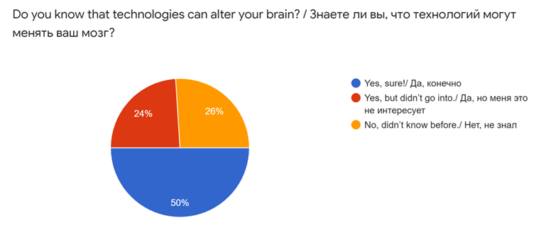
The survey was conducted among 100 people from couple areas of Kazakhstan, namely Oskemen and Nur-Sultan. According to the results of the survey, in general, 50% of respondents were aware that technologies alter human brain. 24% of them did not go into even if they knew, while 26% did not know about it at all. This leads to the conclusion that still there are people, who need to know that technologies can change their brain. (Image 1)
Image 1. Respondents` awareness about effect of technologies on brain

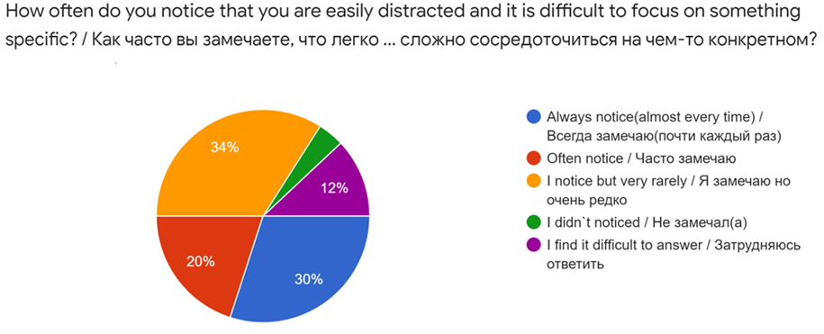
In terms of the distractibility of people, majority of surveyed ones (84%) notice that they easily get distracted, were 34% are notice it almost every time. It shows the relevance of the topic. There is also people who did not notices such phenomenon (4%) and people who find it difficult to answer(12%). (Image 2). Furthermore, if also to look at ages of people, those who are always notice their distractibility are 16-25 aged young people.(Table 1) It explained by the fact that teenagers are the most common users of digital technologies. Majority of people who use technologies in a daily basis are youngsters and teenagers. (Table 2)

Image 2. Information about how often people notice that they are easily distracted, and it is difficult for them to focus on something.

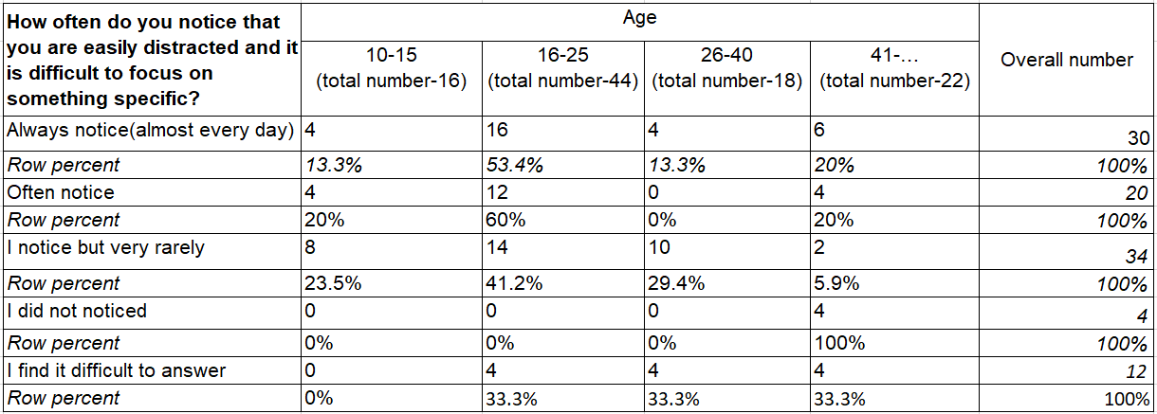

Table 1. Distractibility of people of different ages
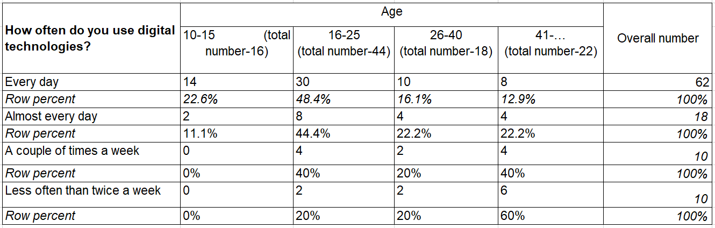
Table 2. Use of technology by people of different ages

In relation to the next question about the level of difficultness of controlling the screen time, for the 54% of the respondents it is quite difficult, while 16% could not answer this question. What was unexpected is that 30%, it means 30 respondents considered that it is not difficult for them to control their screen time and majority of those were people whose age is over 41. It shows that for adults it is easier to manage their screen time than for younger people (Image 3). Probably it is because adults were born earlier- when technologies played less important role in human life and people used to occupy their spare time with other activities. Therefore, adults use digital technologies less and they are not much addicted.

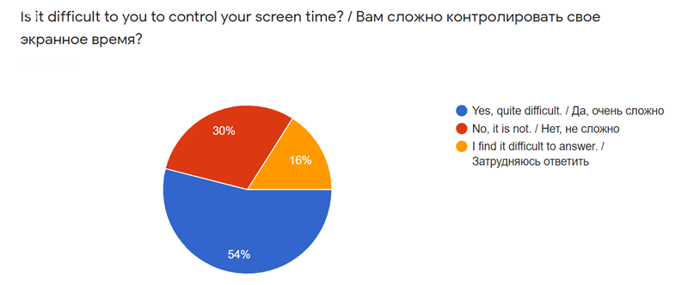
With the help of answers of respondents above, was found an answers to the research question «How technologies affect brain and its development, according to public opinion?»
Image 3. The degree of difficulty in controlling screen time

People`s opinion on how technologies affect human`s social skills vary. Opinions are divided into three: positive impact on social skills, negative impact and zero impact. Those who supported the first idea provided causes like they become more friendly and sociable, and it is easy for them to communicate with people. When it comes to negative effects, people mostly point moments like addiction to social network and becoming dependent on online communication, which decreases people`s ability to build relationships in a real life. In addition, there were some special ideas. For instance: “People do not see each other's emotions and practically do not communicate live, which negatively affects social skills”, “A person practically lives on the phone without noticing living people who are nearby”, “I can control it and use it to my advantage”. Generally speaking, mostly there was mentioned negative effects by respondents. (Image 4)
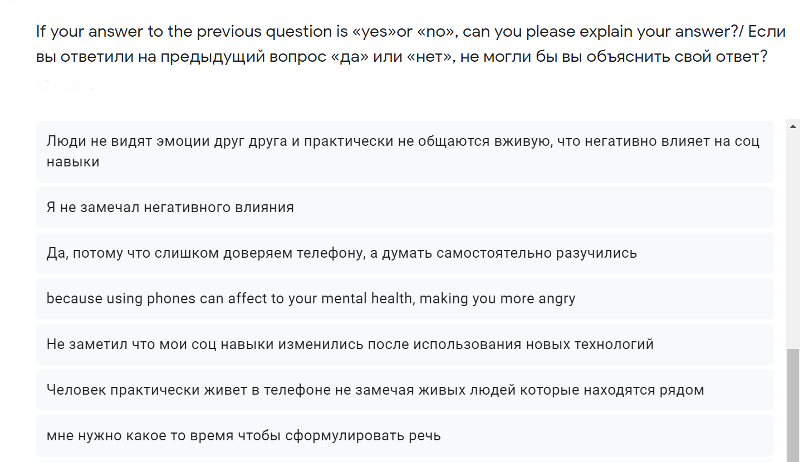

Image 4. People`s opinion about negative effect of technologies on their social skills

Respondents provided lots of examples of the negative effects of technologies on brain health. According to their opinion the main negative effects are:
- Changing the brain`s structure
- Memory impairment
- Degradation
- Too much unnecessary information that the brain does not have time to digest everything, filter out, impairs the state of memory
- Time-consuming, harmful to our health
- Lowering self-esteem
- Absent-mindedness, forgetfulness, not decisiveness, lack of the possibility of real communication with friends, lack of confidence
- Can lead to Alzheimer and other diseases
- Overloaded brain
- People rely heavily on technical information carriers and stop memorizing a large amount of information because there is no need
- Addiction
- The use of technology requires multitasking skills, which overloads our brain, as a result of which the brain is depleted and fatigue appears. (Image 5)

Listed negative effects provide an answer to the question «What are the negative effects of technologies on brain? »

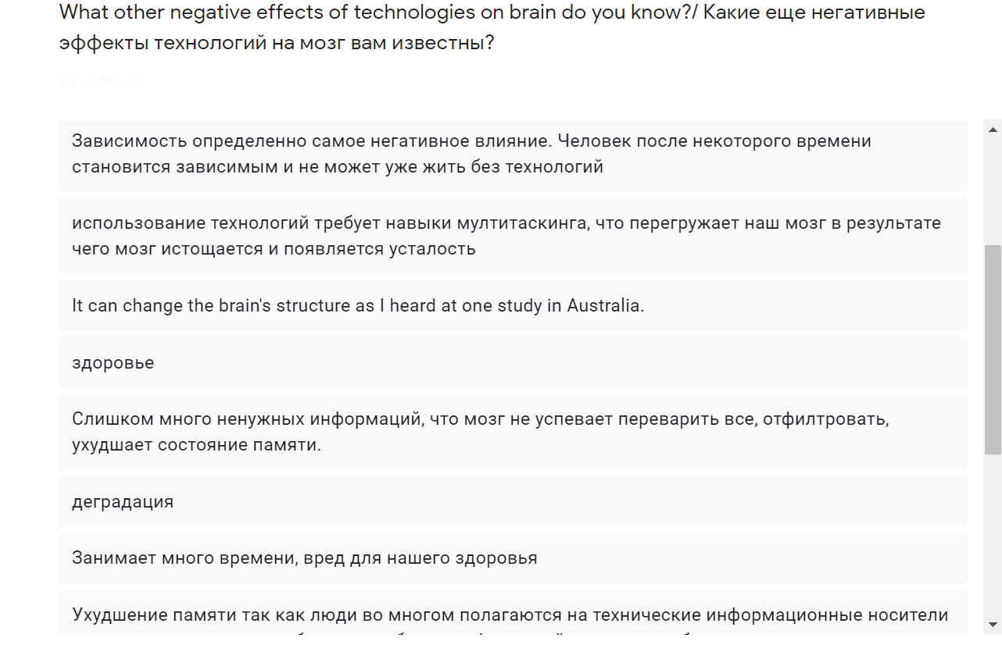

Image 5. Opinion of people about negative effects of technologies

Furthermore, respondents marked some positive effects of technologies on brain:
- cognitive applications help to improve brain work
- Multifunctionality
- information processing skills improvement
- improves organization and time management
- brain develops comprehensively
- It makes study and work easier as it is possible to store a necessary information in computer, mobile phone, or look up to it on the Internet very easily.
- Improve creativity
- Improve perception
- Broaden horizons
- Release stress
- improve brain activity (Image 6)

By this way, respondents helped to answer the question «What are the positive effects of technologies on brain? »

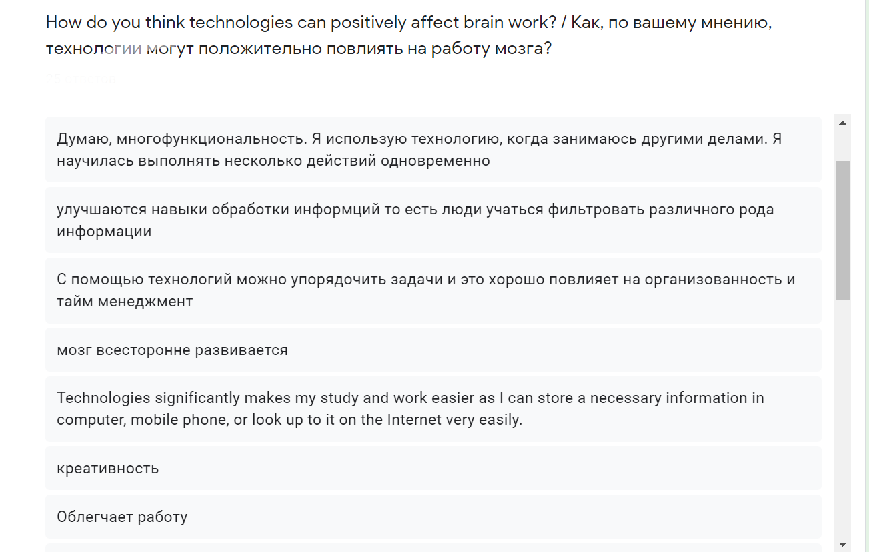
Interestingly, according to the public opinion, multitasking can be considered as both negative and positive effect. Negatively it will affect in terms of the idea that brain overworks and depletes. In opposite, multitasking affect positively through improving brain productivity. It can be noted that answers above are mostly belong to respondents below 40 years old. It leads to the conclusion that youngsters and middle aged ones more interested in technological impact and in aware of its major effects.

Image 6. Opinion of people about positive effects of technologies

The data, which was given by the respondents of the survey was proved by the opinion of interviewees. There was 3 of them: psychologist, neurobiologist, and biology teacher. Their answers helped to find an answer for the research question «How technologies affect brain and its development, according to specialists` opinion? » If to sum up their answers, the following answers were given by interviewees:
- It is known that the cerebral cortex generally develops by the age of 25. Under the influence of technology, the development of the structure of the brain fluctuates. It affects a person's critical thinking skills and intelligence.
- After reaching the age of 25, the brain becomes an expert. However, if a person starts to use new technologies every day and very often, the brain will focus on digital computers and this will impair the functioning of the brain. Namely, the functioning of the frontal part of the brain, which coordinates the functions of the regions of the cortex.
- The impact of technology on behavior depends on age, temperament, and principles. Some people are extremely vulnerable and quickly become addicted to gadgets. Such people may have a deviation in social life. Their brains switch to the digital world, gradually breaking the connection with real people. These are usually teenagers or adults with a vulnerable character. Others can limit their screen time, which greatly minimizes the risk of technology side effects.
- Now virtual communication has a greater privilege than live communication. This significantly impairs the social skills of people of all ages. This is especially dangerous for children, as they may never acquire social skills.
- The use of technology can also have a positive effect on the functioning of the brain. Gadgets are useful if the content of information has a developing and educational influence on a person. What is put inside (games, educational programs, books) has a positive effect on the development of a person's thinking, develops visual and imaginative memory, auditory memory, the emotional sphere in the same way as ordinary books and board games.
- The advantages of gadgets for children are that everything in them is bright, figurative, dynamic, and exciting. Often the child feels himself directly the hero of the events taking place on the screen, he believes in what is happening, as we once believed in fairy tales from books. And this is psychologically justified.
- Digital technology can affect the brain's attention. Distraction increases and the person loses the ability to concentrate. This can lead to severe cognitive-behavioral diseases.
- The uniqueness of the technology is that they simultaneously facilitate the work of the brain, but at the same time impair its abilities, upsetting the balance of consciousness.

By this way, extremely important data was gained from interviewees. Some facts about alteration of brain structure and behavioral effects of technologies as well.

The focus group discussion was aimed at identifying the negative and positive counter effects of technology on the brain. Participants of the discussion had a debate and discussed both advantages and drawbacks of technologies. Therefore, it provided answers to two research questions: «What are the positive effects of technologies on brain? », «What are the negative effects of technologies on brain? ». (Table 3)
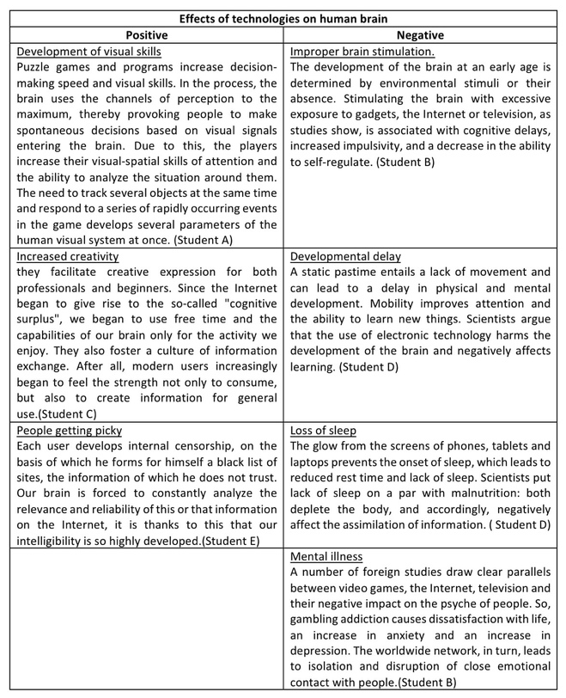
Table 3. Arguments of participants of FGD about positive and negative effects of technologies.

Table above represents valuable arguments for and against technologies. As positive ones were mentioned facts, like video games or interactive programs develop visual perception and make person to pay attention to different details simultaneously. Can be made a conclusion that technologies contribute to development of visual, creativity skills and attentiveness. There are some negative effects as well. Using gadgets, which have a huge impact on brain development can prevent the brain from developing naturally. Additionally, there are some mental illnesses, which were also mentioned by interviewees and respondents of the survey.

One of the research questions was «How can technologies affect human’s behavior and habits, according to public opinion? » All the 3 methods contributed to the answer. For instance, in the survey was identified that majority of people easily get distracted and addicted to gadgets. Interviewee psychologist also mentioned high additivity, which is caused by constant use of technologies. According to conclusions from FGD, technologies also inhibit the development of the brain, which changes the behavioral character of a person. In this way, results of all 3 methods complement each other and construct the answer to this research question.

Conclusion
The aim of the project (to identify the effects of technologies on human brain) has been reached. Over the course of the research, the hypothesis that inappropriate usage of technologies lead to several diseases and mental disorders and appropriate usage can develop thinking skills was proved to be correct. The following research questions were answered:

• How technologies affect brain and its development, according to public opinion?
According to answers of respondents of the survey, the majority of people become easily distracted because of technologies. Their attention span is short, and it is hard to concentrate on something specific for long time. Also, they find it difficult to control screen time, which shows technological addiction. It is also proved by a result of modern telecommunications infrastructure creation in Kazakhstan, which concluded that internet users in the country amounted to 81.3 percent in 2018 and majority of them use internet daily.

• How technologies affect brain and its development, according to specialists’ opinion?
Considering neurobiologist answer, because of technology, the development of the structure of the brain fluctuates. It affects a person's critical thinking skills and intelligence. In a case if people constantly use technologies, the brain will focus on digital computers and this will impair the functioning of the brain. Namely, the functioning of the frontal part of the brain, which coordinates the functions of the regions of the cortex.

Neuroscientists claim that technologies has significant impact on cognitive and brain development, as well. Reading, language skills and behavior can be influenced.
If to compare public and specialists opinion in a primary research, it lead to a conclusion that impact of technologies on brain and its development is huge and it can influence people`s performance in work, study and daily life.

• How can technologies affect human’s behavior and habits, according to public opinion?
Respondents of a survey(primary research) noted that they constantly use new technologies on a daily basis. It obviously become a habit to often check the mobile phone. It also lead to addiction, which make people worry about things happening it a digital world. Additionally, according to the statistics, during the day, smartphone users check their mobile phones very often, which increases their screen time. Also, a large part of users sleep with their mobile phones beside them, which shows how human brain is dependent on devices.

• How can technologies affect human’s behavior and habits, according to specialists’ opinion?
According to interviewed psychologist and neurobiologist the effect of innovation on behavior depends on age, personality, and standards. A few individuals are greatly powerless and rapidly ended up dependent to contraptions. Such individuals may have a deviation in social life. Their brains switch to the computerized world, continuously breaking the association with genuine individuals. These are often youngsters or grown-ups with a powerless character. Others can constrain their screen time, which enormously minimizes the chance of innovation side impacts.

If to compare public and specialists, it can be clearly seen that people notice that technologies changing their life, however they do not know about how technologies altering their brain, whereas psychologist and neurobiologist explained causes and effects of devices on human mind. To conclude, technologies lead to serious addiction in a case if a person will not protect himself using screen time control methods.

• What are the positive effects of technologies on brain?
According to psychologist (interviewee of primary research),gadgets are useful if the content of information has a developing and educational influence on a person. What is put inside (games, educational programs, books) has a positive effect on the development of a person's thinking, develops visual and imaginative memory, auditory memory, the emotional sphere in the same way as ordinary books and board games.

Harvard portal published news, and there was discussed positive effect of technologies. Major of them is that with the help of technologies, people gain the ability to connect with others despite time and distance barriers and strengthen their personal networks and interactions.

With the help of new technologies, it is available to create an interactive learning environment. This is one of the futuristic discoveries of 21st century. The interactive system is aimed at improving memory, attention and associative skills. The correct use of sound, animation, and presentations helps to train working memory and cognitive abilities in relation to memory and attention.

According to the results of research of several scientists and neurobiologists of University of California, Video games improve sensory, perceptual, and spatial cognitive function. Moreover, they increase performance when running an independent memory task.

• What are the harmful effects of technologies on brain?
Digital technology can affect the brain's attention. Distraction increases and the person loses the ability to concentrate. This can lead to severe cognitive-behavioral diseases. In most cases, this can lead to disorder called ADHD (Attention deficit hyperactivity disorder). The US Centers for Disease Control and Prevention found out that the prevalence of ADHD is 5% worldwide. According to the Dr. Dimitri Christakis, a pediatrician and director of the Center for Childhood Health, Behavior, and Development at the Seattle Children's Research Institute, people, often using digital technologies, create a brain habit in which they are constantly looking for something interesting and this leads to distractibility, which is the main problem of people with ADHD.

Consequently, person become absent minded, it will lead to decline in a memorizing skill. According to public opinion(survey of a primary research), technologies overload the brain with unnecessary but highly interesting things, not allowing the brain to save valuable information in it. People rely heavily on technical information carriers and stop memorizing a large amount of information because there is no need.

Spending significant periods of time with digital media, people neglect live communication. Consequently, they become socially isolated, which may cause poor health outcomes and increased mortality. Statistics shows that 90% of young adults in US are users of various social media cites, such us Facebook, Twitter, Snapchat and Instagram, and most of them visit these sites at least daily. It demonstrates one more drawback-technological addiction. People cannot control themselves and become addicted to devices. It starts to be hard to individuals to control their emotions. In some cases, it can be followed by hyperactivity and impulsivity, while some people easily get depressed.

The conclusions are accurate and convincing, as the primary and secondary research was carried out correctly. In the secondary research, exclusively reliable sources were used and in the primary research, transparent work with the public and specialists was carried out. All in all, The question «How technologies affect human brain?» was considered from different angles and it can be concluded that the effect of technology on the brain is individual for everyone. It all depends on the person himself. From how he controls himself and limits his screen time, what sites he visits and how he protects himself from the harm of the Internet. When used correctly, technology can enhance brain development. It would be great if there was a global human mind safety system that would block unnecessary content and filter information. In the course of research work, the understanding of the research problem has advanced, an accurate picture of the global problem has emerged and the causes and consequences of the problem have become clear.

Evaluation
In the course of research work, clear answers to all questions were found. Hence the research goal has been achieved. In general, the work was done in full. Secondary research was conducted with reliable sources and primary research was conducted in cooperation with society.

If to look at strong and weak points of the work design. The main advantage is that research tools consisted of social work. There was conducted a correlation with a people and specialists, which rises the quality of research work and make it social. For instance, people of all ages participated in the survey. They were from two different cities, which helps to get reliable results, which are not dependent on a place of residence. Most of them were giving full answers to open ended questions and provided valuable examples also. Furthermore, interviewees were real specialists, which helped to get a complete answer to the majority of the research questions. They have illustrated scientific view on the problem, which is quite important in reaching the research aim. Also, they could explain the issue using specific and general examples, which is significant as well.

Despite these advantages, can be noticed some weak points. The number of people of different ages was not equal and it affected results. Furthermore, the number of people from Nur-Sultan and Oskemen was not equal. It was also difficult to track since the question of where the respondent lives were not in the survey. Could be obtained more data if there was awareness about location of respondents. Another weak point is the interview. Neurobiologist was interviewed online and his personality was not 100% reliable. Also, some medical facts were not proved by information from internet sources. It casts doubt on his words. To improve the quality of the interview, it should be conducted offline in a medical center with good reputation.

If to evaluate conclusion, can be noticed good generalization. Information, gathered though the primary and secondary research was correlated to five an answer to all research questions. Thanks to this, conclusion possesses wide applicability. It can be used in a medical and scientific articles, or in brochures to warn people. It is also can draw people's attention to the problem and urge them to protect their brains from the negative effects of technology.

Further Research
During the research work, appeared new questions, which worth to be answered. Further research will be suitable for these questions. According to the research, was investigated negative effects of technologies in general. However human brain has different properties and features in different ages, that is why it will be better to investigate each age group separately. It will not only help to know how technologies affect baby brain or brain of an adult, but also to find ways to prevent changes in middle aged brain using some preventive actions while the person is under 10.

It will give more considerable results if to make several surveys for people of different ages. Survey for children should be taken offline using eye contact and psychologist. It will help to get reliable and valuable results. Additionally, it will be better to increase the number of respondents and track the number of people of different categories (age, gender, location) to be equal. This way, it will be easier to generalize the information.

More selective interviewees will help to collect more data. Conducting the interview with more experts of medicine, such as psychologist and neurobiologist may improve the confidence of conclusions. There is need to find highly qualified neuroscientists and psychologists from the capital of the country. This increases the quality and value of information. It is also possible to gather specialists who are engaged in the study of the human brain and behavior and arrange an FGD. Learning from experience and researching examples can bring great results.

Can be implemented observation to look at cases of dramatic negative effects of technology on the human brain, such as psychological disorders and attention deficit disorder. Next, can be interviewed the attending physician and relatives of this person in order to understand the causal relationship of the disease.

All in all, depending on the possibilities can be added some new research questions and methods, which will consider different perspectives and help to obtain huge results with wide applicability. Nevertheless, the main research questions were answered during this investigation.

Bibliography
- Simon Maybin, Mar. 10, 2017, Busting the attention span myth, Retrieved from https://www.bbc.com/news/health-38896790
- TEDx Talks, Jul. 4, 2014, Technology & the human mind | Susan Greenfield | TEDxOxford [Video], Retrieved from: YouTube https://youtu.be/oc7ZYj4CCdM
- Ella Koeze and Nathaniel Popper, Apr. 7, 2020, The Virus Changed the Way We Internet, Retrieved from https://www.nytimes.com/interactive/2020/04/07/technology/coronavirus-internet-use.html
- Jacqueline Howard, Jul. 17, 2018, ADHD study links teens' symptoms with digital media use. Retrieved from https://edition.cnn.com/2018/07/17/health/adhd-symptoms-digital-media-study/index.html
- Small, G. W., Lee, J., Kaufman, A., Jalil, J., Siddarth, P., Gaddipati, H., Moody, T. D., & Bookheimer, S. Y. (2020). Brain health consequences of digital technology use. Dialogues in clinical neuroscience, 22(2), 179–187. https://doi.org/10.31887/DCNS.2020.22.2/gsmall
- Roeder, A. (2020, May 28). Social media use can be positive for mental health and well-being. News. https://www.hsph.harvard.edu/news/features/social-media-positive-mental-health/
- Clemenson, G. D., Stark, S. M., Rutledge, S. M., & Stark, C. (2020). Enriching hippocampal memory function in older adults through video games. Behavioral brain research, 390, 112667. https://doi.org/10.1016/j.bbr.2020.112667 )
- Pradeepika, N. S., Jan. 16, 2020, Using technology to improve memory and brain functions. Retrieved from https://www.researchgate.net/publication/338631334_Using_technology_to_improve_memory_and_brain_functions )
- (Bowles, N. (2019, October 6). Addicted to Screens? That’s Really a You Problem. The New York Times. https://www.nytimes.com/2019/10/06/technology/phone-screen-addiction-tech-nir-eyal.html?smid=url-share
- Zuckerman, A. (2020, May 29). 109 Technology Addiction Statistics: 2020/2021 Data, Facts & Insights. CompareCamp.Com. https://comparecamp.com/technology-addiction-statistics/#:%7E:text=A%20study%20by%20Common%20Sense,%2C%20text%20messages%2C%20and%20notifications. )
- Number of internet users in Kazakhstan exceeds 81%. (2019, August 29). Trend.Az. https://en.trend.az/business/it/3111263.html
- Akbota Tolegenova, May. 2018, PREVALENCE OF INTERNET ADDICTION AND ITS ASSOCIATION WITH MOOD AND SLEEP DISORDERS AMONG YOUNG ADULTS IN ASTANA, KAZAKHSTAN, Retrieved from https://nur.nu.edu.kz/handle/123456789/3303

Appendices
Appendix 1 – Survey
- How old are you?
- 10-15
- 16-25
- 26-40
- 41-…
- What is your gender?
- Male
- Female
- How often do you use digital technologies?
- Every day
- Almost every day
- A couple of times a week
- Less often than twice a week
- Do you know that technologies can alter your brain?
- Yes, sure!
- Yes, but didn’t go into.
- No, didn’t know before.
- How often do you notice that you are easily distracted and it is difficult to focus on something specific?
- Always notice(almost every time).
- Often notice.
- I notice but very rarely.
- I didn`t noticed.
- I find it difficult to answer.
- Is it difficult to you to control your screen time?
- Yes, quite difficult.
- No, it is not.
- I find it difficult to answer.
- Do you think that technologies negatively affect your social skills?
- Yes
- No
- I find it difficult to answer.
- If your answer to the previous question is «yes»or «no», can you please explain your answer?
- What other negative effects of technologies on brain do you know?
- How do you think technologies can positively affect brain work?

Appendix 2 - Semi-structured interview

Questions:(for psychologist and psychiatrist/neurologist)
- What changes in people`s brain work due to the usage of technologies can you highlight?
- How can technologies affect thinking skills of a person?
- In what way technologies affect people`s behavior?
- What are the implications of new technologies for social skills?
- Can you tell about positive effects of technologies on human brain?
- Have you met people with attention deficit in your practice? If so, can you tell me more about them?

Questions:(for teacher)
- How do you think technologies can affect pupils’ study and thinking skills?
- In what way technologies affect student`s behavior and habits?
- What positive effect of technologies on student`s brain work did you notice?
- Have you ever noticed that gadgets negatively affect a child's academic performance? How can you explain this?

Appendix 3 – Focus group discussion

Questions for discussion:
- What role do new technologies play in your life?
- How can technologies affect brain work negatively? Please, give some examples from your daily life.
- How can we improve brain work with the help of technologies? Please, provide some examples from your experience.
- How do you think people can protect their brains from the negative effects of technology?

