Vaccination and its effect on humans!!

Amangeldi Dias 11G

Nazarbayev Intellectual School Oskemen

Word count:

**Introduction**

“A vaccine is a training tool for the immune system, on the basis of which it trains the skills of dealing with a potential enemy.” © Heinrich Ehrlich. What is the harm from the vaccine, or how can a person get benefit from agreeing to the vaccine? We will also consider this issue for different age groups. After all, the human body at different ages is different than before. Maybe the vaccine will be fatal for a child, while it is necessary for an adult like air.

I am greatly interested in the topic of the threat of vaccines or their benefits, as well as their impact on different age groups. In the second term of 2020-2021 several of my classmates received a tetanus shot at the age of 16. This phenomenon made me wonder why this particular time period is chosen and what the significance of age for vaccination is. Just as it will affect the covid-19 vaccines. Children, in turn, tolerate this disease very easily. It is important for me to know what the benefits of vaccination will be. And does it make sense to vaccinate against this virus in general.

My bias in regards with vaccination is that it should not be obligatory for everybody. It should be people who have to make choice for themselves whether to be vaccinated or not. Moreover, freedom should be observed in independent and democratic countries. But depending on the situation, people will presumably be entitled to mandatory vaccinations without taking into account their opinion; otherwise their rights and actions in society will be limited.

After reading this work, patients can draw conclusions about vaccines and choose the best option for themselves. Everyone can choose the best option because this study provides useful information about vaccinations. In the future, if the covid-19 situation causes widespread vaccination, my work will be very rewarding, and those who read it will be ready to receive vaccinations or are willing to refuse them. They will make their choice on the basis of surveys, data from reliable sources, analyzing the opinions of different scientists. My research work will be useful for many people aged 18+. Because compulsory vaccination is planned from 18 to 65. They may well find out the benefits of this action and get vaccines, or they may find out the harm that vaccines can have on their bodies.

**Context**

With the advancement of technology, scientists have opened up a new path to immunization. A vaccine, a biological medicine that provides the body with acquired immunity to a specific antigen, is one of the most cost-effective healthcare investments with proven strategies that make immunization affordable even for the most difficult and vulnerable populations. At the same time, COVID-19 is forcing us to take vaccines more seriously. Vaccines can now become popular, because the situation forces vaccines to participate in society. They are aimed at saving as many of the alive as possible.Immunization is estimated to prevent 2 to 3 million deaths each year (World Health Organization, 2020).

WHO considers it important to vaccinate the population to prevent various diseases. They are fully convinced of the benefits of vaccination for humanity, since according to their data vaccination is a quality remedy against diseases. An estimated 2.6 million people died each year from measles until the first vaccine for the disease was introduced in the 1960s. According to WHO, from 2000 to 2017, the death rate from measles in the world fell by 80%. The organization's experts say vaccinations still prevent two to three million deaths each year. The WHO calls complacency one of the key problems of the population of developing countries - in other words, people have forgotten about the harm from disease ( Roland Hughes, 2019).

From a societal perspective, the vaccine could be seen as a threat. And it all started with this historical lens: In 1998, Andrew Wakefield published a paper in which he erroneously linked autism and bowel disease to the MMR vaccine. People decided not to take the risk of giving their child the vaccine and hoped not to get measles, mumps, or rubella. But that meant the disease would spread more widely with each generation. In the United Kingdom, the Health Protection Agency attributed a major measles outbreak in 2008 and 2009 to a simultaneous drop in the number of children receiving the MMR vaccine. Foci of measles, which can be fatal, have also emerged in Canada and the United States as a result of parental refusal to vaccinate (Laura Eggertson, 2010). It eventually became a myth, now immunization is a foreign substance to the body. This foreignness factor makes the fear wake up.

In their daily lives, young children can find themselves in a wide variety of places and contact with a wide variety of people, thereby placing themselves at serious risk of infection. The vaccination schedule recommended by WHO allows infants and young children to be protected against a number of diseases as early as possible. Infants and young children are often most at risk of illness because their immune systems are still developing and their bodies are less able to fight infections. People over 65 also have poor immunity, but alas, their immune system is not able to fully resist the effects of vaccines. As a result, the health risk becomes very high. There is a high chance of death for those willing to take current COVID-19 vaccines (Vaccines and immunization: What is vaccination?, 2020).

The Ministry of Health of Kazakhstan plans to start mass vaccination of the population against coronavirus infection with the Russian Sputnik V vaccine at the end of February 2021, while the Kazakhstani vaccine will start approximately in March. The department declares that the procedure will be voluntary, and every citizen will have the right to refuse to take the drug. The willingness of this action will raise the confidence of citizens kz, this opportunity will clearly improve the acute situation (Madina Mamyrkhanova, Liter.kz. 2021).

If we look at vaccination under a scientific lens and consider the perspectives of scientists, it comes out that this vaccine is not beneficial for Kazakhstan. The controversy over the quality of research on the new Russian vaccine COVID-19 is reaching a new level. Scientists have already published an open letter on the Italian portal Cattivi Scienziati, which specializes in exposing pseudoscientific theories, where they criticized the publication about the Russian drug. Konstantin Andreev, a virologist and infectious disease specialist at Howard Hughes Medical Institute who is currently studying the molecular mechanisms of the influenza virus at Northwestern University in the United States. Konstantin Andreev: The first thing that struck me as odd when I read the article in The Lancet was that the patient sample taken for this study was only 76 people, 38 for each phase of the study. By comparison, the phase II clinical trial of the vaccine being developed by AstraZeneca in collaboration with Oxford University involved more than a thousand participants. Second, it is unclear whether the time interval between the first and second phases of the study was respected, and why the study results were published without waiting until the end of the 180-day observation period, as stated by the developers themselves in the clinical trial protocols on clinicaltrials.gov (Welle (www.dw.com), D. (n.d.).) . "The lack of transparency of preclinical or clinical trial results, let alone transparency of the procedure itself, remains a concern," agrees Thomas Cooney of the International Federation of Pharmaceutical Manufacturers and Associations (“Это совершенно неприемлемо!” Ученые требуют данные испытаний российской вакцины. 2021. BBC News).

With all of the above in mind, we understand that vaccines are an effective treatment. But it is also worth considering the characteristics of the human body at a certain age and its healthy state. Before making a decision, you need to carefully consider the importance of this action. It is important to understand that the vaccine must be of good quality and not be a pioneer putting oneself in danger.

**Aims**

A study of the role of vaccines in society will provide information on how people perceive immunization. Depending on the answers, the government or various branches of society will be made aware of the importance of immunizations to the future vector of life.

• What are the benefits or disadvantages of vaccination for society?

• What are the main factors that cause people to refuse from vaccination?

• How does the population feel about large-scale vaccination?

• What kinds of vaccinations are mostly preferred by the general public? Why?

I assume that people have never encountered this magnitude of vaccination. I also assume that they will have little awareness of vaccinations. My hypothesis is that most people in society will be negative about universal vaccination.

**Methods**

This research investigates Kazakhstani public awareness about vaccination. Methods have been carried out to collect and analyze information about vaccines and vaccinations in our society. Online survey, focus group discussion and interview were more suitable methods. The survey was conducted in online design, while the other two methods took place offline.

Method 1- Survey

I chose the survey because the survey is a very effective tool that makes it relatively easy to measure large populations. Moreover, it was the best choice at the time of the quarantine regime. The method is ideal for deriving characteristics of large populations. The big disadvantages are that not all participants answer honestly, as well as the need for Internet access. 100 people were surveyed. 100 responses provide fairly good survey accuracy under most survey design assumptions and parameters. The survey was anonymous and consisted of 11 questions. There were no requirements for the participants; they were residents of the city of Ust-Kamenogorsk. All age groups took part in the survey to find out if opinion depends on the generation. Nowadays, the topic of vaccines and vaccinations is of concern to the whole society. During the research, difficulties arose with this tool. First, the respondents were not honest in their answers. For many, it is not interesting to answer questions that require explanation, so their number has been reduced. Secondly, the participants did not want to spend more than 5 minutes on the survey, because of this I changed the questions to the same type and simple questions that require an answer: Yes / No.

Method 2- Focus group

The focus group discussion was chosen because it was easy and quick to conduct. Focus groups provide a unique way to get information because each person's responses tend to overlap. This feature of the method allows you to expand or contradict the original concept, preconceived opinions, etc. The disadvantage was that not all of the participants took proper part in the discussion. 4 NIS students took part in the discussion, because NIS students have a broad outlook and different knowledge. They also know how to do analysis. For example, they were able to analyze the relationship between the quality of vaccines and the opinions of people. Moreover, they identified the benefits and disadvantages of vaccines for society. But there were requirements for students, they must be chemists and biologists. The discussion itself took place offline and did not take more than 30 minutes. However, there were difficulties in the process, such as phone calls and conversations with others. Some of the focus group members were dominant. As a moderator, I tried to give everyone the opportunity to speak. Otherwise, the quality of the information obtained as a result of this research method could be biased.

Method 3- Interview

I chose this method because of its flexibility. Interviews provide more answers than other research methods. Any misunderstanding and mistake can be easily corrected at the interview. However, the process takes up a significant amount of energy and is the most time-consuming. I ran into more prejudice in the interview than in other methods. Therefore, I consider this a disadvantage of the method. I interviewed two doctors. They are experts in their field and gave answers to 10 questions with great accuracy. They expressed their perspectives and gave explanations to the concepts, etc. There were requirements for doctors, they must be familiar with vaccines and with their work. Each interview included 10 questions that required a clear answer. The main goal was to collect as accurate a picture of the current situation with the covid-19 vaccine as possible, the pros and cons from the point of view of specialists. Each person was given about 5 minutes to answer each question and give an example from their own experience. The big problem was the time limit for my interview. Since in the process the doctor B crossed the line in 5 minutes.

**Results**

The survey methodology revealed the opinion of the participants about vaccination. 100 people of different ages took part, starting from 12 years old. The survey revealed 44 percent of people who do not consider widespread vaccination a threat. At the same time, 56 projectors are of the opinion about the danger of widespread vaccination. This means that more than half of the people in society see widespread vaccination as a threat (pie chart No1)

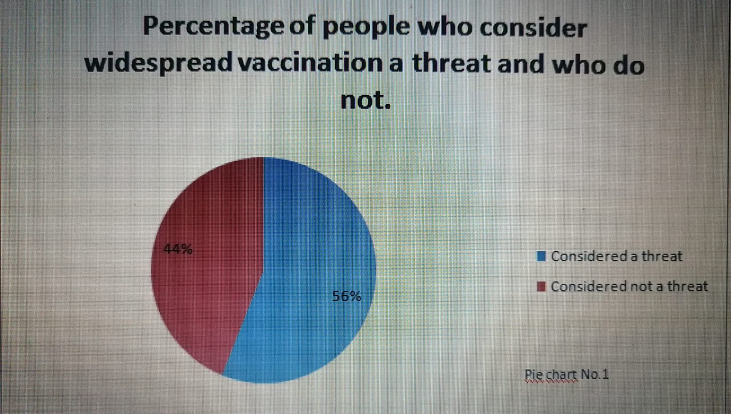

In the online survey, there was a question that can be answered with multiple answers. As a result, the most needed vaccines in society turned out to be the measles vaccine, the tetanus vaccine, the hepatitis B vaccine. At least 50 (max. 100) people chose these vaccines. According to interviews, these vaccines are necessary, in most cases MMR vaccines are needed, and tetanus vaccines are injected periodically, approximately every ten years. (linear histogram, No.1).

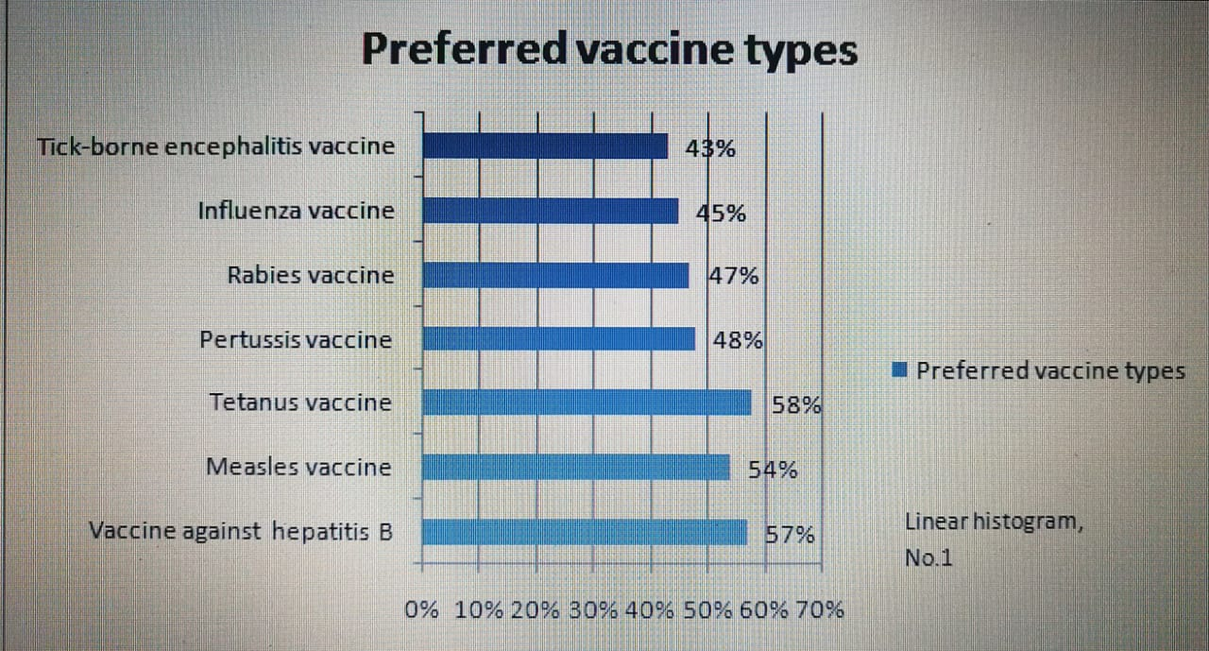

You can observe the main reasons for refusing vaccinations in the linear bar graph No. 2 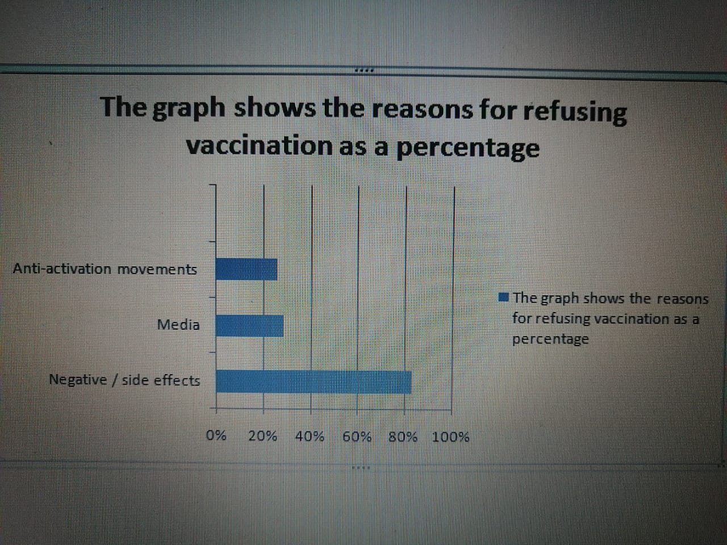

The results of the focus group discussions revealed more about the awareness and opinions of people about vaccination. As a result, the answers of the participants in the discussions are similar. They noted that there are few people in Kazakhstan’s society who are aware of the benefits or dangers of vaccines. They know more than the norm, only people who have received education (information) in this area, and also their relatives. A striking example is student B. But for the majority in our society, vaccination does not matter much, and only the current situation with COVID-19 makes us think about them. People are concerned about more pressing problems, as student A. Students are also well aware of ways to improve awareness of the importance of immunization and herd immunity. Students D and A ideas seem to be more effective in the shortest amount of time.

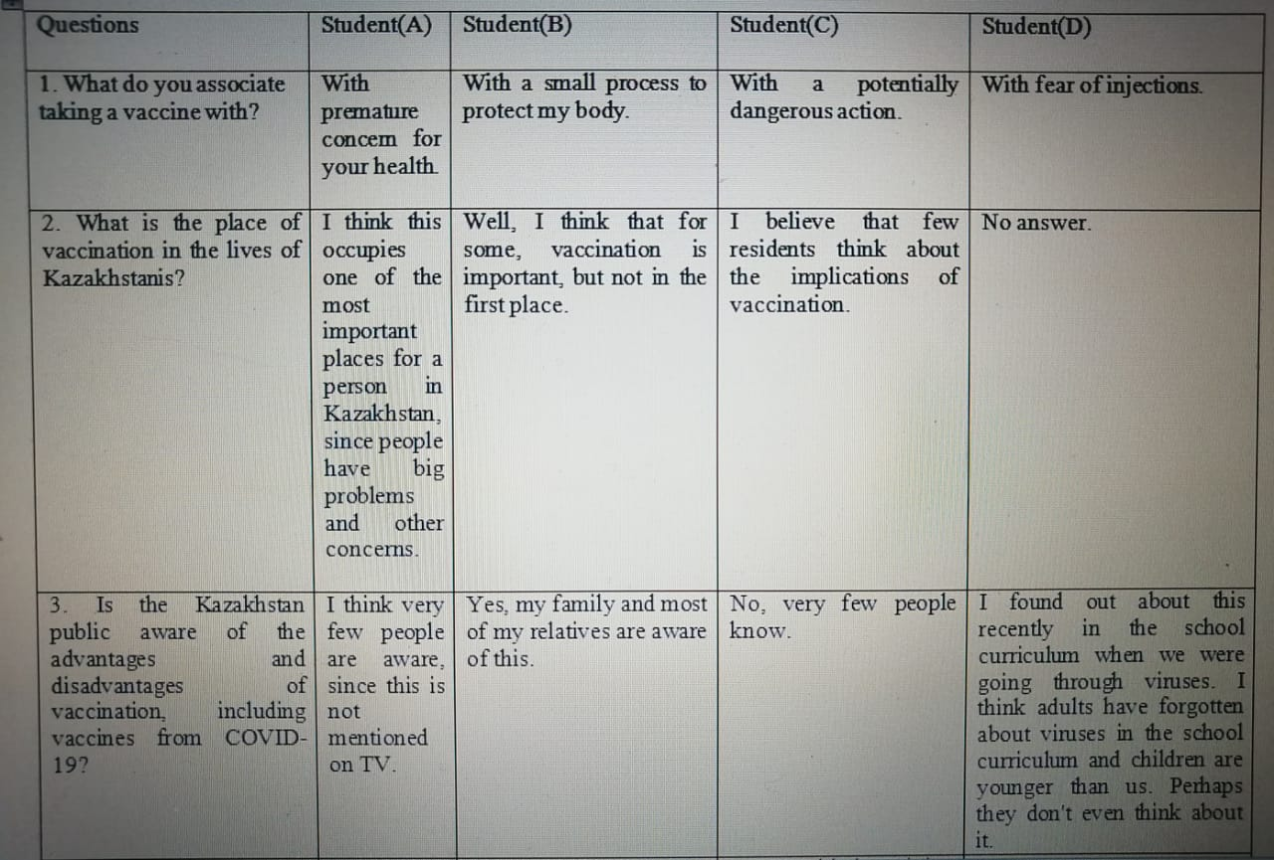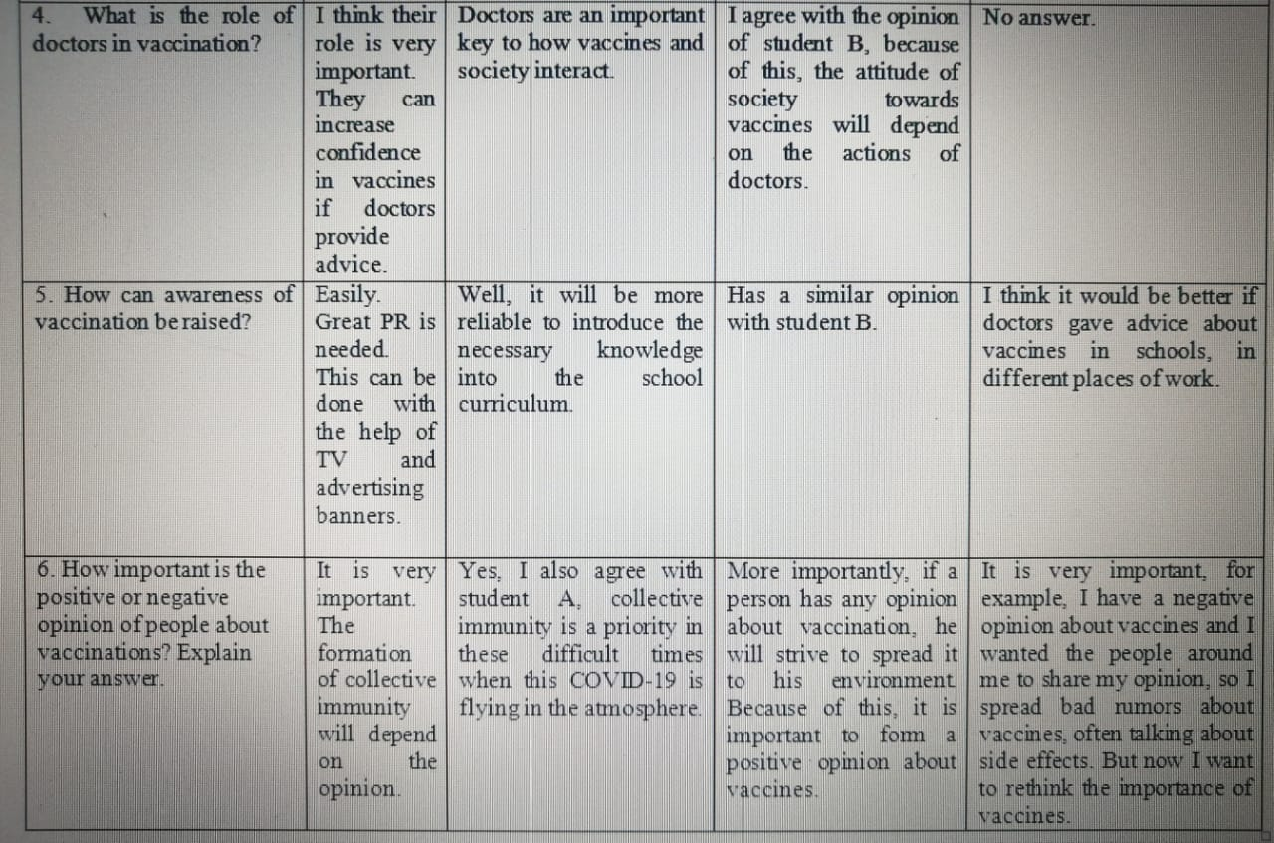

There was consensus among doctors that vaccination has the potential to save many lives for the entire world. For society, vaccination is useful in acquiring collective immunity, which, according to them, speaks of total resistance to a certain disease. Dr. A argues that everyone's input is needed to gain herbal immunity, while Dr. B believes that it will be important to get as many people as possible to get vaccinated, but it should not be overly stressed about it. After all, this is far from the main problem of public health. Dr. A said that in her personal experience, most people refuse to take vaccines due to health conditions or exposure to side effects. Dr. B notes that patients were anxious about their pre-vaccine health because of past experiences when they faced side effects and rumors about vaccinations. They note that the Sputnik-V vaccine is of poor quality and they often observe people who refuse to accept this vaccine today. But Dr. B herself refuses to take this vaccine due to the poor quality of the product. At the same time, both doctors share the same opinion about the importance of widespread vaccination, but in the future, when better quality vaccines become available that will not pose a risk to humans.

Questions:

2. Are you for or against widespread immunization with the COVID-19 vaccine? Why for, why not?

3. What do you think of the Russian COVID-19 vaccine, Sputnik-V?

7. In your practice, have there been cases when patients refused the vaccine (here we mean other vaccines besides covid-19)? Why did they refuse?

The interactions of these questions with the Doctors are indicated below in the Venn diagram.

(Numbered questions that were asked to doctors)

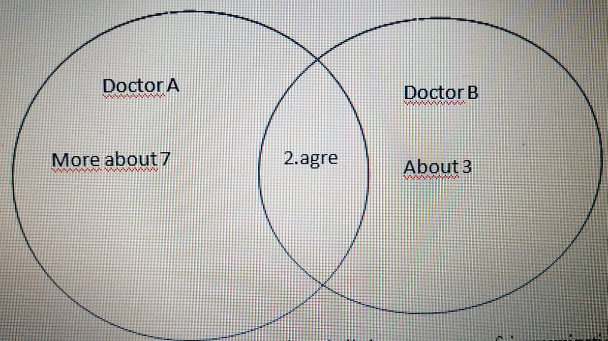

In conclusion, we understand that in Kazakhstan there is little awareness of immunization as a vaccine. Also that most people refuse to take the COVID-19 vaccine. Most often this is due to side effects and poor quality of the vaccine itself, for example, SPUTNIK-V. Most people trust vaccines that have proven to be effective. For example, the measles vaccine. that saves millions of lives. People have identified the opportunities that vaccination offers to society, with an emphasis on acquiring herd immunity.

**Conclusion**

The main aim of the research was: study the role of vaccines / vaccination in society, learn, how people perceive immunization, in order to understand the public opinion about vaccination and use this data as a direction for the vector of health care development. My hypothesis was confirmed because most of the participants who participated in the methods had a negative opinion about universal vaccinations.

•What are the benefits or disadvantages of vaccination for society?

Gaining collective immunity. This same benefit was mentioned in a second study, also the ability to prevent illness through vaccination. People note the side effects of vaccines and their poor quality, that is, the potential danger. This is also known from the Context. As a result, people who know more about the pros and cons of vaccines will feel more comfortable while interacting with them. The degree of confidence and generalization of the result is high, since doctors talk about it and there is a connection with reliable resources, where the results of the methods agree. Generalization arises from the survey, where the majority noted shortcomings. Moreover, each participant in the interview, focus group discussion noted the advantages that were known from the secondary research.

•What are the main factors that cause people to refuse from vaccination?

It can be seen the results of the survey in the conclusion. More main reasons for refusal are the media, the negative effects of vaccines, anti-vaccine movements. In the course of interviews and focus group discussions, other factors such as the quality of vaccines and poor health emerged. The same results were in the survey, but not the majority had such an opinion. And now all three methods show similarities in these reasons. This summarizes the results and makes them more confident. Moreover, in secondary studies, these factors were said to be the main ones. These findings are important for society, and such media coverage can change the way people think and diminish vaccine refusal.

•How does the population feel about large-scale vaccination?

Based on the results of the three methods, it can be noted with complete confidence that more than half of the population has a negative attitude towards large-scale vaccination at the moment. Dr. B also plans to be vaccinated, but only in the future. As experts say, this is most often due to the poor quality of the covid-19 vaccine. As a result, public opinion may change depending on the increase in the power of attorney for the vaccine itself. A similar opinion was expressed by some NIS students who took part in focus group discussions. This is a common feature for them.

•What kinds of vaccinations are mostly preferred by the general public? Why?

According to the survey, the most popular vaccines in society were measles vaccine, tetanus vaccine, hepatitis B vaccine. Frequent practice and accurate data provided by WHO have ensured public confidence in these vaccines. Doctors also agree with this. They highlight the important need for MMR and tetanus vaccines

I find my project useful because it is aimed specifically at understanding the relationship between vaccination and society. Through my research, I got unique opinions; I gathered important information through secondary research.

**Evaluation& Further Research**

The general population was residents of the city of Ust Kamenagorsk. The questionnaire collected data from residents of the city. Interviews were taken with two doctors from hospitals in the city of Ust-Kamenagorsk. While focus groups discussion was held between NIS students. In each method, there is a bias of people regarding the quality of vaccines, but doctors argued their perspectives more professionally.

The weakest part of the methods was the survey tool, because it was built on the docs.google platform, which only Google users have access to. This means that some people who do not have internet access or a Google account will not be able to complete the survey, although they were very interested in participating. Based on the answers, I can say with confidence that not all participants answered truthfully. To solve this problem, you need to conduct an offline survey. In this case, the person will be truthful and responsible, because eye-to-eye contact will be established. Despite some difficulties, the survey was successful and it was the best choice during the quarantine period, I collected enough answers to get general results.

Using three methods, especially focus group discussion and interview, I was able to pretty much get interesting answers that were related to secondary research. And the interview helped explain exactly how vaccine quality and universal vaccination can affect society. The strong point was that the interior was given by experts in their field, and the weak point was that not every medical staff wanted to give interviews and many deviated from the interview. The organization of the focus group discussion method was more time consuming, but the result was worth the cost. Using this method, I was able to get an analyzed answer to questions of interest. There is a strong connection between the methods of interview and focus group discussion. Participant analyzes were similar and generally confirmed secondary studies.

There were a couple of interesting, not expected points in the results of the study. Similarity between focus group discussion and interview results: the participants' analyzes were similar and generally confirmed by secondary studies. But what is more surprising and non-standard in this aspect is that students have a similar opinion with specialists. I was also surprised by the fact that most people note the poor quality of current covid-19 vaccines. This clearly speaks of their awareness.

According to the survey results, the required number of responses for generalization from participants over 35 years old is missing. Therefore, it is necessary to pay attention to the opinions of adults and the elderly. The interview or focus group discussion will include the same questions that were posed to the objectives. Observation is necessary to improve the quality of my research work. This observation will be how people will feel, what behavior will be in people who have received the covid-19 vaccine.

Using this method and additional time. Most preconceived notions about vaccines can be destroyed. Or you can be sure of the poor quality of the current vaccines. In any case, conducting further research, we get a complete picture of what is happening in the future. This will greatly facilitate the fight against this problem in our society. Hence, I see a lot of sense in further research.

For the most part, my views have not changed, but I got food for thought on some interesting questions. Such as the relationship between the quality and the result of vaccines or the globalization of covid-19, vaccination made me think and get a deeper look at this.

**The bibliography:**

[1]- World Health Organization. (2020). *Vaccines and immunization*. Www.who.int. <https://www.who.int/health-topics/vaccines-and-immunization#tab=tab_1>

[2]-  Hughes, R. (2019, June 19). *Почему все больше людей отказывается делать прививки?* BBC News Русская служба; BBC News Русская служба. <https://www.bbc.com/russian/features-48676305>

[3]-  Eggertson, L. (2010). Lancet retracts 12-year-old article linking autism to MMR vaccines. *Canadian Medical Association Journal*, *182*(4), E199–E200. <https://doi.org/10.1503/cmaj.109-3179>

[4]- *Vaccines and immunization: What is vaccination?* (2020, December 31). Www.who.int. <https://www.who.int/news-room/q-a-detail/vaccines-and-immunization-what-is-vaccination>

‌[5]- *Будет ли вакцинация от коронавируса обязательной, рассказали в Минздраве*. (2021, January 6). Liter.kz. <https://liter.kz/108455-2/>

[6]- “Это совершенно неприемлемо!” Ученые требуют данные испытаний российской вакцины. (n.d.). *BBC News Русская служба*. Retrieved February 13, 2021, from <https://www.bbc.com/russian/features-54283103>

[7]- Welle (www.dw.com), D. (n.d.). *“Спутник V”: за что ученые критикуют разработчиков российской вакцины | DW | 18.09.2020*. DW.COM. Retrieved February 13, 2021, from <https://www.dw.com/ru/sputnik-v-za-chto-uchenye-kritikujut-razrabotchikov-rossijskoj-vakciny/a-54963560>

**Appendix:**

Online questionnaire:

<https://docs.google.com/forms/d/e/1FAIpQLSenfUHnFgaVG6Yn_Y3347AQwnPr0CZonID1bFN7VOhqqB4VYg/viewform> - questions

<https://docs.google.com/forms/d/1L8OYy4-Og75MLBkwGzSV6CqMVa9D9KM522KNMFZT2vo/edit#responses> –answers



Focus group discussi

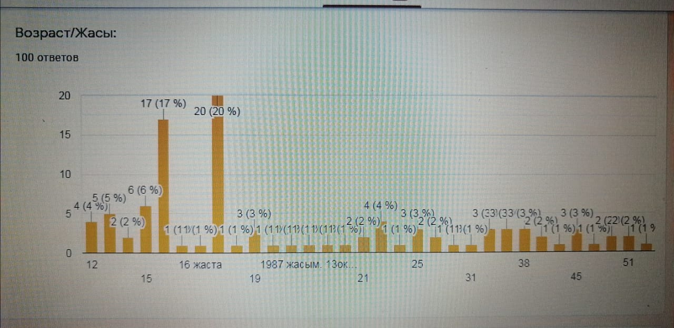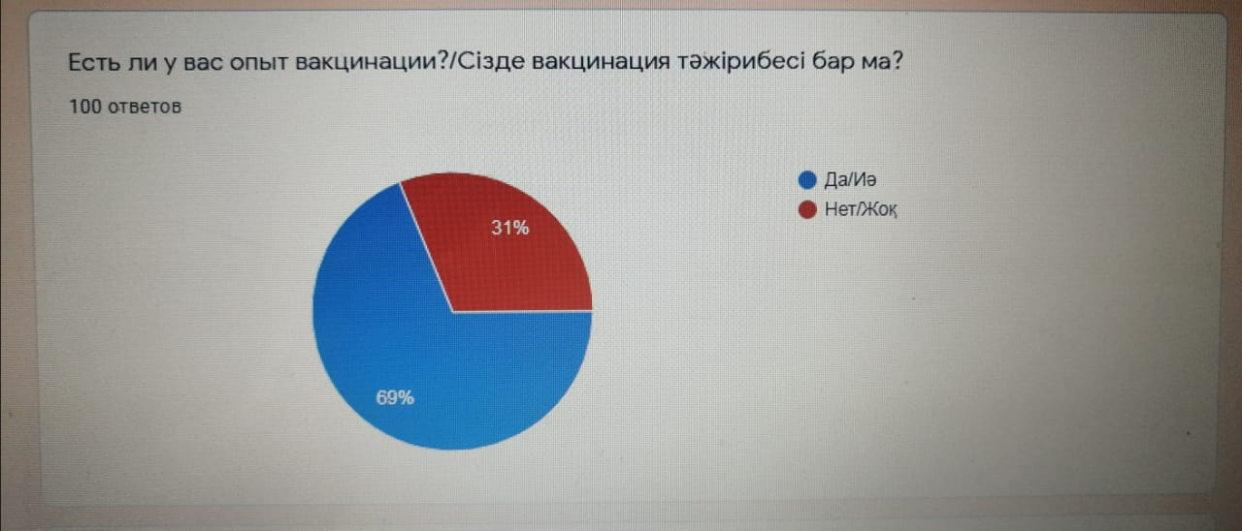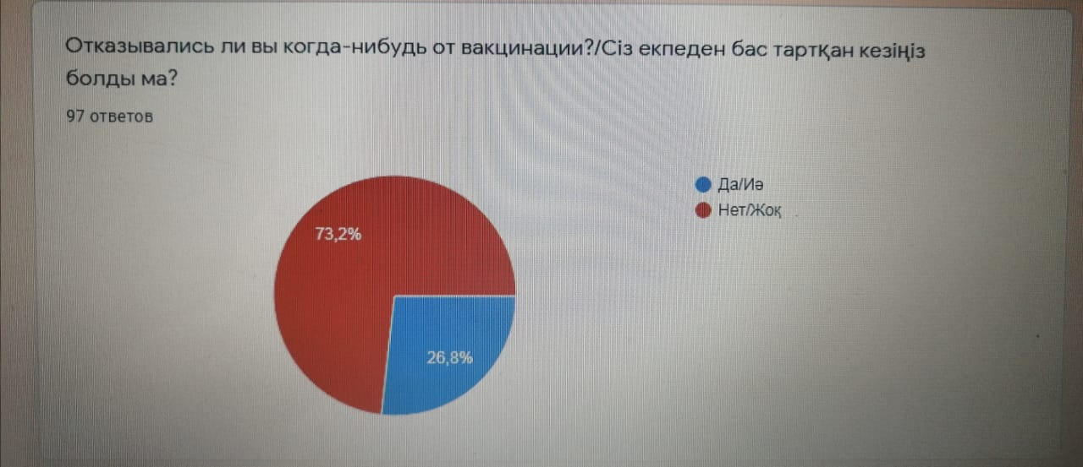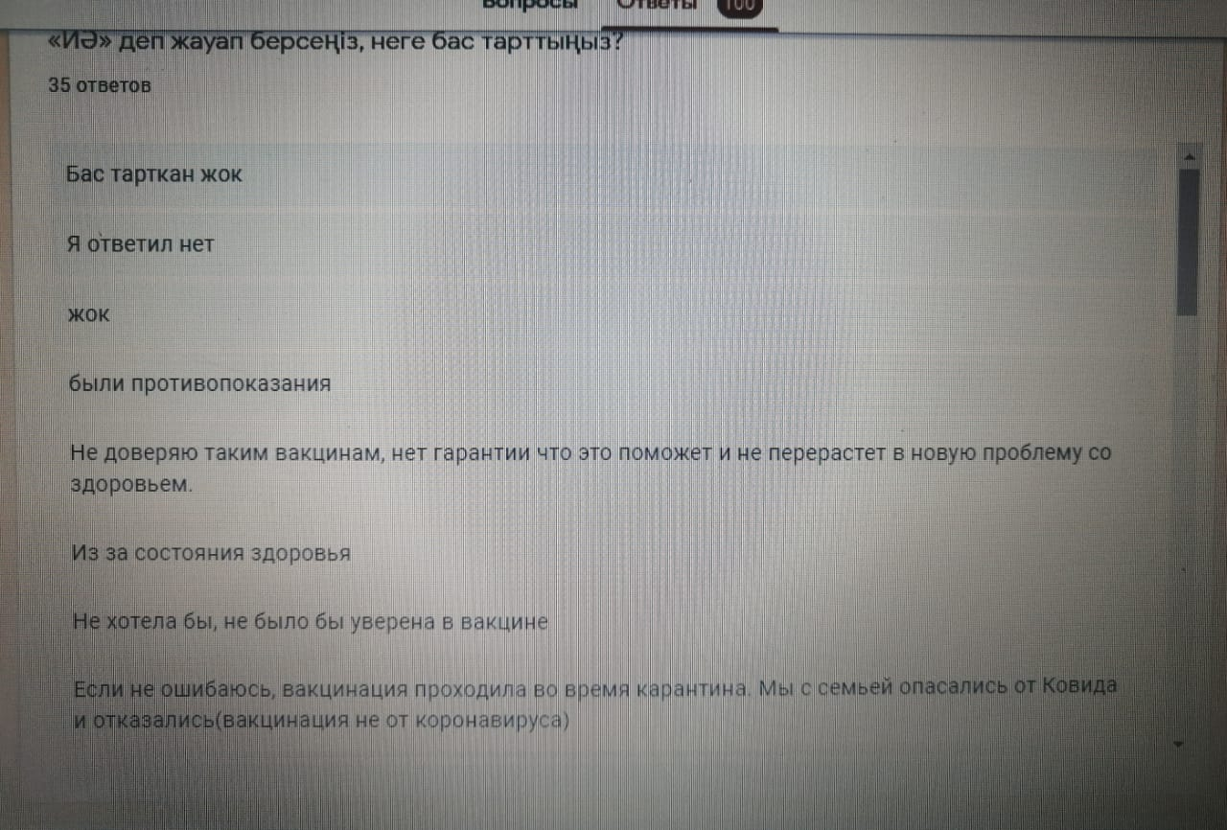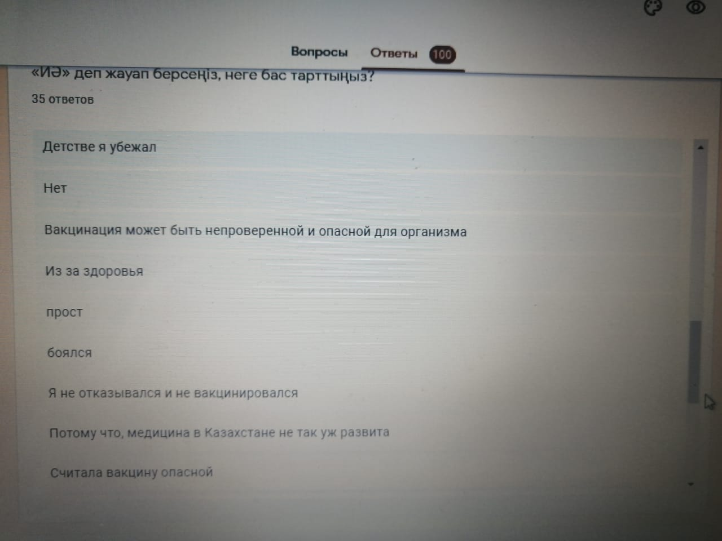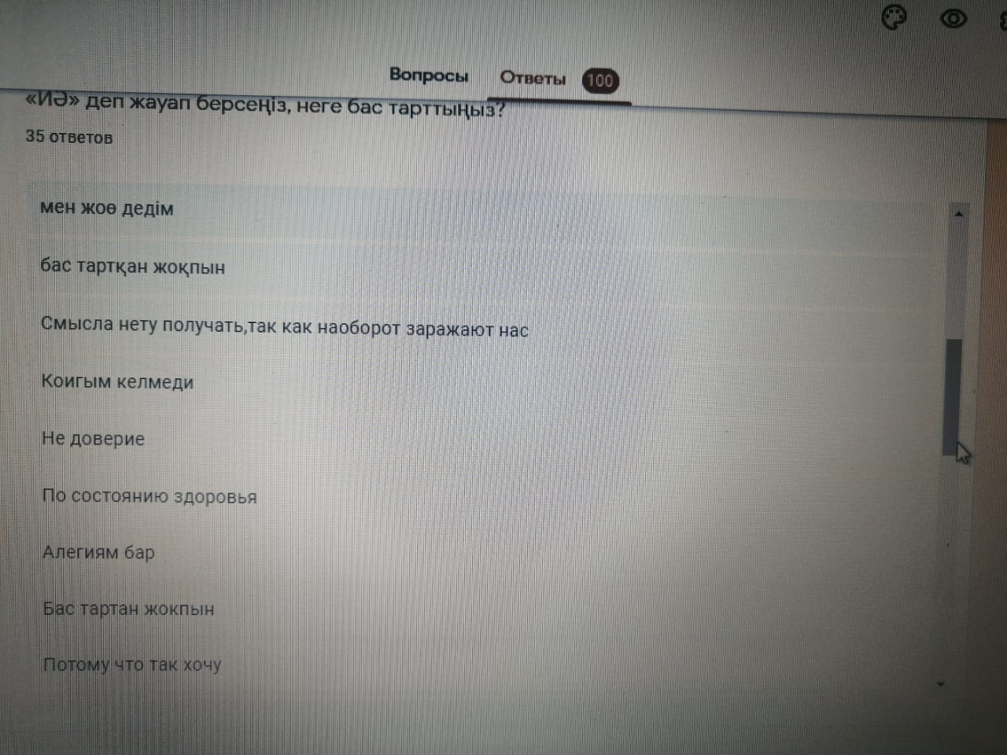

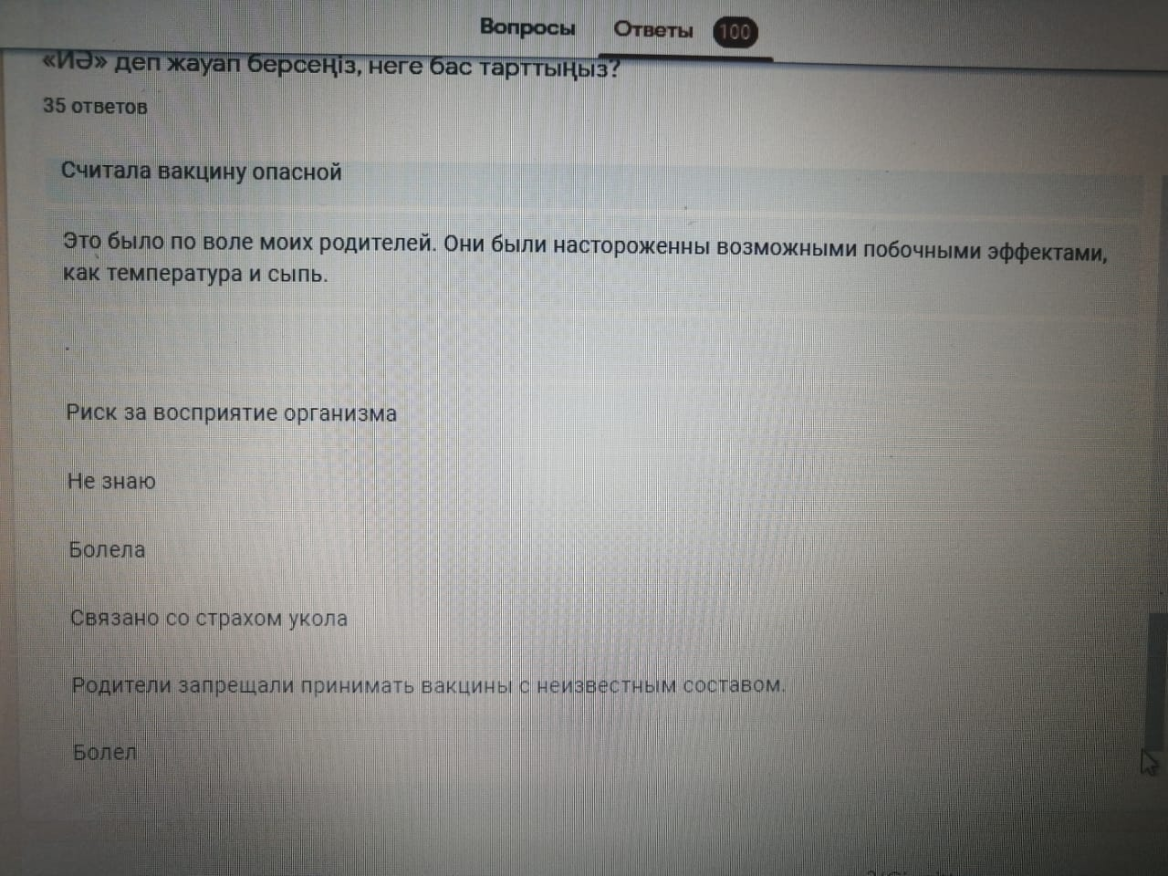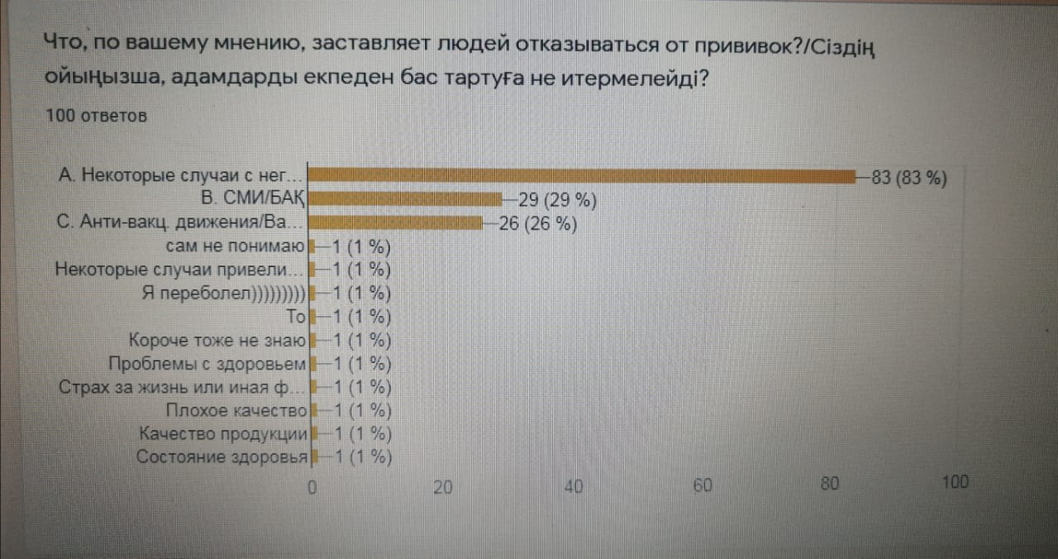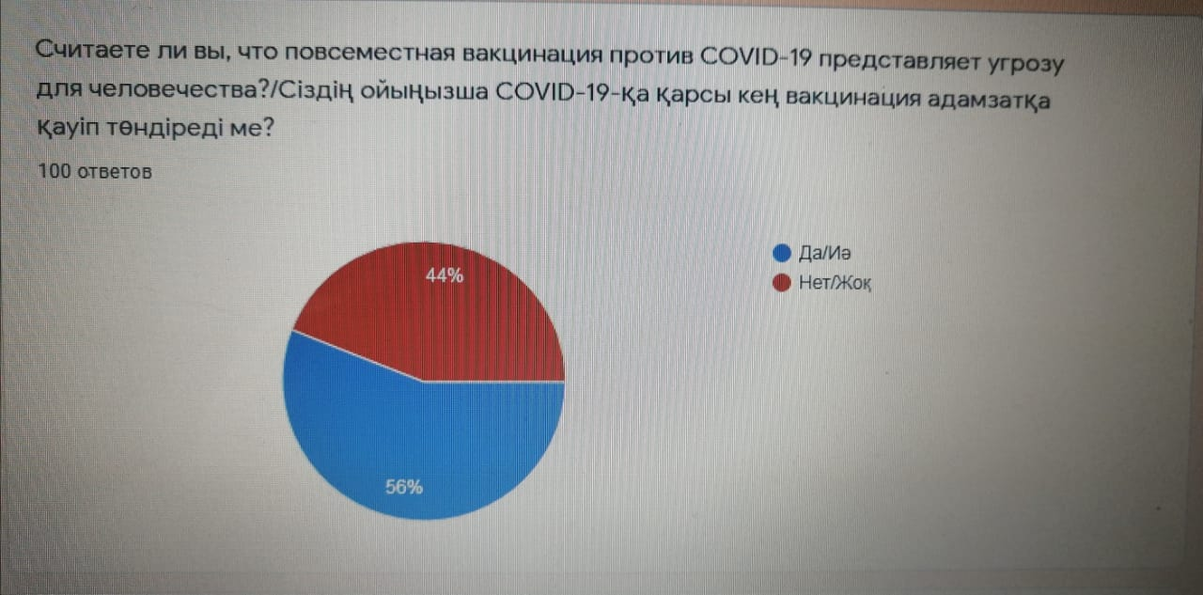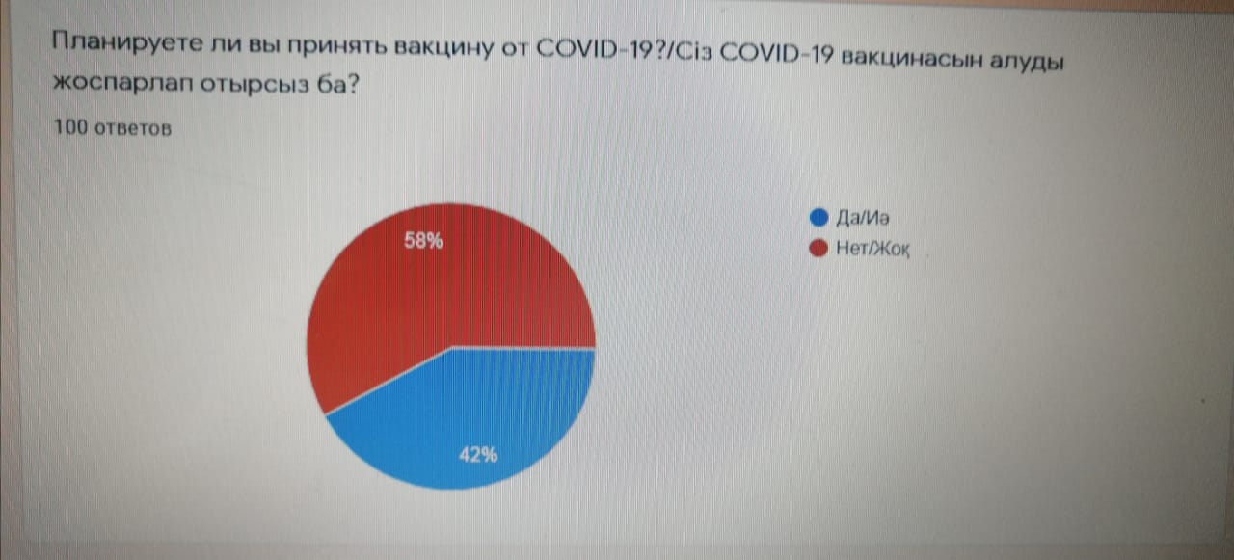

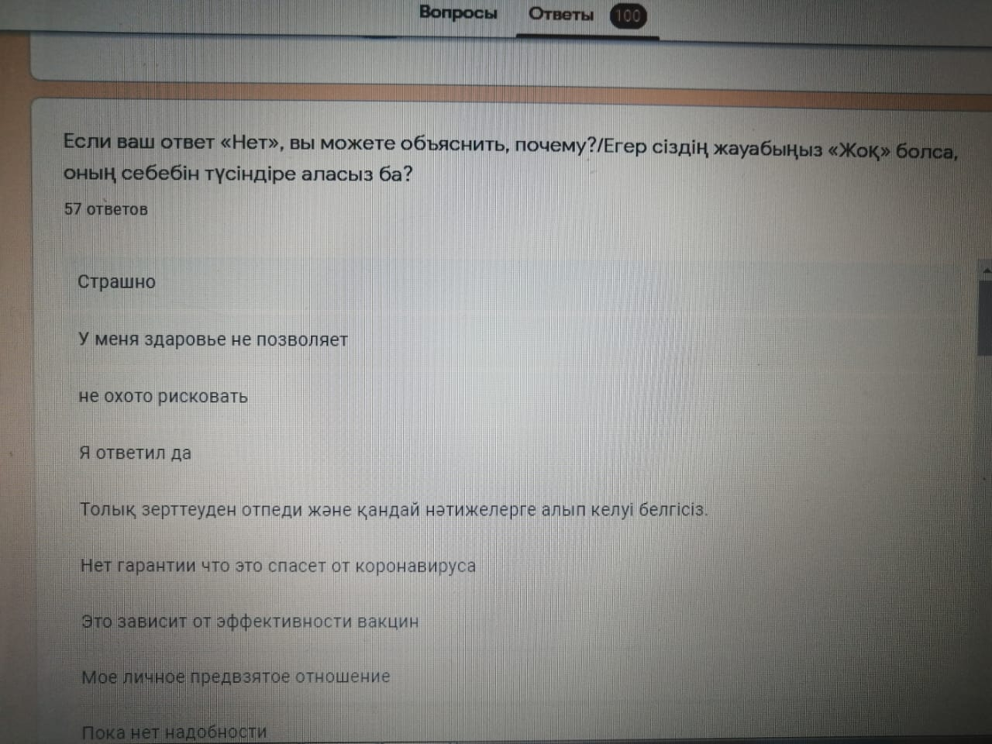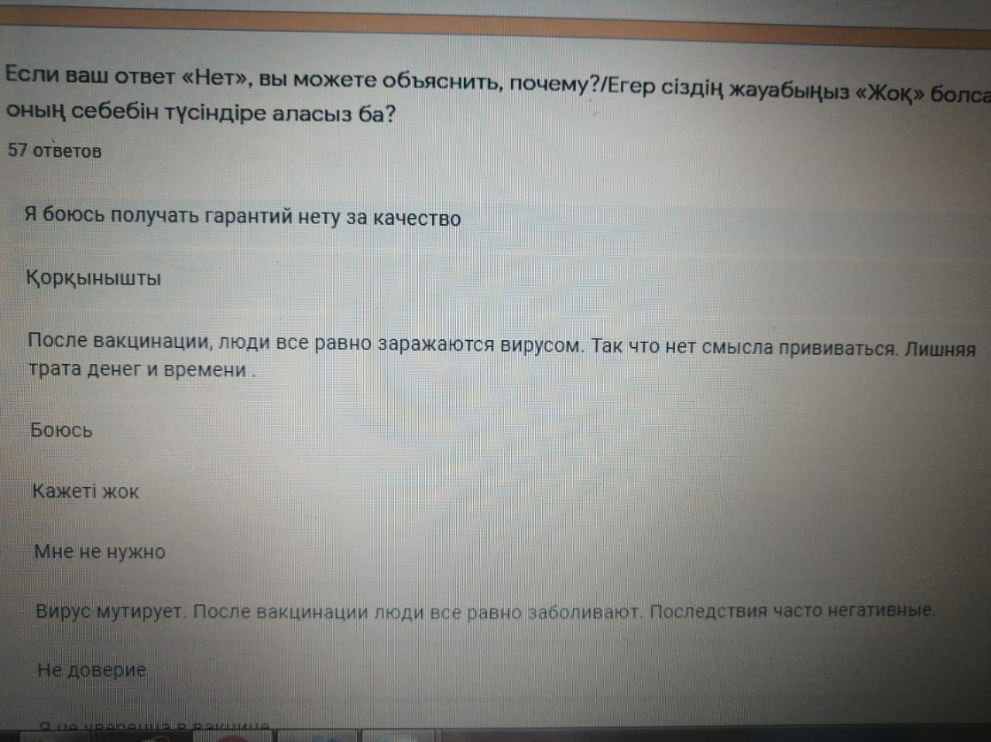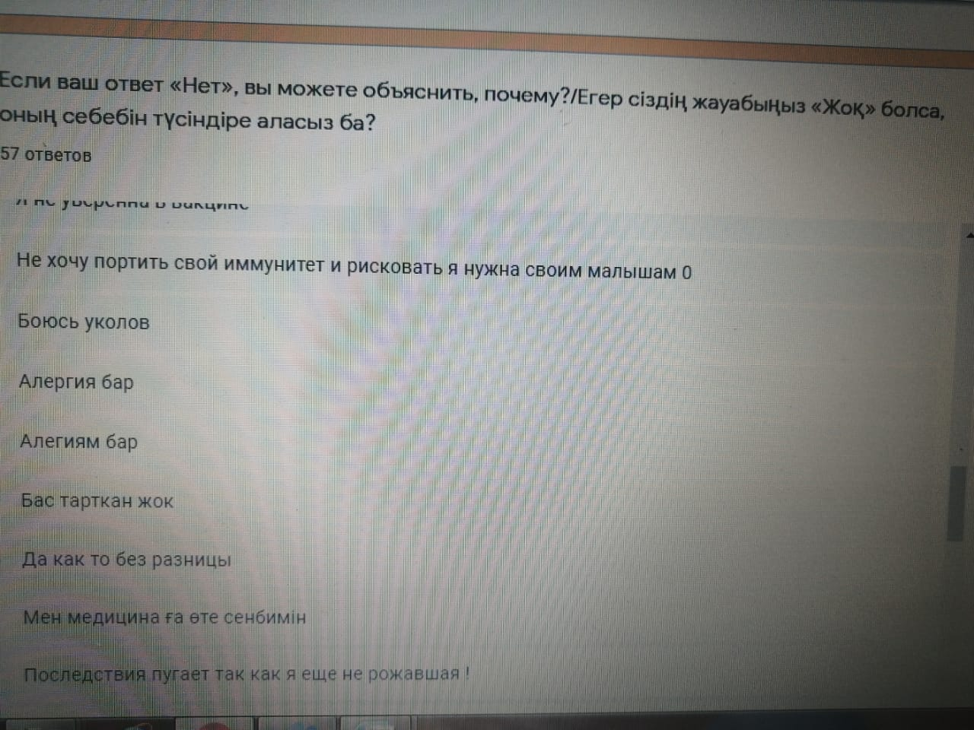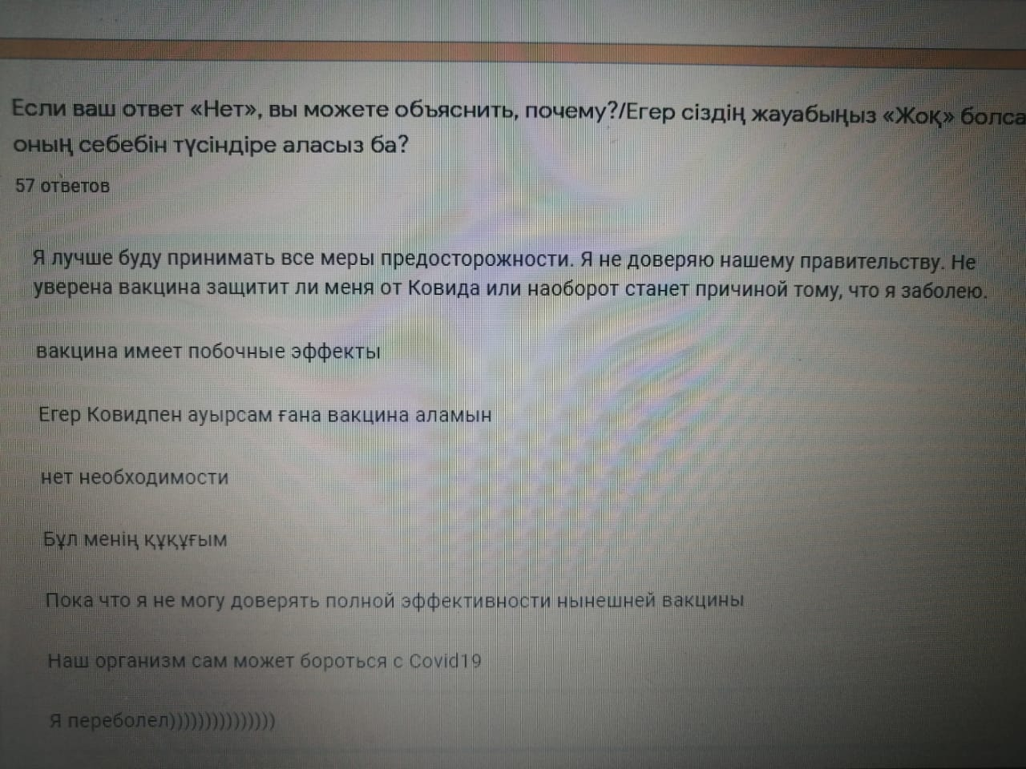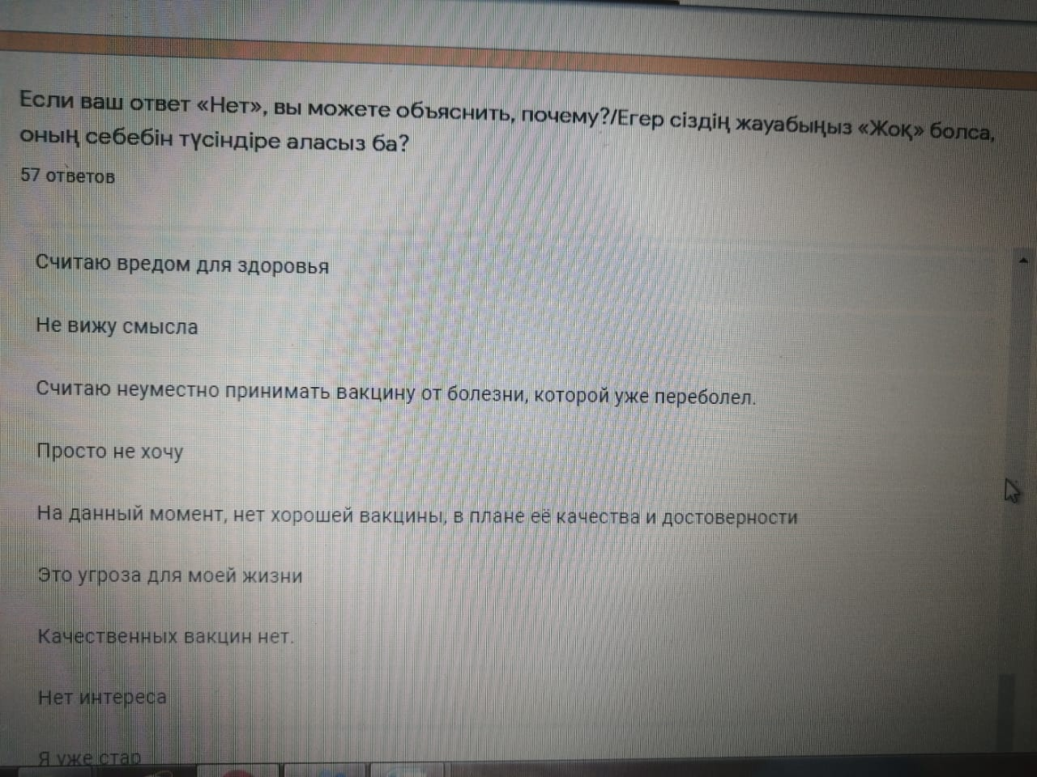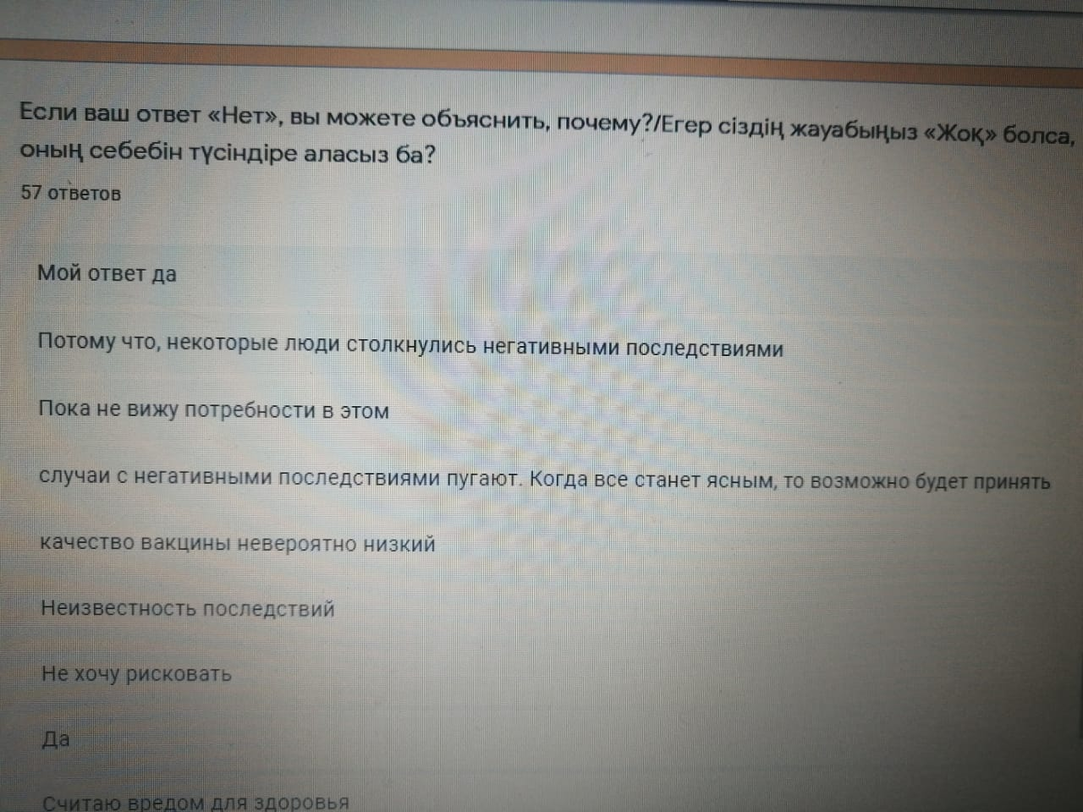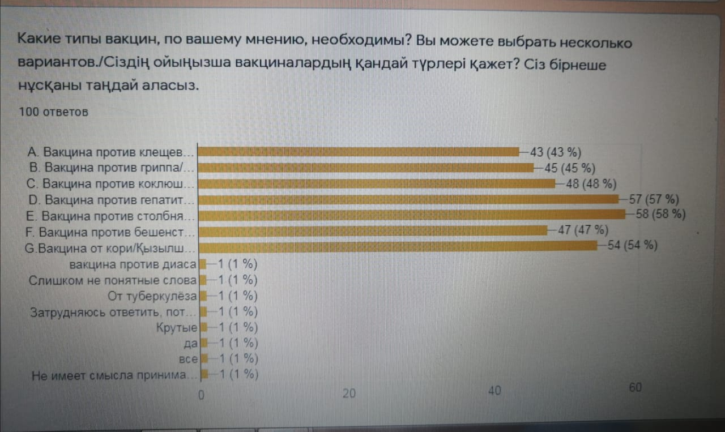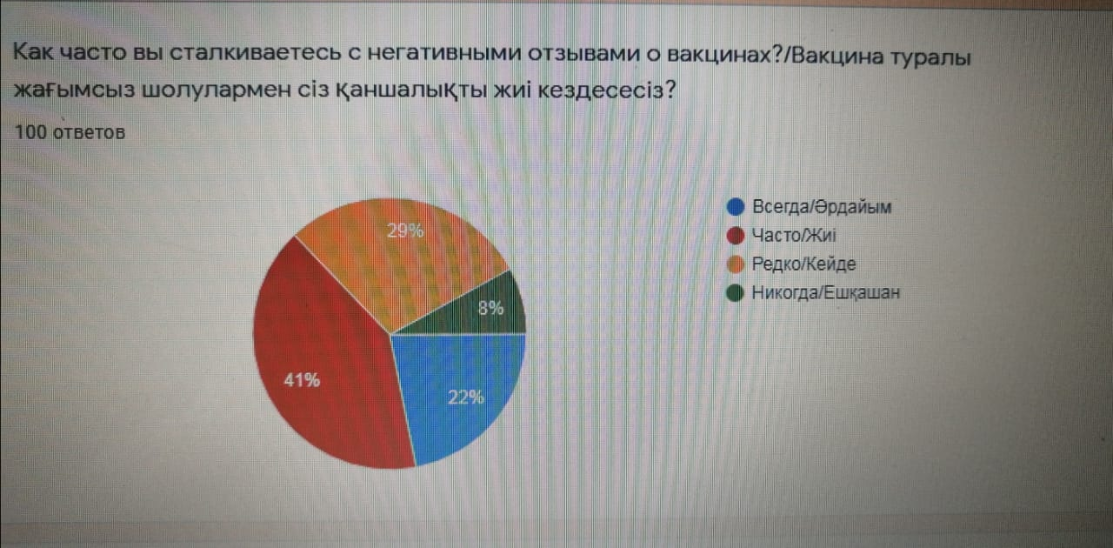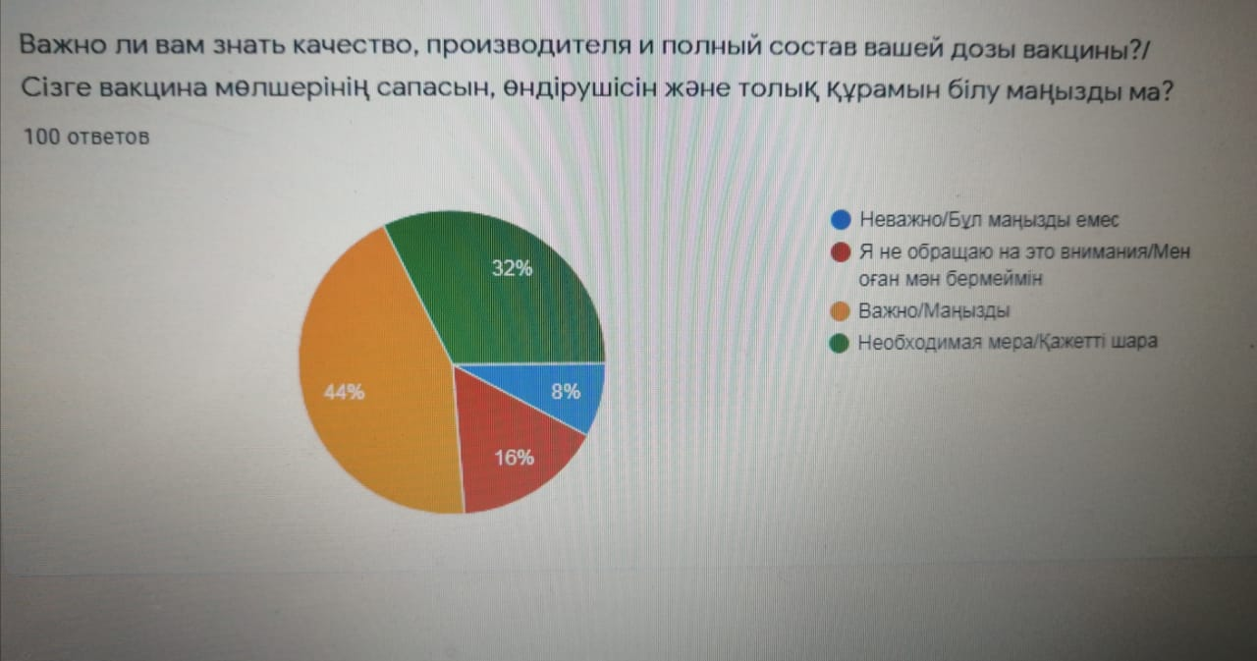

Focus group discussion:



Interview:

Questions:

-Is there a pattern between growing up and being vaccinated?

-Are you for or against widespread immunization with the COVID-19 vaccine? Why for, why not?

-What do you think of the Russian COVID-19 vaccine, Sputnik-V?

-What do you think about public awareness of vaccines and vaccination in general?

-How would you rate the importance of awareness in Kazakhstan?

-What disadvantages of the vaccine for human health can you identify?

-In your practice, have there been cases when patients refused the vaccine (here we mean other vaccines besides covid-19)? Why did they refuse?

-How can you raise awareness about the harms or benefits of the COVID-19 vaccine?

-What do you think about raising public awareness about vaccines and immunization in general?

-What types of vaccines are in demand among patients? Why?

In your practice, are people more likely to take or refuse the vaccine? Why?

With Doctor A:

-Hello, I'll ask you ten questions about immunization.

-Hello, well let's start.

-Is there a pattern between growing up and getting vaccinated?

-Definitely there, it all depends on the immunity of the vaccinated. And as we know, the immunity of children, adults and the elderly is different.

-Are you for or against widespread immunization with the COVID-19 vaccine? Why, why not?

-I am in favor of vaccination, because it will give lymphocytes, that is, the immune system, the ability to fight pathogens. Thus, societies will acquire collective immunity against covid-19. To do this, you need to attract as many people as possible. I believe that everyone should contribute to gaining herd immunity.

-What do you think about the Russian vaccine against COVID-19, Sputnik-V?

- Honestly, I have not studied this vaccine much. As for me, this is another vaccine and there is nothing special about it.

-What do you think about public awareness of vaccines and vaccination in general?

- I think people only know superficially about vaccines. Most of my acquaintances do not attach much importance and patients do the same.

-How would you rate the importance of awareness in Kazakhstan?

-As I said earlier, we have little awareness, but I assess this as a bad indicator. People need to be aware of all matters, and when it comes to health, even more so.

-What disadvantages of the vaccine for human health can you identify?

-In fact, vaccination has many advantages, but there are also disadvantages. Such as, the natural decrease in the immunity of the baby. Moreover, the drug does not give a 100% guarantee that a person will never get sick in the future.

-In your practice, have there been cases when patients refused the vaccine (here we mean other vaccines besides covid-19)? Why did they refuse?

-Yes, it happened because the patients were afraid for their health or they already had a bad vaccination experience. Those who were afraid for their health often had weak immunity.

-How can you raise awareness of the harms or benefits of the COVID-19 vaccine?

-I give advice in the vaccination process, but I think I alone will not be able to change a lot. It would be nice if instead of advertising on TV they showed the benefits of vaccines.

-What do you think about raising public awareness about vaccines and immunization in general?

-This is a good idea and will most likely help avoid misunderstandings between vaccines and the public.

-What types of vaccines are in demand among patients? Why? In your practice, are people more likely to take or refuse the vaccine? Why?

-In my practice, people are more likely to take vaccines, I think they are not afraid of vaccines and take it rationally. Soon there will be a great demand for covid-19 vaccines. And most likely it will be a better version of the Russian vaccine and the Chinese vaccine against covid.

With Doctor B:

-Good afternoon, I'll take an interview from you, the topic is related to vaccination.

-Good day, I'm ready to answer your questions.

-Is there a pattern between growing up and getting vaccinated?

-Yes, for example, the vaccine against covid-19 is not given to people under 18 years of age and people over 65. This is because there is a great risk to their health. Also, we do not have complete confidence in their safety, since their immunity is weak.

-Are you for or against widespread immunization with the COVID-19 vaccine? Why, why not?

-I'm mostly in favor, but it's worth considering the current quality of vaccines. I think in the near future it would be prudent not to vaccinate everyone. But only people who often come into contact with people. However, in the future, it is necessary to carry out a total vaccination. Then the society will be able to resist the disease and thereby stop its spread. For now, it is worth focusing on the more pressing public health issues.

-What do you think about the Russian vaccine against COVID-19, Sputnik-V?

- I don't have a very good opinion of this vaccine. It is presented as good quality, but I already realized that this vaccine is of poor quality. First, it didn't take long for testing and observation to judge the vaccine itself. Second, most non-CIS scientists criticize this vaccine. And I agree with them to some extent.

-What do you think about public awareness of vaccines and vaccination in general?

- I think we have low awareness of vaccines and their benefits.

-How would you rate the importance of awareness in Kazakhstan?

- I think this is very important. It would be good if the parents of today's children became more aware, since recently there has been an increase in the rate that children stop receiving vaccines, due to the fact that parents are against it. Well, I also know that already in schools it is said about biotechnology and because of this I think the future generation will be more aware of this issue.

-What disadvantages of the vaccine for human health can you identify?

-Well, these can be side effects, people with weak immunity can get sick to the fullest. And thus for them vaccines will be like a suicidal measure. Or if you wet it with water, the injection site may swell, although this is only a small drawback.

-In your practice, have there been cases when patients refused the vaccine (here we mean other vaccines besides covid-19)? Why did they refuse?

-In my practice, most of those who refused to vaccinate were worried about their health because they had heard about side effects, or experienced them themselves.

-How can you raise awareness of the harms or benefits of the COVID-19 vaccine?

- I think using Internet resources is the best way out, I'm a busy person, but even so I devote time to Instagram. And you can post catch phrases that raise awareness of vaccines in our society.

-What do you think about raising public awareness about vaccines and immunization in general?

- I think this is a great idea, but you shouldn't put all your efforts into it, it can be done as a secondary matter. There are many more problems that need to be addressed. For example, grants for a new generation or knowledge of a new generation. We are not eternal to replace us with new minds. and now we need to help them grow as specialists.

-What types of vaccines are in demand among patients? Why? In your practice, are people more likely to take or refuse the vaccine? Why?

-Well, vaccines for tetanus are adopted annually and there are a number of such vaccines that are administered to children or adolescents for their future safety, such as MMR vaccines.