What is the effect of insomnia on human well-being in 2021?

Study of human psychology:
Effects of insomnia
Zhumagulov Amir
Nazarbayev Intellectual School, Oskemen
Word count: 3986

Introduction
More and more people are experiencing insomnia lately, which affects their well-being. Most people with insomnia complain of insufficient sleep or poor sleep. In addition, sleep disturbance, especially in adolescence, can lead to depression in both men and women and to an increase in the concentration of stress, consequently, to an unintentional aggressive behavior. Unstable behavior of persons and murders committed by them due to problems with sleep have already been recorded. For instance, in 1878 Simon Fraser killed his 18-month-old son thinking that he had the monster from his frequent nightmares on his neck. My research was intended to answer the most possible questions that may arise about insomnia disease.
Although I do not suffer from insomnia, however, I have already encountered people who suffer from this disease. The surprising thing is that in some cases, people did not take it seriously or did not know what to do. It would be nice to know what to say to people in such situations and how to help them with their disease. Therefore, I would like to prepare for a possible problem that can appear in the future or even better to know how to prevent the possible occurrence of it.
The only potential bias is that people with insomnia, that are comparable to people with depression, often try to hide their problem as much as possible and behave as if nothing had happened. That can lead to the fact that the collected data will seem a little deceitful and unsaid to me even after several rechecks. I also think that many people with insomnia may think that their condition is temporary and will not attach importance to it, because of which they may give irrelevant data.
I hope that my research will somehow help people with insomnia or people who have similar ones, but they do not know what to do with their issue and fear. Namely, to lead to a solution to their problem or simply to inform about it. For example the opportunity to learn various preventive methods for the treatment of insomnia. Otherwise, can get information about the causes of the problem.

Context
Nowadays it is very easy to see people with bruises under the eyes, wrinkles or a tired look at an early age. This indicates that they have a sleep disorder that is characterized by insufficient duration or poor quality of sleep, or a combination of these phenomena over a significant period that is known as insomnia. In addition, right now it is most common because there are more reasons for the occurrence and the past had a greater impact. Unfortunately, for many people this ailment has already become a part of their life.
This disease is often underestimated, although in fact it is very serious and has various consequences among adolescents as well as adults. A person may be experiencing such issues as depression, anxiety, bipolar disorder, schizophrenia. In fact, some people have a rare genetic disorder called fatal familial insomnia, which prevents sleep and can be life threatening (Raj Dasgupta, MD, 2020). Moreover, a lack of sleep is a key factor in motor vehicle accidents (NHTSA, 2018).
An increase in the number of people facing this problem is also closely related to the development of technology. According to the researches, using devices with screens before bed can cause a loss of sleep in young people. Considering the fact that almost all people consider the media, the Internet and their phones an integral part of their lives, this habit becomes impossible to get rid of in many teenagers and even adults. Which leads to the conversion of the required 8 hours of sleep into 4 - 6 hours (Child Adolesc Psychiatr Clin N Am, 2017-2018); (University of Ottawa, 2020).
However, if we consider this problem from the perspective of an ordinary person, it becomes clear that not everyone despairs when they discover insomnia and even finds a small plus in it. That is, the presence of insomnia often leads to a person's awareness that his life could go on the wrong path and everything needs to be radically changed. Starting with treating lack of sleep.
There are enough therapeutic methods and treatment of insomnia. If we consider preventive methods, then lavender and chamomile tea are more suitable, since they are both painkillers and antidepressants presented in a small dose that does not harm the body (Chokroverty, 2017). Nevertheless, it is worth highlighting such a procedure as cognitive behavioral therapy. CBT is a short-term therapy technique that can help people find new ways to behave by changing their thought patterns, since insomnia is primarily a psychological disease (Vara Saripalli, Psy. D. 2018).
Although, if we consider topic of insomnia from a person who understands this issue or researched it, then we can find that not everyone designates it as a problem and for everyone the amount of sleep and their preferences of sleeping or not are individual. One of the reasons for insomnia is the obsession of a person with insomnia. For example, people often ask questions such as "How long?", "How much is normal sleep time?" Nevertheless, not everyone needs the "full" dream that everyone is talking about. For example, the same Madonna, Bill Clinton and Dan Brown (Tony Parsons, 2018).
At the same time, if we look from a local point of view, the state of sleep in Kazakhstan is not at its best. About 30-35% of the population suffers from insomnia. Among 84 types of classified sleep disorders, insomnia ranks first, with complaints about which almost every doctor faces every day. A common cause of insomnia is a decrease in physical activity during wakefulness due to suboptimal work and rest regimes or limitation of life activity (Medical company Suncar). This even more affects Kazakhstanis as in our country 42 percent of residents are rural (National Bureau of Statistics of the Republic of Kazakhstan, 2018), since many lead an agricultural lifestyle due to which their daily routine may be disrupted.
Taking everything above into account, the number of people suffering from insomnia has increased and the causes for their occurrence increased. Despite this, the number of ways to improve person’s well-being with this problem or solve it is also sufficient. Moreover, looking at the trend over time, there is more and more information about this issue.

Aims
The main purpose of this research is to find out what effect insomnia has on the daily life and well-being of people, what can possibly cause that disease and what should people do to treat themselves based on their experiences. At the same time, it is also necessary to study the influence of insomnia on the people of Kazakh nation. In order to answer the main question posed, it was necessary to collect more information about this topic.
Aim questions:
- How common is insomnia?
- Who is more likely to face insomnia? Adults or young people?
- What are the main causes of insomnia?
- What are the possible consequences of insomnia?
- What are the common ways to treat insomnia and how effective they are?
Hypothesis: I believe that the effect and causes of its occurrence will be very easy to identify, as well as the testimony about their condition that the respondents will give will be inclined for the worse. Firstly, because people often exaggerate their problems, and secondly, there are also many serious cases. I also tend to think that in Kazakhstan the problem of insomnia is more common than usual, at least because both in my family and in the families of friends there are people who have certain problems with sleep. Although, also from personal experience, the effect of lack of sleep on people in my region is not as serious as it can be.

Methods

Appropriate research methods are one of the keys for successful research. That is why it is important to choose the right methods. The topic and the process of the research directly depends on interaction with people, method section is necessary. Since their main purpose is to collect information by showing the attitude of people to this problem. I used mixed research design, since it is necessary to identify qualitative motives and ideas that are related to the topic and after that get the data in quantitative form, which helped in the future to make a conclusion.
The first method is survey. This method is quantitative, i.e. it shows the ratio of answers to certain questions provided and their number in a certain group of people differing in age and gender. The reason for choosing this method is that survey provides opportunity to ask questions that depend with the problem to big number of people and obtaining results in a relatively short period. In addition, it is the easiest way to summarize all the information and opinions in a structured way. Hence, it is much easier to make an appropriate decision. It is important to get information from public, because problem of insomnia is widespread, regardless of race and nationality, since even a healthy person can be exposed to it. Therefore, it is significant to choose correct questions in order to make an overall picture of the issue and answer research questions. However, the main disadvantage is that you do not know whether the respondents gave honest answers and there is a chance that the answer given by the majority may turn out to be absolute nonsense and not practical in some way.
All methods are chosen to answer main research questions. Survey’s questionnaire contains questions that will help to answer them. For instance, there are questions where respondents assess the statements made, thereby setting their priorities and giving an understanding of which answers are most common in the modern world. It is important to understand how different age groups’ opinion about the problem is. The reason was that insomnia is common in all ages, but it is presented in different forms.
The next method is an interview. The reason for its use is that it is a qualitative type. I.e. its main aim is to understand and find out the answers questions, which reveal the features of this problem on a given topic in order to determine the concentration of the obtained results in society in further quantitative method. Secondly, this method gives an idea of the topic and in the next method allows the discussion to be conducted at a slightly better level of understanding. It is necessary to interview a specialist that is qualified in this field, because specialist still know more than an ordinary person and able to give a relatively concise, reliable and easy-to-understand answer. This method is to help understand patients’ (people with insomnia) feelings, mental state and changes in their lifestyle in more detail way. For discussion was invited a person who is specialized in somnolology and branches of medicine that interfere with insomnia.
Interview includes eight questions, the speaker was not limited in time to answer the questions, since the problem that is raised in the research is quite difficult to answer quick and relevant. All answers that the interviewer gave were
rewritten to analyze them in appropriate way. The main problem was to find a comfortable time to interview. Nevertheless, it made it possible to get detailed and understandable answers to the questions posed without unnecessary talk. The answers from this method after was used in focus group discussion.
Final method is focused group discussion. This method is considered qualitative as it is aimed at a narrower group of people who, in the process, share their opinions and perspectives. Different points are mentioned to look at the problem from the different sides and form a position according to all the aspects that probably were identified in the discussion. By the way, group that was chosen it is the people who faced the problem of insomnia, either at home or with loved ones, or right during the discussion had various problems with sleep. In order to have contrast viewpoints the sample group were people who have different views and opinions in some ways.

Results
The survey was conducted among 30 people from different areas of Kazakhstan; the interview was taken from a specialist in the field of psychotherapy from the city of Ust-Kamenogorsk; the social experiment was not conducted.
The first question that pops into your head when considering the topic of insomnia is how widespread it is in the society. According to the results of the survey, in general, 40% of surveyed have problems with insomnia. Of course, most people (60%) have not encountered this problem (Figure 1). Nevertheless, this does not negate the fact that the presence of insomnia in every 2 out of 5 people is a lot. It can be concluded that the problem is common based on the results of the survey and the testimony of the focus group.

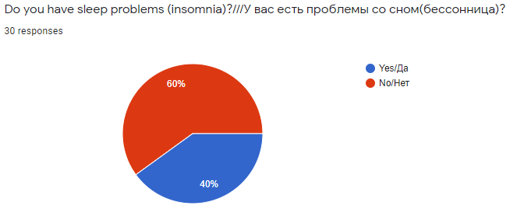
Figure 1

It is noticeable that most people who have sleep problems are adults. More precisely, 83.33 percent of those who have sleep problems are people over the age of 20 and the ratio of adolescents who suffer from insomnia to the total number of respondents is the smallest among the others - 6.67% (Table 1). Therefore, when it comes to the question of who is more prone to have an insomnia, the testimonies of all three methods coincide. Because based on the results of the survey, people who disagree or completely disagree with the statement that adults are more prone to insomnia 4 times less than people who agree or completely agree with it (Figure 2). In addition, according to the specialist herself: "in my experience, most of the people who came to me because of sleep problems were adults and elderly people". During the discussion by the focus group, it was agreed that adults have more problems and their daily schedule is clogged, which leads to greater tense and potential stress.

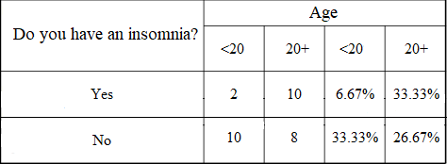
Table 1
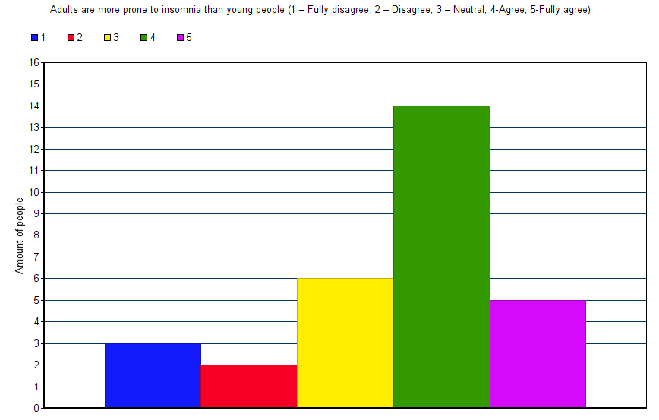
Figure 2

Considering the causes of the occurrence, there were both the same identified results and inconsistencies between survey and interview. Namely, it was revealed that, according to the results of both methods, stress and pain are the main causes of the occurrence and development of the disease. However, there was a difference between the indicators of the respondents and the specialist. According to the Figure 3, 80% of respondents think that lack of physical activity either cannot lead to insomnia, or is insignificant, while the specialist confirmed that most people suffering from insomnia often did not do any sports, that is, they did not have a way to unload the body from tension. This may be because people are used to throwing everything off on external factors and do not accept their fault when they are also guilty in something, in this case, the presence of insomnia.

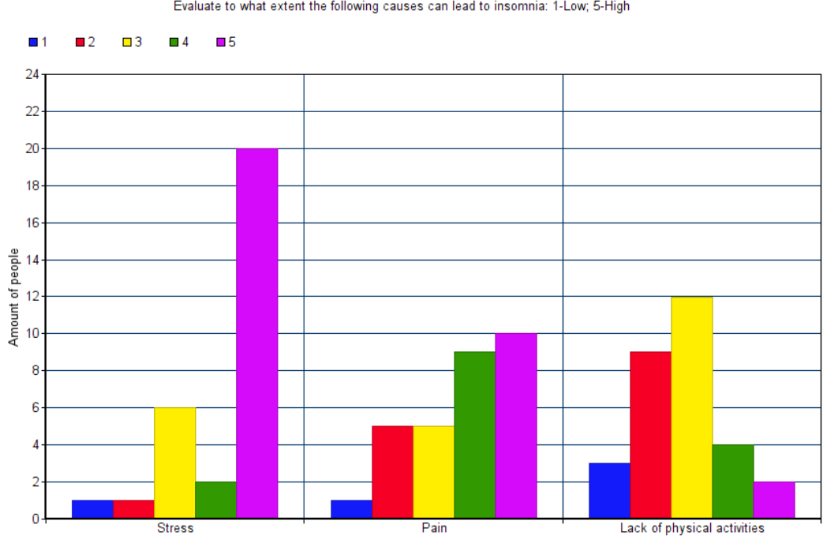
Figure 3

The most likely consequences of insomnia are depression and a decrease in working efficiency. The reason for this statement that more than 90% of people think so (Figure 4). Moreover, according to focus group participants, who previously suffered from insomnia, they say that insomnia does not always make it possible to think soberly, which leads to the fact that a person drives himself into depression and cannot work because of both it and fatigue. However about 70% assume that insomnia most often does not lead to a deterioration in self-esteem and does not prevent a person from remaining faithful to himself (Figure 4).

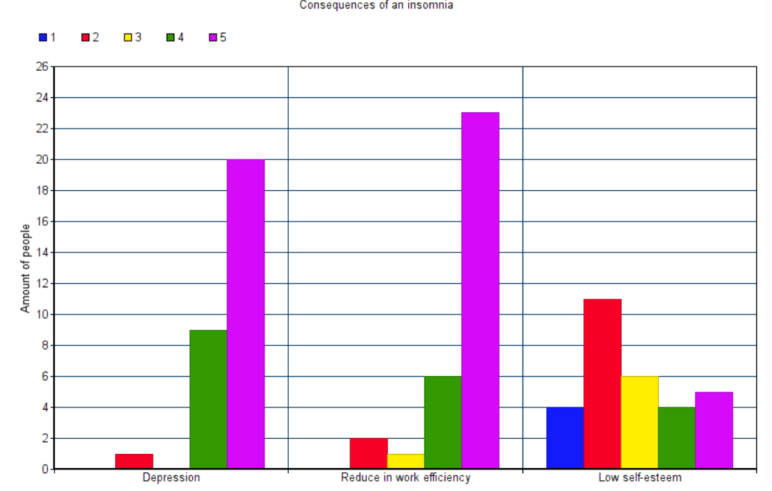
Figure 4

According to the Figure 5, surprisingly, it turned out that only 65.3% of people suffering from insomnia are trying to cure it. The most popular are schedule change (28.6%) and the use of medication (21.4%). The first way is an effective solution, if there is a possibility to use it, while according to the words of the specialist and the focus group, the frequent use of medicaments is not always an effective method of treatment, since they can lead to addiction and in the future to other problems, e.g. larger doses and expenses. However, a visit to a specialist is not a frequent phenomenon and is only 14.3 % (Figure 5). Most likely, this happens due to the fact that people have bias that a psychologist is not able to be that effective and because of the price that good psychologists put forward for their services.

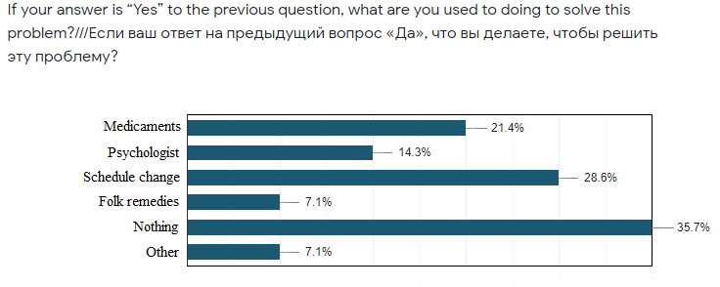
Figure 5

Conclusion

The main purpose of this research was to find out what effect insomnia has on people. In order for my research to be consistent with the purpose, I asked myself the following research questions: “What are the possible causes? Consequences of the disease? What should people do to treat themselves? Who is more likely to face insomnia? Adults or young people?” Survey, interview with the specialist and focus group discussion were chosen to answer these questions. During the research process, the hypothesis was partially confirmed, i.e. I was right about the fact that people can easily identify the causes and consequences of the disease. However, I thought that the people of Kazakhstan, on average, are more prone to face insomnia, but it became clear that the revealed percentage (40%) is within the interval of the average value in the world (30-45%). Without departing from the topic of identifying unexpected results, some of the findings are presented below.
Finding 1: People's contradictory attitude towards insomnia
After reviewing the survey results, it turned out that almost all respondents consider insomnia to be a strong factor that affects their lives and symptoms such as depression and low work efficiency were noted as the most common consequences. What is most surprising is that about a third of all people do nothing about it and just live with the problem causing a paradox between the understanding of seriousness and indifference. This may be because people have a busy schedule and do not have time for a problem, or with previously noted symptoms, which interfere on a psychological level. Even if people use some means to combat insomnia they often are medications that are not so bad, but usually they can be avoided or their consumption can be reduced by timely referral to a specialist. From all of the above, we can conclude that although people are often well aware of the severity and possible danger, the problem remains poorly understood.
Finding 2: Adult are more prone to face insomnia
I was more inclined to believe that the ratio of people suffering from insomnia is about the same for both ages, however, according to the results of all methods, it turned out adult with insomnia are more possible to meet than teenager with the same problem. The reason for it that an adult has more responsibilities and work, consequently, more situations leading to increased stress and anxiety.
Finding 3: The underestimation of physical activities
According to the results of the survey, it turned out that more than 70% of respondents believe that lack of physical activity is not a possible cause of insomnia. Although according to the specialist and his personal experience, they are important and on her account, there are many examples of when they diminished the effects of insomnia.
Research questions:
- Who is more likely to face insomnia? Adults or young people?
Thanks to the information from the Finding 2, I can answer this question in detailed way. Moreover, I have an opportunity to draw conclusions and assumptions why the answer is exactly like this. At the same time, they will not be taken out of thin air, but formed due to the fact that a sufficient number of adults or people that are aware of the problems of adults participated in the survey and the focus group discussion.
- What are the main causes of insomnia?
Unfortunately, no extraordinary answers and results were found here, and they turned out to be quite obvious and predictable. However, my findings, especially 1st and 3rd, suggest some additional information about causes of the disease. In particular, the workload of the schedule of people, their accumulated fatigue and lack of physical activity to unload the body.
- What are the possible consequences of insomnia?
In fact, all my findings in their more in-depth form to some extent reveal the question of consequences, but still the Finding 1 brought more to identify the answer to this question. Namely, thanks not only to the answers themselves, but also to their quantities and its “inconsistencies” in some form, it is possible to determine not only the consequences indicated in the survey, but also to suggest new. For example, serious attitude of people to the problem, but at the same time, closing themselves off from this problem and delaying its solution can lead to the conclusion that in people with a lack of sleep apathy that can be developed will be not only to the world around them but also to themselves.
- What are the common ways to treat insomnia and how effective they are?
When answering this question, the results of the interviews helped the most (where Finding 3 was identified). These findings helped to identify the most frequent (medicaments, schedule/habit change) and effective methods (specialist/psychologist, physical activities, etc.) of dealing with insomnia, as well as inconsistencies in the frequency of use and effectiveness of ways of treatment. In addition, it shows that people should study the issue by themselves better and do not always rely on the conclusions of others to make their health state better.

Evaluation
At the end of the main research, I can say that enough information was obtained to answer all the research questions. This made it possible to draw decent conclusions, hence their quality is quite high.
First of all, a survey was conducted among people of different ages and different residence, since the problem can affect any person. As they could all go through different situations leading to this problem. The questions themselves were clear and easy to understand to respondents, since I received an answer from all respondents even for non-obligatory questions. Therefore, target group and content of question was successfully chosen. However, I did not use all the information that I received during the survey, either because it was useless or because it was not suitable for the context of the study. Therefore, a certain period spent on compiling many questions was wasted. So that, it would be better, instead of trying to do both quantity and quality, to concentrate on one thing, in this case on the quality of some questions, in order to get information that is more useful or detailed.
The second method, interview, was surprisingly much more useful that I thought it would be. Interviewed person was a specialist in many aspects of psychology including sleep disorder. It helped to get sufficient answers about causes of insomnia and the efficiency of the help, which people with insomnia get from various types of treatment methods. Moreover, this method allowed me to distinguish differences between the thoughts of ordinary people, people who suffer from a disease and a person who really understands the disease. However, I made a mistake that I interviewed only one specialist, which could lead to various inconsistencies in the results. Therefore, it would be better to interview at least three people or more next time. Additionally, the complexity of the method itself lies in the fact that people often do not fully understand that interviews can be different in part of structure and requirements of respondent. Therefore, it is sometimes difficult to identify the necessary information and cut off other when a person is immersed in his own speech and unable to stop. In order to avoid this in the future, interviewer should probably better explain to the person what kind of information s/he wants.
The last method that was used is focus group discussion. Right chosen participants with different opinions about the problem had active discussion where both sides provided strong arguments and hence, gave a great overview of the issue. Furthermore, half of the people were adults and all people had knowledge or experience in insomnia, which made the testimonies even more reliable. However, all those involved were simply people without any degree or education in this area, so this could affect the reliability of the responses collected. In order to get answers that are more reliable it is better to replace some people with more informed ones.
In fact, I thought that after doing the research I would be mostly unsurprised. However, it is not fully true statement. Of course, most of my hypothesis was confirmed and my bias did not change, however, the results themselves were unexpected to identify/to see.

Further research
Talking about degree of confidence it is not as high as it could be due to some factors. For example, amount of respondents. Therefore, to have more reliable and confident results some moments should be escaped and fixed in some point.
Firstly, I would like improve my context part. At the next time, I would not include source, which do not mention their author and data of publication. Because I have no confidence, it is reliable information or just disinformation resource. In addition, I would not use the sites of my country except the official ones, because there is the fact that the people of my nationality have little experience in this and if they have, then many things are done irresponsibly.
Secondly, I would like to work with my survey. In questionnaire, I would like to on the qualitative component of my survey, namely on the content, wording, and the scope of the question to obtain more useful information. It will be necessary to work with the number of respondents, namely to increase them and, if possible, attract people from other parts of the world so that the analysis will be as interesting and reliable as possible.
After all these changes, if there is unused time, it can be spent on adding something new, such as questions or goals/aims. Nevertheless, the main research question was answered during this investigation.
Bibliography
Child Adolesc Psychiatr Clin N Am:
https://www.ncbi.nlm.nih.gov/pmc/articles/PMC5839336/
Raj Dasgupta, MD https://www.medicalnewstoday.com/articles/9155#symptoms
NHTSA https://one.nhtsa.gov/people/injury/drowsy_driving1/Drowsy.html
University of Ottawa https://www.sciencedaily.com/releases/2020/12/201207150447.htm
Vara Saripalli, Psy. D. https://www.medicalnewstoday.com/articles/296579
Chokroverty. Sleep disorders medicine: basic science, technical considerations and clinical aspects.
National Bureau of Statistics http://apgazeta.kz/2018/12/31/skolko-nas-7/
Medical company Suncar http://www.morpheus.kz/stati/bessonnica/bessonnica
Tony Parsons https://www.gq.ru/entertainment/pochemu-my-vse-boremsya-s-bessonnicej

Appendices
Appendix 1: Survey for Kazakhstan citizens.

1 How old are you? Choose one:
- 13-18 years old;
- 19-24 years old;
- 25-30 years old;
- 30+ years old.
2 Do you have trouble sleeping / insomnia?
A. Yes
B. No
3 If your answer is “Yes” to the previous question, what are you doing to get rid of this problem?
A. I am taking medication
B. I am treated with folk remedies
C. Seeing a psychologist
D. Comply with the regime
E. Doing nothing
F. Your answer

4 How seriously do you take insomnia? 1 not serious – 10 very serious
(not serious) 1 2 3 4 5 6 7 8 9 10 (very serious)

5 How far do you agree with the following statement?
6 Insomnia is a disease that needs special treatment.
- Disagree
- Partially agree
- Fully agree

7 Evaluate to what extent the following causes can lead to insomnia. (Rate your opinion: 1 –min., 5 – max.)

- Stress;
- Neurological diseases;
- Diseases of internal organs;
- Alcohol;
- Change of time zones;
- External unfavorable conditions;
- Pain;
- Phenomena occurring during sleep;
- Excessive use of gadgets
- Overeating
- Lack of physical activity
- An inconsistent sleeping schedule

8 Rate your opinion: 1 – Fully disagree, 2 – disagree, 3 – neutral 4-agree 5-fully agree (Avoid neutral answers as much as possible).
- Lack of any physical activity can lead to sleep problems;
- Insomnia affects a person only physically;
- Insomnia affects a person only mentally;
- Insomnia affects a person both physically and mentally.
- Adults are more prone to insomnia than young people;
- Children and adolescents are more prone to insomnia than adults.
- Kazakhstanis, on average, are more prone to manifestations of insomnia;
- Insomnia symptoms may lead to lower self-esteem.
- Insomnia develops depression and irritability.
- Insomnia worsens relationships with people around you. Insomnia weakens memory.
- Insomnia reduces work efficiency

9 In your opinion, what methods are more effective in combating insomnia?
A. Medicines
B. Compliance with the correct daily routine
C. Proper nutrition
D. Sports and physical activity
E. Working with a psychologist / psychiatrist
F. Meditation
G. Your answer

Appendix 2: Interview with qualified specialist.
How common is insomnia?
What are the main causes of insomnia?
To what extent are people concerned about insomnia?
What are the possible consequences of insomnia?
What are the common ways to treat insomnia and how effective they are?
Do patients often come with complaints of insomnia?
What do you prescribe for such patients (with insomnia)?
In your opinion, do people perceive insomnia as a disease? In your opinion, how important the studying of a topic such an insomnia for the average person? What is the potential danger of insomnia for its carrier?
What do you think, will knowledge about the problem help a person fix it?
How do you think, for whom this disease poses a great danger to the younger generation or to theolder? Why?
Is it possible to delay the treatment of insomnia or should you immediately contact a specialist?

Appendix 3: Focus group discussion
- What is your age?
- Did/do you suffer from insomnia?
- What is three biggest challenges you face living with insomnia?
- Did your friends/folks suffer from insomnia?
- Could you describe their appearance and changes in behavior and daily routine at that moment?
- What were they doing before the illness? What events could lead them to this state?
- Who do you think is more likely to face insomnia? Adults or young people? Why?

