The causes of health problems that teenagers who use social media face
Adebiyetova Aruzhan 11”C”
Nazarbayev Intellectual School of Chemistry and Biology

Word count: 3765

Introduction
“I feel social media can be very distracting, unhealthy, and harmful to one’s self-confidence. I don’t even log on to it on my phone except when I post something on Instagram.” © Rupi Kaur
The number of users of social media, who have an account increased noticeably last years. The interesting fact is that most of them are teenagers or young people under 25. There are the vision problems, lack of sleep, mental health problems that teenagers, including me and my friends personally, face, as it is believed due to the social media.
Almost all of the people of Generation Z, who have an access to the Internet and have a technological device to surf social media, are aware of different problems from a starvation of people in an African village to the latest trends on TikTok. Although, they are keeping abreast of events and can make new friends there, it takes a lot of time to look for some information that the teen is interested in, which will make them irritated and tired. Therefore, it effects on the adolescents’ relationship with parents, friends, relatives, daily schedule, school performance and the most important – health.
My research will contain information about possible causes of the social media that lead to health problems, that is why it can be beneficial for the teenagers of my age who suffer from mental disorders and physical convalescence. Moreover, teens’ parents may find it useful to mend relations with their kids and try understand them better, and know the reasons for the poor health of their children, so they will not have to buy a new pair of glasses or expensive medicines.
To my mind, the main causes of the health problems that teenagers experience are the online-bullying and the effect of blue light. To make my research objective, I have to consider my bias and try to use more general information that supports different opinions.
Context
The development of the science and technologies gave us a lot of opportunities from searching for different information to buying different things from all over the world. Most of the people have an access to the Internet, so they can easily use food delivery services, if we do not want to go out, or we can make new friends, no matter where they are, even in other country or overseas. If before people got all the information from news or newspapers, now they would scroll the feed for news about everything. This way they can spend most of their time.
Social media are very popular among teenagers of our days. It is well-known that social media allows teens from all over the world, no matter where they are from, to become popular. As Professional Basketball Player, Ray Allen said “You don’t need a corporation or a marketing company to brand you now: you can do it yourself. You can establish who you are with a social media following”. For instance, 16 years-old Charli D’Amelio become the very first blogger who managed to collect 100 million subscribers on TikTok platform (Gazeta.ru, 2020). According to the Mitch Prinstein, PhD, a clinical child and adolescent psychologist who is the John Van Seters distinguished professor of psychology and neuroscience and the director of clinical psychology at the University of North Carolina at Chapel Hill, people, who are more popular have a better health, more chances to get a job and receive a promotion, therefore they are more happier and will live longer.
In addition to this, social media also gives countless opportunities to learn more free and online information about healthcare. About 53% of teens use different platforms as YouTube, SnapChat and Instagram to find out more information about the proper nutrition, exercises and diets to keep fit (Beverly Bennett, 2020). Contributing to this idea, there are a big variety of different web-sites for “physicians only”, where all members of the community can gather on site to discuss some new treatments for diseases and ask their colleagues for expert advice, such as “Sermo” or “Doximity” (C.Lee Ventola, 2014).
Nevertheless, according to the Microsoft researches, who have analysed Twitter accounts of 476 correspondents, said that the wide usage of depressive language, emotions showed the depression in seven out of ten cases (Jessica Brown, bbc.com, 2018). A study published in Computers in Human Behavior journal found the directly relation between depression and the number of social media accounts. Researches used Patient-Reported Outcomes Measurement Information System (PROMIS) and Pew Internet Research scale, and discovered that those who own seven and more accounts in different platforms have a higher risk of getting into depression and anxiety (Computers in Humans Behavior, 2017). By observing this situation from a social lens, the teenage depression can lead to different mental issues, such as bipolar disorder, personality disorder, eating disorders and others, adolescents will be not able to live as before, their perception of the world surrounding them will change and the things or relationships that they valued before will not matter, therefore it will lead to family conflicts and ruining of the household relations ( mentalhealth.org.uk, 2016 ).
Moreover, activities in social media have affected on teenagers’ sleep pattern. For instance, the British study, that has been published in the Journal of Youth Studies, one-fifth the teens between 12 and 15 years said that they “almost always” wake up at night to check their social media accounts. Therefore, they are “constantly” tired at school compared to their friends at the same age, who do not log on social media (Mediapost.com, 2017). Researches from Harvard and their colleagues made an experiment to compare the effect from the blue light and green light, which showed that blue light suppressed melatonin for 3 hours, while green light could do it only for 1.5 hours, which is twice less. It means that person, who was under the effect of blue rays will have problems with his/her sleep (health.harvard.edu, 2020).
At the same time, looking at this situation on a local level, according to the the Ministry of Healthcare’s National Centre for Public Health press service, more than 12 percent of teenagers between ages 11-15 are victims of cyberbullying and 11 percent of teens have experienced it at least one time in their life (Astanatimes.com, 2020). In accordance with the study that researches have conducted among 402 children from 40 different school, there were more cases when students faced cyberbullying, for example: one girl did not get with another girl from high school, so she was searching for her victim through the social media “Agent” and even in a real life (unicef.org, 2013).
Taking all things into consideration, social media can provide teenagers with beneficial information, but it brings more harmful effect than positive. One of the most common causes in teenagers’ health problem are cyberbullying and effect of “blue light”.
Aims
The main aim of this research is to find out what actions can be taken to solve health problem caused by social media. It is important to find ways to help them, because they are part of our society and our future. Therefore, to reach my goal following questions have to be answered:
- What are the reasons for teenagers spend a lot of time on social media?
- What kind of problems did teenagers face when they used social media?
- What measures can be taken to reduce the time spend on social media and negative impact of it?
Based on the outcomes of the research, I hypothesize that the reason of such activity was caused because parents, friends and surrounding of teenagers do not pay enough attention to teens, moreover the most common problem that they face will be vision problems and problems with sleeping. I predict that, the average time adolescents spend on social media will be about 11 hours per day and their possible suggestions might be to develop the sphere of entertainment or create new entertainment facilities.
Methods
This research was aimed to explore the people’s attitude towards the negative impact of social media on adolescents’ health and the possible solutions that can be taken to reduce this effect. Three different types of researching tools have been used – questionnaire, interview and non-participant observation.
Method 1 – Questionnaire
The first method that I used was a questionnaire. Its topic was “Health problems that were caused by the effect of social media” and it was aimed to find out the general information about the reasons of health problems that occurred and the measures that can be taken to solve this issue. I have chosen this particular type of tool because it takes little time to create it and to conduct, because you can send it to people and they will be able to take it at any free time. In addition, it gave me an opportunity to collect qualitative and quantitative data simultaneously because of the open-ended questions that I included to the main list of questions. The sample of my questionnaire was teenagers between the age of 12 and 19, so that it could be students of NIS grades 7-12 and other schools.

Method 2 – Interview
The second method that has been used was an interview. Interview is a good way to obtain qualitative data, rather than quantitative data, because it was possible to see the reaction of people to given questions, the way they move their hands while answering and etc. Interview was directed to specific people from different areas of live, so that it could give me different perspectives according to the topic of my interview related to the “Effect of the social media on the health of the teenagers”. Due to the fact that interview is time-consuming, relatively, there was 4 people picked to conduct it. I decided to choose one psychologist, one curator, one student and one parent, and use structured interview, which included some same questions to all interviewers and some questions different related to their activity. According to the diversity of the sample of the interview, it could be possible for me to gain different perspectives of people toward this problem.
Method 3 – Non-participant observation
The third and the final research tool that was used is a non-participant observation. The non-participant observation could give me an opportunity to observe the simple activities of people, but do not take a part in that. The sample that has been chosen were people on the streets, buses and some entertaining places. I was looking at people and their actions without letting them know that they have been observed to obtain true information and their natural behavior. My sample was people of different categories, from various aspects of live that I could see at that places. I had to observe the way people act with others when they use smartphones, especially when they were on social media. I wanted to watch at the behavior of a person, what state he is in, whether he has signs of illness, due to the effect of social networks. At this point I could gather qualitative data as well as quantitative data, for example: the age, gender of observing people, the percentage of adolescents to the main group of people.

Results
The three different research methods have been used to gather information related to the topic of my research “The causes of health problems that teenagers who use social media face”.
The first research method – questionnaire was conducted among 50 students of grades 7-12. The results of the questionnaire that was created through the Microsoft Forms showed that most of the respondents, 22 students, spend from 4 to 7 hours a day on social media. At the same time, 13 students spend 0-3 hours, 10 students 7-9 hours and the minority of answered, 5 teenagers, spend more than 10 hours a day on social networks.

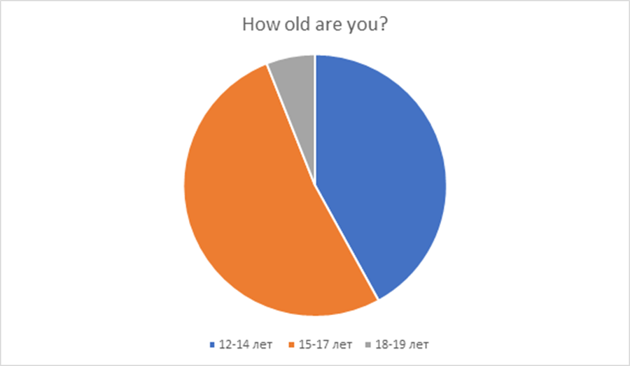
Pie chart 1. Age of respondents
The most common health problems that teenagers who use social media face, were vision problems, back problems and mental health problems such as social media addiction and social isolation. In addition to this, the majority of the respondents was students between 15-17 ages (26), approximately the half of the students were adolescents between 12 and 14 years old (21).
Moreover, it became clear that nearly half of the teenagers (23) have and use actively 4 and more social media accounts, whereas one fifth have 2, 9 people have 3 and only 8 people have 1 social media account. What is interesting is that almost all the answerers have chosen Instagram (40) and YouTube (36) as one of their favorite social networking sites.
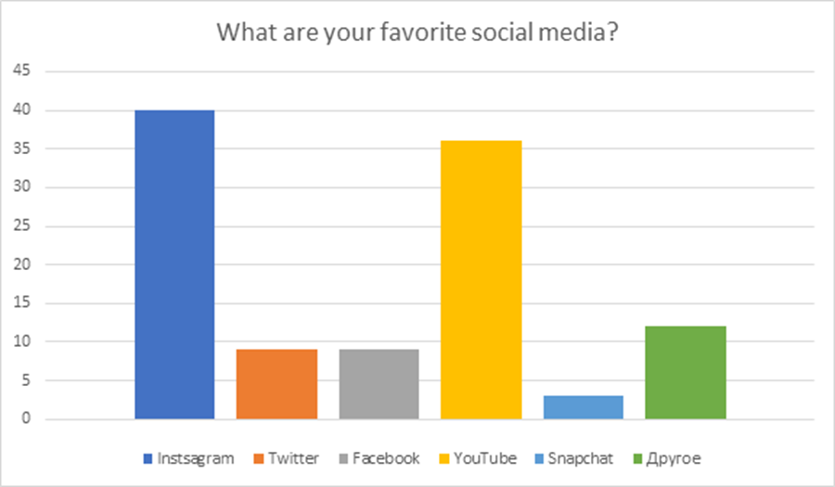
Bar chart 1. Favorite social media
Adolescents who had any health problems caused by social media (11) mostly mentioned vision impairment problems. The most prevalent reasons for spending time on social media were “to keep in touch with friends” (35%) and “to keep abreast of the latest news” (32%), also “to follow the life of the celebrities” (22%) and “for entertaining” occasions have been written. According to the answers, in general family relationships and school performance did not change since teens started using social media accounts, Finally, in the question about the actions that can be taken by parents, friends and government I have received different answers, but the more mentioned answers were about finding a new interest, control the time spent on social media, communicate more in a real life.
As the second research tool interview has been used. Interview was conducted with 4 different people from different spheres of life which influence on the teenagers: parents, curator, psychologist and teenager himself.
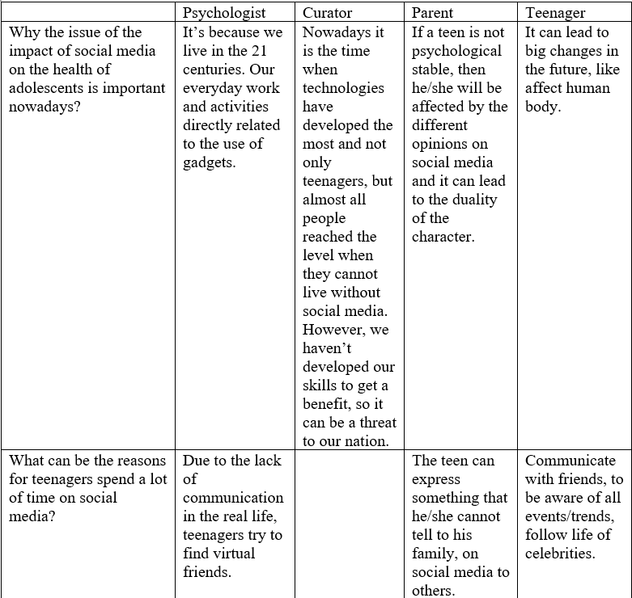
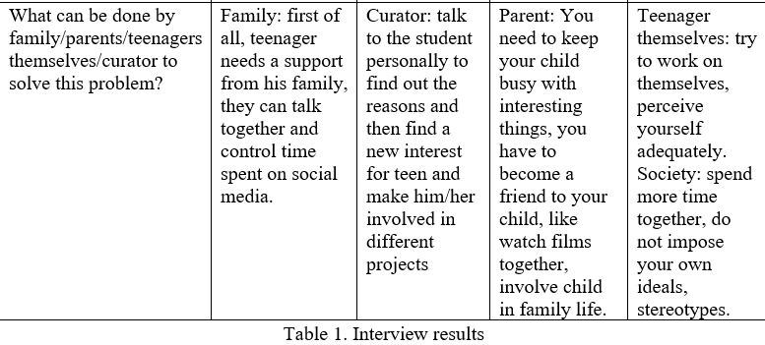

In accordance with the table above, all four people understand the importance of this problem, but all of them thought about different causes of the problem being actual. Despite this, all three interviewees answered almost the same to the question about the reasons of spending much time on social media – to communicate online, virtually with their friends or other users of the net. To the last question about actions that can be taken to solve the problem all four respondents gave different answers: psychologist said that family should give a teen support, curator said that they talk to the adolescent and try to make such students participate in school life actively, while parent decided that as the parent you have to become a friend to your child, involve him in family life and teenager herself said shared that you have to work on yourself and perceiving yourself adequately.
The third method was a non-participant observation, which allowed me to observe a natural activities people do on their daily routine. The different groups of people have been observed during the certain period of time. Almost all of the observed people were adolescents between 14-18 years old. Most of the teenagers did not talk too much with other teenagers, but they were on their cellphones, namely in social networks. Based on the observations that were done, I have analyzed that most of the teens were wearing glasses for sight, and they were looking down at their phones, so they might have posture and back problems.

Conclusion
The main aim of my research was to find out actions that can be taken to solve or to help to solve the problems caused by the social media. Consequently, additional research questions were created: “What are the reasons for teenagers spend a lot of time on social media?”, “What kind of problems did teenagers face when they used social media?”, “What measures can be taken to reduce the time spend on social media and negative impact of it?”, by answering which I can achieve my goal. To find answers to my questions, three different research tools have been used, they are – online questionnaire, interviews and non-participant observation. My personal bias was that the effect of blue light and online-bullying would be the main causes of health problems that adolescents face.
- What are the reasons for teenagers spend a lot of time on social media?
Based on the results of the questionnaire that has been conducted among 50 teenagers and interviews with 4 people, the most common reasons were to communicate with friends, to keep abreast of the latest news and trends. Also, some respondents answered that the reasons were to relax in social media, for entertaining, follow celebrities’ lives and as the non-participant observation showed lack of communication in the real life plays a big role in it. Therefore, as the results of the questionnaire showed, most of the adolescents spend from 4 to 7 hours a day on social media.
- What kind of problems did teenagers face when they used social media?
According to the results of the online questionnaire, the most mentioned problems were vision problems, back and posture problems, however other respondents shared with another ideas, for instance they have noticed weak immunity and muscle tone, insomnia, obesity, deterioration in social skills, memory and hearing impairment and emotional instability.
- What measures can be taken to reduce the time spend on social media and negative impact of it?
According to the results of the open-ended question in the questionnaire and personal interviews on the given topic, there were several different suggestions from different people. As it shown in Table 1, psychologist claims that family support and joint control time can be a good option, curator said that they can talk to such teenagers personally and make them involved in school life, so they can be interested in other activities, parent said that as a parent it is important to be a friend to your child and spend time together as a family, while teenager thought that as the teenager it is possible to work on yourself and society can stop creating non-existent ideals of a person.
Evaluation
Since all my research questions have been answered, it allowed me to reach my initial aim and make a conclusion of work that has been done.
In general, work done was pretty good, but it could have been done better. It had strong sides like the relevance of the chosen topic, good choice of interviewees and the use of three different research tools. Despite these pros, there were still some cons such as the certain problems in methods used, the inference from results could be made more accurate.
The first method used was a questionnaire, conducted among 50 teenagers. The questions were oriented to the topic of the research and were appropriate to the school students, that is why it is possible to say that sample was chosen correctly. However, some questions were not necessary, like “What are favorite social media?” and the order of the questions was not right, for instance the question about the reasons of spending a time on social media could have been placed earlier, also some new, another questions that will not be affected my personal bias could be included “Have you heard about this problem?”, “Why this problem is important?”.
The second method was an interview with different people from different spheres of life, which was helpful to gather some information for open-ended questions. Due to the fact that all 4 interviewees were doing different activities it allowed me to gain various perspectives on one topic. Moreover, one of the strong points of this research tool is that it was structured interview, where questions were created initially and were same to all people, but some questions varied from person to person based on their occupation. Nevertheless, there were some disadvantages of this method, for instance because most of the questions were different for everyone it was hard to make some connections between all of the given answers. Also, since interviews were conducted online it was impossible to collect any qualitative data, such as reaction to some questions, their gestures and behavior in general.
The non-participant observation was the third method that was used. It gave me opportunity to observe the natural behavior of people without letting them know that they have been observed. Since people did not know that they were observed, it was possible to watch at them at different places. Though, there were a lot of opportunities to make my remarks, as I did not have certain criteria to follow it was pretty hard, because there were a lot of people. Moreover, it is time-consuming tool, on account of sometimes there is no suitable people, so you have to wait and look for such group of people to be observed. n
Further research
According to the results of my research, there is still a lot of areas for improvement in the future.
To begin with, the total number of answers that I received was only 50, so it is not enough to conduct a complete research, therefore it will be useful to increase the number of responds up to 100. Also, since the problem occurs in many other countries, it will be better to conduct the online questionnaire in other countries, so that it can be considered on the global level.
The target population of the questionnaire is adolescents from 12 to 19 years old, but to look at the problem from different it is necessary to change the sample. It is possible to create another questionnaire on another topic for older people in order to get information about their attitude to the problem and their perspectives. It is also possible to include some definitions at the beginning of the questionnaire, because older people not always familiar with modern slang and some trends.
Moreover, it will be more useful to conduct interviews in personal to collect some qualitative data from the interviewees. In addition, the type of the interview can be changed from structured to semi-structured one, because during the interview person can give answers that will arise new questions from interviewer.
Furthermore, it will be possible to change the third research tool – non-participant observation to another method like focus group discussion to gather the certain group of people and conduct a conversation on the topic, asking questions or to have pre-written criteria for people to be observed.
In conclusion, taking all things into consideration, at the end of the research my personal perspective has changed. In the future, to make my research more valid research methods and some questions have to be reconsidered several times. The outcomes of the research can be generalized to most of the adolescents in different countries and can be used in other project works related to the topic health problems caused by the use of social media. In the future I would like to consider this issue more extensively, and take as a topic “The impact of social media on the health of generation Z”. I had learnt a lot of new information that I was not familiar with before.
Bibliography
https://www.gazeta.ru/tech/2020/11/23/13371523/tiktok_100mln.shtml
https://www.healthtechzone.com/topics/healthcare/articles/2020/01/20/444262-students-healthcare-positive-negative-impact-social-media-health.htm
https://www.bbc.com/future/article/20180104-is-social-media-bad-for-you-the-evidence-and-the-unknowns
https://www.verywellfamily.com/ways-social-media-affects-teen-mental-health-4144769
https://www.mediapost.com/publications/article/293065/sleep-loss-in-teens-linked-to-social-media.html
https://www.sciencedirect.com/science/article/abs/pii/S0747563216307543
https://www.ncbi.nlm.nih.gov/pmc/articles/PMC4103576/
https://astanatimes.com/2020/01/every-fifth-teenager-is-bully-or-victim-of-one-say-kazakh-scientists/
https://www.unicef.org/kazakhstan/media/2076/file/%D0%9F%D1%83%D0%B1%D0%BB%D0%B8%D0%BA%D0%B0%D1%86%D0%B8%D1%8F%20%D0%BD%D0%B0%20%D0%B0%D0%BD%D0%B3%D0%BB.pdf
https://www.health.harvard.edu/staying-healthy/blue-light-has-a-dark-side
https://www.hopkinsmedicine.org/psychiatry/specialty_areas/moods/adap/docs/adap-booklet_final.pdf
https://www.mentalhealth.org.uk/a-to-z/c/children-and-young-people
Appendices
Appendix 1 - Questionnaire
1) How old are you?
- 12-14
- 15-17
- 18-19
2) What is your gender?
- Male
- Female
3) How much time a day do you spend on social media?
- 0-3 hours
- 4-7 hours
- 7-9 hours
- 10 hours and more
4) What are your favorite social media?
- Instagram
- Twitter
- Facebook
- YouTube
- Snapchat
- Other
5) How many social media accounts do you have?
- 0
- 1
- 2
- 3
- 4 and more
6) What health problems have you noticed in teenagers who use social networks?
7) Do you have any health problems caused by social media?
- Yes
- No
- I find it difficult to answer
8) If you answered "Yes" to the previous question, can you describe the problem/problems?
9) Why do you spend time on social media?
- To keep in touch with friends
- To follow the life of the celebrities
- To keep abreast of the latest news
- Others
10) Have your relationships with your family changed since you started using social media accounts?
- Yes, they became better
- Yes, they got worse
- No, they haven’t changed
- I find it difficult to answer
11) Have your school performance changed since you started using social media accounts?
- Yes, it has improved
- Yes, it got worse
- No, it hasn’t changed
- I find it difficult to answer
12) What can your parents/friends/government do to reduce the time you spend on social media?
Appendix 2 – Structured interview
The interview beginning:
- Have you heard about the issue of health problems that teenagers faced due to the social media?
- What is personal opinion about this situation?
For psychologists:
- Why the issue of the impact of social media on the health of adolescents is important nowadays?
- Have you faced such teenagers in your work experience?
- What can be the reasons for teenagers spend a lot of time on social media?
- What is the effect of this problem on teenagers’ mental health?
- What are the signs of the health problems appeared due to the social media?
- How family can help the teenagers who have these problems?
- How do you think, what will happen to the teen if he/she does not solve the problem?
For curators:
- Why the issue of the impact of social media on the health of adolescents is important nowadays?
- Did you have the teenagers with such problems in your classes?
- Does school administration pay attention to this problem?
- As a curator, what can you possibly do to help the student?
For parents:
- Why the issue of the impact of social media on the health of adolescents is important nowadays?
- What can be the reasons for teenagers spend a lot of time on social media?
- Did your children have health problems that occurred due to the social media?
- As a parent, what can you possibly do to help your child?
For students:
- Why the issue of the impact of social media on the health of adolescents is important nowadays?
- What can be the reasons for teenagers spend a lot of time on social media?
- Did you experience this problem in your own life?
- What are the consequences of the problem?
- What can be done by the teenagers themselves to solve this problem?
- What society can do to reduce the negative impact of social media on teenagers’ lives?

