Interaction with terminally ill children:
Should parents of terminally ill children disclose genetic information?
Temirbekov Yerassyl
Nazarbayev Intellectual school of Chemistry and Biology in Ust-Kamenogorsk

Word count: 3880

Should parents of terminally ill children disclose genetic information?

Introduction
Some genetic diseases are late onset, which means that people who inherited a disease would encounter with symptoms only after long period of their lives. There are many examples of these disorders: Huntington’s disease, Alzheimer’s disease, schizophrenia, AIDS and many others. Frequency of all diseases is varying from 3 to 7 per 100 000 people for Huntington’s disease (MedlinePlus, 2020), Alzheimer affected 6-7 million people (WHO, 2020), and 20 million people suffer from schizophrenia worldwide (OurWorldInData, 2018). All of them have no effective treatment and apart from absence of cure, they initiate another relevant problem - what is less harmful to society and child with life-threatening disease: to know about it or to live normal life until onset of the disease?
Often medical researches cover only scientific part of any illness and does not tackle with ethical sides of genetic diseases; however, ethics and morality are also important. Families with genetic disorders are not large part of our society, but we cannot ignore minorities. The main reason why I chose this topic is that different people have different points and sometimes these points are not considering main group of people – people who have disorders and it is hard to distinguish which approach will be less harmful.
My personal bias on this problem is that parents should say about possible disease only if their children are going to create new family – in order to prevent transmission of disease. It is too cruel to inform child that he or she will have shorter life span than average person will; it can deprive them of life goals.
One of the main reasons why this research is relevant is that often parents are only people who are required to cope with this dilemma and in order to make important choice wisely they should know opinion of public and specialists. In all scales, this research can give answer for hundreds of people in Kazakhstan and around the world how to act in this particular situation.

Context
There are some late onset disorders, which do not give symptoms during long period. Thousands of people are suffering from these kinds of diseases: Huntington’s disease, long QT syndrome, Lynch syndrome, Alzheimer disease, schizophrenia etc. Families with such disorders deal with dilemma: whether it is important to do genetic screening and inform child about life-threatening disease, or to have normal life until onset of symptoms.
Prof Alan Stein et al in their article about communication with children (Stein et al, 2019) propose different ways of communicating with children at different ages, considering their perception of diseases, death and future. This method of communication with children is important because at different ages children react and understand information in different manner. Another research (Vavolizza et al, 2015) showed that majority of people support the idea of obligation to share genetic information with family members, authors collected data from people who have cardiac arrhythmia (fast and chaotic heartbeats) or who have close relatives with cardiac event/died from cardiac arrest. Although results show that people generally have one opinion towards issue, but it did not show situation of communication between parents and children.
It is important to consider issue from perspective of children - they are not only able to understand and accept reality, but they feel responsibility. According to Dr. Emily Harrop (“Talking to Children About Terminal Illness”, 2019) children at age around 5 to 7 worry about their parents, and it is much harder to accept disease when they realize not only danger to their lives, but also condition of their parents. If parents decided to say about life-threatening disease, they should be ready for some patterns of behavior from children: “why me?” or “am I going to die?” and parents should deal with them (“Caring of a seriously ill child”, 2015).
From the perspective of doctors, such diseases are also very hard to explain and inform parents about risks. This issue is closely related to issue of doctor-patient confidentiality (Peterson, 2018) - doctors can only guide and give advice to parents. Despite the fact that doctors are not involved in process of decision-making, their confidentiality and regulations from government, require researching problem from ethical lens.
In research of colorectal cancer patients (Porteous, 2003) majority of participants found acceptable to know about genetic risk of colorectal cancer to be aware of disease. Participants were in age group from 31 to 55 years and they have potentially high risk of hereditary cancer. The main difference between this sample and sample in this research is that in case of colorectal cancer, chance of getting cancer is significantly higher, but cancer can be treated and success of treatment depends on at which stage person started treatment, whereas some diseases have consequences that are more serious.
Huntington disease fits into the model of life-threatening condition, which can significantly affect life of person only after first symptoms. Perspective of parents was analyzed from different sides, involving study of different parent groups: who did not know about HD before planning child, who had children despite the fact that they have disease. Research of Quaid (Quaid et al, 2013) showed that people do this with different intention: hoping for a cure, magical thinking, feeling guilty, and getting it wrong. Some people hope that in near future their child will be provided with effective treatment and having children and informing them about HD seems logical, but this intention can only give false hope to the child. However, first theoretical cure of HD was found in 2017, and it is not available for all people around the world and only small steps are made towards ready treatment (Pfalzer, 2019).
From the lens of public health, however, this issue of disclosing genetic information does not have an obvious answer, in order to decrease the amount of people with genetic diseases and decrease frequency of negative traits people should create families with children only if they are confident about their own health and health of their future children (WHO, 1996). Considering feelings of small group of people harms major part of society. From this point of view, disclosing genetic information is the best solution for these diseases on larger scales, to eradicate these disorders.
In local scale, research cannot significantly increase quality of life of whole population; however, we cannot ignore minorities. If we consider each disorder independently, we get small numbers: 1/2000 person with long QT syndrome, 1/50000 for Huntington’s disease, 1/2000 for Lynch syndrome. When we apply these frequencies to Oskemen – 333 thousand people (The population of the Republic of Kazakhstan, 2020), number of people suffering from these three diseases is more than 300, but it is not real number because each city is isolated population, with nonrandom mating and this can increase or decrease frequency of some diseases. On the scale of country and on international level, research is covering several million people across the world.
As a result, this problem still requires additional research to find exact answers, many studies were done to find up relationships between doctors and patient, parent and ill child, but these researches are covering only problems of expressing diagnosis and communication with person who already informed. When studies tackle with problem of disclosing genetic information authors operate with government regulations and medical ethics without questioning real issue. It is important to give realistic and applicable answers and to help parents make their decision taking into account more relevant arguments and data.
Aims
The main purpose of this research is to identify what is the best option in case of child with life-threatening disease: to disclose genetic information and explain possible risks or to keep information secret to avoid negative consequences on life. To achieve aim following research questions should be answered:
1. What are the most common decisions made by parents of children with terminal illnesses?
2. What are the most common suggestions made by the public/healthcare workers?
3. What are the major arguments for disclosing genetic information and keeping it in secret?
4. How children with genetic disorders would act if they were in place of their parents?

My hypothesis is that majority of respondents would strongly support idea of disclosing genetic information for children, and the main argument will be that they should be prepared for symptoms and consider the fact of genetic disease in case of creating family. People consider this issue only evaluating benefit for society, without considering feelings of individual.

Methods
Research question is choosing between disclosing or informing children about genetic disorders and find best approach for disclosing this information. In order to analyze different situations and decision, gather data from public and collect different perspectives I conducted primary research using several research tools: survey, interview and case study.
Problem of interacting with terminally ill children and disclosing genetic information requires both qualitative and quantitative data analysis. Survey question provide only multiple-choice questions to get quantitative data about position of public and find correlation between answers. Interview with specialists and case study involved active discussion of questions and helped to develop position of people about the issue and show point of research from different perspectives. This approach provides much more qualitative data about problem and position of respondents, who will represent population and specialists.
First tool was a survey that enabled to collect data from large number of different people. Survey with small number of open-ended questions covered large sample that could objectively represent the population. Large number of respondents allowed me to group positions and opinions find general trends and analyze overall result. Even if some people would answer not correctly and honestly, the answers of other participants mitigated deviation from real situation. Main weakness of this research tool is limited expression of position because it would be hard to state opinion if respondent’s mindset completely differs from majority of people.
Population is young people under 20 years old; sample for survey is students in schools. They were chosen because in future, they will create families and, since they will live in world of developed medicine and health care, they would much more frequently encounter with this situation in real life. Genetic screening is becoming much more popular right now, doctors can predict disorders with high probability, and since the people older than 20 already have children or planning them, it is not beneficial to do research exclusively for them, also results can be biased because they feel much more empathy to children.
Second tool is interview. Interview consisted of several open-ended questions and each of these questions were discussed to get more qualitative data. Respondents were able to fully express their opinion and give unbiased and neutral information about issue. Also, during interview, I changed questions by adding some new points and ask for additional discussion where it was necessary – interview was much more flexible tool but requires more efforts to conduct and organize it.
I interviewed specialists from healthcare system: doctors or genetic counselors. They are familiar with problem and feel empathy, but also their reasoning is based on scientific data and facts. Usually, only family and their personal doctor are trying to solve problem of disclosing genetic information, and even if doctors are not responsible for decision, they still influence the decision of parents by giving advice.
Third tool is case study. This tool involved deep and careful analysis of context of particular case that happened in real world. Such analysis provided with the information about main motives and intentions during disclosing genetic information. Usually, case study helps to understand why people behaved in particular manner in particular situation and it was possible to apply this conclusion to other cases in real life. Sample for case study is students of 11 grade and a parent of child, this sample was used because students are probably will be parents in future and they can theoretically encounter with problem of genetic consulting/family planning and communication with children, whereas person who already has child can adopt described situation and use personal experience to analyze situation.

Results

The research methods provided information to answer aim research questions. First research methods is survey that was conducted among students of NIS and topic of survey was disclosing genetic information to children. 24 students from different cities completed survey and among them 50% suggested to wait until the onset of first symptoms and only after this event to disclose information about genetic disease (Graph 1). Interestingly, second most popular choice was disclosing the presence of illness as soon as possible – 33%, other people preferred to do it in adolescence – 17%.
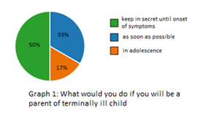

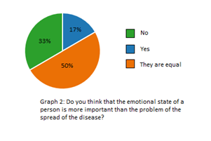
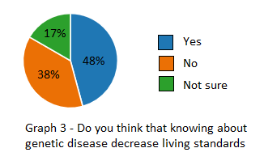
These answers are consistent with several questions and answers: 54% consider that being informed about disease decrease living standard (graph 4), 75% support parents that chose to keep information in secret (graph 5). Arguments of students are stating that children can refer to information inadequately or this information can significantly decrease living standard.
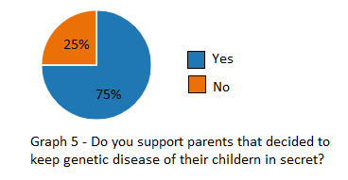
However, other questions are contradicting, for example majority of respondents (42%) are willing to know about disorder if they were in place of child. Moreover, 33% of students think that potential risk from keeping information in secret is more important than emotional state of individual (Graph 2). Answer choice “they are equal” is neutral in this question and was added for those, who not sure.
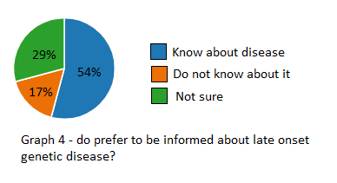
This information shows that even if people understand problem and feel empathy to parents and children they are not able to form unified opinion towards issue, in different wording and positions, from which questions were asked, students are acting in different ways. In question for graph 2, answer choice only considers abstract probability of child with disease and there are no real child with problem, at this point people can use their theoretical knowledge and logic without empathy. This trend can be seen in arguments for this question: “society is more important than individual”, “negative impact on next generation”, “parents should check themselves before planning family”, “anyway child will get information about disease”.
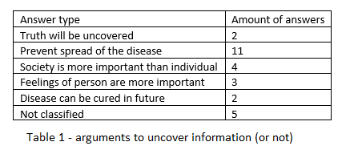
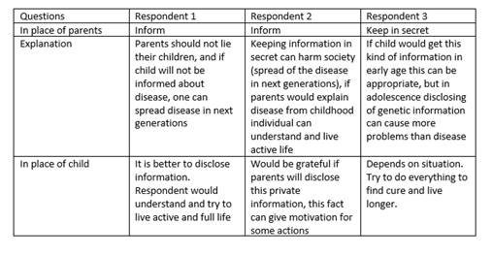
Second research tool was case study in form of group discussion. Three persons discussed given case with problem and stated their position regarding issue. Topic of discussion: “You are one of the parents of child with late onset disease, first symptoms will develop only at the age of 30-50 and before this age person will have normal life.”

Respondents considered problem from two perspectives: from position of parent and from position of child with disease. Two of the respondents prefer to inform their child in case of genetic disorder and have relatively same motivation: to prevent spread of disease to the next generations. Third respondent prefers to keep genetic information in secret and main motivation for this decision is that being informed about disease can cause more problems in life of child. In place of child all participants would be grateful to get information about disease and this fact can give them motivation to live active and full live, of to find a cure for disease.
As in the results of survey in case study respondents are not fully confident in decision, in case study one of the respondents change opinion with the change in perspective, whereas in survey results changed more dramatically. In case study respondents see reaction of other, participants and opinion of first person can affect opinion of other people.
Third research method, interview, was conducted with health care worker with some experience in field of genetic consulting and genetic disorders. Doctors and other medical workers are not allowed to disclose information about patient to anyone and this why their role is not significant in the process of decision-making. In personal experience doctor mentioned, that often people keep genetic information because they do not want to upset their relatives. In addition, there are other reasons: not wanting to feel pitiful, not wanting to feel as outsiders, and not wanting to be blamed (if they have child and family). What is more important is that truth always come to surface. Suggestion for parents of terminally ill children: “Do not try to change situation or deny the diagnosis (this also happens sometimes), it is better to concentrate on life of child and follow all instructions given by doctors.”

Conclusion
My hypothesis was that people generally support idea of disclosing genetic information to children and relatives and this part is consistent with data from primary and secondary research. Second part of hypothesis – reason for disclosing not matched with reality. I suggested being prepared to symptoms as a major argument and spread of disease as a second. However, people chose spread of disease as a main purpose for disclosing genetic information.
Aim questions:
- What are the most common decision made by parents of children with terminal illnesses?
Case study and interview showed that even if respondents are not sure about situation from perspective of parents, they prefer to be informed about disease in place of child. Even if 50% of respondents want to wait until onset of symptoms and 83% support parents that keeping information in secret, they are choosing to disclose information due to the risk of spreading of disease in next generations. Interview with specialist provided position that is more specific – information should be disclosed because truth always comes to the surface.

- What are the most common suggestions made by the general public/health care workers?
Health care worker (doctor with several years of experience) suggested to disclose information because it is significant data that should be considered during life of person. Even if people choose not to disclose information it will be disclosed after period of time and this can alter relationships between people (parents and child, person and relatives). Main suggestion is to disclose information, follow instruction of doctor and concentrate on the life of child.

- What are the major arguments for disclosing genetic information and keeping it in secret?
Arguments for keeping information in secret: do not want to upset relatives, do not want to be outsider, do not want to feel pitiful, do not want to be blamed (if they already have child), care about emotional state of person with disease. Arguments for disclosing information: prevent negative impact on next generations, support relationships of trust between parents and children.

- How children with genetic disorders would act if they were in place of their parents?
Case study and survey was conducted from to perspectives, even if there were no real case of terminally ill person, majority of people decided to disclose information. First questions were from the position of parents, from this perspective respondents showed dispersion in answers, however from perspective of children respondents prefer to know about disease 42% of respondents in interview, and all 3 participants of case study.

Even if this problem is not connected to the location and region where people are encountering with problem these results cannot be generalized with high degree of confidence, because research was conducted only among public from Ust-Kamenogorsk and one health care specialist from Russia. However, these results can be used for next researches and as foundation for methods for communication with terminally ill person.

Evaluation
Primary research answered research questions, and each research question was addressed via several research methods to get reliable data for analysis. Secondary research gave many resources from previous researches, which was beneficial in determining real issues and constructing comprehensive questions for primary research. Interview and survey were conducted as it was planned initially and all questions and provided important information about public position and perspective of healthcare workers. Sample for survey and interview was chosen correctly and answers of respondents satisfied research requirements. However, quality and credibility of case study can be improved in several ways: choose more diverse sample of participants, find people who encountered with problem of research and specialists who can maintain meaningful discussion. Initial sample was parents and healthcare specialists.
Survey was conducted among students in different cities and interview was taken from specialists from another country. Even with the small sample, this diversity in location and people provide high degree of generalization, since people from different locations are answering questions in same way. This why results of research can be applied in Kazakhstan and other countries, at least countries that share same cultural values (central Asia, post-soviet countries). Nevertheless, this degree of generalization can be increased if more than 100 people would participate in research, particularly in survey and case study. Parents of children with genetic disorders can be the most important and valuable participants from whole population, but concerning ethics it can be tactless to ask them to answer to questions associated with their personal problems.
Outcomes can be used as a list of advices to parents of children with terminal diseases and they can be confident in their decision and will avoid feeling of being fault. Personal advices from doctor and advices obtained during discussion in case study are able to help those people. Novice healthcare workers also can use this research to communicate with parents and children with genetic disorders. In addition, this research can be basis for new research covering topics of medical ethics and genetic disorders.

Further research
Many not mentioned research questions and topics could serve as further research questions connected with this research paper. For example - What is general consequences of genetic diseases apart from their clinical symptoms? – this research can cover mental problems, process of disclosing their genetic information to their new friends, and to what extent they are involved in social life. Another possible research question for further research - “To what extent young people are concerned about genetic diseases during family planning?” This research can cover position towards genetic consulting, awareness of the importance of doing some research before planning child, how usually parents decide to have children despite the risk. In addition, it is important to do research about medical ethics – “Do doctors satisfied with medical ethics regulations and what they want to change in it?” During primary and secondary research, I realized that doctors are highly restricted in their abilities apart from prescribing treatment, they are not able to change decision of patient, and they are not able to share with information even if this information can save someone’s life. These questions arose as primary and secondary research was conducted.
These suggested further research topics can used to change methods of interaction with parents of children, patients with genetic diseases, improve quality of medical service that can help to patient in different ways. Research about family planning can be initial trigger to start company, supporting genetic counseling and careful family planning.
Further research should conducted with higher degree of generalization and to increase it, I can use suggestion given in evaluation part: increase number of respondents to at least 100 people from different people, discuss problem with more specialists and people, who actually encountered with issue.
After conducting primary and secondary research, analyzing data and writing conclusion my opinion regarding problem is not changed significantly, however some points like restrictions in medical ethics, awareness of genetic diseases, and amount of people who encounter with genetic diseases are dramatically altered my perception of this topic. I had realized real scales of problems of disclosing genetic information: problem is present everywhere and often public does not even know about this issue, whereas healthcare workers are very restricted in their help.

Bibliography
Huntington disease. (2020). MedlinePlus. https://medlineplus.gov/genetics/condition/huntingtondisease/#frequency
Dementia. (2020, September 21). World Health Organization. https://www.who.int/news-room/factsheets/detail/dementia#:~:text=Worldwide%2C%20around%2050%20million%20people,dependenc%20among%20older%20people%20worldwide.
Mental Health. (2018, April). OurWorldInData. https://ourworldindata.org/mentalhealth#:~:text=The%20prevalence%20of%20schizophrenia%20typically(around%2010%20million%20each).
Stein et al (2019, march 16). Communication with children and adolescents about the diagnosis of their own life-threatening condition. The Lancet, volume 393, issue 10176
Vavolizza, R. D., Kalia, I., Erskine Aaron, K., Silverstein, L. B., Barlevy, D., Wasserman, D., Walsh, C., Marion, R. W., & Dolan, S. M. (2015). Disclosing Genetic Information to Family Members About Inherited Cardiac Arrhythmias: An Obligation or a Choice?. Journal of genetic counseling, 24(4), 608–615. https://doi.org/10.1007/s10897-014-9783-7
Perri Klass (2019, march 18). Talking to children about terminal illness. The New York Times. Retrieved from https://www.nytimes.com/2019/03/18/well/family/talking-to-children-about-terminal-illness.html
Larissa Hirsch (2015, September). Caring for a seriously ill child. Kids Health. Retrieved from https://kidshealth.org/en/parents/seriously-ill.html
Peterson JLH. Confidentiality in medicine: how far should doctors prioritise the confidentiality of the individual they are treating? Postgrad Med J. 2018 Oct;94(1116):596-600. doi: 10.1136/postgradmedj-2018-136038. Epub 2018 Nov 13. PMID: 30425141.
Porteous, M., Dunckley, M., Appleton, S., Catt, S., Dunlop, M., Campbell, H., & Cull, A. (2003). Is it acceptable to approach colorectal cancer patients at diagnosis to discuss genetic testing? A pilot study. British journal of cancer, 89(8), 1400–1402. https://doi.org/10.1038/sj.bjc.6601332
Control of hereditary diseases. Report of a WHO Scientific Group. World Health Organ Tech Rep Ser. 1996;865:1-84. PMID: 8952444.
Quaid, K. A., Swenson, M. M., Sims, S. L., Harrison, J. M., Moskowitz, C., Stepanov, N., Suter, G. W., Westphal, B. J., & Huntington Study Group PHAROS Investigators and Coordinators (2010). What were you thinking?: individuals at risk for Huntington Disease talk about having children. Journal of genetic counseling, 19(6), 606–617. https://doi.org/10.1007/s10897-010-9312-2
The population of the Republic of Kazakhstan by sex in the context of regions, cities, districts, district centers and villages at the beginning of 2020, (2020, April 21). Committee on Statistics of the Ministry of National Economy of the Republic of Kazakhstan
Pfalzer, A. (2019, July 17). Details emerge of first Huntington’s disease gene therapy clinical trial. HD Buzz. https://en.hdbuzz.net/274

Appendix
Interview:
-Можете ли вы столкнуться с проблемой раскрытия генетической информации пациентам?
-Да
-Можете ли вы влиять на решение пациента в данный момент?
-Нет
-Считаете ли вы, что раскрытие генетической информации родственникам и детям является обязанностью человека?
-Да
Были ли в вашей практике люди, которые не хотели раскрывать генетическую информацию?
-Да
-Если были, то можете рассказать подробнее о таком случае?
-Не хотели расстраивать родственников, доставлять им лишние неудобства, поэтому предпочитали скрывать заболевание.
-Есть ли какие-нибудь положительные стороны скрытия информации, и какие аргументы используют пациенты чаще всего?
-Правда всегда лучше лжи, на мой взгляд, какой бы она не была. Некоторые из аргументов перечислены выше, так же иногда не хотят рассказывать, чтобы не вызывать к себе лишней жалости, чтобы окружающие не относились как к аутсайдеру, также если заболевание передалось ребенку от родителя, хотели скрыть от супруга(и), боялись обвинений в свой адрес, но в итоге правда всегда конечно же раскрывалась
-Какие бы были ваши действия, если бы вы оказались на месте родителей детей с генетическими заболеваниями?
-Не пытаться исправить ситуацию, отрицать заболевание и пр., а принять произошедшее и направлять свои действия на улучшение качества жизни ребенка, выполнять все указания врачей для наискорейшего достижения ремиссии заболевания (если это возможно).

Survey:
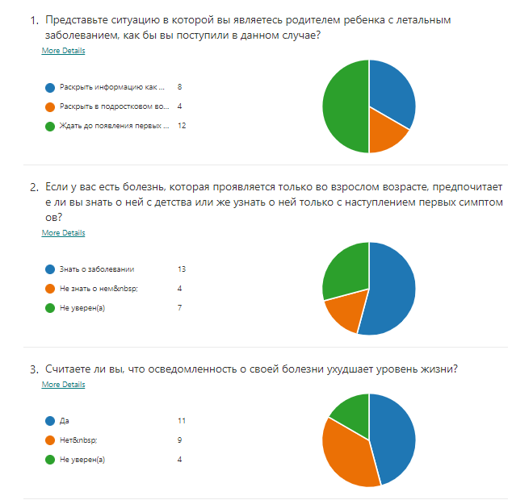

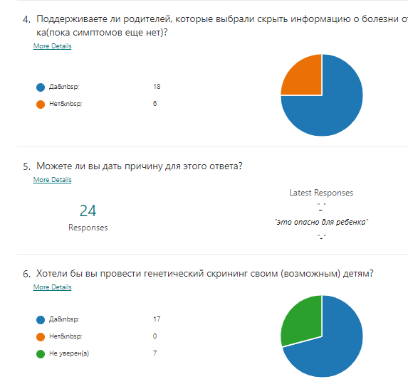

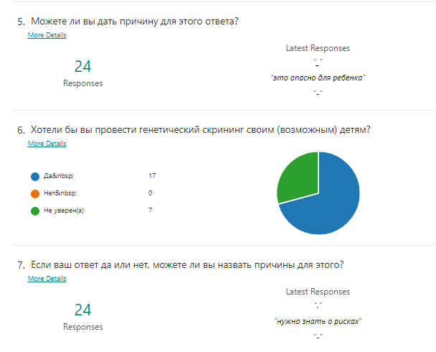

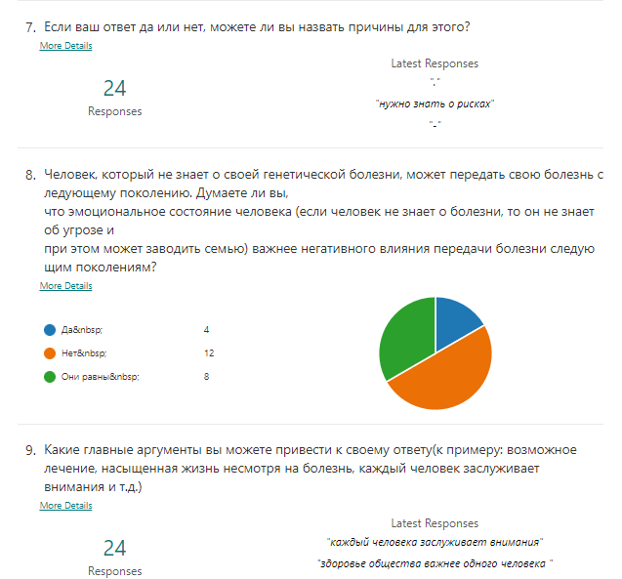

Case study:

-Что бы вы сделали, будучи на месте родителей детей с генетическими заболеваниями?

R1-По моему мнению, скрывать о таких болезнях это безответственно со стороны родителей, даже если правда болезненна, нужно учитывать то что болезнь генетическая, и если человек не будет знать о ней, то она так и будет передаваться из поколения в поколение, и его невозможно будет искоренить. Лично в такое ситуации я бы рассказал об это ребенку, это будущее и это необратимо, если он будет жить во лжи, то я не могу достичь взаимоотношение с ребенком, если я буду врать ему в глаза это будет неприятно, во-вторых это будет вредно и человечеству.

R2-Я бы тоже не скрывала от ребенка, тут есть несколько причин. Если оно генетическое, то его встречали в семье, то ребенок понимает, что они другие, и могут считать для себя это нормой. Ребенок не должен сравнивать себя с другими, и если с детства это объяснять, то особого вреда психике не будет. Еще также, как и сказала R1, если не рассказывать, то может быть поздно и это пошатнет доверие. Надо дать ребенку понять, что ему с этим жить.

R3-Я являюсь сама родителем, рассказать в раннем возрасте можно, но если ребенку 17-18 лет, когда появляются отношения, тогда эта информация не должна быть раскрыта, это приведет к шоку. Все-таки в данном возрасте я бы не раскрыла информацию, а время до наступления болезни можно использовать для поиска лекарства.

-Если бы вам на месте ребенка родители сразу рассказали информацию о болезни?

R1-Я бы их поняла, и жила бы в свое удовольствие, с пониманием краткости жизни, это даже может давать мотивацию для рассмотрения положительных аспектов.

R2-Я бы тоже поняла, поскольку это личная информация, и почему вообще ее должны скрывать? Меня может это вдохновило бы на какие-то исследования в этой сфере. Если бы раскрыли, то поняла бы, а если бы нет – то не поняла.

R3-В зависимости от человека сама болезнь может сыграть малую роль в его жизни, а как ребенок я бы поняла бы позицию родителей. Родители не рожают детей чтобы они были нездоровыми, просто так может сложиться ситуация.

